***Assignment #2B***

***Jesus Gutierrez***

Enabling File Redirection in your Shell

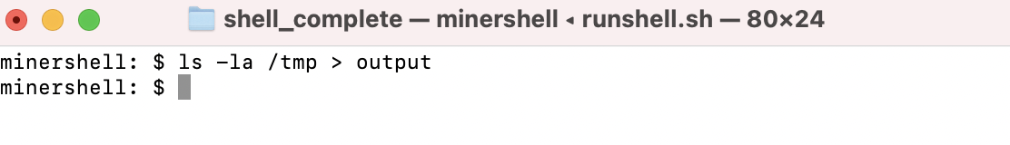

User input **“ls -la /tmp > output”** nothing is displayed on shell screen, rather an ouput file is created as shown below:

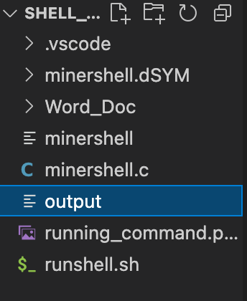

Then inside this output file, we basically get what user inputs in the shell as shown:

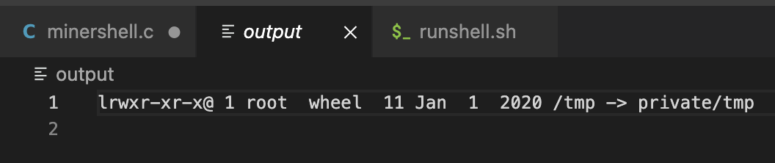

We also have the flexibility to overwrite it, as shown below:

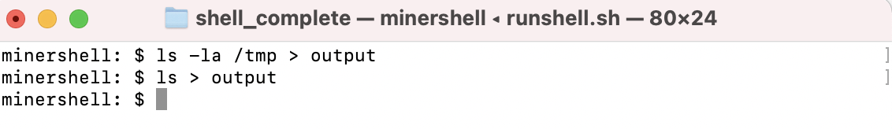

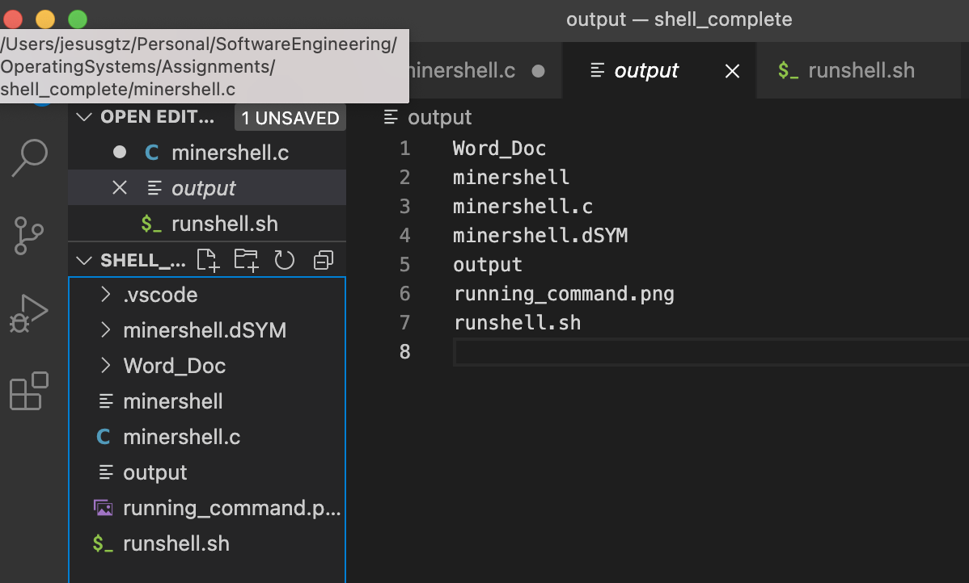

Appending to Files

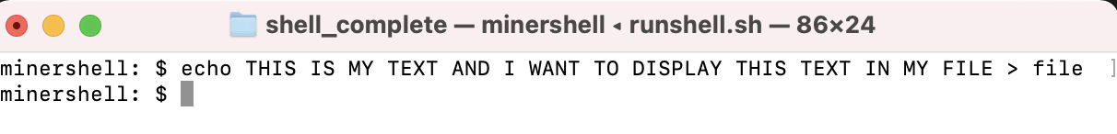

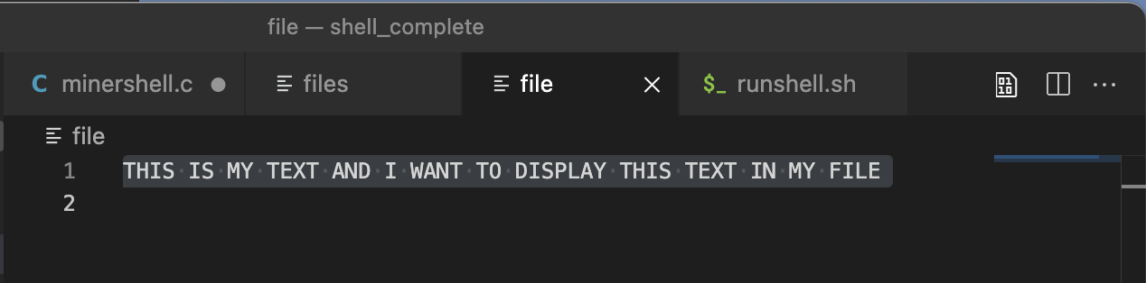

We can append files, and in this example, we show how using echo command to exact output lines into a file.