***Assignment #2C***

***Jesus Gutierrez***

Augmenting your “Minershell” with pipelining functionality:

In the below example, “sort” command takes the output of “ls <mydirectory>” as its input.

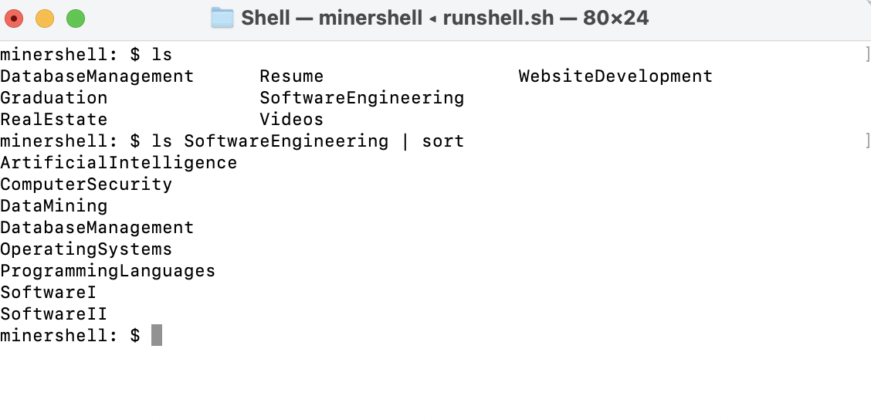

You can also execute commands with **at least one pipe** (e.g**. ls | wc**) as shown below, as well as taking any input on ls command.

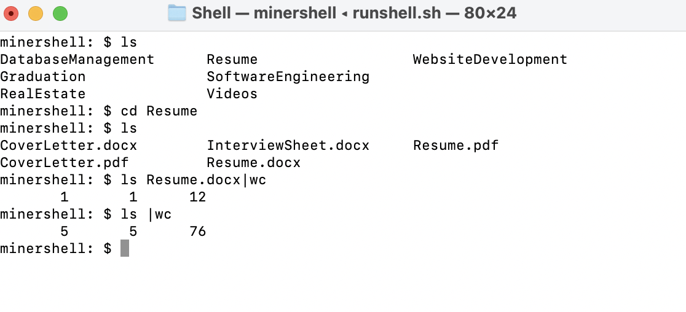

**Hurdles faced while implementing:**

Out of all the labs regarding the shell, I personally feel like piping was the most difficult to implement into my existing shell due to the fact that it is such a hassle to execute, in my opinion. Adding it into my existing function ‘execute’ was nearly enough, few errors came up, but at the end, all was resolved and implemented the right way.

**References:**

[**https://people.cs.rutgers.edu/~pxk/416/notes/c-tutorials/pipe.html**](https://people.cs.rutgers.edu/~pxk/416/notes/c-tutorials/pipe.html)

[**https://en.wikipedia.org/wiki/Pipeline_(Unix)**](https://en.wikipedia.org/wiki/Pipeline_(Unix))