HERALD — Milestone 2 Progress Report
Hierarchical Escalating Retrieval and LLM Disagreement Pipeline
Data Preparation & Initial Agent Implementation | 2026-03-15

1. What HERALD Does
HERALD validates outputs from economics research LLM agents before they enter reports or downstream reasoning. Claims are routed through progressively expensive validators — stopping as soon as any tier is confident — balancing cost, latency, and accuracy.
Five checkpoint types are validated:
CP | Type | What is checked
1 | Retrieval | Retrieved document is topically relevant to the query
2 | Claim Extraction | Extracted claim directly entailed by source; numbers exact
3 | Synthesis | Paragraph faithfully represents all contributing claims
4 | Numerical | Numbers within accepted rounding; direction correct
5 | Causal | Causal language does not overstate source's evidence strength

Verdicts: VALID / INVALID / UNCERTAIN (→ human review).

2. System Architecture
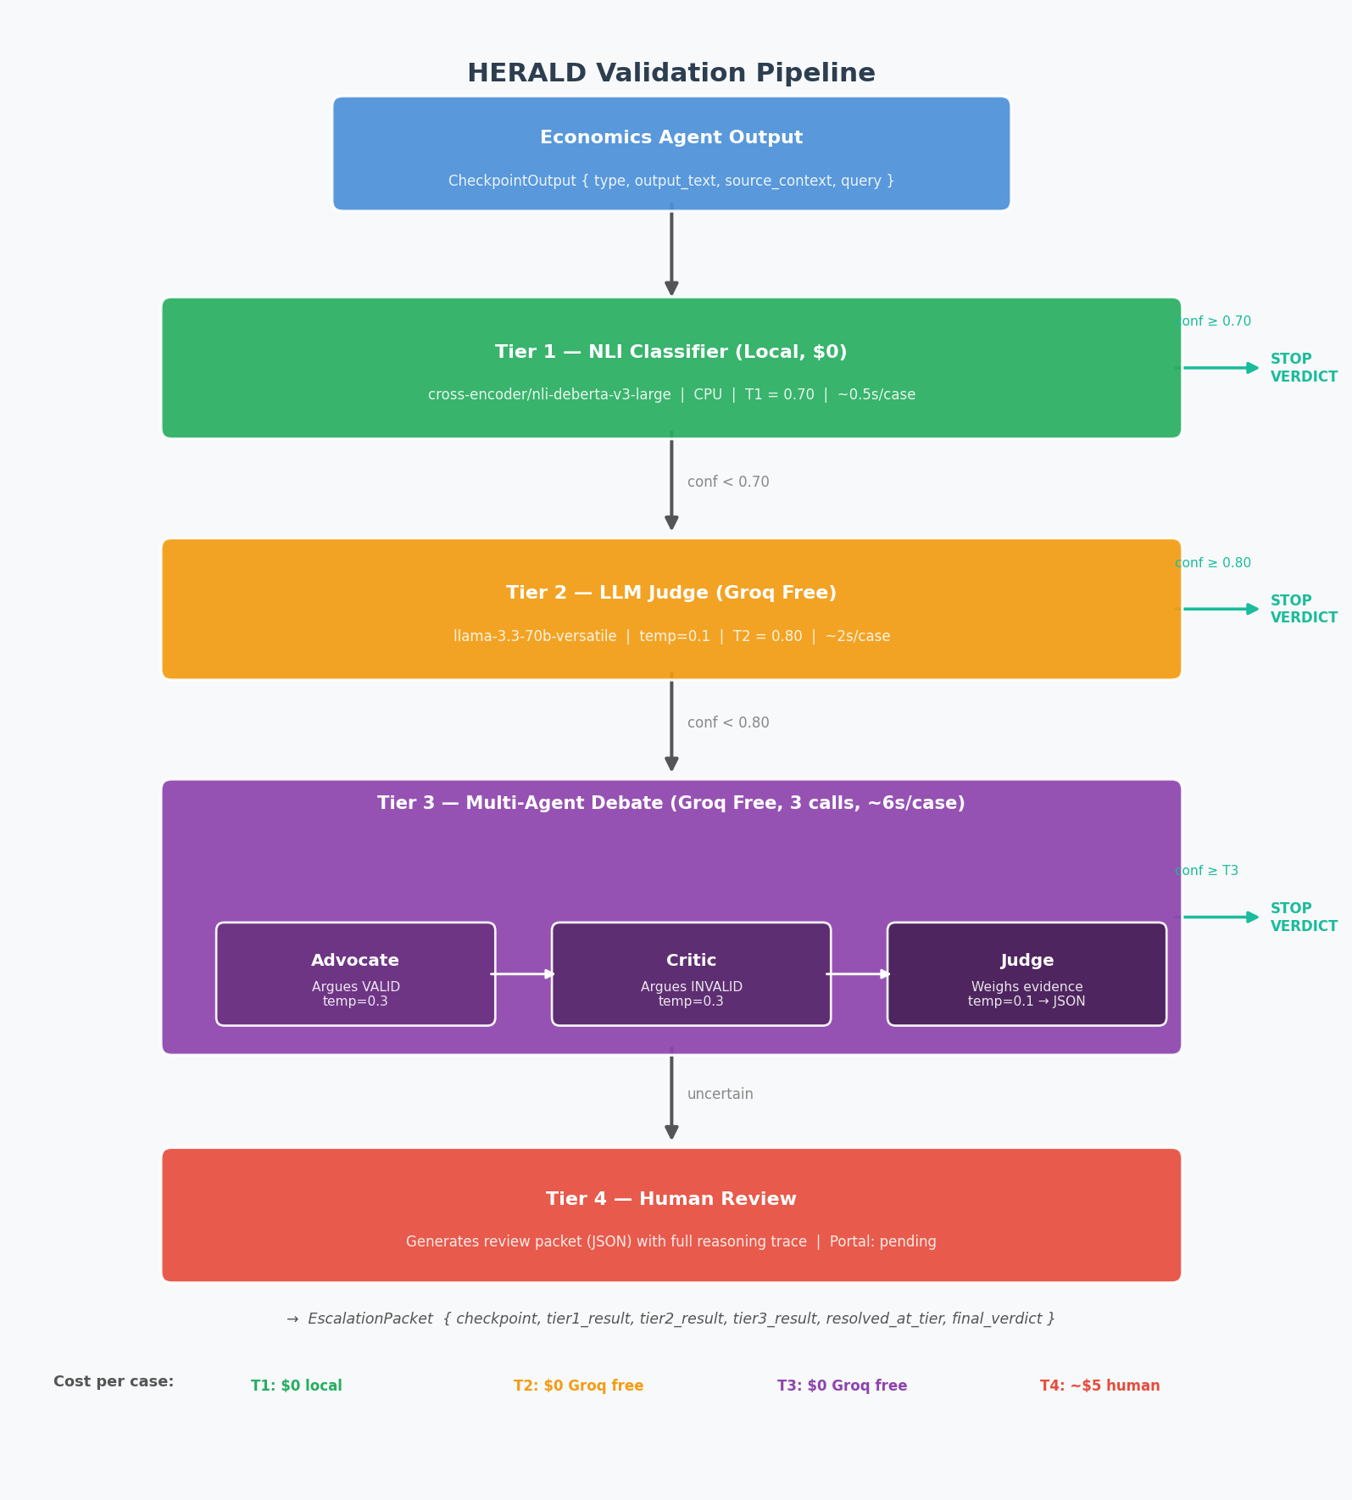
Figure 1 — HERALD four-tier escalation pipeline. Each tier runs only if the previous tier's confidence falls below its threshold.
Every case returns a complete EscalationPacket with verdicts, confidence scores, and reasoning from every tier that ran — providing a full audit trail. Thresholds T1 = 0.70 and T2 = 0.80 are configurable in configs/default.yaml without code changes.

3. Data Pipeline

3.1 Datasets
Dataset | Cases | Purpose
sample_cases.json | 10 | Labeled eval set (ground truth)
feasibility_samples.json | 40 | Expanded NLI feasibility / smoke-test set
unlabeled_pairs.json | 30 | Source/claim pairs for Groq labeling
weak_labeled.json | ~40 | Groq-generated weak labels for fine-tuning

All cases are grounded in U.S. macroeconomics (Fed policy, inflation, housing, labor markets) with three-way labels: valid / invalid / ambiguous. Validity criteria for each checkpoint type are precisely defined — for example, CP4 (Numerical) allows ±1 unit of rounding ('1.08M' from source '1.078M' is valid; '5% decline' from '3.2%' is not).

3.2 Feasibility Gate — NLI Signal Verification
Before building the full pipeline, a GO/NO-GO gate verified that the base DeBERTa model produces meaningful discriminative signal on economics data without any fine-tuning.
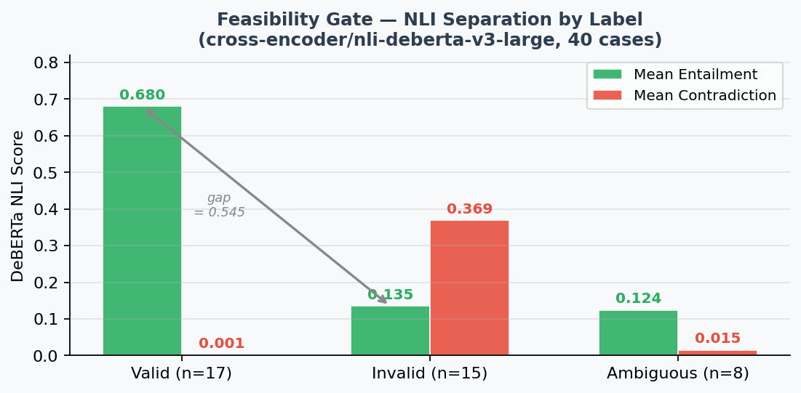
Figure 2 — DeBERTa entailment/contradiction scores by label (40 cases). The 0.545 entailment gap confirms Tier 1 can discriminate without fine-tuning.
Gate passed. Fine-tuning (script notebooks/finetune_tier1.py is ready) is repositioned as a Phase 2 improvement once 500+ weak-labeled pairs exist — not a Phase 1 prerequisite. This unblocked the pipeline 2–3 weeks earlier than planned.

4. Agent Implementation

Tier 1 — NLI Classifier
Runs locally on CPU; zero cost. Source context is the NLI premise, agent output is the hypothesis. DeBERTa produces entailment / contradiction / neutral probabilities; the highest-scoring class becomes the verdict subject to the T1 threshold (0.70). For multi-source checkpoints (CP1, CP3), three aggregation strategies are supported: max_entailment, max_contradiction, and mean.

Tier 2 — LLM Judge
Single Groq call to llama-3.3-70b-versatile (free tier, temp=0.1). The judge receives the output text, source context, and Tier 1's raw NLI scores. It returns structured JSON { verdict, confidence, reasoning, key_issues } enforced via Groq's json_object response format. If stated confidence is below T2 (0.80), the verdict is overridden to UNCERTAIN and the case escalates. Three-attempt retry with 2s backoff handles rate limits.

Tier 3 — Multi-Agent Debate
Three sequential Groq calls (~6s total). The Advocate builds the strongest case the output is valid (temp=0.3); the Critic argues it is not (temp=0.3); the Judge rules on source evidence — not rhetorical quality — and returns a structured JSON verdict (temp=0.1). Both advocate and critic receive the full prior analysis (Tier 1 scores + Tier 2 reasoning), targeting the debate at exactly the point of disagreement.
Design note: the 0.3 / 0.1 temperature split was added after testing showed near-zero temperature produces near-identical advocate/critic arguments, collapsing the debate.

Tier 4 — Human Review
When all automated tiers remain uncertain, the pipeline generates a structured JSON review packet: full reasoning trace from all prior tiers, a framed question tailored to the source of uncertainty, and all context needed for review. Packet generation is complete; a web portal for verdict submission is the primary remaining gap (see Risks).

5. Results

5.1 Summary — 10 Labeled Cases
Metric | Value
Overall accuracy | 90% (9/10)
Resolved at Tier 1 (NLI only) | 7 cases — 85.7% accuracy
Resolved at Tier 2 (LLM judge) | 2 cases — 100% accuracy
Resolved at Tier 3 (debate) | 1 case — 100% accuracy
Human review required | 0 cases
Total cost | $0.00

5.2 Escalation Profile and Error Analysis — 40-Case Run
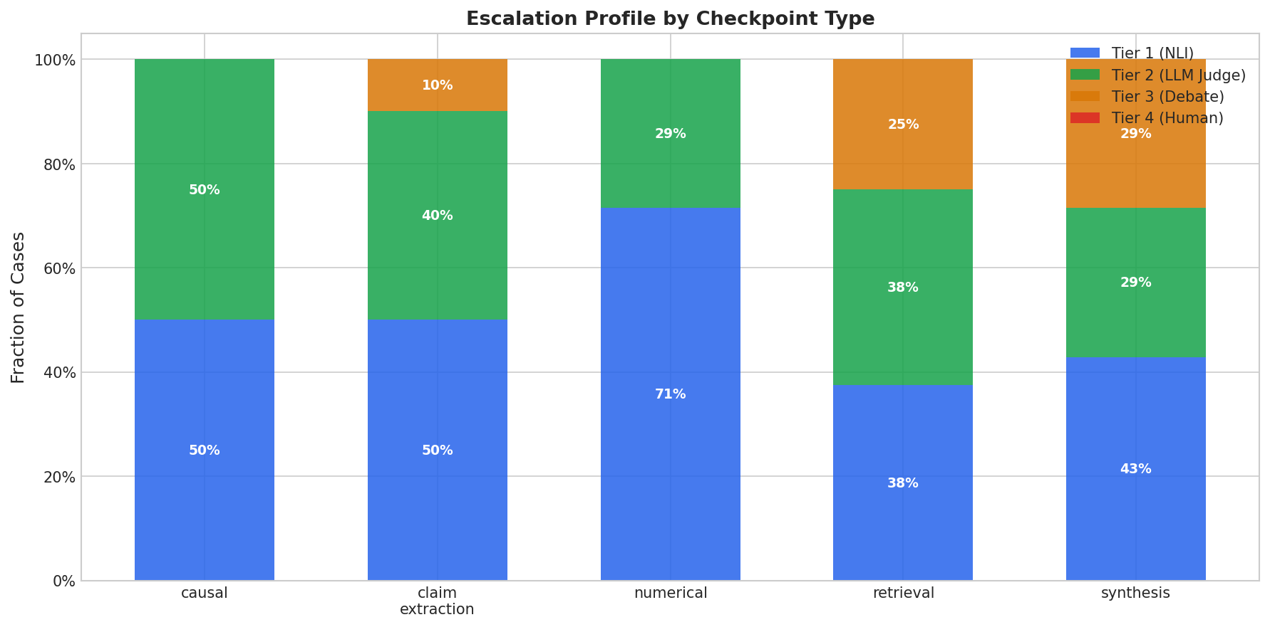
Figure 3 — Escalation profile by checkpoint type. Numerical resolves 71% at Tier 1; synthesis and causal consistently require Tier 2 or Tier 3.
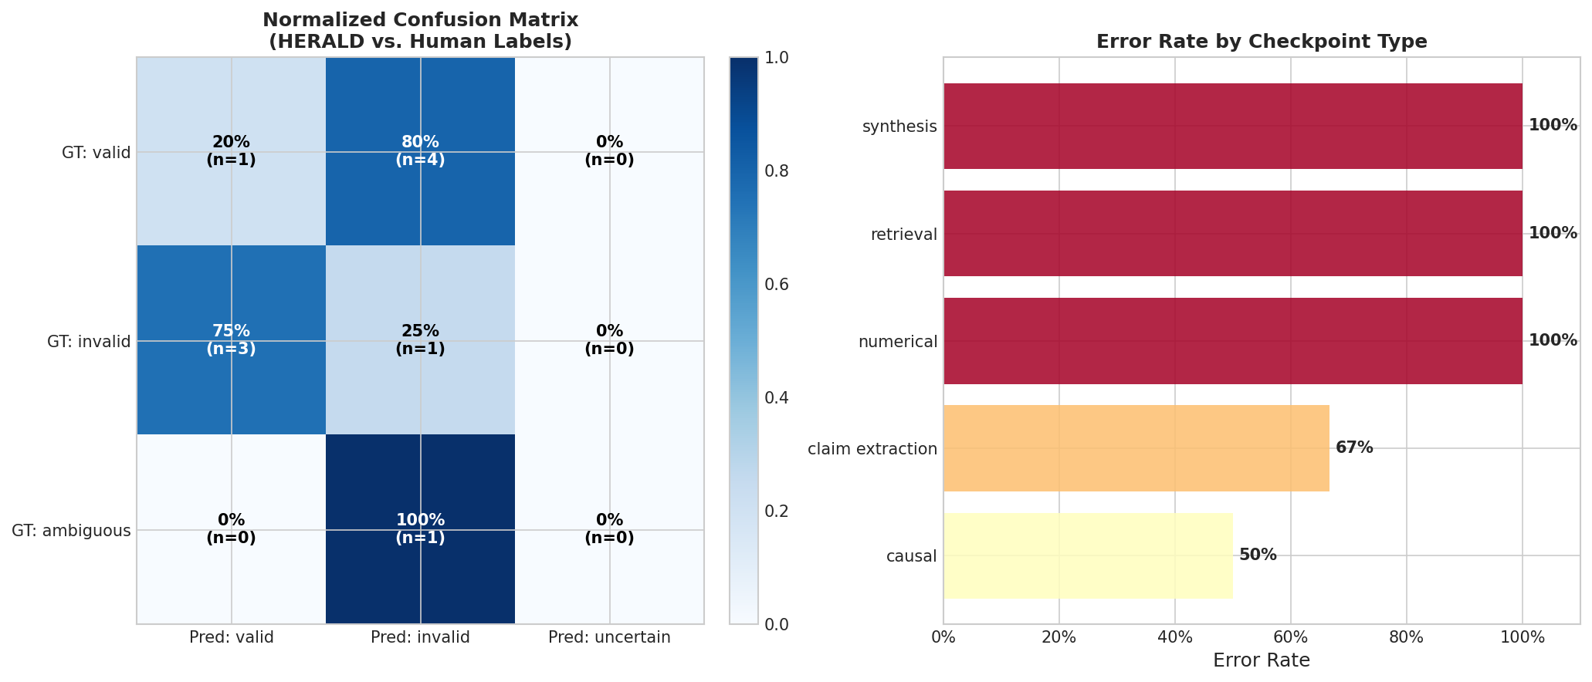
Figure 4 — Confusion matrix and per-checkpoint error rate. The single misclassification is the ambiguous test case, mis-resolved at Tier 1 with 0.832 confidence.
The confusion matrix shows HERALD never outputs UNCERTAIN on this test set, meaning the ambiguous case receives a confident wrong verdict at Tier 1 rather than escalating. This is the expected failure mode and drives the risk mitigations below.

6. Architecture Updates from Early Learnings
- Base DeBERTa is strong enough to defer fine-tuning. The feasibility gate showed a 0.545 entailment gap without domain adaptation. Fine-tuning is now a Phase 2 improvement, unblocking the pipeline 2–3 weeks early.
- Synthesis and causal checkpoints need a dedicated high-confidence path. The escalation profile confirms 50–57% of CP3/CP5 cases route through Tier 2 or Tier 3 (vs. 29% for numerical). Tier 3 debate is now designed as the expected resolution path for these types, not a rare fallback.
- Debate quality requires temperature differentiation. Advocate and critic run at temp=0.3 to produce meaningfully opposed arguments; the judge uses temp=0.1 for consistent verdicts.

7. Risks and Mitigation Plans
Risk | Severity | Mitigation
Groq rate limits interrupt multi-case runs | High | Two of four deliverable plots failed mid-run due to 429 errors. Retry logic (3 attempts, 2s backoff) is in place. Additional: result caching by checkpoint hash, configurable inter-request delay, Groq paid tier as fallback (~$5 for full 40-case sweep).
DeBERTa confidence miscalibrated for ambiguous cases | High | The ambiguous test case resolved at Tier 1 with 0.832 confidence instead of escalating. Mitigation: run calibration_analysis.py to compute ECE; consider checkpoint-type-specific thresholds (lower T1 for CP3/CP5) to force borderline cases through higher tiers.
No Tier 4 review portal | Medium | The 0% human review rate reflects a mostly clear-cut test set. Synthesis/causal cases in production will require review. Packet generation is done; a minimal Streamlit or Flask form is the next build priority.
Weak label quality contaminates fine-tuning | Medium | LLM-generated labels may be systematically wrong for subtle causal overstatement. Mitigation: filter to confidence ≥ 0.85 before training; A/B evaluate fine-tuned vs. base model on the hand-labeled 10-case set before deploying.

8. Status Summary
Component | Status
Full 4-tier escalation pipeline | Complete
Tier 1 NLI classifier (DeBERTa, local) | Complete
Tier 2 LLM judge (Groq) | Complete
Tier 3 multi-agent debate | Complete
Tier 4 human review packet generation | Complete
Labeled datasets (50 cases total) | Complete
Weak label generation | Complete
Evaluation framework | Complete
Threshold sweep / baseline comparison | Complete
DeBERTa fine-tuning | Pending (script ready; needs 500+ pairs)
Tier 4 review portal UI | Not started
2 remaining deliverable plots | Blocked by Groq rate limits

Branch: manav-dev | Commit: b35bf2d | Herald v1.1

