Riv Instruction
Author
Rykka G.Forest
Date
2012-06-29 10:38:56
Version
0.66
Github
https://github.com/Rykka/riv.vim
Riv is a vim plugin for managing and writing reStructuredText documents. Short for 'reStructuredText in Vim'.
It is for people either want to manage documents in a wiki way, or writing reStructuredText documents in an easy way.

Features
These features are for all reStructuredText files.
Sections
Section level and section number auto detected.
Lists
Auto Numbered and auto leveled bullet and enumerated list.
Links
Jumping with links.
Table
Auto formatted table.
Folding
Fold document by document structures (Section/List/Block).
Indent
Improved indentation
Insert
Improvment of some mapping in insert mode.
Highlighting
Improved syntax file.
These features are for the Riv Project.
Project
Manage your reStructuredText documents in a wiki way.
File
Links to local file in rst documents.
Scratch
A place for writing diary or hold idea and thoughts.
Todos
Writing todo lists in reStructuredText documents .
Helpers
A help window for showing and doing something.
- Todo Helper: Managing todo items of project.
Publish
some wrapper to convert rst files to html/xml/latex/odt/... (require python docutils package )
- Take a glance
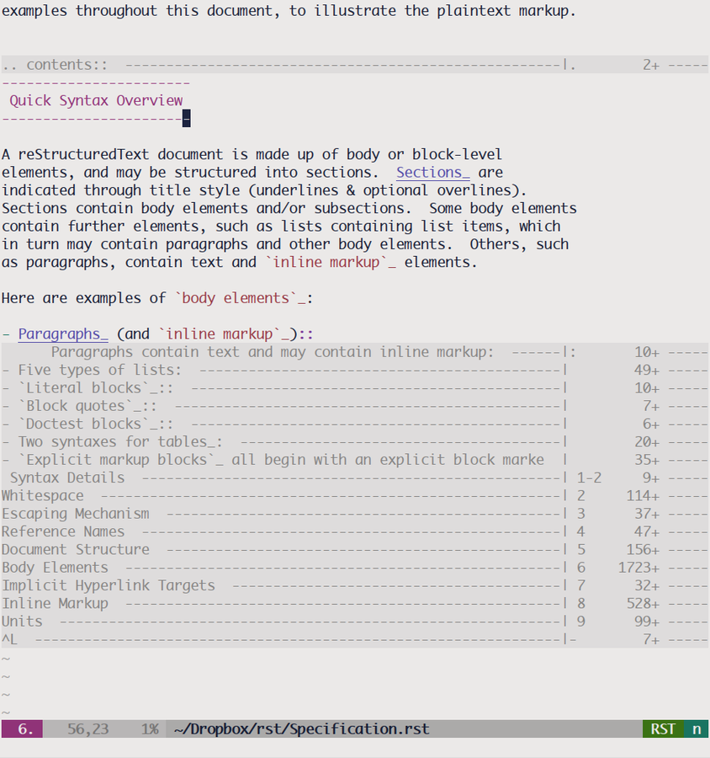
- To Start: see Instruction Details

Install
- Using Vundle (Recommend)
Add this line to your vimrc:
Bundle 'Rykka/riv.vim'
- Using downloaded file. Just extract to your .vim folder .
NOTE
Make sure the your .vim folder in option runtimepath is before the $VIMRUNTIME.
Otherwise the syntax/indent files for rst file will using the vim built-in one.
- Recommend plugins:
  - Syntastic for syntax checking of rst files. (require python docutils package )
  - Calendar setting datestamp easier.

Issues
- Currently it's a developing version. So things may change quickly. keep up-to-date.
- Both bug reports and feature request are welcome. Please Post issues at https://github.com/Rykka/riv.vim/issues

Todo

Prev
See Changelog in doc/riv.txt
- 0.65:
  - DONE 2012-06-27 take care of the slash of directory in windows .
  - FIXED 2012-06-28 correct cursor position when creating todo items and list items.
  - FIXED 2012-06-28 link highlight group removed after open another buffer.
  - FIXED 2012-06-28 auto mkdir when write file to disk
  - DONE 2012-06-28 format the scratch index, sort with year/month/day

This
Things todo in this version.
- 0.66:
Todos
DONE 2012-06-29 add field list for todo items.
Indent
DONE 2012-06-29 the indentation in directives should return 0 after 2 blank lines
Todos
FIXME the calculation of child todo items
Indent
FIXME <BS> indentation to reach the begin of field list.

Next
Things todo in next versions.
Links
The standalone web link with / is detected as local file.
File
A template or snippet or shortcut for adding ./ and ../ and files. Maybe a sphinx doc ref as well.
Documents
Document part: options / commands.
Documents
Sreencast and screenshot of intro.
Documents
Seperate instruction and intro. help use instruction.rst
Documents
Add Specification/Intro of reStructuredText.
Publish
An option to enable highlighting todo items.
Helpers
An option Helper and option cache. Let people use it even without touching .vimrc .
Scratch
Show Scratch sign in Calendar.
Publish
Support the reStructuredText document not in a project.
Helpers
A command helper?
Links
Link tags infile ?
Todos
Todo item priorities?
Table
Support simple table format?
Table
Support column span?
Table
A vim table parser for compatible?
Table
A shortcut or command to create table with row * col.
Sections
Adjust section level.
Sections
Shortcut to add sections like the content directive?
Folding
A buf parser write in python for performance?

Instruction Details
- How to use?
  - For writing reStructuredText documents in an easy way.
When editing an reStructuredText document (*.rst ), these settings will be automatically on. (make sure filetype on in your vimrc)
  - For managing documents in a wiki way, you should setup a project first, see Project.
- About the mapping
Default leader map for Riv is <C-E>. You can change it by following options.
  - g:riv_global_leader : leader map for Riv global mapping.
    - :RivIndex <C-E>ww to open the project index.
    - :RivAsk <C-E>wa to choose one project to open.
    - :RivScratchCreate <C-E>cc Create or jump to the scratch of today.
    - :RivScratchView <C-E>cv View Scratch index.
  - g:riv_buf_leader : leader map for reStructuredText buffers.
  - g:riv_buf_ins_leader : leader map for reStructuredText buffers's insert mode.

For reStructuredText
These features are for all reStructuredText files.

Sections
Section levels and numbers are auto detected.
The section number will be shown when folded.
Pressing <Enter> or double clicking on section title will toggle the folding of the section.
Clicking on the section reference will bring you to the section title.
e.g. Features link will bring you to the Feature Section (in vim)
- Create Section Title:
Normal and Insert:
  - Use :RivTitle1 <C-E>s1 ... :RivTitle6 <C-E>s6 , To create level 1 to level 6 section title from current word.
If it's empty, you will be asked to input one.
NOTE
Although you can define a section title with most punctuations.
Riv use following punctuations for titles:
=-~"'` , you can change it with g:riv_section_levels

Lists
Auto numbered and auto leveled bullet and enumerated list.
The Sequence of the list level is:
* + - 1. A. a. I. i. 1) A) a) I) i) (1) (A) (a) (I) (i)
- Editing Lists:
Normal and Visual:
  - > or <C-ScrollWheelDown> Add Indentation, And add a level for list.
if the first item is a list , the indentation is based on the list item. otherwise the indentation is based on 'shiftwidth'.
  - < or <C-ScrollWheelUp> Remove Indentation, And remove a level for list.
Insert Mode Only:
  - <CR>\<KEnter> (enter key and keypad enter key) Insert the content of this list.
To insert content in new line of this list item. add a blank line before it.
  - <C-CR>\<C-KEnter> Insert a new list of current list level
  - <S-CR>\<S-KEnter> Insert a new list of current child list level
  - <C-S-CR>\<C-S-KEnter> Insert a new list of current parent list level
Normal and Insert:
  - :RivListTypeNext <C-E>l1 Change current list item symbol to next type
  - :RivListTyePrev <C-E>l2 Change current list item symbol to prev type
  - :RivListTypeRemove <C-E>lx Delete current list item symbol
NOTE
To contain a second paragraph (or blocks) in a list , you should make the left edge lines up with the main paragraph.
See reStructuredText Bullet Lists

Links
Clicking on links will executing it's default behavior (open browser/edit file/jump to internal target)
<Tab>/<S-Tab> in Normal mode will jump to next/prev link.
- Create Links:
Normal Mode Only :
  - :RivCreateLink <C-E>il create a link from current word.
If it's empty, you will be asked to input one.
  - :RivCreateFoot <C-E>if create a auto numbered footnote. And append the footnote target to the end of file.

Table
Auto Format Table (Grid Table Only). (Currently require vim compiled with python. )
When folded, the numbers of rows and columns will be shown.
Currently only Support the Grid Table with equal columns each row .
Insert Mode Only:
To create a table , just insert | xxx | and press <Enter>.
The Grid Table | Will be Auto Formatted after Leave Insert Mode
Lines | - <Enter> in column to add a new line of column  - This is the second line of in same row of table.
Rows | <Enter> in seperator to add a new row
Cells | <Tab> and <S-Tab> in table will switch to next/prev cell

Folding
Fold reStructuredText file with sections, lists, and blocks automatically.
When folded, some info of the item will be shown at the foldline.
Folding will be updated after you write buffer to file.
Pressing <Enter> or double clicking on folded lines will open that fold.
- Update Folding: use zx or <C-E><Space>j
- Toggle Folding: use za or <C-E><Space><Space>
- Toggle all Folding: use zA or <C-E><Space>m
To show the blank lines in the end of a folding, use g:riv_fold_blank.
- when set to 2 , will fold all blank lines.
- when set to 1 , will fold all blank lines, but showing one blank line if there are some.
- when set to 0 , will fold one blank line , but will showing the rest.
- default is 2
For large files. calculate folding may cost time. So there are some options about it.
- g:riv_fold_level set which structures to be fold.
  - when set to 3 , means 'sections,lists and blocks'.
  - when set to 2 , means 'sections and lists'
  - when set to 1 , means 'sections'
  - when set to 0 , means 'None'
  - default is 3.
- g:riv_auto_fold_force, enable reducing fold level when editing large files.
  - when set to 1 , means 'On'.
  - default is 1.
- g:riv_auto_fold1_lines, the minimum lines file containing, to force set fold_level to section only.
default is 5000.
- g:riv_auto_fold2_lines, the minimum lines file containing, to force set fold_level to section and list only.
default is 3000.
To set an initial folding level for a file . you can use modeline:
.. vim: fdl=0 :
This means all fold will be folded when opening files

Highlighting
Improved syntax file.
- Lists Highlightings
- Code Block syntax highlighting:
.. code:: python
# python highlighting
# github does not support syntax highlighting for rst file yet.
x = [0 for i in range(100)]
You can use g:riv_highlight_code to set which type of code to highlight. default is lua,python,cpp,javascript,vim,sh
NOTE
To enable highlighting in converted file, python pygments package must installed for docutils parsing syntax highlighting.
see http://docutils.sourceforge.net/sandbox/code-block-directive/tools/pygments-enhanced-front-ends/
- The links under cursor are highlighted. Disable it by set g:riv_hover_link_hl to 0

Indent
Improved indent file.
In Insert mode , when starting a newline or
- starting newline (<Enter> or o in Normal mode): will start newline with correct indentation
- <BS> (BackSpace key). will goto correct indentation if no preceding non-whitespace character and after the indentation's &shiftwidth position , otherwise <BS>

Insert
Improvment for some mapping in insert mode. Detail in each section.
Also most shortcut can be used in insert mode. like <C-E>ee <C-E>s1 ...
- Enter: Insert lists with <C-Enter> , <S-Enter> and <C-S-Enter>.
When in a table, <Enter> to create a new line
When not in a table, will start new line with correct indentation
- Tab: When in a table , <Tab> to next cell , <S-Tab> to previous one.
When not in a table , will act as <C-N> or <C-P> if insert-popup-menu is visible.
Otherwise output a <Tab>
- BackSpace: for indent, will goto correct indentation if no preceding non-whitespace character and after the indentation's &shiftwidth position , otherwise <BS>

For Riv
These features are for the Riv Project.

Project
Manage your reStructuredText documents in a wiki way.
- By default. the path of project is at '~/Documents/Riv', you can set it by adding project to g:riv_projects in your vimrc.:
let project1 = { 'path': '~/Dropbox/rst',}
let g:riv_projects = [project1]
" You could add multiple projects as well
let project2 = { 'path': '~/Dropbox/rst2',}
let g:riv_projects = [project1, project2]
- Use :RivIndex <C-E>ww to open the project index.
- Use :RivAsk <C-E>wa to choose one project to open.

File
As reStructuredText haven't define a pattern for local files currently.
Riv provides two kinds of style to determine the local file in the rst documents.
The bare extension style and square bracket style
- You can switch the style with g:riv_localfile_linktype
  - when set to 1, use bare extension style:
words like xxx.rst xxx.py xxx.cpp will be detected as file link.
words like xxx/ will be considered as directory , and link to xxx/index.rst
words like /xxxx/xxx.rst ~/xxx/xxx.rst x:/xxx.rst will be considered as external file links
words like /xxxx/xxx/ ~/xxx/xxx/ will be considered as external directory links, and link to the directory.
You can add other extensions with g:riv_file_link_ext. which default is vim,cpp,c,py,rb,lua,pl , meaning these files will be recongized.
  - when set to 2, square bracket style:
words like [xxx] [xxx.vim] will be detected as file link.
words like [xxx/]' will link to ``xxx/index.rst
words like [/xxxx/xxx.rst] [~/xxx/xxx.rst] [x:/xxx/xxx.rst] will be considered as external file links
words like [/xxxx/xxx/] [~/xxx/xxx/] will be considered as external directory links, and link to the directory.
  - when set to 0, no local file link.
  - default is 1.
- When Publish to html, all detected local file link will be converted to an embedded link.
e.g. xxx.rst xxx.py
- To delete a local file in project.
:RivDelete <C-E>df it will also delete all reference to this file in index.rst of the directory.

Scratch
The scratches is created auto named by date in '%Y-%m-%d' format. It is a place for writing diary or hold idea and thoughts.
Scratches will be put in scratch folder in project directory. You can change it with 'scratch_path' of project setting ,default is 'Scratch':
" Use another directory
let project1.scratch_path = 'Diary'
" Use absolute path, then no todo helper and no converting for it.
let project1.scratch_path = '~/Documents/Diary'
- :RivScratchCreate <C-E>cc Create or jump to the scratch of today.
- :RivScratchView <C-E>cv View Scratch index.
The index is auto created. You can change the month name using g:riv_month_names.
default is:
January,February,March,April,May,June,July,August,September,October,November,December

Todos
Writing and highlighting todo items in reStructuredText documents. It's not the reStructuredText syntax. So no highlighting when converted.
Todo items are todo-box or todo-keywords in bullet/enumerated/field lists.
Datestamps are supported to show todo items's start/end date.
The statistics of the todo progress (include child items) will be shown when folded.
- A Todo item:
  - [ ] This is a todo item of initial state.
  - [o] This is a todo item that's in progress.
  - [X] This is a todo item that's finished.
- Datestamps:
  - You can set the todo item timestamp style with 'g:riv_todo_timestamp'
    - when set to 2 , will init with a start datestamp. and when it's done , will add a finish datestamp.
      - [ ] 2012-06-23 This is a todo item with start datestamp
      - [X] 2012-06-23 ~ 2012-06-23 A todo item with both start and finish datestamp.
    - when set to 1 , no init datestamp , will add a finish datestamp when it's done.
      - [X] 2012-06-23 This is a todo item with finish datestamp,
    - when set to 0 , no datestamp
    - Default is 1
- Keyword groups:
  - FIXED A todo item of FIXME/FIXED keyword.
  - DONE 2012-06-13 ~ 2012-06-23 A todo item of TODO/DONE keyword.
  - You can define your own keyword group for todo items with g:riv_todo_keywords
each keyword is seperated by ',' , each group is seperated by ';'
default is TODO,DONE;FIXME,FIXED;START,PROCESS,STOP,
- Actions:
  - Use :RivTodoToggle or <C-E>ee to add or switch the todo status.
  - Double Click or <Enter> in the box/keyword to swith the todo status
  - Double Click or <Enter> or :RivTodoDate on a datestamp to change date.
If you have Calendar installed , it will use it to choose date.
  - Use :RivTodoType1 <C-E>e1 ... :RivTodoType4 <C-E>e4 to add or change the todo item by group.
  - Use :RivTodoAsk <C-E>e` will show an keyword group list to choose.
  - Use :RivTodoDel <C-E>ex will delete the todo item
  - Use :RivCreateDate <C-E>id to insert a datestamp of today anywhere.
  - Use :RivCreateTime <C-E>it to insert a timestamp of current time anywhere.
  - Use :RivTodoHelper or <C-E>ht to open a Todo Helper

Helpers
A window to show something of the project.
- Todo Helper : A helper to manage todo items of current project.
  - :RivTodoHelper or <C-E>ht Open to view all todo-items. Default is in search mode.
    - / to search todo item matching inputing, <Enter> or <Esc> to quit search mode.
Set g:riv_fuzzy_help to 1 to enable fuzzy searching in helper.
    - <Tab> to switch content, there are 'All/Todo/Done' contents for Todo Helper.
    - <Enter> or Double Click to jump to the todo item.
    - <Esc> or q to quit the window

Publish
Some wrapper to convert rst files to html/xml/latex/odt/... (require python docutils package )
NOTE
When converting, It will first try rst2xxxx2.py , then try rst2xxxx.py
You should install the package of python2 version .
Otherwise errors will occour.
- :Riv2HtmlFile <C-E>2hf convert to html file.
- :Riv2HtmlAndBrowse <C-E>2hh convert to html file and browse. default is 'firefox'
The browser is set with g:riv_web_browser
- :Riv2HtmlProject <C-E>2hp converting whole project into html. And all the file with extension in g:riv_file_link_ext will be copied there too.
Convert to the file and browse.
- :Riv2Odt <C-E>2oo convert to odt file and browse by ft browser
The browser is set with g:riv_ft_browser. default is (unix:'xdg-open', windows:'start')
- :Riv2Xml <C-E>2xx convert to xml file and browse by web browser
- :Riv2S5 <C-E>2ss convert to s5 file and browse by web browser
- :Riv2Latex <C-E>2ll convert to latex file and edit by gvim
- For the files that are in a project. The path of converted files by default is under _build in your project directory.
  - To change the path. Set it in your vimrc:
" Assume you have a project name project 1
let project1.build_path = '~/Documents/Riv_Build'
  - Open the build path: :Riv2BuildPath <C-E>2b
- For the files that not in a project. g:riv_temp_path is used to determine the output path
  - When it's empty , the converted file is put under the same directory of file ,
  - Otherwise the converted file is put in the g:riv_temp_path, make sure it's an absolute path.
  - Also no local file link will be converted.

