Institute of Systems Science, National University of Singapore

MASTER OF TECHNOLOGY USER GUIDE

**Project MerchantOboarding**

**TEAM MEMBERS**

DAI YIRUI -1

DONG MEIRONG -2

GU LIJIAN-3

GUO FENG-4

WONG YOKE KEONG-5

ZAHNG LE-6

MASTER OF TECHNOLOGY Institute of System Science, National University of Singapore

1

**INTELLIGENT REASONING SYSTEMS (IRS) - MACHINE REASONING (MR)**

User Guide

Merchant Onboarding System Institute of System Science, National University of Singapore

2

**REQUIREMENTS:**

**RECOMMENDED BROWSERS**

Merchant Onboarding supports the following Web Browsers:

• Internet Explorer 11

• Microsoft Edge 39 and above

• Firefox 53 and 52 ESR and above

• Google Chrome Version 59 and above

• Safari Version 10 and above

**SYSTEM OVERVIEW**

The Merchant Onboarding system is an integrated web based system. Our main target users are financial institutions who need to make critical assessment on their potential business partners. Moreover, our system provides their potential partners with accessibility to the assessment submission platform. The web platform will require users (potential business partners) to input several key characteristics of their business.

**USER INTERFACE**

The front-end system hosts HTML5 on Python Django framework.

**DEPLOYMENT**

Our system is capable of running on both Windows or Linus Systems. To demonstrate, we will only deploy in ISS Virtual Machine.

[ 1 ] To prepare the Virtual Machine Environment:

* download pre-built virtual machine from http://bit.ly/iss-vm
* start iss-vm
* open terminal in iss-vm
* start the Tool KIE 7.12 on desktop
* wait until KIE server successfully started up

[ 2 ] To run the back-end JBPM project on KIE server:

* Go to URL using web browser http://localhost:8080/jbpm-console
* Login using username/password: wbadmin/wbadmin
* import project using git import from URL:https://github.com/gu-lijian/mr_groupproject.git
* Deploy the MerchantOnborading Project, and make sure it is running with version 1.0.0

[ 3 ] To run the front-end Python Project:

* make sure django framework is available (pip install django)
* make a new directory, and start a command prompt at this directory
* clone project from git clone URL:https://github.com/gu-lijian/mr_groupproject_web.git
* use cd command to go to /mr_groupproject_web/merchantapp
* run command: $ python manage.py runserver
* Go to URL using web browser http://127.0.0.1:8000/

Institute of System Science, National University of Singapore

3

**START**

Open up your preferred browser and go to the URL “http://127.0.0.1:8000/” as shown below:

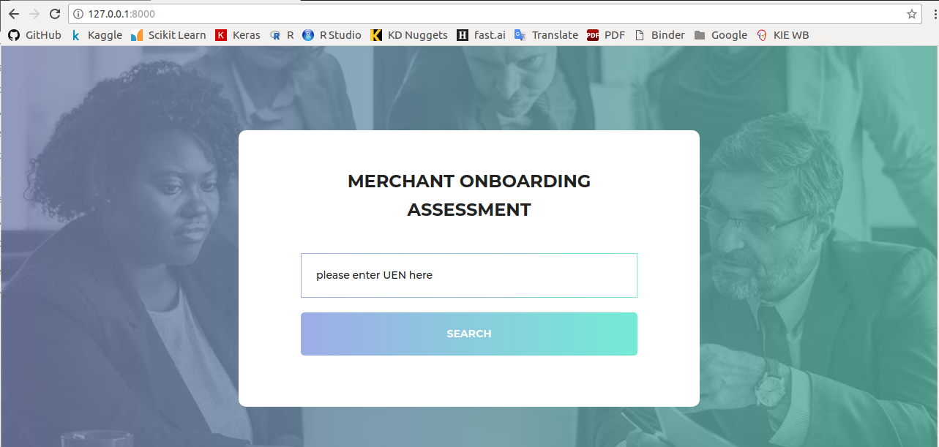

Key in your Unique Entity Number (UEN: e.g. 53272992K) and Click on the Search button. Please note this queries real life ACRA API which returns actual data related to this UEN. Failure of providing correct UEN will lead to rejection of application. Below is an example:

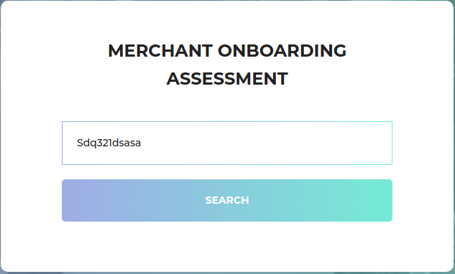

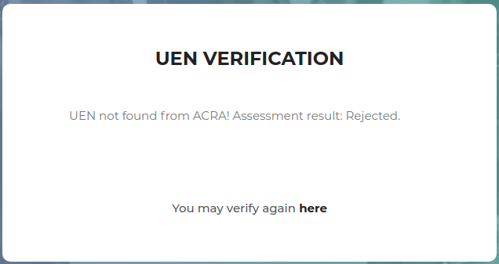

Upon successfully validate UEN, the system will display corresponding business entity information. Shown below:

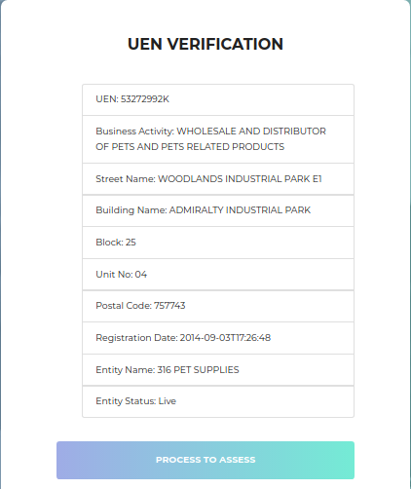

Institute of System Science, National University of Singapore

4

Once user clicks “Process To Assess” button. The system will prompt 7 fields for user to key in. After all the critical information have been obtained, the web platform will kick start assessment process on back-end system. Using our back-end rule engine, the system will then output back-end process id and certainty factors that describe user’s business entity from 3 perspectives and an overall final certainty factor. Below shows one such example of the output:

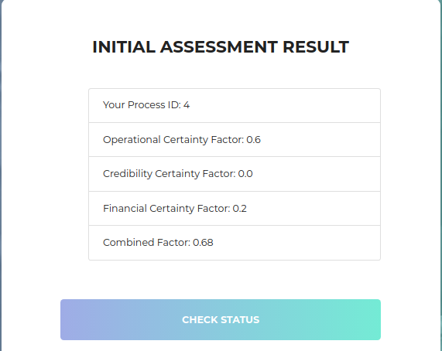

Now that application has been submitted to back-end user (bank: wbadmin in this case) for final approval. System will display final result once back-end user completes the process. Shown below:

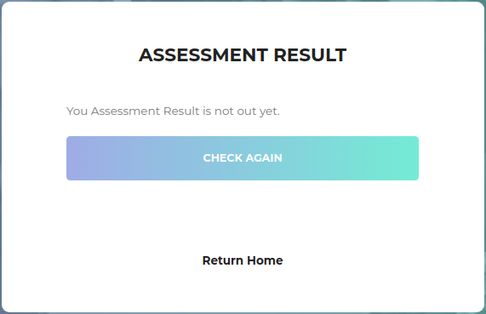

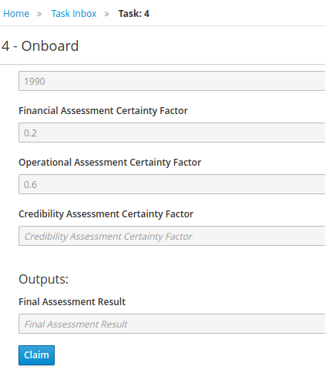

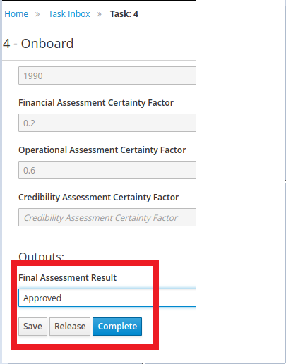

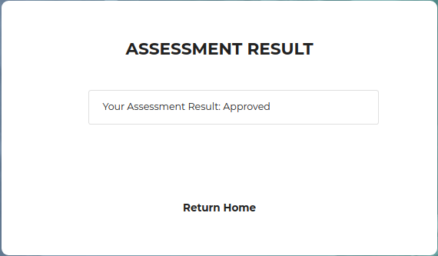

Institute of System Science, National University of Singapore

5

Institute of System Science, National University of Singapore

6

**BUSINESS SCENARIOS: SAMPLE INPUT & SYSTEM OUTPUT**

<To-Be-Done>

*Figure 6: Outline of System Flow* Institute of Systems Science, National University of Singapore

|  |  |  |  |  |  |
| --- | --- | --- | --- | --- | --- |
| **2.1 SCENARIO 1** Characteristic of user (Standard Case) | | | <To-Be-Done> | | |
| Questions: | | | <To-Be-Done> | | |
|  | | | | | |
|  |  | |  | |  |
|  | |  | |  | |
|  | |  | |  | |