E-Farming
Software Requirements Specification
Version 2.0

Vairamuthu S.

Contents

1. Introduction 4
2. Purpose 4
3. Scope 4
4. Definitions, Acronyms and Abbreviations 4
5. References 5
6. Overall Description 6
7. External Interface Requirements 12
8. Functional Requirements 13
9. Non Functional Requirements 43
9.1 Usability 43
9.2 Security 44
9.3 Performance 44
9.4 Capacity 45
9.5 Recovery 45
9.6 Availability 45
9.7 Reliability 45
9.8 Maintainability 45
9.9 Portability 46
9.10 Privacy 46
10. User interface screens 47

Revision History
Name | Date | Reason For Changes | Version
Gurpreet | 24/1/13 | Context Diagram, Non Functional Requirements Change | 1.0
Gurpreet | 31/1/13 | Functional requirements Changes, User Interface Screen shots | 2.0

Introduction

Being a Developing country ,indian farmers provide a great source of food products for last decades.It increases the economy power of india.Tons of wheat ,rice and many other raw food export to other countries.In the same way lots of rice and wheats are getting spoil in the warehousig.To reduce this ,there is a need of direct interaction between the farmers and wholesalers so that they are not getting robbed by unauthroized dealers.To do this we need to educate the farmers,teach them how to use the computer.In this way they can sell there products easily.By creating an online website to buy fruits and other food goods in which people can buy there daily grocery needs without any rush.

Purpose
The purpose of this Software Requirements Specification (SRS) document is to describe the overall behavior of e-farming system. This SRS defines and describes the operations, performance, and quality assurance requirements of the e-farming that is to be developed. This document also describes the nonfunctional requirements. It also describes the design constraints and technologies that are to be considered when the system is to be designed, and other factors necessary to provide a complete description of the requirements for the system. This Software Requirements Specification (SRS) captures the complete software requirements for the system. Requirements described in this document will be used as guidelines to develop the online e-framing website.

Scope

The E-farming System is supposed to have the following features.

- Course material
- Support different languages
- Online transitions(billing)
- Record maintenance – product selling/buying
- Computer proffessionals
- E-mail facility

Definitions, Acronyms and Abbreviations

Abbreviation | Designation
FER | Farmers
GU | Guest users
WS | wholesalers
CP | Computer proff.
Ad | Admin

References
http://www.google.com

Overall Description

- Product Perspective

The E-Farming System provide farmers a great platform to sell their goods to wide range of customers
In different cities of the country. .On other side it may help the farmers to use the computer effectively.

- Product Functions

The following are the user requirements for the system

- The farmers registration forum has following requirement.
  - Name
  - Address
  - Phone
  - DOB
  - Gender
  - Country
  - Products
  - Adhaar ID
  - Bank account
- The wholesalers fourm has following requirement
  - Name
  - Address
  - Gender
  - Bank account
  - Phone
  - Email id
  - Adhaar ID
- Admin has following requirement
  - username
  - password
- email id admin has power to add the product in product list or remove it.He will monitor all type of activity on the screen.
- Farmers just add their products and sell it to the customers .
- Computer professional will schedule online classes for the farmers.
- Guest users will buy the product without login.
- Wholesaler will be able to contact all the farmers.
- Framers can send email to wholesaler/guest /customers.

- User characteristics
The farmer will add/remove the product from product list. Admin will monitor all kind of problem such as complaint. Computer professional will teach the farmers and schedule their classes.

- Constraints

  - Some knowledge about computer is required
  - Net banking
  - Validation of voter id,passport id,adhaar id entered into the system
  - Computer professional will teach the farmers

- Assumptions and dependencies

- All the products will be characterized .
- No return facility.
- While adding products farmers should inform admin about their prices.
- All products are within expiry date.
- Cash on delivery services provided.
- User Interfaces

- The system will provide GUI for the users.
- The users will be able to access the system using their web browsers

- Hardware Interfaces

- The system will have an interface with the finger print scanner .

- Software Interfaces

- The system will have an interface with the server database for validation of email id.
- User authentication process is required before buying/selling.

- Communications Interfaces

- The system will use HTTPS protocol for secure transfer of information between the client and the web server

Functional Requirements

- Use Case Diagrams

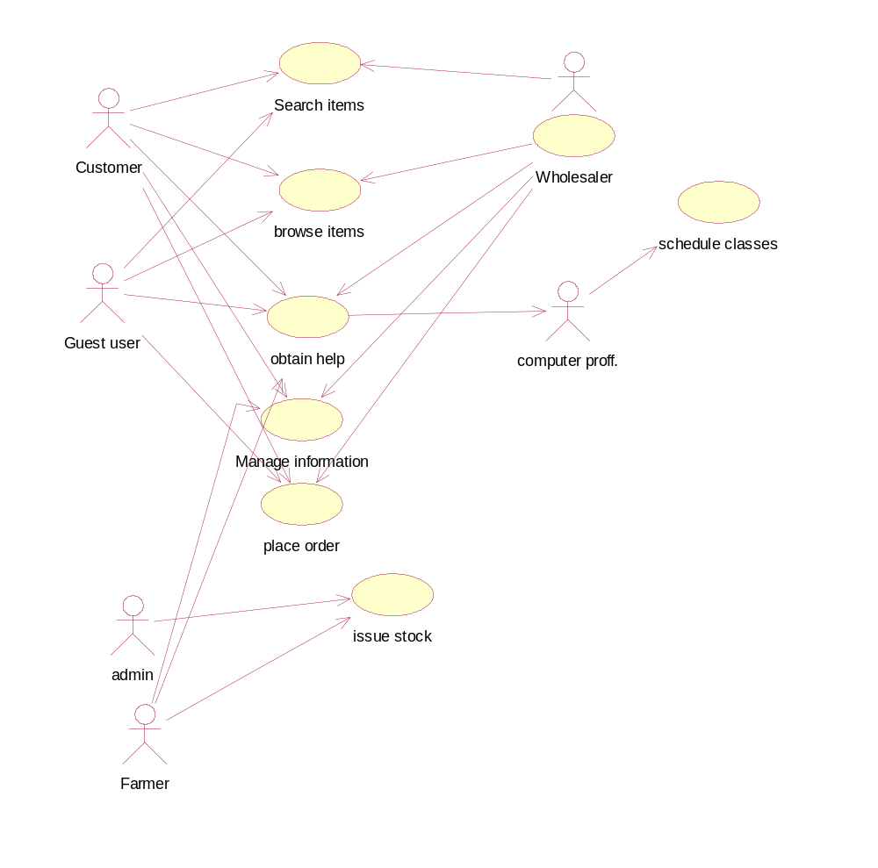

- Use Case Scenario Description

Use Case ID | 1
Use Case name | Browse items
Summary | The user will see the items based on the requirements  - Vegetables  - Wheat  - Rice  - Fruits
Preconditions | The user who want to Browse items can be a registered user or may be a Guest user
Success End Condition | User can see the required items on the screen
Failed End Condition | Please fill in the required fields Message to the User when any of the given fields is blanks or all zeroes
Primary, Secondary Actors | Customer,vendor,Guest user
Trigger | This use case is initiated based on the request from the Customer wholesalers and guest user
DESCRIPTION | Step | Action
 | 1 | The End user selects the Registration link
 | 2 | Choose specific type of products
 | 4 | Select the product from product list
 | 5 | The user selects the account type as guest,customer,wholesaler
 | 6 | Special identification marks will be entered by the user in a text box
 | 7 | The End User Clicks on the Submit Button
EXTENSIONS | Step | Branching Action
 | 1a | The system will retrieve the data from the database.

Use Case ID | 2
Use Case name | Search items
Summary | user will be able to search for a product using the following  - product name  - Product ID
Preconditions | Must be a wholesaler/guest/costumer before search any product.
Success End Condition | The details of the product will be displayed to the user along with product name and product id.
Failed End Condition | Invalid product name is displayed to the user
Primary, Secondary Actors | Costumer/wholesaler/guest
Trigger | This use case is initiated based on the request from the farmer/wholesaler /guest searching the product.
DESCRIPTION | Step | Action
 | 1 | The End user selects the Search link
 | 2 | The End user selects the type of id from the drop down box
 | 3 | The end user enters the id in the text box
 | 4 | The End User Clicks on the Submit Button
EXTENSIONS | Step | Branching Action
 | 1a | Database search is done and the result set is returned to the application

Use Case ID | 3
Use Case name | Issue stocks
Summary | The System will update the database to hold the following details for a product  - Product type  - Product cost  - Product Description  - Farmer Description  - Product Id
Preconditions | Must login with Admin/Farmers id
Success End Condition | Product Registration Successful Confirmation Message is displayed to the user
Failed End Condition | Please fill in the required fields Message to the User when any of the given fields is blanks or all zeroes
Primary, Secondary Actors | Farmer,admin
Trigger | This use case is initiated based on the request from the farmer/admin registering the product
DESCRIPTION | Step | Action
 | 1 | The End user selects the Product Registration link
 | 2 | The product id is auto generated by the system
 | 3 | The end user selects the product type from a drop down box
 | 4 | The End user selects Date of registering from a calendar display
EXTENSIONS | Step | Branching Action
 | 1a | The system retrieves the login id and corresponding product type ID and updates it with the other product details into the database

Use Case ID | 4
Use Case name | Manage information
Summary | The system hold the following information in database  - Name  - Address  - Email id  - Bank account numaber
Preconditions | - The user who enters the account Details should be registered with the system as a customer/wholesaler/farmer. It can be a guest user who can browse the items and place the order.
Success End Condition | User Details Successful Confirmation Message is displayed to the user
Failed End Condition | - Please fill in the required fields Message to the User when any of the modified fields is blanks or all zeroes  - Invalid registration ID  - Invalid email id
Primary, Secondary Actors | Wholesaler/Farmer/costumer
Trigger | This use case is initiated based on the request from the wholesaler/farmer/computer proff. modifying the user details
DESCRIPTION | Step | Action
 | 1 | The End user selects the manage Account Details link
 | 2 | The End user Selects the type of id used for retrieving the details of the user– email id/address/name
 | 2 | The Id is entered by the user in the text box and presses submit button
EXTENSIONS | Step | Branching Action
 | 1a | System updates the data into the database.

Use Case ID | 5
Use Case name | Place order
Summary | The System will asked about the following requirement for place an order  - Payement mode  - Address  - Items Description  - Items cost
Preconditions | - The user who place the order could be registered with the system or it can be guest user .
Success End Condition | Product placed Successful Confirmation Message is displayed to the user
Failed End Condition | - Please fill in the required fields Message to the User when any of the modified fields is blanks or all zeroes  - Invalid Product ID
Primary, Secondary Actors | Guest/wholesaler/customer
Trigger | This use case is initiated based on the request from the farmer modifying the product details
DESCRIPTION | Step | Action
 | 1 | The End user selects the place order link
 | 2 | The user has to fill all the required information such as address/email id/phone number
 | 4 | The end user makes changes to the details and presses the place order button
EXTENSIONS | Step | Branching Action
 | 1a | The order id get updated into the database.

Use Case ID | 6
Use Case name | Obtain help
Summary | The computer proffesionals can help the user with any issues regarding to products/order/schedule classes .following information are required.  - Name  - Email id
Preconditions | - The user who enters the obtain help link should already have registered with the system or it can be guset user.
Success End Condition | User login Successful Confirmation Message is displayed to the user
Failed End Condition | - Please fill in the required fields Message to the User when any of the modified fields is blanks or all zeroes  - Invalid ID
Primary, Secondary Actors | Farmer/wholesaler/customer
Trigger | This use case is initiated based on the request from the user
DESCRIPTION | Step | Action
 | 1 | The End user will request to computer proffessionals for help.
 | 2 | The End user send its email to CP.
 | 2 | Solve the complaint
EXTENSIONS | Step | Branching Action
 | 1a | System stores the comlaints and issues into the database.

Use Case ID | 7
Use Case name | Schedule classes
Summary | The computer proffesionals can teach the farmer by schedule the class.The following information are required to register as CP  - Name  - Email id  - Age  - education
Preconditions | - only computer professionals can registered
Success End Condition | User login Successful Confirmation Message is displayed to the user
Failed End Condition | - Please fill in the required fields Message to the User when any of the modified fields is blanks or all zeroes  - Invalid ID
Primary, Secondary Actors | CP
Trigger | This use case is initiated based on the request from the user
DESCRIPTION | Step | Action
 | 1 | The End user will schedule the classes for farmers
 | 2 | The End user send its email to FER.
 | 2 | Solve the doubt
EXTENSIONS | Step | Branching Action
 | 1a | System stores the farmer register under course into the database.

Non Functional Requirements

This section describes in detail all the non-functional requirements

Usability
  - The system shall allow the users to access the system from the Internet using HTML or it’s derivative technologies like XML/CSS. The system uses a web browser as an interface.
  - online help will be available for the system
  - The end users will be able to able to adapt to the system with a minimum training of 40 hours
  - Key board short cuts will be available for all functions of the system
  - The admin can configure the system to view the pages in the following regional languages
Hindi, English

Security
- Login requirements -
  - User will be provided access to the system after they are registered. User will be logging into the system using their ID and one time password emailed to them.
  - On login they will be asked to change their passwords
- Password requirements
- Passwords must have a minimum length of 8 characters
- Inactivity timeouts
- System should timeout when there is no activity for five minutes.

Performance
- Response time
- The response time will be less than 8 seconds for 95% requests made to the system

Capacity
- Throughput
- The application shall be able to successfully handle 500 requests per hour
- Storage
- Hard disk space –
450 GB – Content
50 GB – Transaction Logs

Recovery
- Recovery time scales
- The system will be recovered within four hours from the down time
- Backup Frequencies

Availability
- Hours of operation
- The system will be available on all days 24*7

Reliability
- Mean Time between Failures
- The mean time between failures for the system will be 1000 hours

Maintainability
- Mean Time to Recovery
- The Mean Time To Recovery (MTTR) shall not exceed one person day.

Portability
- The system will run on windows 95/98/2000/NT/XP/Vista/Windows7

Privacy
- only admin can see the activity of other users.
- No other user can see the activity of other user.
- The transaction history of a user will be visible in their account.

User interface screens

