As to neural network, we need to set up the network models, test different methods and finally use some ways to improve the currency. Now, we have already gained a dataset of 800 images and I divided them into three parts: 400 for training, 200 for testing and 200 for validation.

Next, is to load the environment of deep-learning models and the following is my environments:

Operation systems: Win10 21H2

Anaconda virtual environment:

Python 3.6

Keras 2.6

Tensorflow 2.0.0

Tensorlow-gpu 2.0.0

Pillow 8.3.1

CPU: intel core i7 gen9th

GPU: NVIDIA RTX1660ti

CUDA 10.0.0.

With these preparation, we can now build some neural network models first and I firstly tried to add three convolution layers with four maxpooling layers, and followed by a flatten layer then two dense layer, with the parameter activation of relu and sigmoid separately.

However, the training accuracy of this way is not ideal so I tried another way.

VGG16, which is a pre-trained neural network and is made by Visual Geometry Group from Oxford, has five convolution layers with max pooling layers and three fully connected layers and a softmax layers. As it is a pretrained model, we only need to change several parameters and add the flatten and the Dense layers. In this project, I initially choose the input image shape of (120,120,3). it is powerful than the first model.

Next is data augment. Data augment is a way to increase the dataset by some digital basic image processing ways such as rotate, zoom but at the same time do not lose the characters of the images, so it is widely used in dealing with images. By using this way can we can gain the same effect by using a dataset containing over thousands of pictures, and it is useful because our dataset is so small.

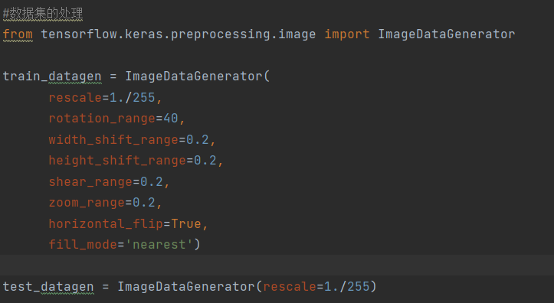

Thus, in this way we choose VGG+ data augmentation method and I still believe I did not get the best solution so I also tried another way to improve the accuracy, and I changed the input size of the images from (150,150,3) to (250,250,3), because the key point to classify is to find the contrast boundary between oil and sea, so larger size will contain more information. Finally the all above it what we chose as the model to test the accuracy of different methods and I also tested its initial accuracy and here is the result.

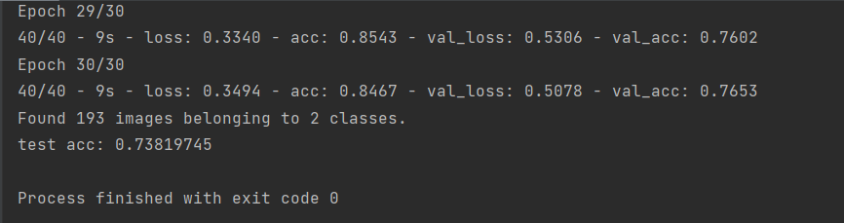

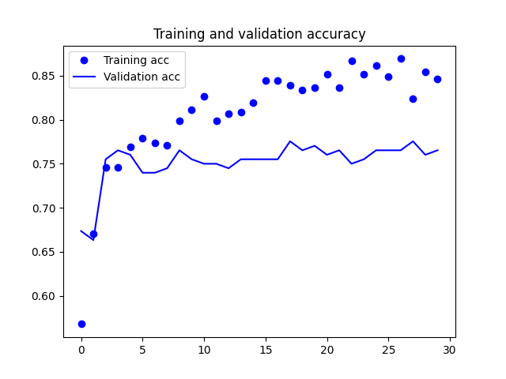

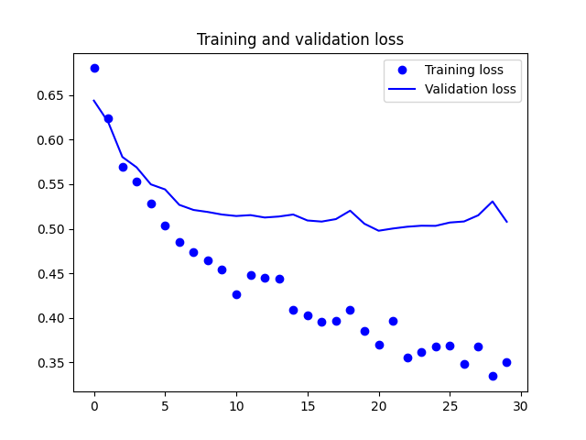

We can now test the methods just by changing the giving dataset, and we already applied all of the images to the five methods and gained five datasets. Moreover, all of the training results I show next is the epochs the model just begin to overfitting. So, I actually ran over 50 epochs to find by which epochs the model become overfitting, then I change the epoch times and run to train the model again. The first white background picture on the left is the accuracy plot, and we can see the training and validation accuracy increasement as epochs increased. The second one is the loss plot. At the time validation loss do not decrease mean the model start to overfitting and the image in black is the test accuracy and this accuracy can show the true ability of the model.

The followings are the results of different methods.

Method1:

Method2:

Method3:

Method4:

Method5:

So, in comparation the method1 is the best and we improve the accuracy from 72% to 82%, and now this is the partial best solution of our model.

In conclusion, by using neural network and a dataset of 800 images, we can now get an accuracy of 82% model to identify the oil-polluted sea or the normal sea. By using our models can help the researchers to identify if there is any oil-polluted areas and to deal with it.

We still can have a lot to deal with this project to improve the accuracy, and here are several further ways: we can find more images to make our dataset bigger so that the model can learn the different more easily and we also need to spend some time to pick out the unsuitable images such as the photos captured undersea. We also need to apply our method to different images because even though method1 is the best generally, but it is surly not the best for all the images. We can find the way to apply different method to different kind of images to make them more contrast. Also, we can improve the model by uniting different pre-trained models together to improve the model.