**IPython**

IPython is an important piece in the development workflow

Execute-Explore vrs Edit Compile Run workflow

So instead of complexy your environment you can use a simple text editor and IPython. Or go to a more advanced option like Visual Studio(*)

Basics:

You can launch Ipython from the command line:

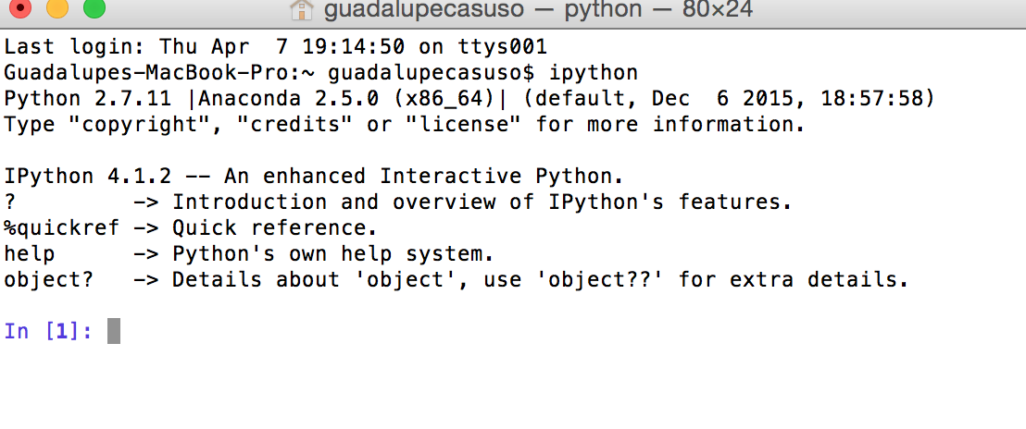

Tab Completition is a big asset (press tab)

Object Introspection (?)

.py Files execution %run / %run –i (parameters)

Identation is key

%paste or %cpaste

Magic commands - %timeit

%magic

ipython qtconsole –pylab=inline

The IPython team has developed a Qt framework-based GUI console, designed to wed the features of the terminal-only applications with the features provided by a rich text widget, like embedded images, multiline editing, and syntax highlighting.
McKinney, Wes (2012-10-08). Python for Data Analysis: Data Wrangling with Pandas, NumPy, and IPython (Kindle Locations 1227-1229). O'Reilly Media. Kindle Edition.

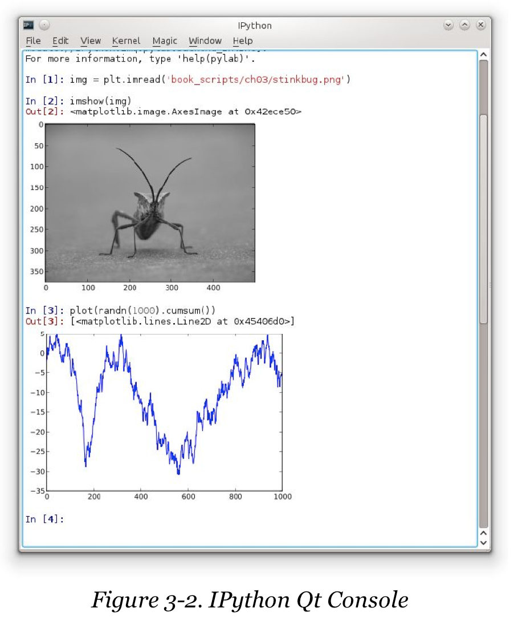

Starting a line in IPython with an exclamation point !,

or bang, tells IPython to execute everything after the bang in the system shell. This means that you can delete files (using rm or del, depending on your OS), change directories, or execute any other process.

%debug

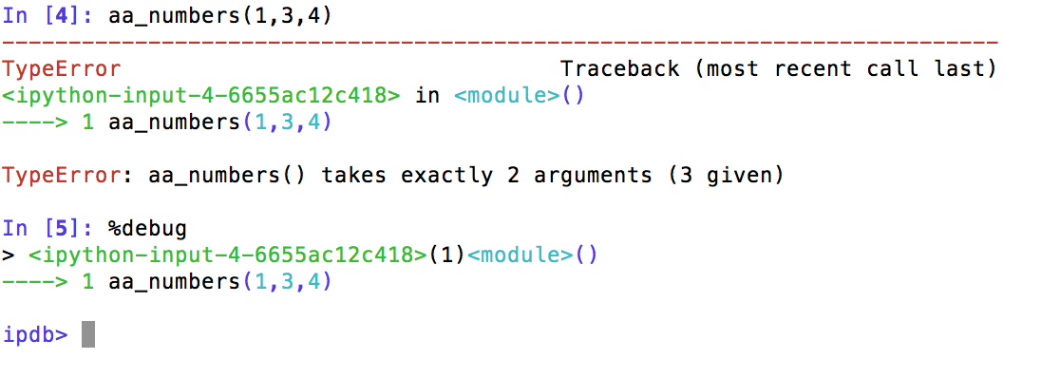

Debugging

Timing

Trace

**Ipython Notebook**