一个SQLite典型table样例：
卡号 车牌号 入场时间 照片路径
------- ---------- -------------------- ------------------------------
0xb212f 渝HKB9DT 2015/8/22 04:35:23 /path/to/photos/渝HKB9DT.jpg
0x756ed 宁V29DTH 2015/8/22 04:35:24 /path/to/photos/宁V29DTH.jpg
0xa175d 台D09DTH 2015/8/22 04:35:27 /path/to/photos/台D09DTH.jpg
0x4784e 台WAKB9D 2015/8/22 04:35:29
0x032ed 沪E4LSAK 2015/8/22 04:35:31 /path/to/photos/沪E4LSAK.jpg
0x083fd 桂J8CXF5 2015/8/22 04:35:33 /path/to/photos/桂J8CXF5.jpg
0xee16d 鄂J4LSAK 2015/8/22 04:35:35 /path/to/photos/鄂J4LSAK.jpg
0x30fbd 桂CVXF5E 2015/8/22 04:35:37 /path/to/photos/桂CVXF5E.jpg
0xd80bd 吉AKB9DT 2015/8/22 04:35:39
0xbf89d 宁J34LSA 2015/8/22 04:35:42
0x9573d 粤FPNDTH 2015/8/22 04:35:43 /path/to/photos/粤FPNDTH.jpg
0xc81bd 台PVXF5E 2015/8/22 04:35:45
0xd3ccf 吉XXF5EX 2015/8/22 04:35:47 /path/to/photos/吉XXF5EX.jpg

创建上述table的SQL语句：
sqlite> CREATE TABLE carinfo(cardid TEXT PRIMARY KEY,
> licence TEXT NOT NULL,
> time_in TEXT NOT NULL,
> photo TEXT,
> CHECK(LENGTH(licence)==7));

NULL不是真，也不是假，也不是0，也不是空字符串，它表示未知，它就是它自己。

SQLite约束条件：
NOT NULL 不可为空
UNIQUE 不可重复
PRIMARY KEY 主键，不可为空，不可重复
FOREIGN KEY 外键
CHECK 测试特定的字段值是否符合自定义表达式的约束
COLLATE 指定字段的排序规则
以上所有约束关键字都可作为字段级约束条件，其中粗体显示的3个还能表示表一级约束条件。

主键和UNIQUE字段的区别：
A) 主键不可为NULL（如果为NULL系统为自动递增），UNIQUE字段可以是NULL
B) 一个表有且只有一个主键，但可以有0个或多个UNIQUE字段
C) 逻辑设计上，主键用以标识记录，而UNIQUE字段就是说明不重复
一言以蔽之：PRIMARY KEY = UNIQUE + NOT NULL

SQLite的表总有且只有一个主键，这是一个64bits的整型字段，他的名字叫做rowid、_rowid_或oid，除非你自己定义了类型和约束条件为 INTEGER PRIMARY KEY的字段，否则以上字段总是被自动定义。
主键默认会自动递增，但当到达最大值时，会重新利用已经删除的值，因此主键并不是一定严格顺序增长的，如果要保证必须顺序增长，比如在指明主键说明INTEGER PRIMARY KEY的时候加上AUTOINCREMENT。

AUTOINCREMENT意味着阻止SQLite回收主键值

SQLite系统视图sqlite_master记录了数据库中所有的表、视图、索引和trigger。

SQLite存储类（数据类型）：
INTEGER 整数，可以是1、2、3、4、6或8个字节，SQLite会根据数值大小自动调整。
REAL 实数（浮点数），一律使用8个字节存储
TEXT 文本，最大支持长度为1,000,000,000个字符的单个字符串
BLOB 二进制对象，最大支持长度为1,000,000,000个字节
NULL 没有值
说明：
SQLite支持动态数据类型，根据具体的输入决定其类型。

经典SQL
==========
1，gec@ubuntu:~ $ sqlite3 parking.db
解析：
启动sqlite3，并指定一个数据库名parking.db。如果该数据库不存在，sqlite3并不会立即创建它，而是要等到其中有了实质性的内容（比如表、视图等）才会真正创建。

2，sqlite> CREATE table carinfo(_id INTEGER PRIMARY KEY NOT NULL, licence TEXT);
解析：
在数据库parking.db中（后续的所有命令都是针对此数据库，故不再另做说明）创建表carinfo
此表包括两个域：_id和licence，其中
A) _id是类型是整数，并且是主键，并且不能为空
B) licence类型是文本，没有约束条件

3，sqlite> INSERT INTO carinfo(licence) VALUES('粤B9MK48'); // 第1辆车信息
sqlite> INSERT INTO carinfo(_id, licence) VALUES(100, '粤ASLF45'); // 第2辆车信息
解析：
在表carinfo中插入两条记录。
由于_id是主键，因此如果没写的话，系统会自动递增填充

4，sqlite> SELECT * FROM carinfo;
解析：
将carinfo中的信息全部列出来。

5，sqlite> SELECT last_INSERT_rowid();
解析：
汇报最后一条记录的主键的值

6，sqlite> .tables
carinfo
解析：
汇报当前所有的表（包括其视图，如果有的话）

7，sqlite> CREATE index carinfo_idx on carinfo (licence);
sqlite> CREATE view 只看车牌 as SELECT licence FROM carinfo;
解析：
创建一个索引index ， 创建一个视图view

8，sqlite> .indices carinfo
解析：
查看索引 carinfo

9，sqlite> .schema
CREATE TABLE carinfo(_id INTEGER PRIMARY KEY NOT NULL, licence TEXT);
CREATE INDEX carinfo_idx on carinfo (licence);
CREATE VIEW schema as SELECT * FROM sqlite_master;
解析：
返回所有DLL（表、索引和视图的定义）语句

10，sqlite> SELECT * FROM sqlite_master;
type name tbl_name sql
---------- ---------- --------------- ------------------------------------------------
table carinfo carinfo CREATE TABLE carinfo(_id INTEGER PRIMARY KEY, licence TEXT)
index carinfo_id carinfo CREATE INDEX carinfo_idx on carinfo (licence)
view 只看车牌 schema CREATE VIEW 只看车牌 as SELECT * FROM sqlite_master
解析：
查看系统详细的schema信息，即所有的表、索引、视图和trigger。

11，sqlite> .dump
PRAGMA foreign_keys=OFF;
BEGIN TRANSACTION;
CREATE TABLE carinfo(_id INTEGER PRIMARY KEY NOT NULL, licence TEXT);
INSERT INTO "carinfo" VALUES(1,'粤B9MK48');
INSERT INTO "carinfo" VALUES(5,'粤F8EI45');
INSERT INTO "carinfo" VALUES(44,NULL);
INSERT INTO "carinfo" VALUES(100,'粤ASLF4');
INSERT INTO "carinfo" VALUES(101,'未知车牌');
CREATE INDEX carinfo_idx on carinfo (licence);
CREATE VIEW schema as SELECT * FROM sqlite_master;
COMMIT;
解析：
不带参数的.dump将导出整个数据库的DDL（数据库定义语句）和DML（数据库操作语句）命令。
注意：
.dump默认从屏幕输出，如果要将DDL和DML保存为一个文件，做法如下：
sqlite> .output parking.sql
sqlite> .dump
sqlite> .output stdout

12，sqlite> .read parking.sql
解析：
读取导出的SQL语句，并立即执行里面的所有内容

13，sqlite> .prompt ‘SQLite > ‘
解析：
修改sqlite命令提示符

14，sqlite> .mode col
解析：
修改输出模式为列模式

15，sqlite> .header on
解析：
修改输出模式为开启首行头部信息

16，sqlite> .width 5 10 20
解析：
修改输出模式中从左到右每一个字段的宽度

17，sqlite> .show
解析：
查看当前的输出模式格式

18，sqlite> drop table example;
sqlite> drop table if exists example;
解析：
第一行表示直接丢弃表example
第二行表示在表example存在的情况下，将其丢弃

19，sqlite> alter table carinfo rename to parkinginfo;
解析：
将表carinfo更名为parkinginfo

20，sqlite> alter table parkinginfo add column time_in TEXT;
解析：
为表parkinginfo增加一个字段：time_in，后面的TEXT是类型，还可以加上可选的约束列表

21，sqite> SELECT * FROM parkinginfo WHERE licence like '粤%';
解析：
找出表parkinginfo中字段licence以粤字开头的记录
注意：
like不区分大小写字母，如果要区分，请用glob代替like，并用*代替%
%代表任意长度的任意字符，类似于shell中的通配符*；%是贪婪匹配
_代表一个任意字符，类似于shell中的通配符?

22，sqlite> SELECT * FROM parkinginfo WHERE licence not like '粤%';
解析：
找出表parkinginfo中字段licence不以粤字开头的记录

23，sqlite> SELECT * FROM parkinginfo ORDER BY licence;
解析：
按licence排序输出（默认升序，即asc），降序使用如下命令：
SELECT * FROM parkinginfo ORDER BY licence desc;

24，sqlite> SELECT * FROM parkinginfo limit 10, 20;
解析：
限制输出结果集中的第10到20行记录

25，sqlite3> SELECT COUNT(*) FROM parkinginfo ORDER BY licence;
count(*)
----------
6
解析：
计算选择出来的记录的总数，COUNT()是众多聚合函数之一，其他的聚合函数有：
ABS()：绝对值
UPPER()：大小字母
LOWER()：小写字母
LENGTH()：长度
SUM()：求和
MIN()：最小值
MAX()：最大值
AVG()：平均值

26，sqlite> SELECT *,count(*) FROM parkinginfo WHERE _id != 44 group by time_in;
_id licence time_in count
----- ------------ ------------------------ -----
100 粤ASLF4 3
103 鲁B8888 2017/09/10 10:10:10 2
解析：
按time_in分组。
注意：
此语句的过滤规范是：数据先经过WHERE子句的过滤，结果给到gourp by分组，分完的每一组给到SELECT子句去聚合，也就是说SELECT子句对每组单独应用聚合而不是对整个结果。

27，sqlite> SELECT count(*) FROM parkinginfo WHERE licence in ('粤B9MK48', '鲁B8888');
count
-----
2
解析：
子查询，在指定范围内执行SELECT子句

28，sqlite> INSERT INTO parkinginfo VALUES(83, '粤L99NK5', '2011/11/11 11:11:11');
sqlite> INSERT INTO parkinginfo VALUES(NULL, '赣SU097L', '2011/11/11 11:11:12');
解析：
如果插入的记录包含所有的字段，则可省略字段列表。NULL可以用来出发主键的自动增长，NULL可以写成NULL。

29，sqlite> INSERT INTO 粤 SELECT cardid, licence FROM carinfo WHERE licence like '粤%';
解析：
将表carinfo中凡是车牌（license）以粤开头的记录插入表粤中。
注意：
由于INSERT子句没有指定字段列表，因此SELECT子句中的cardid、licence必须是表粤的所有字段。

30，sqlite>CREATE table 台(cardid TEXT, licence TEXT, time_in TEXT);
sqlite> INSERT INTO 台(cardid, licence) SELECT cardid, licence FROM carinfo WHERE licence like '台%';
sqlite> SELECT * FROM 台;
cardid licence time_in
---------- ---------- ----------
0xa175d8b9 台D09DTH
0x4784e059 台WAKB9D
0xc81bdcb9 台PVXF5E
0xa01cd7b9 台PI5EXF
解析：
第一句创建了一个具有3个字段的表台。
第二句，从表：carinfo中抽取cardid和licence字段插入表台中。
注意：
A) 由于INSERT子句指定了字段列表(cardid, licence)，因此SELECT子句可以不包含time_in字段。
B) SELECT子句只负责选择对应的字段的值，不包括其约束条件，换句话讲，对于表carinfo而言cardid是具有唯一性约束的主键，但是这个性质并不会传递给表台。

31，sqlite> update 台 set cardid='0x88880000' WHERE cardid='0x4784e059';
解析：
修改一个表台中的字段cardid。

32，sqlite> SELECT distinct * FROM 台 ORDER BY cardid;
解析：
选择不重复的记录

33，sqitel> CREATE table t(a INTEGER, b TEXT, PRIMARY KEY(a, b));
解析：
创建一个表t，并创建表一级约束。这与字段级约束的rowid并无冲突。
注意：
由于作为INTEGER类型的rowid并未因为表一级主键的存在而消失，因此虽然不可插入相同的a和b字段，但如果两个字段为NULL则没问题。即：
插入两个相同a和b是错误的：
sqlite> INSERT INTO t VALUES(100, ‘hello’);
sqlite> INSERT INTO t VALUES(100, ‘hello’);
Error: UNIQUE constraint failed: t.a, t.b
但是插入两次（NULL, NULL）确实可以的：
sqlite> INSERT INTO t VALUES(NULL, NULL);
sqlite> INSERT INTO t VALUES(NULL, NULL); TEXT

34，sqlite> CREATE table times(id INTEGER, date NOT NULL default current_date,
> time NOT NULL default current_time,
> timestamp NOT NULL default current_timestamp);
解析：
创建一个表times，其中字段date、time和timestamp具有默认值。
注意：
current_time、current_date和current_timestamp是SQLite内置变量，分别代表当前时间、当前如期和当前时间戳。

35，sqlite> CREATE table contact(name TEXT NOT NULL,
> phone TEXT, UNIQUE(name, phone),
> CHECK(LENGTH(phone)==11));
解析：
创建一个具有CHECK约束条件的表contact，要求插入的电话号码phone的长度必须是11个字符（但由于字段phone并没有NOT NULL约束，因此它可以是NULL）

- sqlite> delete FROM carinfo WHERE licence like ‘台%’;
解析：
将表carinfo中凡是以’台’开头的车牌号的记录删除掉。

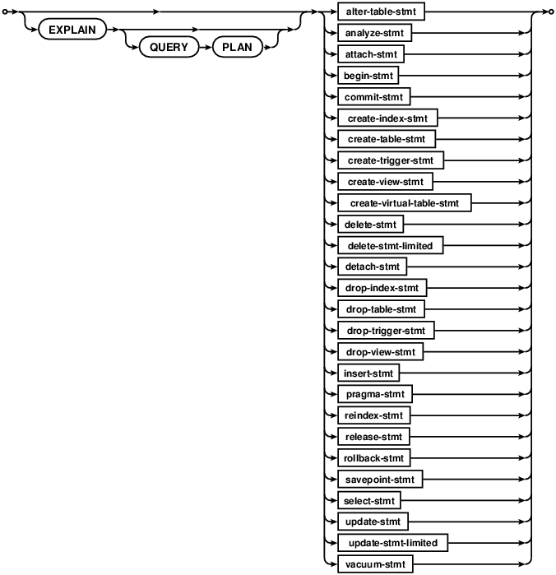
图1 SQL语句规范总览

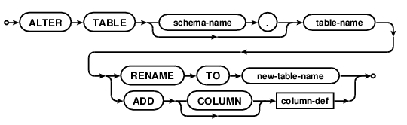
图2 更新表格的SQL语句规范
例：
ALTER TABLE schema.student RENAME TO friends;
ALTER TABLE schema.student ADD COLUMN address TEXT UNIQUE;
解析：
SQLite允许修改一个表的名字，或者为一个已存在的表添加新的列。

语法RENAME TO 用来修改表名，值得注意点是，这个命令只能用来修改某个数据库中的表名，而不能用来在已连接的、不同的数据库之间移动表。

如果被更名的表具有触发器或者索引，那么它们在表被更名之后依然有效。然而，如果该表有相关联的视图，或者某触发器所执行的语句涉及到该更名的表，则它们不会自动使用表的新名字。有需要的话，这样的视图或者触发器必须手工地被销毁，并使用表的新名字来重新创建。

如果被更名的表有外键约束，If foreign key constraints are enabled when a table is renamed, then any REFERENCES clauses in any table (either the table being renamed or some other table) that refer to the table being renamed are modified to refer to the renamed table by its new name.

The ADD COLUMN syntax is used to add a new column to an existing table. The new column is always appended to the end of the list of existing columns. The column-def rule defines the characteristics of the new column. The new column may take any of the forms permissible in a CREATE TABLE statement, with the following restrictions:

The column may not have a PRIMARY KEY or UNIQUE constraint.
The column may not have a default value of CURRENT_TIME, CURRENT_DATE, CURRENT_TIMESTAMP, or an expression in parentheses.
If a NOT NULL constraint is specified, then the column must have a default value other than NULL.
If foreign key constraints are enabled and a column with a REFERENCES clause is added, the column must have a default value of NULL.
Note also that when adding a CHECK constraint, the CHECK constraint is not tested against preexisting rows of the table. This can result in a table that contains data that is in violation of the CHECK constraint. Future versions of SQLite might change to validate CHECK constraints as they are added.

The execution time of the ALTER TABLE command is independent of the amount of data in the table. The ALTER TABLE command runs as quickly on a table with 10 million rows as it does on a table with 1 row.

After ADD COLUMN has been run on a database, that database will not be readable by SQLite version 3.1.3 (2005-02-20) and earlier.

Making Other Kinds Of Table Schema Changes
The only schema altering commands directly supported by SQLite are the "rename table" and "add column" commands shown above. However, applications can make other arbitrary changes to the format of a table using a simple sequence of operations. The steps to make arbitrary changes to the schema design of some table X are as follows:

If foreign key constraints are enabled, disable them using PRAGMA foreign_keys=OFF.

Start a transaction.

Remember the format of all indexes and triggers associated with table X. This information will be needed in step 8 below. One way to do this is to run a query like the following: SELECT type, sql FROM sqlite_master WHERE tbl_name='X'.

Use CREATE TABLE to construct a new table "new_X" that is in the desired revised format of table X. Make sure that the name "new_X" does not collide with any existing table name, of course.

Transfer content from X into new_X using a statement like: INSERT INTO new_X SELECT ... FROM X.

Drop the old table X: DROP TABLE X.

Change the name of new_X to X using: ALTER TABLE new_X RENAME TO X.

Use CREATE INDEX and CREATE TRIGGER to reconstruct indexes and triggers associated with table X. Perhaps use the old format of the triggers and indexes saved from step 3 above as a guide, making changes as appropriate for the alteration.

If any views refer to table X in a way that is affected by the schema change, then drop those views using DROP VIEW and recreate them with whatever changes are necessary to accommodate the schema change using CREATE VIEW.

If foreign key constraints were originally enabled then run PRAGMA foreign_key_check to verify that the schema change did not break any foreign key constraints.

Commit the transaction started in step 2.

If foreign keys constraints were originally enabled, reenable them now.

The procedure above is completely general and will work even if the schema change causes the information stored in the table to change. So the full procedure above is appropriate for dropping a column, changing the order of columns, adding or removing a UNIQUE constraint or PRIMARY KEY, adding CHECK or FOREIGN KEY or NOT NULL constraints, or changing the datatype for a column, for example. However, a simpler and faster procedure can optionally be used for some changes that do no affect the on-disk content in any way. The following simpler procedure is appropriate for removing CHECK or FOREIGN KEY or NOT NULL constraints, renaming columns, or adding or removing or changing default values on a column.

Start a transaction.

Run PRAGMA schema_version to determine the current schema version number. This number will be needed for step 6 below.

Activate schema editing using PRAGMA writable_schema=ON.

Run an UPDATE statement to change the definition of table X in the sqlite_master table: UPDATE sqlite_master SET sql=... WHERE type='table' AND name='X';

Caution: Making a change to the sqlite_master table like this will render the database corrupt and unreadable if the change contains a syntax error. It is suggested that careful testing of the UPDATE statement be done on a separate blank database prior to using it on a database containing important data.

If the change to table X also affects other tables or indexes or triggers are views within schema, then run UPDATE statements to modify those other tables indexes and views too. For example, if the name of a column changes, all FOREIGN KEY constraints, triggers, indexes, and views that refer to that column must be modified.

Caution: Once again, making changes to the sqlite_master table like this will render the database corrupt and unreadable if the change contains an error. Carefully test of this entire procedure on a separate test database prior to using it on a database containing important data and/or make backup copies of important databases prior to running this procedure.

Increment the schema version number using PRAGMA schema_version=X where X is one more than the old schema version number found in step 2 above.

Disable schema editing using PRAGMA writable_schema=OFF.

(Optional) Run PRAGMA integrity_check to verify that the schema changes did not damage the database.

Commit the transaction started on step 1 above.

If some future version of SQLite adds new ALTER TABLE capabilities, those capabilities will very likely use one of the two procedures outlined above.

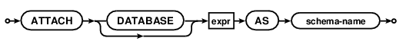
图3 连接数据库的SQL语句规范
例：

解析：
The ATTACH DATABASE statement adds another database file to the current database connection. Database files that were previously attached can be removed using the DETACH DATABASE command.

The filename for the database to be attached is the value of the expression that occurs before the AS keyword. The filename of the database follows the same semantics as the filename argument to sqlite3_open() and sqlite3_open_v2(); the special name ":memory:" results in an in-memory database and an empty string results in a new temporary database. The filename argument can be a URI filename if URI filename processing is enable on the database connection. The default behavior is for URI filenames to be disabled, however that might change in a future release of SQLite, so application developers are advised to plan accordingly.

The name that occurs after the AS keyword is the name of the database used internally by SQLite. The schema-names 'main' and 'temp' refer to the main database and the database used for temporary tables. The main and temp databases cannot be attached or detached.

Tables in an attached database can be referred to using the syntax schema-name.table-name. If the name of the table is unique across all attached databases and the main and temp databases, then the schema-name prefix is not required. If two or more tables in different databases have the same name and the schema-name prefix is not used on a table reference, then the table chosen is the one in the database that was least recently attached.

Transactions involving multiple attached databases are atomic, assuming that the main database is not ":memory:" and the journal_mode is not WAL. If the main database is ":memory:" or if the journal_mode is WAL, then transactions continue to be atomic within each individual database file. But if the host computer crashes in the middle of a COMMIT where two or more database files are updated, some of those files might get the changes where others might not.

There is a limit, set using sqlite3_limit() and SQLITE_LIMIT_ATTACHED, to the number of databases that can be simultaneously attached to a single database connection.

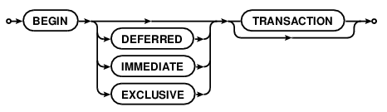
图4 开始执行的SQL语句规范
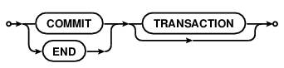
图5 递交操作的SQL语句规范
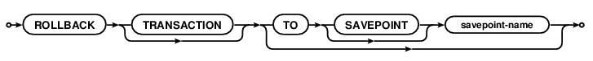
图6 回滚操作的SQL语句规范

例：

解析：
No changes can be made to the database except within a transaction. Any command that changes the database (basically, any SQL command other than SELECT) will automatically start a transaction if one is not already in effect. Automatically started transactions are committed when the last query finishes.

Transactions can be started manually using the BEGIN command. Such transactions usually persist until the next COMMIT or ROLLBACK command. But a transaction will also ROLLBACK if the database is closed or if an error occurs and the ROLLBACK conflict resolution algorithm is specified. See the documentation on the ON CONFLICT clause for additional information about the ROLLBACK conflict resolution algorithm.

END TRANSACTION is an alias for COMMIT.

Transactions created using BEGIN...COMMIT do not nest. For nested transactions, use the SAVEPOINT and RELEASE commands. The "TO SAVEPOINT name" clause of the ROLLBACK command shown in the syntax diagram above is only applicable to SAVEPOINT transactions. An attempt to invoke the BEGIN command within a transaction will fail with an error, regardless of whether the transaction was started by SAVEPOINT or a prior BEGIN. The COMMIT command and the ROLLBACK command without the TO clause work the same on SAVEPOINT transactions as they do with transactions started by BEGIN.

Transactions can be deferred, immediate, or exclusive. The default transaction behavior is deferred. Deferred means that no locks are acquired on the database until the database is first accessed. Thus with a deferred transaction, the BEGIN statement itself does nothing to the filesystem. Locks are not acquired until the first read or write operation. The first read operation against a database creates a SHARED lock and the first write operation creates a RESERVED lock. Because the acquisition of locks is deferred until they are needed, it is possible that another thread or process could create a separate transaction and write to the database after the BEGIN on the current thread has executed. If the transaction is immediate, then RESERVED locks are acquired on all databases as soon as the BEGIN command is executed, without waiting for the database to be used. After a BEGIN IMMEDIATE, no other database connection will be able to write to the database or do a BEGIN IMMEDIATE or BEGIN EXCLUSIVE. Other processes can continue to read from the database, however. An exclusive transaction causes EXCLUSIVE locks to be acquired on all databases. After a BEGIN EXCLUSIVE, no other database connection except for read_uncommitted connections will be able to read the database and no other connection without exception will be able to write the database until the transaction is complete.

An implicit transaction (a transaction that is started automatically, not a transaction started by BEGIN) is committed automatically when the last active statement finishes. A statement finishes when its prepared statement is reset or finalized. An open sqlite3_blob used for incremental BLOB I/O counts as an unfinished statement. The sqlite3_blob finishes when it is closed.

The explicit COMMIT command runs immediately, even if there are pending SELECT statements. However, if there are pending write operations, the COMMIT command will fail with an error code SQLITE_BUSY.

An attempt to execute COMMIT might also result in an SQLITE_BUSY return code if an another thread or process has a shared lock on the database that prevented the database from being updated. When COMMIT fails in this way, the transaction remains active and the COMMIT can be retried later after the reader has had a chance to clear.

In very old versions of SQLite (before version 3.7.11 - 2012-03-20) the ROLLBACK will fail with an error code SQLITE_BUSY if there are any pending queries. In more recent versions of SQLite, the ROLLBACK will proceed and pending statements will often be aborted, causing them to return an SQLITE_ABORT or SQLITE_ABORT_ROLLBACK error. In SQLite version 3.8.8 (2015-01-16) and later, a pending read will continue functioning after the ROLLBACK as long as the ROLLBACK does not modify the database schema.

If PRAGMA journal_mode is set to OFF (thus disabling the rollback journal file) then the behavior of the ROLLBACK command is undefined.

Response To Errors Within A Transaction
If certain kinds of errors occur within a transaction, the transaction may or may not be rolled back automatically. The errors that can cause an automatic rollback include:

SQLITE_FULL: database or disk full
SQLITE_IOERR: disk I/O error
SQLITE_BUSY: database in use by another process
SQLITE_NOMEM: out or memory
For all of these errors, SQLite attempts to undo just the one statement it was working on and leave changes from prior statements within the same transaction intact and continue with the transaction. However, depending on the statement being evaluated and the point at which the error occurs, it might be necessary for SQLite to rollback and cancel the entire transaction. An application can tell which course of action SQLite took by using the sqlite3_get_autocommit() C-language interface.

It is recommended that applications respond to the errors listed above by explicitly issuing a ROLLBACK command. If the transaction has already been rolled back automatically by the error response, then the ROLLBACK command will fail with an error, but no harm is caused by this.

Future versions of SQLite may extend the list of errors which might cause automatic transaction rollback. Future versions of SQLite might change the error response. In particular, we may choose to simplify the interface in future versions of SQLite by causing the errors above to force an unconditional rollback.

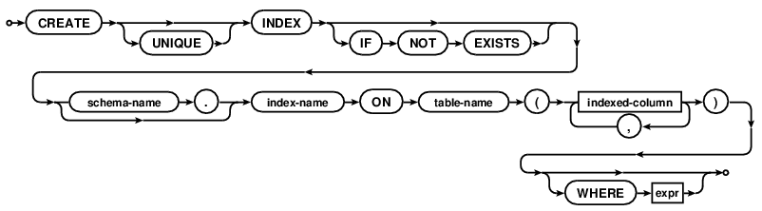
图7 创建索引的SQL语句规范
例：

解析：
The CREATE INDEX command consists of the keywords "CREATE INDEX" followed by the name of the new index, the keyword "ON", the name of a previously created table that is to be indexed, and a parenthesized list of table column names and/or expressions that are used for the index key. If the optional WHERE clause is included, then the index is a "partial index".

Each column name or expression can be followed by one of the "ASC" or "DESC" keywords to indicate sort order. The sort order may or may not be ignored depending on the database file format, and in particular the schema format number. The "legacy" schema format (1) ignores index sort order. The descending index schema format (4) takes index sort order into account. Only versions of SQLite 3.3.0 (2006-01-11) and later are able to understand the descending index format. For compatibility, version of SQLite between 3.3.0 and 3.7.9 use the legacy schema format by default. The newer schema format is used by default in version 3.7.10 (2012-01-16) and later. The legacy_file_format pragma can be used to change set the specific behavior for any version of SQLite.

The COLLATE clause optionally following each column name or expression defines a collating sequence used for text entries in that column. The default collating sequence is the collating sequence defined for that column in the CREATE TABLE statement. Or if no collating sequence is otherwise defined, the built-in BINARY collating sequence is used.

Expressions in an index may not reference other tables and may not use subqueries nor functions whose result might change (ex: random() or sqlite_version()). Expressions in an index may only refer to columns in the table that is being indexed. Indexes on expression will not work with versions of SQLite prior to version 3.9.0 (2015-10-14). See the Indexes On Expressions document for additional information about using general expressions in CREATE INDEX statements.

There are no arbitrary limits on the number of indices that can be attached to a single table. The number of columns in an index is limited to the value set by sqlite3_limit(SQLITE_LIMIT_COLUMN,...).

If the UNIQUE keyword appears between CREATE and INDEX then duplicate index entries are not allowed. Any attempt to insert a duplicate entry will result in an error. For the purposes of unique indices, all NULL values are considered different from all other NULL values and are thus unique. This is one of the two possible interpretations of the SQL-92 standard (the language in the standard is ambiguous) and is the interpretation followed by PostgreSQL, MySQL, Firebird, and Oracle. Informix and Microsoft SQL Server follow the other interpretation of the standard.

If the optional IF NOT EXISTS clause is present and another index with the same name already exists, then this command becomes a no-op.

Indexes are removed with the DROP INDEX command.

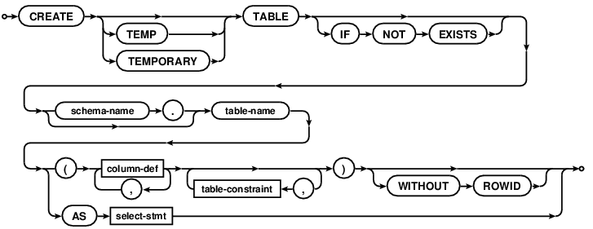
图8 创建表格的SQL语句规范
例：

解析：
The "CREATE TABLE" command is used to create a new table in an SQLite database. A CREATE TABLE command specifies the following attributes of the new table:

The name of the new table.

The database in which the new table is created. Tables may be created in the main database, the temp database, or in any attached database.

The name of each column in the table.

The declared type of each column in the table.

A default value or expression for each column in the table.

A default collation sequence to use with each column.

Optionally, a PRIMARY KEY for the table. Both single column and composite (multiple column) primary keys are supported.

A set of SQL constraints for each table. SQLite supports UNIQUE, NOT NULL, CHECK and FOREIGN KEY constraints.

Whether the table is a WITHOUT ROWID table.

Every CREATE TABLE statement must specify a name for the new table. Table names that begin with "sqlite_" are reserved for internal use. It is an error to attempt to create a table with a name that starts with "sqlite_".

If a schema-name is specified, it must be either "main", "temp", or the name of an attached database. In this case the new table is created in the named database. If the "TEMP" or "TEMPORARY" keyword occurs between the "CREATE" and "TABLE" then the new table is created in the temp database. It is an error to specify both a schema-name and the TEMP or TEMPORARY keyword, unless the schema-name is "temp". If no schema name is specified and the TEMP keyword is not present then the table is created in the main database.

It is usually an error to attempt to create a new table in a database that already contains a table, index or view of the same name. However, if the "IF NOT EXISTS" clause is specified as part of the CREATE TABLE statement and a table or view of the same name already exists, the CREATE TABLE command simply has no effect (and no error message is returned). An error is still returned if the table cannot be created because of an existing index, even if the "IF NOT EXISTS" clause is specified.

It is not an error to create a table that has the same name as an existing trigger.

Tables are removed using the DROP TABLE statement.

CREATE TABLE ... AS SELECT Statements
A "CREATE TABLE ... AS SELECT" statement creates and populates a database table based on the results of a SELECT statement. The table has the same number of columns as the rows returned by the SELECT statement. The name of each column is the same as the name of the corresponding column in the result set of the SELECT statement. The declared type of each column is determined by the expression affinity of the corresponding expression in the result set of the SELECT statement, as follows:

Expression Affinity Column Declared Type
TEXT "TEXT"
NUMERIC "NUM"
INTEGER "INT"
REAL "REAL"
BLOB (a.k.a "NONE") "" (empty string)
A table created using CREATE TABLE AS has no PRIMARY KEY and no constraints of any kind. The default value of each column is NULL. The default collation sequence for each column of the new table is BINARY.

Tables created using CREATE TABLE AS are initially populated with the rows of data returned by the SELECT statement. Rows are assigned contiguously ascending rowid values, starting with 1, in the order that they are returned by the SELECT statement.

Column Definitions
Unless it is a CREATE TABLE ... AS SELECT statement, a CREATE TABLE includes one or more column definitions, optionally followed by a list of table constraints. Each column definition consists of the name of the column, optionally followed by the declared type of the column, then one or more optional column constraints. Included in the definition of "column constraints" for the purposes of the previous statement are the COLLATE and DEFAULT clauses, even though these are not really constraints in the sense that they do not restrict the data that the table may contain. The other constraints - NOT NULL, CHECK, UNIQUE, PRIMARY KEY and FOREIGN KEY constraints - impose restrictions on the tables data, and are are described under SQL Data Constraints below.

Unlike most SQL databases, SQLite does not restrict the type of data that may be inserted into a column based on the columns declared type. Instead, SQLite uses dynamic typing. The declared type of a column is used to determine the affinity of the column only.

The DEFAULT clause specifies a default value to use for the column if no value is explicitly provided by the user when doing an INSERT. If there is no explicit DEFAULT clause attached to a column definition, then the default value of the column is NULL. An explicit DEFAULT clause may specify that the default value is NULL, a string constant, a blob constant, a signed-number, or any constant expression enclosed in parentheses. A default value may also be one of the special case-independent keywords CURRENT_TIME, CURRENT_DATE or CURRENT_TIMESTAMP. For the purposes of the DEFAULT clause, an expression is considered constant if it does contains no sub-queries, column or table references, bound parameters, or string literals enclosed in double-quotes instead of single-quotes.

Each time a row is inserted into the table by an INSERT statement that does not provide explicit values for all table columns the values stored in the new row are determined by their default values, as follows:

If the default value of the column is a constant NULL, text, blob or signed-number value, then that value is used directly in the new row.

If the default value of a column is an expression in parentheses, then the expression is evaluated once for each row inserted and the results used in the new row.

If the default value of a column is CURRENT_TIME, CURRENT_DATE or CURRENT_TIMESTAMP, then the value used in the new row is a text representation of the current UTC date and/or time. For CURRENT_TIME, the format of the value is "HH:MM:SS". For CURRENT_DATE, "YYYY-MM-DD". The format for CURRENT_TIMESTAMP is "YYYY-MM-DD HH:MM:SS".

The COLLATE clause specifies the name of a collating sequence to use as the default collation sequence for the column. If no COLLATE clause is specified, the default collation sequence is BINARY.

The number of columns in a table is limited by the SQLITE_MAX_COLUMN compile-time parameter. A single row of a table cannot store more than SQLITE_MAX_LENGTH bytes of data. Both of these limits can be lowered at runtime using the sqlite3_limit() C/C++ interface.

SQL Data Constraints
Each table in SQLite may have at most one PRIMARY KEY. If the keywords PRIMARY KEY are added to a column definition, then the primary key for the table consists of that single column. Or, if a PRIMARY KEY clause is specified as a table-constraint, then the primary key of the table consists of the list of columns specified as part of the PRIMARY KEY clause. The PRIMARY KEY clause must contain only column names — the use of expressions in an indexed-column of a PRIMARY KEY is not supported. An error is raised if more than one PRIMARY KEY clause appears in a CREATE TABLE statement. The PRIMARY KEY is optional for ordinary tables but is required for WITHOUT ROWID tables.

If a table has a single column primary key and the declared type of that column is "INTEGER" and the table is not a WITHOUT ROWID table, then the column is known as an INTEGER PRIMARY KEY. See below for a description of the special properties and behaviors associated with an INTEGER PRIMARY KEY.

Each row in a table with a primary key must have a unique combination of values in its primary key columns. For the purposes of determining the uniqueness of primary key values, NULL values are considered distinct from all other values, including other NULLs. If an INSERT or UPDATE statement attempts to modify the table content so that two or more rows have identical primary key values, that is a constraint violation.

According to the SQL standard, PRIMARY KEY should always imply NOT NULL. Unfortunately, due to a bug in some early versions, this is not the case in SQLite. Unless the column is an INTEGER PRIMARY KEY or the table is a WITHOUT ROWID table or the column is declared NOT NULL, SQLite allows NULL values in a PRIMARY KEY column. SQLite could be fixed to conform to the standard, but doing so might break legacy applications. Hence, it has been decided to merely document the fact that SQLite allowing NULLs in most PRIMARY KEY columns.

A UNIQUE constraint is similar to a PRIMARY KEY constraint, except that a single table may have any number of UNIQUE constraints. For each UNIQUE constraint on the table, each row must contain a unique combination of values in the columns identified by the UNIQUE constraint. For the purposes of UNIQUE constraints, NULL values are considered distinct from all other values, including other NULLs. As with PRIMARY KEYs, a UNIQUE table-constraint clause must contain only column names — the use of expressions in an indexed-column of a UNIQUE table-constraint is not supported.

In most cases, UNIQUE and PRIMARY KEY constraints are implemented by creating a unique index in the database. (The exceptions are INTEGER PRIMARY KEY and PRIMARY KEYs on WITHOUT ROWID tables.) Hence, the following schemas are logically equivalent:

CREATE TABLE t1(a, b UNIQUE);

CREATE TABLE t1(a, b PRIMARY KEY);

CREATE TABLE t1(a, b);
CREATE UNIQUE INDEX t1b ON t1(b);

A CHECK constraint may be attached to a column definition or specified as a table constraint. In practice it makes no difference. Each time a new row is inserted into the table or an existing row is updated, the expression associated with each CHECK constraint is evaluated and cast to a NUMERIC value in the same way as a CAST expression. If the result is zero (integer value 0 or real value 0.0), then a constraint violation has occurred. If the CHECK expression evaluates to NULL, or any other non-zero value, it is not a constraint violation. The expression of a CHECK constraint may not contain a subquery.

A NOT NULL constraint may only be attached to a column definition, not specified as a table constraint. Not surprisingly, a NOT NULL constraint dictates that the associated column may not contain a NULL value. Attempting to set the column value to NULL when inserting a new row or updating an existing one causes a constraint violation.

Exactly how a constraint violation is dealt with is determined by the constraint conflict resolution algorithm. Each PRIMARY KEY, UNIQUE, NOT NULL and CHECK constraint has a default conflict resolution algorithm. PRIMARY KEY, UNIQUE and NOT NULL constraints may be explicitly assigned a default conflict resolution algorithm by including a conflict-clause in their definitions. Or, if a constraint definition does not include a conflict-clause or it is a CHECK constraint, the default conflict resolution algorithm is ABORT. Different constraints within the same table may have different default conflict resolution algorithms. See the section titled ON CONFLICT for additional information.

ROWIDs and the INTEGER PRIMARY KEY
Except for WITHOUT ROWID tables, all rows within SQLite tables have a 64-bit signed integer key that uniquely identifies the row within its table. This integer is usually called the "rowid". The rowid value can be accessed using one of the special case-independent names "rowid", "oid", or "_rowid_" in place of a column name. If a table contains a user defined column named "rowid", "oid" or "_rowid_", then that name always refers the explicitly declared column and cannot be used to retrieve the integer rowid value.

The rowid (and "oid" and "_rowid_") is omitted in WITHOUT ROWID tables. WITHOUT ROWID tables are only available in SQLite version 3.8.2 (2013-12-06) and later. A table that lacks the WITHOUT ROWID clause is called a "rowid table".

The data for rowid tables is stored as a B-Tree structure containing one entry for each table row, using the rowid value as the key. This means that retrieving or sorting records by rowid is fast. Searching for a record with a specific rowid, or for all records with rowids within a specified range is around twice as fast as a similar search made by specifying any other PRIMARY KEY or indexed value.

With one exception noted below, if a rowid table has a primary key that consists of a single column and the declared type of that column is "INTEGER" in any mixture of upper and lower case, then the column becomes an alias for the rowid. Such a column is usually referred to as an "integer primary key". A PRIMARY KEY column only becomes an integer primary key if the declared type name is exactly "INTEGER". Other integer type names like "INT" or "BIGINT" or "SHORT INTEGER" or "UNSIGNED INTEGER" causes the primary key column to behave as an ordinary table column with integer affinity and a unique index, not as an alias for the rowid.

The exception mentioned above is that if the declaration of a column with declared type "INTEGER" includes an "PRIMARY KEY DESC" clause, it does not become an alias for the rowid and is not classified as an integer primary key. This quirk is not by design. It is due to a bug in early versions of SQLite. But fixing the bug could result in backwards incompatibilities. Hence, the original behavior has been retained (and documented) because odd behavior in a corner case is far better than a compatibility break. This means that the following three table declarations all cause the column "x" to be an alias for the rowid (an integer primary key):

CREATE TABLE t(x INTEGER PRIMARY KEY ASC, y, z);
CREATE TABLE t(x INTEGER, y, z, PRIMARY KEY(x ASC));
CREATE TABLE t(x INTEGER, y, z, PRIMARY KEY(x DESC));
But the following declaration does not result in "x" being an alias for the rowid:

CREATE TABLE t(x INTEGER PRIMARY KEY DESC, y, z);
Rowid values may be modified using an UPDATE statement in the same way as any other column value can, either using one of the built-in aliases ("rowid", "oid" or "_rowid_") or by using an alias created by an integer primary key. Similarly, an INSERT statement may provide a value to use as the rowid for each row inserted. Unlike normal SQLite columns, an integer primary key or rowid column must contain integer values. Integer primary key or rowid columns are not able to hold floating point values, strings, BLOBs, or NULLs.

If an UPDATE statement attempts to set an integer primary key or rowid column to a NULL or blob value, or to a string or real value that cannot be losslessly converted to an integer, a "datatype mismatch" error occurs and the statement is aborted. If an INSERT statement attempts to insert a blob value, or a string or real value that cannot be losslessly converted to an integer into an integer primary key or rowid column, a "datatype mismatch" error occurs and the statement is aborted.

If an INSERT statement attempts to insert a NULL value into a rowid or integer primary key column, the system chooses an integer value to use as the rowid automatically. A detailed description of how this is done is provided separately.

The parent key of a foreign key constraint is not allowed to use the rowid. The parent key must used named columns only.

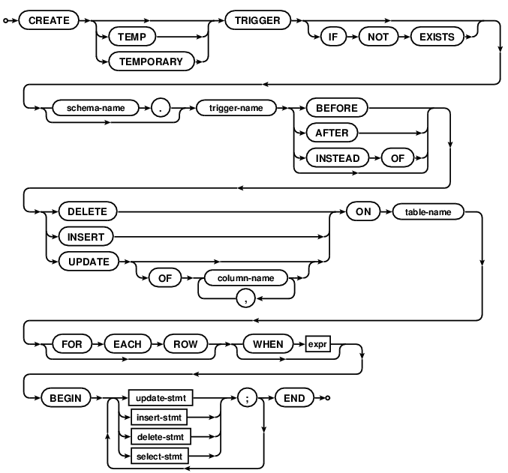
图9 创建触发器的SQL语句规范
例：

解析：
The CREATE TRIGGER statement is used to add triggers to the database schema. Triggers are database operations that are automatically performed when a specified database event occurs.

A trigger may be specified to fire whenever a DELETE, INSERT, or UPDATE of a particular database table occurs, or whenever an UPDATE occurs on on one or more specified columns of a table.

At this time SQLite supports only FOR EACH ROW triggers, not FOR EACH STATEMENT triggers. Hence explicitly specifying FOR EACH ROW is optional. FOR EACH ROW implies that the SQL statements specified in the trigger may be executed (depending on the WHEN clause) for each database row being inserted, updated or deleted by the statement causing the trigger to fire.

Both the WHEN clause and the trigger actions may access elements of the row being inserted, deleted or updated using references of the form "NEW.column-name" and "OLD.column-name", where column-name is the name of a column from the table that the trigger is associated with. OLD and NEW references may only be used in triggers on events for which they are relevant, as follows:

INSERT NEW references are valid
UPDATE NEW and OLD references are valid
DELETE OLD references are valid
If a WHEN clause is supplied, the SQL statements specified are only executed if the WHEN clause is true. If no WHEN clause is supplied, the SQL statements are executed every time the trigger fires.

The BEFORE or AFTER keyword determines when the trigger actions will be executed relative to the insertion, modification or removal of the associated row.

An ON CONFLICT clause may be specified as part of an UPDATE or INSERT action within the body of the trigger. However if an ON CONFLICT clause is specified as part of the statement causing the trigger to fire, then conflict handling policy of the outer statement is used instead.

Triggers are automatically dropped when the table that they are associated with (the table-name table) is dropped. However if the trigger actions reference other tables, the trigger is not dropped or modified if those other tables are dropped or modified.

Triggers are removed using the DROP TRIGGER statement.

Syntax Restrictions On UPDATE, DELETE, and INSERT Statements Within Triggers
The UPDATE, DELETE, and INSERT statements within triggers do not support the full syntax for UPDATE, DELETE, and INSERT statements. The following restrictions apply:

The name of the table to be modified in an UPDATE, DELETE, or INSERT statement must be an unqualified table name. In other words, one must use just "tablename" not "database.tablename" when specifying the table.

For non-TEMP triggers, the table to be modified or queried must exist in the same database as the table or view to which the trigger is attached. TEMP triggers are not subject to the same-database rule. A TEMP trigger is allowed to query or modify any table in any ATTACH-ed database.

The "INSERT INTO table DEFAULT VALUES" form of the INSERT statement is not supported.

The INDEXED BY and NOT INDEXED clauses are not supported for UPDATE and DELETE statements.

The ORDER BY and LIMIT clauses on UPDATE and DELETE statements are not supported. ORDER BY and LIMIT are not normally supported for UPDATE or DELETE in any context but can be enabled for top-level statements using the SQLITE_ENABLE_UPDATE_DELETE_LIMIT compile-time option. However, that compile-time option only applies to top-level UPDATE and DELETE statements, not UPDATE and DELETE statements within triggers.

Common table expression are not supported for statements inside of triggers.

INSTEAD OF triggers
Triggers may be created on views, as well as ordinary tables, by specifying INSTEAD OF in the CREATE TRIGGER statement. If one or more ON INSERT, ON DELETE or ON UPDATE triggers are defined on a view, then it is not an error to execute an INSERT, DELETE or UPDATE statement on the view, respectively. Instead, executing an INSERT, DELETE or UPDATE on the view causes the associated triggers to fire. The real tables underlying the view are not modified (except possibly explicitly, by a trigger program).

Note that the sqlite3_changes() and sqlite3_total_changes() interfaces do not count INSTEAD OF trigger firings, but the count_changes pragma does count INSTEAD OF trigger firing.

Some Example Triggers
Assuming that customer records are stored in the "customers" table, and that order records are stored in the "orders" table, the following UPDATE trigger ensures that all associated orders are redirected when a customer changes his or her address:

CREATE TRIGGER update_customer_address UPDATE OF address ON customers
BEGIN
UPDATE orders SET address = new.address WHERE customer_name = old.name;
END;
With this trigger installed, executing the statement:

UPDATE customers SET address = '1 Main St.' WHERE name = 'Jack Jones';
causes the following to be automatically executed:

UPDATE orders SET address = '1 Main St.' WHERE customer_name = 'Jack Jones';
For an example of an INSTEAD OF trigger, consider the following schema:

CREATE TABLE customer(
cust_id INTEGER PRIMARY KEY,
cust_name TEXT,
cust_addr TEXT
);
CREATE VIEW customer_address AS
SELECT cust_id, cust_addr FROM customer;
CREATE TRIGGER cust_addr_chng
INSTEAD OF UPDATE OF cust_addr ON customer_address
BEGIN
UPDATE customer SET cust_addr=NEW.cust_addr
WHERE cust_id=NEW.cust_id;
END;
With the schema above, a statement of the form:

UPDATE customer_address SET cust_addr=$new_address WHERE cust_id=$cust_id;
Causes the customer.cust_addr field to be updated for a specific customer entry that has customer.cust_id equal to the $cust_id parameter. Note how the values assigned to the view are made available as field in the special "NEW" table within the trigger body.

Cautions On The Use Of BEFORE triggers
If a BEFORE UPDATE or BEFORE DELETE trigger modifies or deletes a row that was to have been updated or deleted, then the result of the subsequent update or delete operation is undefined. Furthermore, if a BEFORE trigger modifies or deletes a row, then it is undefined whether or not AFTER triggers that would have otherwise run on those rows will in fact run.

The value of NEW.rowid is undefined in a BEFORE INSERT trigger in which the rowid is not explicitly set to an integer.

Because of the behaviors described above, programmers are encouraged to prefer AFTER triggers over BEFORE triggers.

The RAISE() function
A special SQL function RAISE() may be used within a trigger-program, with the following syntax

raise-function:
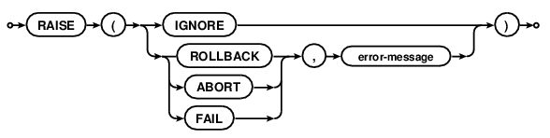
syntax diagram raise-function
When one of RAISE(ROLLBACK,...), RAISE(ABORT,...) or RAISE(FAIL,...) is called during trigger-program execution, the specified ON CONFLICT processing is performed the current query terminates. An error code of SQLITE_CONSTRAINT is returned to the application, along with the specified error message.

When RAISE(IGNORE) is called, the remainder of the current trigger program, the statement that caused the trigger program to execute and any subsequent trigger programs that would have been executed are abandoned. No database changes are rolled back. If the statement that caused the trigger program to execute is itself part of a trigger program, then that trigger program resumes execution at the beginning of the next step.

TEMP Triggers on Non-TEMP Tables
A trigger normally exists in the same database as the table named after the "ON" keyword in the CREATE TRIGGER statement. Except, it is possible to create a TEMP TRIGGER on a table in another database. Such a trigger will only fire when changes are made to the target table by the application that defined the trigger. Other applications that modify the database will not be able to see the TEMP trigger and hence cannot run the trigger.

When defining a TEMP trigger on a non-TEMP table, it is important to specify the database holding the non-TEMP table. For example, in the following statement, it is important to say "main.tab1" instead of just "tab1":

CREATE TEMP TRIGGER ex1 AFTER INSERT ON main.tab1 BEGIN ...
Failure to specify the schema name on the target table could result in the TEMP trigger being reattached to a table with the same name in another database whenever any schema change occurs.

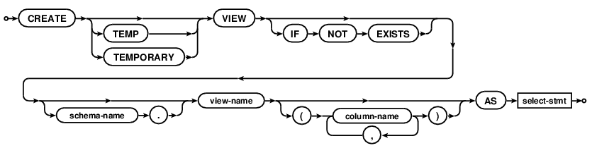
图10 创建视图的SQL语句规范
例：

解析：
The CREATE VIEW command assigns a name to a pre-packaged SELECT statement. Once the view is created, it can be used in the FROM clause of another SELECT in place of a table name.

If the "TEMP" or "TEMPORARY" keyword occurs in between "CREATE" and "VIEW" then the view that is created is only visible to the database connection that created it and is automatically deleted when the database connection is closed.

If a schema-name is specified, then the view is created in the specified database. It is an error to specify both a schema-name and the TEMP keyword on a VIEW, unless the schema-name is "temp". If no schema name is specified, and the TEMP keyword is not present, the VIEW is created in the main database.

You cannot DELETE, INSERT, or UPDATE a view. Views are read-only in SQLite. However, in many cases you can use an INSTEAD OF trigger on the view to accomplish the same thing. Views are removed with the DROP VIEW command.

If a column-name list follows the view-name, then that list determines the names of the columns for the view. If the column-name list is omitted, then the names of the columns in the view are derived from the names of the result-set columns in the select-stmt. Note that the column-name list syntax is only supported in SQLite versions 3.9.0 (2015-10-14) and later.

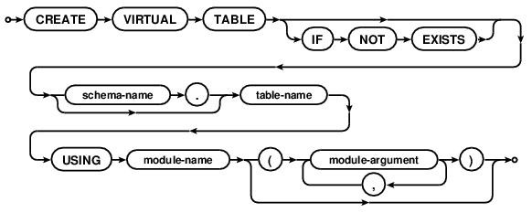
图11 创建虚拟表格的SQL语句规范
例：

解析：
A virtual table is an interface to an external storage or computation engine that appears to be a table but does not actually store information in the database file.

In general, you can do anything with a virtual table that can be done with an ordinary table, except that you cannot create indices or triggers on a virtual table. Some virtual table implementations might impose additional restrictions. For example, many virtual tables are read-only.

The module-name is the name of an object that implements the virtual table. The module-name must be registered with the SQLite database connection using sqlite3_create_module() or sqlite3_create_module_v2() prior to issuing the CREATE VIRTUAL TABLE statement. The module takes zero or more comma-separated arguments. The arguments can be just about any text as long as it has balanced parentheses. The argument syntax is sufficiently general that the arguments can be made to appear as column definitions in a traditional CREATE TABLE statement. SQLite passes the module arguments directly to the xCreate and xConnect methods of the module implementation without any interpretation. It is the responsibility of the module implementation to parse and interpret its own arguments.

A virtual table is destroyed using the ordinary DROP TABLE statement. There is no DROP VIRTUAL TABLE statement.

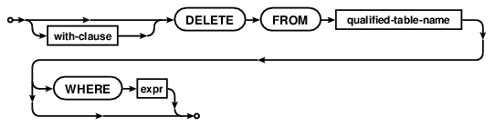
图12 删除表格记录的SQL语句规范
例：

解析：
The DELETE command removes records from the table identified by the qualified-table-name.

If the WHERE clause is not present, all records in the table are deleted. If a WHERE clause is supplied, then only those rows for which the WHERE clause boolean expression is true are deleted. Rows for which the expression is false or NULL are retained.

Restrictions on DELETE Statements Within CREATE TRIGGER
The following restrictions apply to DELETE statements that occur within the body of a CREATE TRIGGER statement:

The table-name specified as part of a DELETE statement within a trigger body must be unqualified. In other words, the schema-name. prefix on the table name is not allowed within triggers. If the table to which the trigger is attached is not in the temp database, then DELETE statements within the trigger body must operate on tables within the same database as it. If the table to which the trigger is attached is in the TEMP database, then the unqualified name of the table being deleted is resolved in the same way as it is for a top-level statement (by searching first the TEMP database, then the main database, then any other databases in the order they were attached).

The INDEXED BY and NOT INDEXED clauses are not allowed on DELETE statements within triggers.
The LIMIT and ORDER BY clauses (described below) are unsupported for DELETE statements within triggers.
Optional LIMIT and ORDER BY clauses
If SQLite is compiled with the SQLITE_ENABLE_UPDATE_DELETE_LIMIT compile-time option, then the syntax of the DELETE statement is extended by the addition of optional ORDER BY and LIMIT clauses:
delete-stmt-limited:
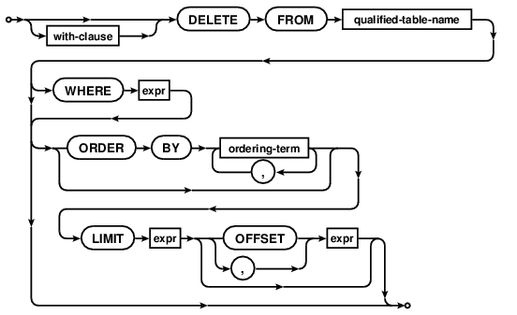

syntax diagram delete-stmt-limited
If a DELETE statement has a LIMIT clause, the maximum number of rows that will be deleted is found by evaluating the accompanying expression and casting it to an integer value. If the result of the evaluating the LIMIT clause cannot be losslessly converted to an integer value, it is an error. A negative LIMIT value is interpreted as "no limit". If the DELETE statement also has an OFFSET clause, then it is similarly evaluated and cast to an integer value. Again, it is an error if the value cannot be losslessly converted to an integer. If there is no OFFSET clause, or the calculated integer value is negative, the effective OFFSET value is zero.

If the DELETE statement has an ORDER BY clause, then all rows that would be deleted in the absence of the LIMIT clause are sorted according to the ORDER BY. The first M rows, where M is the value found by evaluating the OFFSET clause expression, are skipped, and the following N, where N is the value of the LIMIT expression, are deleted. If there are less than N rows remaining after taking the OFFSET clause into account, or if the LIMIT clause evaluated to a negative value, then all remaining rows are deleted.

If the DELETE statement has no ORDER BY clause, then all rows that would be deleted in the absence of the LIMIT clause are assembled in an arbitrary order before applying the LIMIT and OFFSET clauses to determine the subset that are actually deleted.

The ORDER BY clause on a DELETE statement is used only to determine which rows fall within the LIMIT. The order in which rows are deleted is arbitrary and is not influenced by the ORDER BY clause.

The Truncate Optimization
When the WHERE is omitted from a DELETE statement and the table being deleted has no triggers, SQLite uses an optimization to erase the entire table content without having to visit each row of the table individually. This "truncate" optimization makes the delete run much faster. Prior to SQLite version 3.6.5 (2008-11-12), the truncate optimization also meant that the sqlite3_changes() and sqlite3_total_changes() interfaces and the count_changes pragma will not actually return the number of deleted rows. That problem has been fixed as of version 3.6.5 (2008-11-12).

The truncate optimization can be permanently disabled for all queries by recompiling SQLite with the SQLITE_OMIT_TRUNCATE_OPTIMIZATION compile-time switch.

The truncate optimization can also be disabled at runtime using the sqlite3_set_authorizer() interface. If an authorizer callback returns SQLITE_IGNORE for an SQLITE_DELETE action code, then the DELETE operation will proceed but the truncate optimization will be bypassed and rows will be deleted one by one.

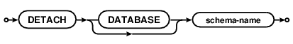
图13 断开与数据库的连接的SQL语句规范

例：

解析：
This statement detaches an additional database connection previously attached using the ATTACH statement. When not in shared cache mode, it is possible to have the same database file attached multiple times using different names, and detaching one connection to a file will leave the others intact.

In shared cache mode, attempting to attach the same database file more than once results in an error.

图14 销毁索引的SQL语句规范
例：

解析：
The DROP INDEX statement removes an index added with the CREATE INDEX statement. The index is completely removed from the disk. The only way to recover the index is to reenter the appropriate CREATE INDEX command.

图15 销毁表格的SQL语句规范
例：

解析：
The DROP TABLE statement removes a table added with the CREATE TABLE statement. The name specified is the table name. The dropped table is completely removed from the database schema and the disk file. The table can not be recovered. All indices and triggers associated with the table are also deleted.

The optional IF EXISTS clause suppresses the error that would normally result if the table does not exist.

If foreign key constraints are enabled, a DROP TABLE command performs an implicit DELETE FROM command before removing the table from the database schema. Any triggers attached to the table are dropped from the database schema before the implicit DELETE FROM is executed, so this cannot cause any triggers to fire. By contrast, an implicit DELETE FROM does cause any configured foreign key actions to take place. If the implicit DELETE FROM executed as part of a DROP TABLE command violates any immediate foreign key constraints, an error is returned and the table is not dropped. If the implicit DELETE FROM causes any deferred foreign key constraints to be violated, and the violations still exist when the transaction is committed, an error is returned at the time of commit.

图16 销毁触发器的SQL语句规范
例：

解析：
The DROP TRIGGER statement removes a trigger created by the CREATE TRIGGER statement. Once removed, the trigger definition is no longer present in the sqlite_master (or sqlite_temp_master) table and is not fired by any subsequent INSERT, UPDATE or DELETE statements.

Note that triggers are automatically dropped when the associated table is dropped.

图17 销毁视图的SQL语句规范
例：

解析：
The DROP VIEW statement removes a view created by the CREATE VIEW statement. The view definition is removed from the database schema, but no actual data in the underlying base tables is modified.

The view to drop is identified by the view-name and optional schema-name specified as part of the DROP VIEW statement. This reference is resolved using the standard procedure for object resolution.

If the specified view cannot be found and the IF EXISTS clause is not present, it is an error. If the specified view cannot be found and an IF EXISTS clause is present in the DROP VIEW statement, then the statement is a no-op.

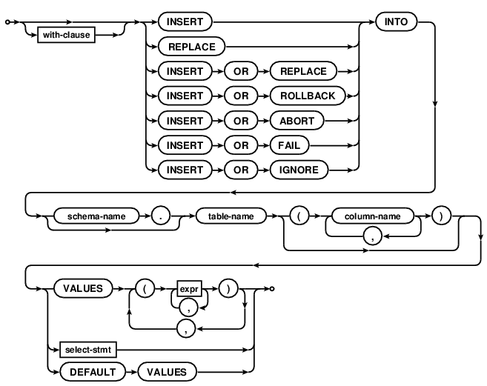
图18 在表格中插入新记录的SQL语句规范

例：

解析：
插入记录语句有三种基本的形式：The INSERT statement comes in three basic forms.
第一种：
INSERT INTO table VALUES(...);
该种形式（携带关键字VALUES）的插入语句将会在一个已有的表格中创建一行或多行记录。If the column-name list after table-name is omitted then the number of values inserted into each row must be the same as the number of columns in the table. In this case the result of evaluating the left-most expression from each term of the VALUES list is inserted into the left-most column of each new row, and so forth for each subsequent expression. If a column-name list is specified, then the number of values in each term of the VALUE list must match the number of specified columns. Each of the named columns of the new row is populated with the results of evaluating the corresponding VALUES expression. Table columns that do not appear in the column list are populated with the default column value (specified as part of the CREATE TABLE statement), or with NULL if no default value is specified.

INSERT INTO table SELECT ...;

The second form of the INSERT statement contains a SELECT statement instead of a VALUES clause. A new entry is inserted into the table for each row of data returned by executing the SELECT statement. If a column-list is specified, the number of columns in the result of the SELECT must be the same as the number of items in the column-list. Otherwise, if no column-list is specified, the number of columns in the result of the SELECT must be the same as the number of columns in the table. Any SELECT statement, including compound SELECTs and SELECT statements with ORDER BY and/or LIMIT clauses, may be used in an INSERT statement of this form.

INSERT INTO table DEFAULT VALUES;

The third form of an INSERT statement is with DEFAULT VALUES. The INSERT ... DEFAULT VALUES statement inserts a single new row into the named table. Each column of the new row is populated with its default value, or with a NULL if no default value is specified as part of the column definition in the CREATE TABLE statement.

The initial "INSERT" keyword can be replaced by "REPLACE" or "INSERT OR action" to specify an alternative constraint conflict resolution algorithm to use during that one INSERT command. For compatibility with MySQL, the parser allows the use of the single keyword REPLACE as an alias for "INSERT OR REPLACE".

The optional "schema-name." prefix on the table-name is supported for top-level INSERT statements only. The table name must be unqualified for INSERT statements that occur within CREATE TRIGGER statements. Similarly, the "DEFAULT VALUES" form of the INSERT statement is supported for top-level INSERT statements only and not for INSERT statements within triggers.

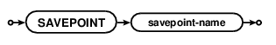
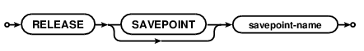
图19 创建还原点、销毁还原点和回滚到某个还原点的SQL语句规范

解析：
SAVEPOINTs are a method of creating transactions, similar to BEGIN and COMMIT, except that the SAVEPOINT and RELEASE commands are named and may be nested.

The SAVEPOINT command starts a new transaction with a name. The transaction names need not be unique. A SAVEPOINT can be started either within or outside of a BEGIN...COMMIT. When a SAVEPOINT is the outer-most savepoint and it is not within a BEGIN...COMMIT then the behavior is the same as BEGIN DEFERRED TRANSACTION.

The ROLLBACK TO command reverts the state of the database back to what it was just after the corresponding SAVEPOINT. Note that unlike that plain ROLLBACK command (without the TO keyword) the ROLLBACK TO command does not cancel the transaction. Instead of cancelling the transaction, the ROLLBACK TO command restarts the transaction again at the beginning. All intervening SAVEPOINTs are canceled, however.

The RELEASE command is like a COMMIT for a SAVEPOINT. The RELEASE command causes all savepoints back to and including the most recent savepoint with a matching name to be removed from the transaction stack. The RELEASE of an inner transaction does not cause any changes to be written to the database file; it merely removes savepoints from the transaction stack such that it is no longer possible to ROLLBACK TO those savepoints. If a RELEASE command releases the outermost savepoint, so that the transaction stack becomes empty, then RELEASE is the same as COMMIT. The COMMIT command may be used to release all savepoints and commit the transaction even if the transaction was originally started by a SAVEPOINT command instead of a BEGIN command.

If the savepoint-name in a RELEASE command does not match any savepoint currently in the transaction stack, then no savepoints are released, the database is unchanged, and the RELEASE command returns an error.

Note that an inner transaction might commit (using the RELEASE command) but then later have its work undone by a ROLLBACK in an outer transaction. A power failure or program crash or OS crash will cause the outer-most transaction to rollback, undoing all changes that have occurred within that outer transaction, even changes that have supposedly been "committed" by the RELEASE command. Content is not actually committed on the disk until the outermost transaction commits.

There are several ways of thinking about the RELEASE command:

Some people view RELEASE as the equivalent of COMMIT for a SAVEPOINT. This is an acceptable point of view as long as one remembers that the changes committed by an inner transaction might later be undone by a rollback in an outer transaction.

Another view of RELEASE is that it merges a named transaction into its parent transaction, so that the named transaction and its parent become the same transaction. After RELEASE, the named transaction and its parent will commit or rollback together, whatever their fate may be.

One can also think of savepoints as "marks" in the transaction timeline. In this view, the SAVEPOINT command creates a new mark, the ROLLBACK TO command rewinds the timeline back to a point just after the named mark, and the RELEASE command erases marks from the timeline without actually making any changes to the database.

Transaction Nesting Rules
The last transaction started will be the first transaction committed or rolled back.

The BEGIN command only works if the transaction stack is empty, or in other words if there are no pending transactions. If the transaction stack is not empty when the BEGIN command is invoked, then the command fails with an error.

The COMMIT command commits all outstanding transactions and leaves the transaction stack empty.

The RELEASE command starts with the most recent addition to the transaction stack and releases savepoints backwards in time until it releases a savepoint with a matching savepoint-name. Prior savepoints, even savepoints with matching savepoint-names, are unchanged. If the RELEASE command causes the transaction stack to become empty (if the RELEASE command releases the outermost transaction from the stack) then the transaction commits.

The ROLLBACK command without a TO clause rolls backs all transactions and leaves the transaction stack empty.

The ROLLBACK command with a TO clause rolls back transactions going backwards in time back to the most recent SAVEPOINT with a matching name. The SAVEPOINT with the matching name remains on the transaction stack, but all database changes that occurred after that SAVEPOINT was created are rolled back. If the savepoint-name in a ROLLBACK TO command does not match any SAVEPOINT on the stack, then the ROLLBACK command fails with an error and leaves the state of the database unchanged.

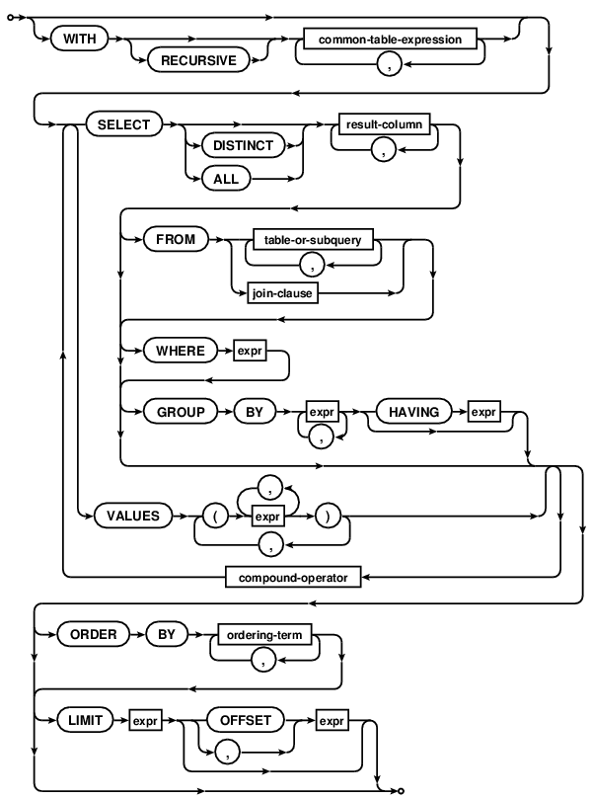
图20 查找记录的SQL语句规范

例：

解析：
The SELECT statement is used to query the database. The result of a SELECT is zero or more rows of data where each row has a fixed number of columns. A SELECT statement does not make any changes to the database.

The "select-stmt" syntax diagram above attempts to show as much of the SELECT statement syntax as possible in a single diagram, because some readers find that helpful. The following "factored-select-stmt" is an alternative syntax diagrams that expresses the same syntax but tries to break the syntax down into smaller chunks.

factored-select-stmt: show

Note that there are paths through the syntax diagrams that are not allowed in practice. Some examples:

A VALUES clause can be the first element in a compound SELECT that uses a WITH clause, but a simple SELECT that consists of just a VALUES clause cannot be preceded by a WITH clause.
The WITH clause must occur on the first SELECT of a compound SELECT. It cannot follow a compound-operator.
These and other similar syntax restrictions are described in the text.
The SELECT statement is the most complicated command in the SQL language. To make the description easier to follow, some of the passages below describe the way the data returned by a SELECT statement is determined as a series of steps. It is important to keep in mind that this is purely illustrative - in practice neither SQLite nor any other SQL engine is required to follow this or any other specific process.

Simple Select Processing
The core of a SELECT statement is a "simple SELECT" shown by the select-core and simple-select-stmt syntax diagrams below. In practice, most SELECT statements are simple SELECT statements.

simple-select-stmt:
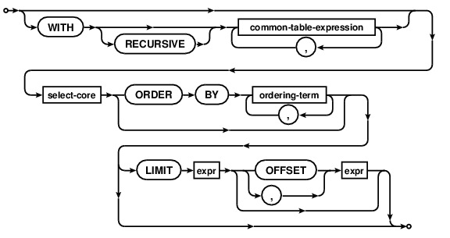

select-core:
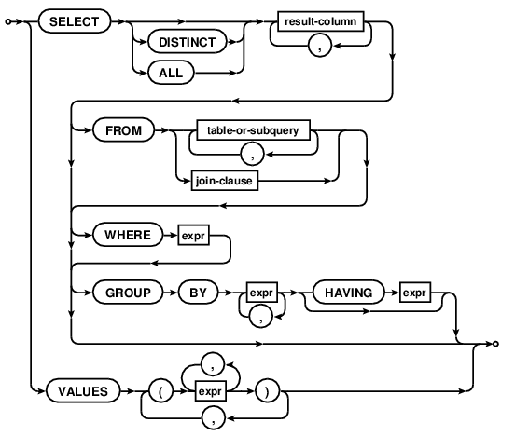

Generating the results of a simple SELECT statement is presented as a four step process in the description below:

FROM clause processing: The input data for the simple SELECT is determined. The input data is either implicitly a single row with 0 columns (if there is no FROM clause) or is determined by the FROM clause.

WHERE clause processing: The input data is filtered using the WHERE clause expression.

GROUP BY, HAVING and result-column expression processing: The set of result rows is computed by aggregating the data according to any GROUP BY clause and calculating the result-set expressions for the rows of the filtered input dataset.

DISTINCT/ALL keyword processing: If the query is a "SELECT DISTINCT" query, duplicate rows are removed from the set of result rows.

There are two types of simple SELECT statement - aggregate and non-aggregate queries. A simple SELECT statement is an aggregate query if it contains either a GROUP BY clause or one or more aggregate functions in the result-set. Otherwise, if a simple SELECT contains no aggregate functions or a GROUP BY clause, it is a non-aggregate query.

1. Determination of input data (FROM clause processing).

The input data used by a simple SELECT query is a set of N rows each M columns wide.

If the FROM clause is omitted from a simple SELECT statement, then the input data is implicitly a single row zero columns wide (i.e. N=1 and M=0).

If a FROM clause is specified, the data on which a simple SELECT query operates comes from the one or more tables or subqueries (SELECT statements in parenthesis) specified following the FROM keyword. A subquery specified in the table-or-subquery following the FROM clause in a simple SELECT statement is handled as if it was a table containing the data returned by executing the subquery statement. Each column of the subquery has the collation sequence and affinity of the corresponding expression in the subquery statement.

If there is only a single table or subquery in the FROM clause, then the input data used by the SELECT statement is the contents of the named table. If there is more than one table or subquery in FROM clause then the contents of all tables and/or subqueries are joined into a single dataset for the simple SELECT statement to operate on. Exactly how the data is combined depends on the specific join-operator and join-constraint used to connect the tables or subqueries together.

All joins in SQLite are based on the cartesian product of the left and right-hand datasets. The columns of the cartesian product dataset are, in order, all the columns of the left-hand dataset followed by all the columns of the right-hand dataset. There is a row in the cartesian product dataset formed by combining each unique combination of a row from the left-hand and right-hand datasets. In other words, if the left-hand dataset consists of Nleft rows of Mleft columns, and the right-hand dataset of Nright rows of Mright columns, then the cartesian product is a dataset of Nleft×Nright rows, each containing Mleft+Mright columns.

If the join-operator is "CROSS JOIN", "INNER JOIN", "JOIN" or a comma (",") and there is no ON or USING clause, then the result of the join is simply the cartesian product of the left and right-hand datasets. If join-operator does have ON or USING clauses, those are handled according to the following bullet points:

If there is an ON clause then the ON expression is evaluated for each row of the cartesian product as a boolean expression. Only rows for which the expression evaluates to true are included from the dataset.

If there is a USING clause then each of the column names specified must exist in the datasets to both the left and right of the join-operator. For each pair of named columns, the expression "lhs.X = rhs.X" is evaluated for each row of the cartesian product as a boolean expression. Only rows for which all such expressions evaluates to true are included from the result set. When comparing values as a result of a USING clause, the normal rules for handling affinities, collation sequences and NULL values in comparisons apply. The column from the dataset on the left-hand side of the join-operator is considered to be on the left-hand side of the comparison operator (=) for the purposes of collation sequence and affinity precedence.

For each pair of columns identified by a USING clause, the column from the right-hand dataset is omitted from the joined dataset. This is the only difference between a USING clause and its equivalent ON constraint.

If the NATURAL keyword is in the join-operator then an implicit USING clause is added to the join-constraints. The implicit USING clause contains each of the column names that appear in both the left and right-hand input datasets. If the left and right-hand input datasets feature no common column names, then the NATURAL keyword has no effect on the results of the join. A USING or ON clause may not be added to a join that specifies the NATURAL keyword.

If the join-operator is a "LEFT JOIN" or "LEFT OUTER JOIN", then after the ON or USING filtering clauses have been applied, an extra row is added to the output for each row in the original left-hand input dataset that corresponds to no rows at all in the composite dataset (if any). The added rows contain NULL values in the columns that would normally contain values copied from the right-hand input dataset.

When more than two tables are joined together as part of a FROM clause, the join operations are processed in order from left to right. In other words, the FROM clause (A join-op-1 B join-op-2 C) is computed as ((A join-op-1 B) join-op-2 C).

Side note: Special handling of CROSS JOIN. There is no difference between the "INNER JOIN", "JOIN" and "," join operators. They are completely interchangeable in SQLite. The "CROSS JOIN" join operator produces the same result as the "INNER JOIN", "JOIN" and "," operators, but is handled differently by the query optimizer in that it prevents the query optimizer from reordering the tables in the join. An application programmer can use the CROSS JOIN operator to directly influence the algorithm that is chosen to implement the SELECT statement. Avoid using CROSS JOIN except in specific situations where manual control of the query optimizer is desired. Avoid using CROSS JOIN early in the development of an application as doing so is a premature optimization. The special handling of CROSS JOIN is an SQLite-specific feature and is not a part of standard SQL.

2. WHERE clause filtering.

If a WHERE clause is specified, the WHERE expression is evaluated for each row in the input data as a boolean expression. Only rows for which the WHERE clause expression evaluates to true are included from the dataset before continuing. Rows are excluded from the result if the WHERE clause evaluates to either false or NULL.

For a JOIN or INNER JOIN or CROSS JOIN, there is no difference between a constraint expression in the WHERE clause and one in the ON clause. However, for a LEFT JOIN or LEFT OUTER JOIN, the difference is very important. In a LEFT JOIN, the extra NULL row for the right-hand table is added after ON clause processing but before WHERE clause processing. A constraint of the form "left.x=right.y" in an ON clause will therefore allow through the added all-NULL rows of the right table. But if that same constraint is in the WHERE clause a NULL in "right.y" will prevent the expression "left.x=right.y" from being true, and thus exclude that row from the output.

3. Generation of the set of result rows.

Once the input data from the FROM clause has been filtered by the WHERE clause expression (if any), the set of result rows for the simple SELECT are calculated. Exactly how this is done depends on whether the simple SELECT is an aggregate or non-aggregate query, and whether or not a GROUP BY clause was specified.

The list of expressions between the SELECT and FROM keywords is known as the result expression list. If a result expression is the special expression "*" then all columns in the input data are substituted for that one expression. If the expression is the alias of a table or subquery in the FROM clause followed by ".*" then all columns from the named table or subquery are substituted for the single expression. It is an error to use a "*" or "alias.*" expression in any context other than a result expression list. It is also an error to use a "*" or "alias.*" expression in a simple SELECT query that does not have a FROM clause.

The number of columns in the rows returned by a simple SELECT statement is equal to the number of expressions in the result expression list after substitution of * and alias.* expressions. Each result row is calculated by evaluating the expressions in the result expression list with respect to a single row of input data or, for aggregate queries, with respect to a group of rows.

If the SELECT statement is a non-aggregate query, then each expression in the result expression list is evaluated for each row in the dataset filtered by the WHERE clause.

If the SELECT statement is an aggregate query without a GROUP BY clause, then each aggregate expression in the result-set is evaluated once across the entire dataset. Each non-aggregate expression in the result-set is evaluated once for an arbitrarily selected row of the dataset. The same arbitrarily selected row is used for each non-aggregate expression. Or, if the dataset contains zero rows, then each non-aggregate expression is evaluated against a row consisting entirely of NULL values.

The single row of result-set data created by evaluating the aggregate and non-aggregate expressions in the result-set forms the result of an aggregate query without a GROUP BY clause. An aggregate query without a GROUP BY clause always returns exactly one row of data, even if there are zero rows of input data.

If the SELECT statement is an aggregate query with a GROUP BY clause, then each of the expressions specified as part of the GROUP BY clause is evaluated for each row of the dataset. Each row is then assigned to a "group" based on the results; rows for which the results of evaluating the GROUP BY expressions are the same get assigned to the same group. For the purposes of grouping rows, NULL values are considered equal. The usual rules for selecting a collation sequence with which to compare text values apply when evaluating expressions in a GROUP BY clause. The expressions in the GROUP BY clause do not have to be expressions that appear in the result. The expressions in a GROUP BY clause may not be aggregate expressions.

If a HAVING clause is specified, it is evaluated once for each group of rows as a boolean expression. If the result of evaluating the HAVING clause is false, the group is discarded. If the HAVING clause is an aggregate expression, it is evaluated across all rows in the group. If a HAVING clause is a non-aggregate expression, it is evaluated with respect to an arbitrarily selected row from the group. The HAVING expression may refer to values, even aggregate functions, that are not in the result.

Each expression in the result-set is then evaluated once for each group of rows. If the expression is an aggregate expression, it is evaluated across all rows in the group. Otherwise, it is evaluated against a single arbitrarily chosen row from within the group. If there is more than one non-aggregate expression in the result-set, then all such expressions are evaluated for the same row.

Each group of input dataset rows contributes a single row to the set of result rows. Subject to filtering associated with the DISTINCT keyword, the number of rows returned by an aggregate query with a GROUP BY clause is the same as the number of groups of rows produced by applying the GROUP BY and HAVING clauses to the filtered input dataset.

Side note: Bare columns in an aggregate queries. The usual case is that all column names in an aggregate query are either arguments to aggregate functions or else appear in the GROUP BY clause. A result column which contains a column name that is not within an aggregate function and that does not appear in the GROUP BY clause (if one exists) is called a "bare" column. Example:

SELECT a, b, sum(c) FROM tab1 GROUP BY a;
In the query above, the "a" column is part of the GROUP BY clause and so each row of the output contains one of the distinct values for "a". The "c" column is contained within the sum() aggregate function and so that output column is the sum of all "c" values in rows that have the same value for "a". But what is the result of the bare column "b"? The answer is that the "b" result will be the value for "b" in one of the input rows that form the aggregate. The problem is that you usually do not know which input row is used to compute "b", and so in many cases the value for "b" is undefined.

Special processing occurs occurs when the aggregate function is either min() or max(). Example:

SELECT a, b, max(c) FROM tab1 GROUP BY a;
When the min() or max() aggregate functions are used in an aggregate query, all bare columns in the result set take values from the input row which also contains the minimum or maximum. So in the query above, the value of the "b" column in the output will be the value of the "b" column in the input row that has the largest "c" value. There is still an ambiguity if two or more of the input rows have the same minimum or maximum value or if the query contains more than one min() and/or max() aggregate function. Only the built-in min() and max() functions work this way.
4. Removal of duplicate rows (DISTINCT processing).

One of the ALL or DISTINCT keywords may follow the SELECT keyword in a simple SELECT statement. If the simple SELECT is a SELECT ALL, then the entire set of result rows are returned by the SELECT. If neither ALL or DISTINCT are present, then the behavior is as if ALL were specified. If the simple SELECT is a SELECT DISTINCT, then duplicate rows are removed from the set of result rows before it is returned. For the purposes of detecting duplicate rows, two NULL values are considered to be equal. The usual rules apply for selecting a collation sequence to compare text values.

Compound Select Statements
Two or more simple SELECT statements may be connected together to form a compound SELECT using the UNION, UNION ALL, INTERSECT or EXCEPT operator, as shown by the following diagram:
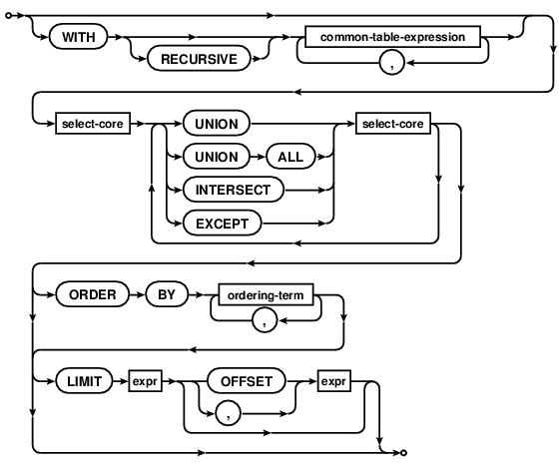
In a compound SELECT, all the constituent SELECTs must return the same number of result columns. As the components of a compound SELECT must be simple SELECT statements, they may not contain ORDER BY or LIMIT clauses. ORDER BY and LIMIT clauses may only occur at the end of the entire compound SELECT, and then only if the final element of the compound is not a VALUES clause.

A compound SELECT created using UNION ALL operator returns all the rows from the SELECT to the left of the UNION ALL operator, and all the rows from the SELECT to the right of it. The UNION operator works the same way as UNION ALL, except that duplicate rows are removed from the final result set. The INTERSECT operator returns the intersection of the results of the left and right SELECTs. The EXCEPT operator returns the subset of rows returned by the left SELECT that are not also returned by the right-hand SELECT. Duplicate rows are removed from the results of INTERSECT and EXCEPT operators before the result set is returned.

For the purposes of determining duplicate rows for the results of compound SELECT operators, NULL values are considered equal to other NULL values and distinct from all non-NULL values. The collation sequence used to compare two text values is determined as if the columns of the left and right-hand SELECT statements were the left and right-hand operands of the equals (=) operator, except that greater precedence is not assigned to a collation sequence specified with the postfix COLLATE operator. No affinity transformations are applied to any values when comparing rows as part of a compound SELECT.

When three or more simple SELECTs are connected into a compound SELECT, they group from left to right. In other words, if "A", "B" and "C" are all simple SELECT statements, (A op B op C) is processed as ((A op B) op C).

The ORDER BY clause
If a SELECT statement that returns more than one row does not have an ORDER BY clause, the order in which the rows are returned is undefined. Or, if a SELECT statement does have an ORDER BY clause, then the list of expressions attached to the ORDER BY determine the order in which rows are returned to the user.

In a compound SELECT statement, only the last or right-most simple SELECT may have an ORDER BY clause. That ORDER BY clause will apply across all elements of the compound. If the right-most element of a compound SELECT is a VALUES clause, then no ORDER BY clause is allowed on that statement.

Rows are first sorted based on the results of evaluating the left-most expression in the ORDER BY list, then ties are broken by evaluating the second left-most expression and so on. The order in which two rows for which all ORDER BY expressions evaluate to equal values are returned is undefined. Each ORDER BY expression may be optionally followed by one of the keywords ASC (smaller values are returned first) or DESC (larger values are returned first). If neither ASC or DESC are specified, rows are sorted in ascending (smaller values first) order by default.

Each ORDER BY expression is processed as follows:

If the ORDER BY expression is a constant integer K then the expression is considered an alias for the K-th column of the result set (columns are numbered from left to right starting with 1).

If the ORDER BY expression is an identifier that corresponds to the alias of one of the output columns, then the expression is considered an alias for that column.

Otherwise, if the ORDER BY expression is any other expression, it is evaluated and the returned value used to order the output rows. If the SELECT statement is a simple SELECT, then an ORDER BY may contain any arbitrary expressions. However, if the SELECT is a compound SELECT, then ORDER BY expressions that are not aliases to output columns must be exactly the same as an expression used as an output column.

For the purposes of sorting rows, values are compared in the same way as for comparison expressions. The collation sequence used to compare two text values is determined as follows:

If the ORDER BY expression is assigned a collation sequence using the postfix COLLATE operator, then the specified collation sequence is used.

Otherwise, if the ORDER BY expression is an alias to an expression that has been assigned a collation sequence using the postfix COLLATE operator, then the collation sequence assigned to the aliased expression is used.

Otherwise, if the ORDER BY expression is a column or an alias of an expression that is a column, then the default collation sequence for the column is used.

Otherwise, the BINARY collation sequence is used.

In a compound SELECT statement, all ORDER BY expressions are handled as aliases for one of the result columns of the compound. If an ORDER BY expression is not an integer alias, then SQLite searches the left-most SELECT in the compound for a result column that matches either the second or third rules above. If a match is found, the search stops and the expression is handled as an alias for the result column that it has been matched against. Otherwise, the next SELECT to the right is tried, and so on. If no matching expression can be found in the result columns of any constituent SELECT, it is an error. Each term of the ORDER BY clause is processed separately and may be matched against result columns from different SELECT statements in the compound.

The LIMIT clause
The LIMIT clause is used to place an upper bound on the number of rows returned by the entire SELECT statement.

In a compound SELECT, only the last or right-most simple SELECT may contain a LIMIT clause. In a compound SELECT, the LIMIT clause applies to the entire compound, not just the final SELECT. If the right-most simple SELECT is a VALUES clause then no LIMIT clause is allowed.

Any scalar expression may be used in the LIMIT clause, so long as it evaluates to an integer or a value that can be losslessly converted to an integer. If the expression evaluates to a NULL value or any other value that cannot be losslessly converted to an integer, an error is returned. If the LIMIT expression evaluates to a negative value, then there is no upper bound on the number of rows returned. Otherwise, the SELECT returns the first N rows of its result set only, where N is the value that the LIMIT expression evaluates to. Or, if the SELECT statement would return less than N rows without a LIMIT clause, then the entire result set is returned.

The expression attached to the optional OFFSET clause that may follow a LIMIT clause must also evaluate to an integer, or a value that can be losslessly converted to an integer. If an expression has an OFFSET clause, then the first M rows are omitted from the result set returned by the SELECT statement and the next N rows are returned, where M and N are the values that the OFFSET and LIMIT clauses evaluate to, respectively. Or, if the SELECT would return less than M+N rows if it did not have a LIMIT clause, then the first M rows are skipped and the remaining rows (if any) are returned. If the OFFSET clause evaluates to a negative value, the results are the same as if it had evaluated to zero.

Instead of a separate OFFSET clause, the LIMIT clause may specify two scalar expressions separated by a comma. In this case, the first expression is used as the OFFSET expression and the second as the LIMIT expression. This is counter-intuitive, as when using the OFFSET clause the second of the two expressions is the OFFSET and the first the LIMIT. This reversal of the offset and limit is intentional - it maximizes compatibility with other SQL database systems. However, to avoid confusion, programmers are strongly encouraged to use the form of the LIMIT clause that uses the "OFFSET" keyword and avoid using a LIMIT clause with a comma-separated offset.

The VALUES clause
The phrase "VALUES(expr-list)" means the same thing as "SELECT expr-list". The phrase "VALUES(expr-list-1),...,(expr-list-N)" means the same thing as "SELECT expr-list-1 UNION ALL ... UNION ALL SELECT expr-list-N". Both forms are the same, except that the number of SELECT statements in a compound is limited by SQLITE_LIMIT_COMPOUND_SELECT whereas the number of rows in a VALUES clause has no arbitrary limit.

There are some restrictions on the use of a VALUES clause that are not shown on the syntax diagrams:

A VALUES clause cannot be followed by ORDER BY.

A VALUES clause cannot be followed by LIMIT.

The WITH Clause
SELECT statements may be optionally preceded by a single WITH clause that defines one or more common table expressions for use within the SELECT statement.

Table-valued Functions In The FROM Clause
A virtual table that contains hidden columns can be used like a table-valued function in the FROM clause. The arguments to the table-valued function become constraints on the HIDDEN columns of the virtual table. Additional information can be found in the virtual table documentation.

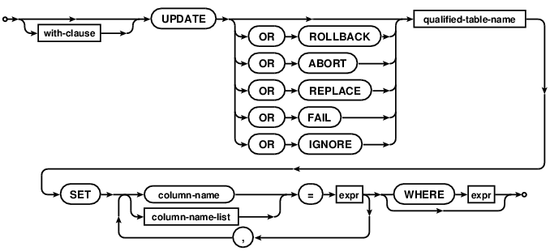
图21 更新表格内容的SQL语句规范

例：

解析：
An UPDATE statement is used to modify a subset of the values stored in zero or more rows of the database table identified by the qualified-table-name specified as part of the UPDATE statement.

If the UPDATE statement does not have a WHERE clause, all rows in the table are modified by the UPDATE. Otherwise, the UPDATE affects only those rows for which the WHERE clause boolean expression is true. It is not an error if the WHERE clause does not evaluate to true for any row in the table - this just means that the UPDATE statement affects zero rows.

The modifications made to each row affected by an UPDATE statement are determined by the list of assignments following the SET keyword. Each assignment specifies a column-name to the left of the equals sign and a scalar expression to the right. For each affected row, the named columns are set to the values found by evaluating the corresponding scalar expressions. If a single column-name appears more than once in the list of assignment expressions, all but the rightmost occurrence is ignored. Columns that do not appear in the list of assignments are left unmodified. The scalar expressions may refer to columns of the row being updated. In this case all scalar expressions are evaluated before any assignments are made.

Beginning in SQLite version 3.15.0 (2016-10-14), an assignment in the SET clause can be a parenthesized list of column names on the left and a row value of the same size on the right.

The optional "OR action" conflict clause that follows the UPDATE keyword allows the user to nominate a specific constraint conflict resolution algorithm to use during this one UPDATE command. Refer to the section entitled ON CONFLICT for additional information.

Restrictions on UPDATE Statements Within CREATE TRIGGER
The following additional syntax restrictions apply to UPDATE statements that occur within the body of a CREATE TRIGGER statement.

The table-name specified as part of an UPDATE statement within a trigger body must be unqualified. In other words, the schema-name. prefix on the table name of the UPDATE is not allowed within triggers. Unless the table to which the trigger is attached is in the TEMP database, the table being updated by the trigger program must reside in the same database as it. If the table to which the trigger is attached is in the TEMP database, then the unqualified name of the table being updated is resolved in the same way as it is for a top-level statement (by searching first the TEMP database, then the main database, then any other databases in the order they were attached).

The INDEXED BY and NOT INDEXED clauses are not allowed on UPDATE statements within triggers.

The LIMIT and ORDER BY clauses for UPDATE are unsupported within triggers, regardless of the compilation options used to build SQLite.

Optional LIMIT and ORDER BY Clauses
If SQLite is built with the SQLITE_ENABLE_UPDATE_DELETE_LIMIT compile-time option then the syntax of the UPDATE statement is extended with optional ORDER BY and LIMIT clauses as follows:
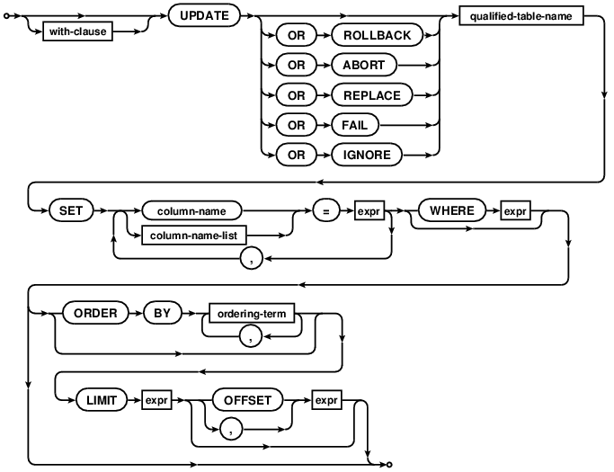

If an UPDATE statement has a LIMIT clause, the maximum number of rows that will be updated is found by evaluating the accompanying expression and casting it to an integer value. A negative value is interpreted as "no limit".

If the LIMIT expression evaluates to non-negative value N and the UPDATE statement has an ORDER BY clause, then all rows that would be updated in the absence of the LIMIT clause are sorted according to the ORDER BY and the first N updated. If the UPDATE statement also has an OFFSET clause, then it is similarly evaluated and cast to an integer value. If the OFFSET expression evaluates to a non-negative value M, then the first M rows are skipped and the following N rows updated instead.

If the UPDATE statement has no ORDER BY clause, then all rows that would be updated in the absence of the LIMIT clause are assembled in an arbitrary order before applying the LIMIT and OFFSET clauses to determine which are actually updated.

The ORDER BY clause on an UPDATE statement is used only to determine which rows fall within the LIMIT. The order in which rows are modified is arbitrary and is not influenced by the ORDER BY clause.

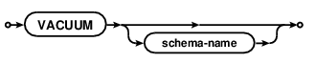
图22 瘦身数据库的SQL语句规范

例：

解析：
The VACUUM command rebuilds the database file, repacking it into a minimal amount of disk space. There are several reasons an application might do this:

Unless SQLite is running in "auto_vacuum=FULL" mode, when a large amount of data is deleted from the database file it leaves behind empty space, or "free" database pages. This means the database file might be larger than strictly necessary. Running VACUUM to rebuild the database reclaims this space and reduces the size of the database file.

Frequent inserts, updates, and deletes can cause the database file to become fragmented - where data for a single table or index is scattered around the database file. Running VACUUM ensures that each table and index is largely stored contiguously within the database file. In some cases, VACUUM may also reduce the number of partially filled pages in the database, reducing the size of the database file further.

Normally, the database page_size and whether or not the database supports auto_vacuum must be configured before the database file is actually created. However, when not in write-ahead log mode, the page_size and/or auto_vacuum properties of an existing database may be changed by using the page_size and/or pragma auto_vacuum pragmas and then immediately VACUUMing the database. When in write-ahead log mode, only the auto_vacuum support property can be changed using VACUUM.

By default, VACUUM only works only on the main database. Attached databases can be vacuumed by appending the appropriate schema-name to the VACUUM statement.

Compatibility Warning: The ability to vacuum attached databases was added in version 3.15.0 (2016-10-14). Prior to that, a schema-name added to the VACUUM statement would be silently ignored and the "main" schema would be vacuumed.

The VACUUM command works by copying the contents of the database into a temporary database file and then overwriting the original with the contents of the temporary file. When overwriting the original, a rollback journal or write-ahead log WAL file is used just as it would be for any other database transaction. This means that when VACUUMing a database, as much as twice the size of the original database file is required in free disk space.

The VACUUM command may change the ROWIDs of entries in any tables that do not have an explicit INTEGER PRIMARY KEY.

A VACUUM will fail if there is an open transaction, or if there are one or more active SQL statements when it is run.

An alternative to using the VACUUM command to reclaim space after data has been deleted is auto-vacuum mode, enabled using the auto_vacuum pragma. When auto_vacuum is enabled for a database free pages may be reclaimed after deleting data, causing the file to shrink, without rebuilding the entire database using VACUUM. However, using auto_vacuum can lead to extra database file fragmentation. And auto_vacuum does not compact partially filled pages of the database as VACUUM does.

