Copyright (c) 2012-2016 Isaac Morales Durán. All rights reserved.
Institute of Astrophysics of Andalusia, IAA-CSIC

This file is part of FMPT (Fiber MOS Positioning Tools)

FMPT is free software: you can redistribute it and/or modify
it under the terms of the GNU General Public License as published by
the Free Software Foundation, either version 3 of the License, or
(at your option) any later version.

This program is distributed in the hope that it will be useful,
but WITHOUT ANY WARRANTY; without even the implied warranty of
MERCHANTABILITY or FITNESS FOR A PARTICULAR PURPOSE. See the
GNU General Public License for more details.

You should have received a copy of the GNU General Public License
along with this program. If not, see <http://www.gnu.org/licenses/>.
Acronyms:

CP Configuration Plan
CB Configuration Block
MCS MEGARA Control System

FMAT Fiber MOS Assignment Tool
FMOSA Fiber MOS Assignment file
FMOSAT FMOSA Table

FMPT Fiber MOS Positioning Tool
SAA Stand Alone Application
MP Motion Program
PP Positioning Program
DP Depositioning Program

RP Robotic Positioner
EA Exclusion Area
FMM Fiber MOS Model
MPG Motion Program Generator
PPA Pair of Positions Angles
SP Sky Point
INDEX
FMPT ARCHITECTURE 4
1. GETTING the FMPT source code 4
2. INTERFACES 4
3. Status diagram 5
4. Estatus of a RP 6
5. Files 7
6. SRC Módules 8
7. Flux diagram 10
7.1 Function int main(argc, argv) 10
7.2 generatePairPPDP_offline( 12
7.3 generatePairPPDP(PPvalid, DPvalid, Collided, Obstructed, PP, DP, 15
7.4 generateDepositioningProgram(DPvalid, Collided, Obstructed, DP, 17
7.5 generateRecoveryProgram(Collided, Obstructed, RecoveryProgram, 19

FMPT ARCHITECTURE

GETTING the FMPT source code
All source files of the FMPT are included in the file Megara-fmpt-3.3.0.tar.gz (or .xz). This file contains a directory containing the release ‘megara-fmpt-3.3.0’. The release has been developed using an hg-mercurial repository which also can be cloned from the following URL:
http://guaix.fis.ucm.es/hg/megarafmpt
For clone the repository execute:
$ hg clone https://guaix.fis.ucm.es/hg/megarafmpt
Then you can execute $ autogen.sh for generate aclocal files or $ autoclear.sh for remove if it is necessary. For can make $ hg commit, you need add the username in the file ‘megarafmpt/.hg/hgrc’; eg:
[ui]
username = Isaac Morales Durán isaac@iaa.es

INTERFACES

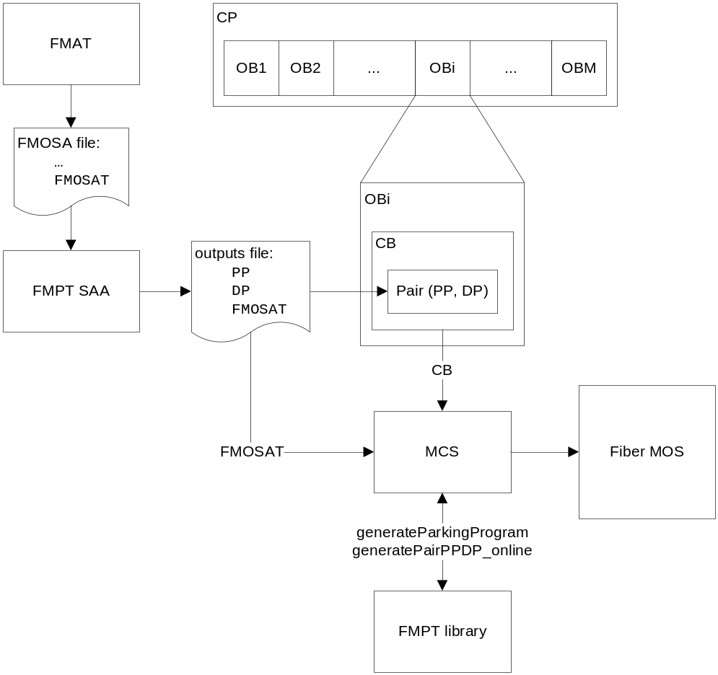
Figure 1: interfaces in the use of the FMPT.

Status diagram

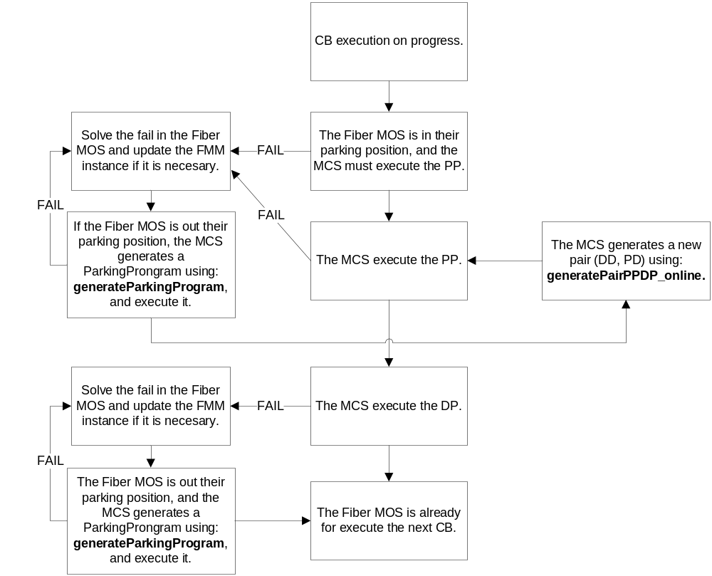

Figure 2: status in the use of the FMPT.

Estatus of a RP
RP STATE |  | DESCRIPTION
Parked |  | (p_1, p___3) = (0, 0)
Security Position |  | When either p_1>0 or p___3>0, and minimum distance between the RP and any adjacent RP, can’t be less than the sum of the SMPs of both.
Insecurity Position | Not collided and not obstructed | When there isn’t any adjacent RP whose arm is to a distance less than the sum of the SPMs of both RPs, and there aren’t obstacles that prevent the retraction of the arm.
Insecurity Position | Not collided and obstructed | When there isn’t any adjacent RP whose arm is to a distance less than the sum of the SPMs of both RPs, and there is some obstacle that prevents retraction of the arm.
Insecurity Position | Collided and  not obstructed | When there is some adjacent RP whose arm is to a distance less than the sum of the SPMs of both RPs, and there isn’t others obstacles that prevent the retraction of the arm.
Insecurity Position | Collided and obstructed | It is considered simply collided.
Figure 3: status of a RP.
Note that SPM values can be referred to either the RPs are set for generate a pair (PP, DP) or RPs are set for generate a parking program.

Files
The last version FMPT Stand Alone Application is provided in a single file called:
‘megara-fmpt-3.3.0.tar.gz’ (or ‘.xz’)
In any case, it will contain the following files:
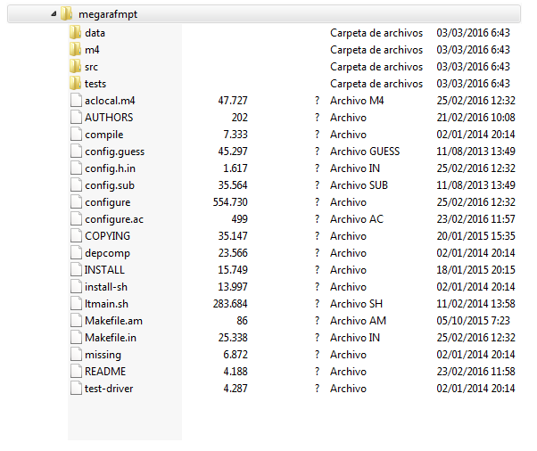
Figure 4: files of the FMPT.

The source code is located in the following folders:
- ‘megara-fmpt-3.3.0/data’: containing a subfolder with the Fiber MOS Model instance, and and other folder containing some FMOSA files how examples.
- ‘megara-fmpt-3.3.0/src’: containing the source files ‘.cpp’ and ‘.h’.
- ‘megara-fmpt-3.3.0/test: containing the source test files ‘.cpp’ and ‘.h’

SRC Módules
For more legibility, the source files can be grouped into subsets:

General functions
Math:  vclemu  Exceptions  Vectors  Constants  Scalars  Geometry | Strings:  Strings  StrPR  StrSymbolic  TextFile | Lists:  SlideArray  PointersSlideArray  ItemsList  PointersList  Vector | Operators:  Quantificator  Function  ComposedMotionFunction  RampFunction  SquareFunction  MotionFunction
Figure 5: general functions of the FMPT.

Models |  | Generator
Fiber MOS Model:  Instruction  RoboticPositionerList1  RoboticPositionerList2  RoboticPositionerList3  ExclusionAreaList  FiberConnectionModel  FiberMOSModel  FileMethods | Telescope Projection Model:  SkyPoint  ProjectionPoint  FMOSATable  PositionerCenter  Tile  TelescopeProjectionModel | Motion Program Generator:  MessageInstruction  MotionProgram  Allocation  AllocationList  MotionProgramValidator  MotionProgramGenerator  Outputs
Figure 6: specific functions of the FMPT.

A FMM is accurate representation of the real Fiber MOS which allow represent the RPs in any possible status, including some setting status of the controller, and possible anomalous status of the RP, for simulate the motion of the RPs and determine the risk of collision between their arms and any possible obstacles. A FMM is used by a MPG for generate MPs which avoid the risk of collision. The files describing the FMM and the MPG has been named with the same name of the main class that each describe, although some files can contains more things or only functions. They are briefly described below:
Instruction: an instruction serve for configure the motion function of a RP of the FMM.
RoboticPositionerList1/2/3: a RP list represent the RPs of the FMM.
ExclusionAreaList: an EA list represents the EAs of the FMM. This is the occupied space by the IFU placed in the center of the Fiber MOS.
FiberConnectionModel: a fiber connection model can be used for determine the Id of each fiber connected to each RP, and their position in the focal plan and the pseudo-slot. This is a characteristic not used in the FMPT, but it was useful during MEGARA project developing.
FiberMOSModel: a FMM is composed by a RP list and an EA list, and it is used by a MPG for generate MPs without risk of collisions.
FileMethods: contains functions for facilitate the loading and saving of the Fiber MOS Model instance.
SkyPoint: a projection point can be calculated from a SP, using the telescope projection model. This is a characteristic not used in the FMPT, but it was useful during MEGARA project developing.
ProjectionPoint: a set of projection points allow represent the points where the fibers must be positioned as close as possible of them.
FMOSATable: a FMOSA table is a structure for facilitate the load and saving of the files type FMOSA. For see a description of file type FMOSA, see either the user manual of the FMPT or the user manual of the FMAT.
PositionerCenter: a positioner center is a structure containing the properties (Id, x0, y0). A positioner center list allows facilitate the loading and saving of tables with the fields (Id, x0, y0). This is useful for process the table provided by the manufacturer of the Fiber MOS.
Tile: a tile is a structure, containing a projection point list whose coordinates are given respect the coordinate system of the focal plane of the telescope. This is a characteristic not used in the FMPT, but it was useful during MEGARA project developing.
TelecopeProjectionModel: a Telescope Projection Model allows get a tile from the whole set of SPs and a given set of Fiber MOS Pointing Parameters. This is a characteristic not used in the FMPT, but it was useful during MEGARA project developing.
MessageInstruction: a message instruction is a structure containing the Id of a RP and an Instruction. A MP is composed by a list of list of message instructions.
MotionProgram: a MP is a structure composed by a list of list of message instructions.
Allocation: an allocation is a structure containing an Id of a RP and a projection point.
AllocationList: an allocation list is part of the MPG, and it is given by the FMOSA file.
MotionProgramValidator: a MPV allows check if a MP produces any collision. For this, the MPG requires a FMM. The FMM shall be configured with the starting positions from with the MP will be executed. Furthermore the FMM shall be configured with the purpose of check the MP, so that the SPM of the RPs is right.
MotionProgramGenerator: a MPG allow generates MPs without risk of collision. The MPG can be used for generates either parking program or a pair (PP, DP).
Outputs: an outputs structure is composed by the data {PP, DP, FMOSAT}, and it facilitates the loading and saving output files.

Flux diagram
The main function is located in the file:
‘megara-fmpt-3.3.0/src/main.cpp’
Let’s see a flux diagram since the main function to the enough degree of depth, for serve as a starting point to understand the rest of code:

Function int main(argc, argv)
The main function is called when the program is executed in a console of the system. The arguments of the main function are the same arguments that are written after the name of the program. The first of these arguments is always a command followed by their arguments.
For see a detailed description of use of the FMPT SAA, consul the user manual (document TEC_MEG_171), wear can be found a description of the commands, their arguments, and the input and output files for each functionality of the application FMPT SAA.

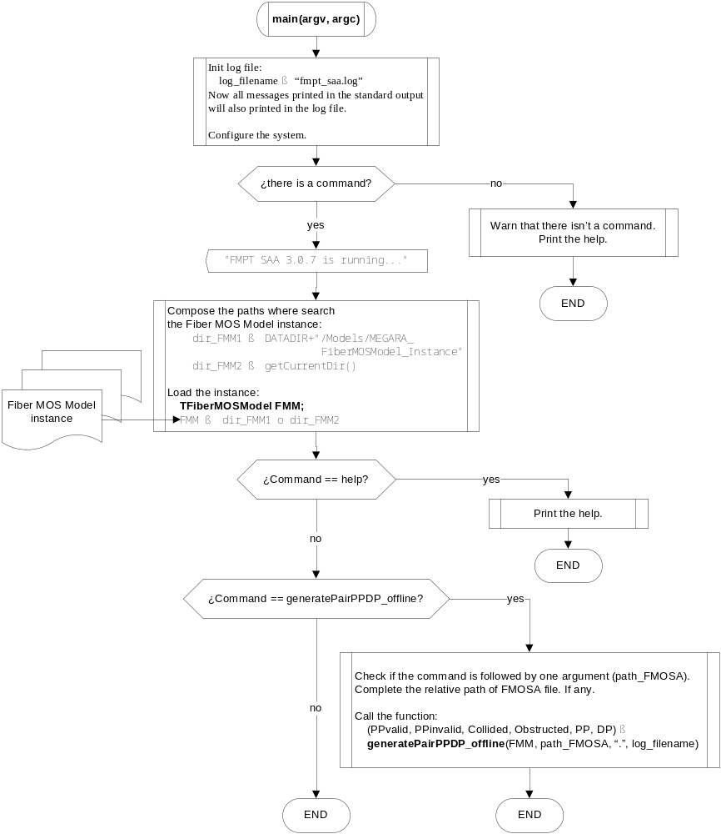
Figure 7: the main flux diagram of the FMPT.

generatePairPPDP_offline(

PPvalid, DPvalid, Collided, Obstructed, PP, DP,

FMM, input_path, output_dir, log_filename)
This is a function of the MPG which serves for generate a pair (PP, DP) from a FMOSA file.
Inputs:
- FMM: the Fiber MOS Model configured with the instance loaded from the directory: ‘/usr/local/share/megara-fmpt/Models/MEGARA_FiberMOSModel_Instance’. The MPG has access to the MPG, since the MPG is built attached to the FMM.
- inputh_path: the path of the FMOSA file, containing the allocations (of RPs to projection points).
- output_dir: the directory where the output files will be saved.
- log_filename: the name of the log file, where will be wrote the same that is wrote in the standard output (it is to say, the console).
Outputs:
- PPvalid: indicates if the generated PP, avoid any collisions.
- DPvalid: indicates if the generated DP, avoid any collisions.
- Collided: list of RPs whose security positions can’t be recovered, because are in collision status.
- Obstructed: list of RPs whose security positions can’t be recovered, because are obstructed in insecurity positions, locked by adjacent obstacles.
- PP: the positioning program to be generated.
- DP: the depositioning program to be generated.

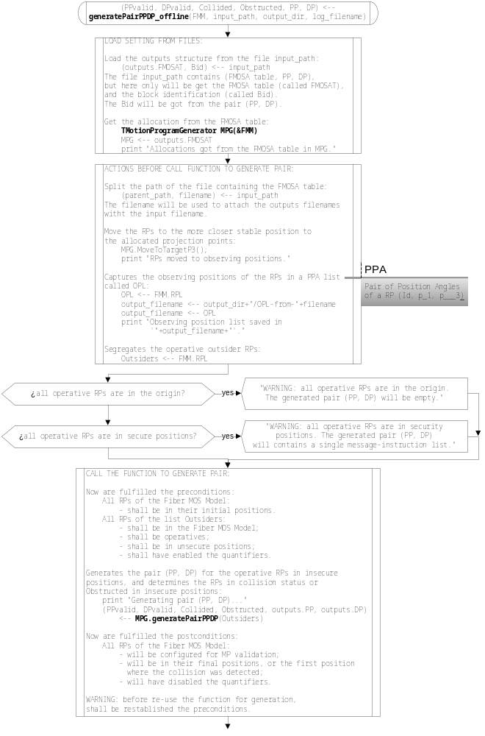
Figure 8: flux diagran of the function generatePairPPDP_offline.Part 1.

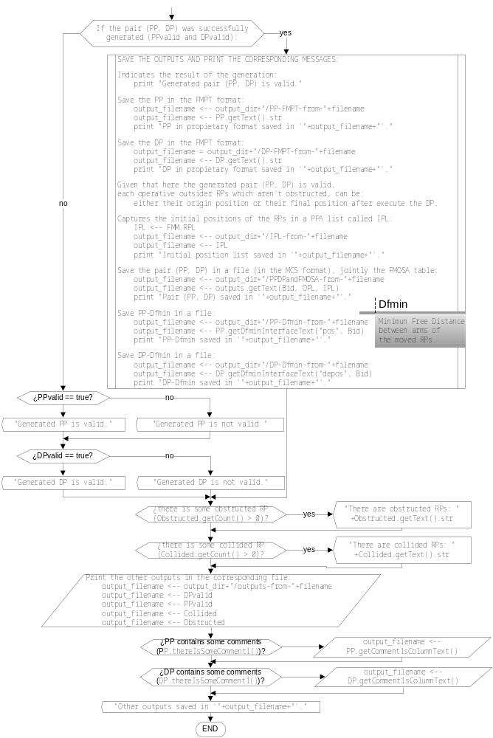
Figure 9: flux diagran of the function generatePairPPDP_offline.Part 2.

generatePairPPDP(PPvalid, DPvalid, Collided, Obstructed, PP, DP,

Outsiders)
This is a function of the MPG which serves for generate a pair (PP, DP) from a FMM with the RPs in their observing points, and the list Outsiders. This functions is used either online or offline. The use of this function requires a series of previous preparations, which can be summarized how load the FMM instance and load the allocations of RPs to projection points. For the use offline has been implemented the function generatePairPPDP_offline, and the use online has been illustrated in the example provided with the FMPT, in the file:
‘Main_example_generatePairPPDP_online.cpp’
Implicit input parameters:
- RP-to-projection-point Allocation list: the MPG must have previously assigned the allocation. These allocations must be got from the FMOSA file passed how argument to the command generatePairPPDP_offline.
- The FMM with the RPs in their observing positions: the MPG has access to the MPG, for that the MPG must be built attached to the FMM.
Explicit input parameters:
- Outsiders: list of RPs whose observing positions are in insecurity positions.
Return parameters:
- PPvalid: indicates if the generated PP, avoid collisions.
- DPvalid: indicates if the generated DP, avoid collisions.
- Collided: list of RPs whose security positions can’t be recovered, because are in collision status.
- Obstructed: list of RPs whose security positions can’t be recovered, because are obstructed in insecurity positions, locked by adjacent obstacles.
- PP: the positioning program to be generated.
- DP: the depositioning program to be generated.

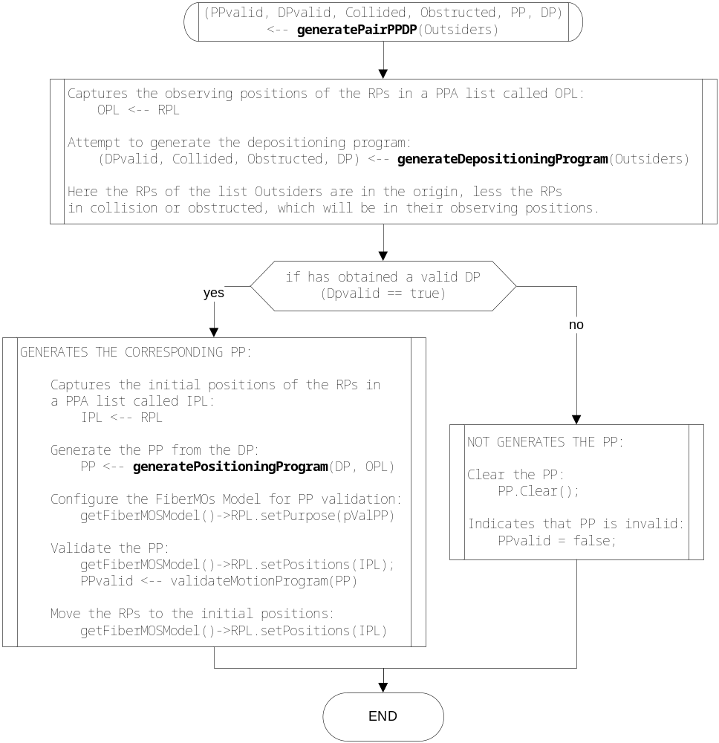
Figure 10: flux diagram of the function generatePairPPDP.

generateDepositioningProgram(DPvalid, Collided, Obstructed, DP,

Outsiders)
This is a function of the MPG which serves for generate a DP.
Implicit input parameters:
- RP-to-projection-point Allocation list: the MPG must have previously assigned the allocation. These allocations must be got from the FMOSA file passed how argument to the command generatePairPPDP_offline.
- The FMM with the RPs in their observing positions: the MPG has access to the MPG, for that the MPG must be built attached to the FMM.
Explicit input parameters:
- Outsiders: list of RPs whose observing positions are in insecurity positions.
Return parameters:
- DPvalid: indicates if the generated DP, avoid collisions.
- Collided: list of RPs whose security positions can’t be recovered, because are in collision status.
- Obstructed: list of RPs whose security positions can’t be recovered, because are obstructed in insecurity positions, locked by adjacent obstacles.
- DP: the depositioning program to be generated.
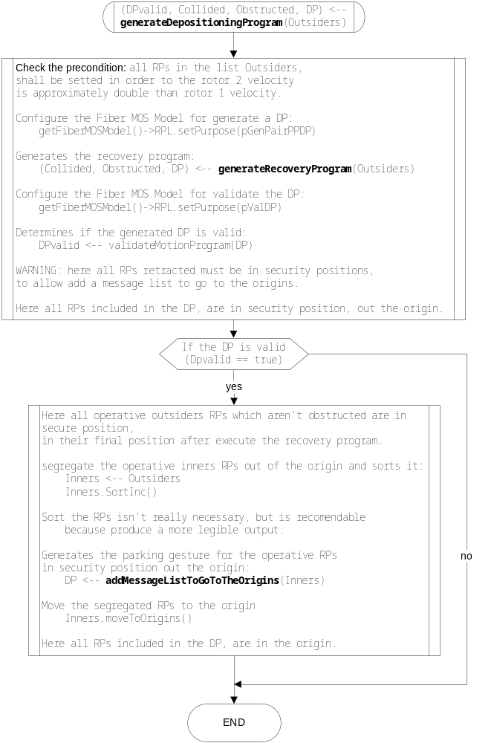
Figure 11: flux diagram of the function generateDepositioningProgram.

generateRecoveryProgram(Collided, Obstructed, RecoveryProgram,

Outsiders)
This is a function of the MPG which serves for generate a recovery program. A recovery program is a depositioning program less the last step to go to the initial position. It is to say, a recovery program is a program to go to the security positions avoiding collisions.
Implicit input parameters:
- RP-to-projection-point Allocation list: the MPG must have previously assigned the allocation. These allocations must be got from the FMOSA file passed how argument to the command generatePairPPDP_offline.
- The FMM with the RPs in their observing positions: the MPG has access to the MPG, for that the MPG must be built attached to the FMM.
Explicit input parameters:
- Outsiders: list of RPs whose observing positions are in insecurity positions.
Return parameters:
- Collided: list of RPs whose security positions can’t be recovered, because are in collision status.
- Obstructed: list of RPs whose security positions can’t be recovered, because are obstructed in insecurity positions, locked by adjacent obstacles.
- RecoveryProgram: the recovery program to be generated.

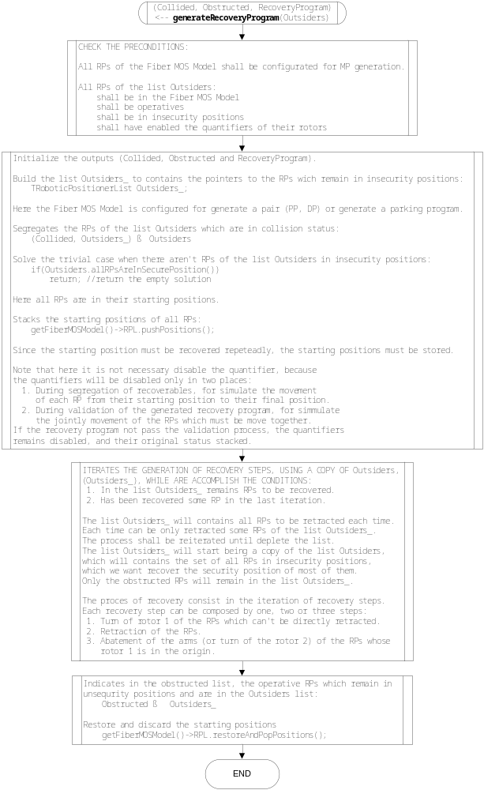
Figure 12: flux diagram of the function generateRecoveryProgram.

