手工编译VTK代码

CMAKE指定编译好的路径。

VTK_DIR D:\git_clone\github\VTK\VTK-8.0.0\Build

VTK_DIR 可以配置成环境变量，或把路径添加系统变量Path里面

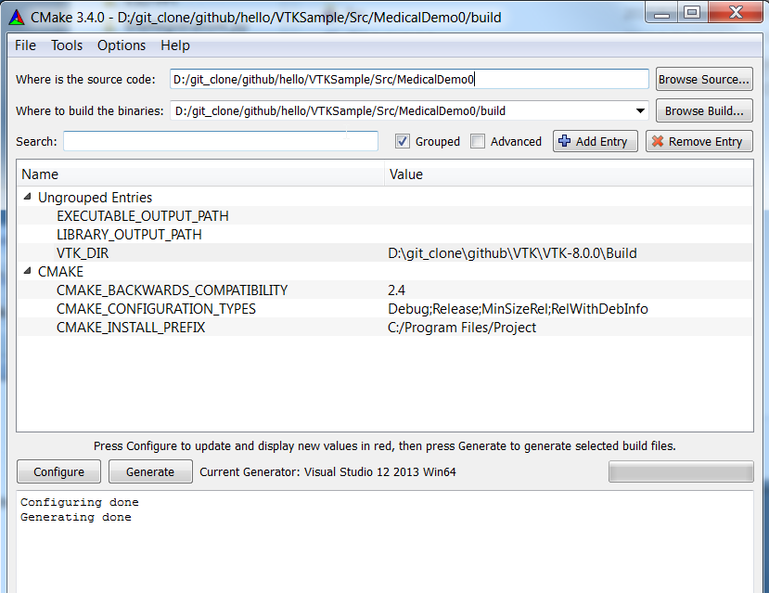

或者

添加头文件和宏定义：

#include <vtkAutoInit.h>

VTK_MODULE_INIT(vtkRenderingOpenGL);

VTK_MODULE_INIT(vtkInteractionStyle);

VTK_MODULE_INIT(vtkRenderingVolumeOpenGL);

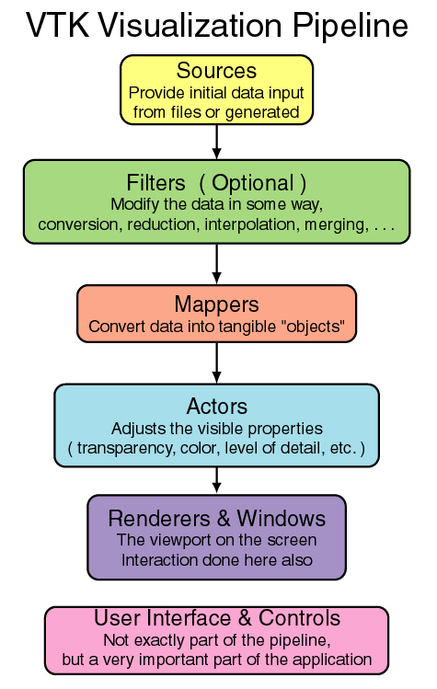  
Volume Rendering

CubicVolume.cxx

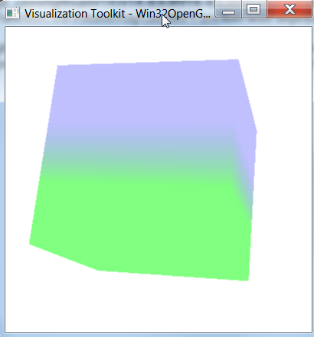

数据

const int width = 4;

const int height = 4;

const int depth = 4;

const int channel = 1;//commonly channel is 1.

unsigned char cImage[width * height * depth * channel];

unsigned char value = 0;

for (unsigned int row = 0; row < height; ++row) {

for (unsigned int col = 0; col < width; ++col) {

for (unsigned int z = 0; z < depth; ++z) {

cImage[row * width * depth + col * depth + z] = 50 + (row * 2 >= width) * 50;

}

}

}

Opacity分段映射函数

// Create transfer mapping scalar value to opacity

vtkPiecewiseFunction *opacityTransferFunction = vtkPiecewiseFunction::New();

opacityTransferFunction->AddPoint(0, 0.0);

opacityTransferFunction->AddPoint(100, 0.5);

RGB分段映射函数

// Create transfer mapping scalar value to color

vtkColorTransferFunction *colorTransferFunction = vtkColorTransferFunction::New();

colorTransferFunction->AddRGBPoint(0.0, 0.0, 0.0, 0.0);

colorTransferFunction->AddRGBPoint(50.0, 0.0, 0.0, 1.0);

colorTransferFunction->AddRGBPoint(100.0, 0.0, 1.0, 0.0);