Lab Session #6

**Part 1 – On paper**

1. Consider the following snippet of code (assume it is within the main method). After the code executes, what values will be stored in x, y, and z?

int x;

x = 3;

int y;

y = x + 10;

x = y;

int z;

z = x – 5;

x = 3;

1. Convert the following binary numbers to base 10, assuming a signed byte:

11100000 =

01010001 =

1. Convert the following base 10 numbers to binary, assuming you are converting it to 1 signed byte:

-65

47

12810 (Does the answer make any sense?)

1. Write an algorithm (no Java code), which accepts 3 numbers and calculates, using the quadratic formula, the solutions to the equation.

Recall the quadratic formula: Given the formula ax^2 + bx + c = 0, the solutions to the equation occur when x is either of the 2 values below (2 values because you add the term in the square root for 1 value and subtract the term for the other value)

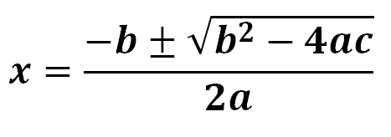

Hint: If b^2 – 4ac is a negative number, then there are no real solutions to the equation since you can’t take the square root of a negative number without using complex numbers. If b^2 – 4ac equals 0, then there is only 1 solution to the equation (since you are adding/subtracting 0 at the step)

Your algorithm should take the above two cases into account. Also, are there any other “weird” cases based on values of a,b,c your algorithm should consider?

**Part 2 - Programming**

1. Modify your application from Lab 4 (The program to calculate the perimeter of a rectangle) so that you can accept the length and the width from the user instead of having fixed values of 20 and 10.
2. Last lab, you wrote a program for calculating the perimeter of a right triangle given 2 other sides. Now, modify that program to get the 2 sides as input from the user.
3. Write a program that takes three numbers from the user and prints the average of the three numbers
4. Write a program to calculate the distance between two points. Recall that given two points (x1, y1) and (x2, y2), the distance between the two points is calculated as follows:

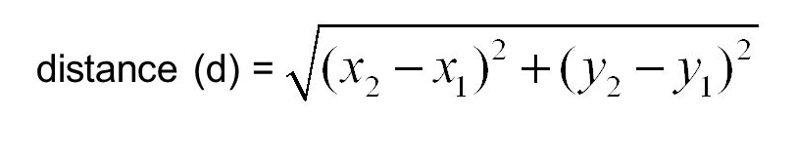

Your program must get 4 numbers as input from the user and store them in 4 variables (x1, y1, x2, y2). You may assume that the user will enter whole numbers. But the distance value may be a fractional number! Hint: Remember the Math.sqrt command from the previous lab.