# Report Lab1

# ChatGPT in Rasa

—————————————

# 1 The difference and connection between openai.Completion.create and openai.ChatCompletion.create

## 1.1 Connection

1.1.1 Definition

Both openai.Completion.create and openai.ChatCompletion.create are API methods provided by OpenAI's GPT-3 language model.Sharing OpenAI's GPT-3 language model means that they have access to the same large corpus of training data and can generate responses with similar levels of sophistication and coherence.

1.1.2 Usage

First,both methods take a **prompt(or message)** as input and use it as the starting point for text generation. The prompt can be provided as a string or a list of strings (in the case of openai.ChatCompletion.create).Besides,the prompt needs to be carefully designed to meet the requirements.

Second,Both methods can be configured with various **parameters** such as the maximum length of the generated text, the temperature (which controls the level of randomness in the generated text), and the presence or absence of certain tokens (such as profanity or specific keywords).

1.1.3 Function

Both methods return **a completion object** that includes the generated text, along with some additional metadata. The completion object can be parsed in order to extract the generated text or other information.

## 1.2 Difference

1.2.1 Application Target

openai.Completion.create is designed for generating text based on a prompt or input, with the goal of generating a coherent continuation or completion of that input.

openai.ChatCompletion.create is specifically designed for generating text in the context of a conversation or dialogue. It is meant to simulate human-like responses to user inputs.As a result,it also requires a conversation history to be provided as input,in a format of a list of strings representing previous messages in the conversation.

1.2.2 Language Model

According to their different application target,**available language models** differ between openai.Completion.create and openai.ChatCompletion.create.

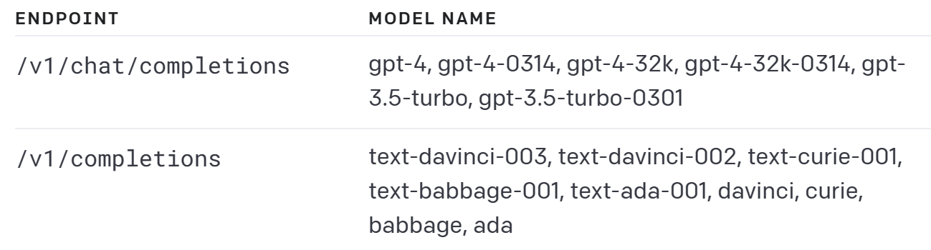

1.2.3 Required Parameters

They have some differences in the parameters they accept due to their distinct use cases.

First and primarily,**prompt vs message**.openai.Completion.create requires prompts to generate completions for,in string or array.While openai.ChatCompletion.uses a messages parameter instead of a single prompt parameter. The messages parameter is a list of message objects, where each object has a role (either "system", "user", or "assistant") and content (the text of the message). This allows a conversation history to be provided as input,for more interactive and dynamic conversations in the context of a chatbot application.

Besides,some other parameters also **differ in their specific usage and meaning**.For example,the ‘temperature’ parameter controls the randomness or creativity of the generated text.In the ‘Completion’ method,it applies to the entire text generated by the model, without any distinction between different parts of the text.In contrast, in the ‘ChatCompletion’ method, the temperature parameter can be applied to each message in the conversation separately.

Here are instances.

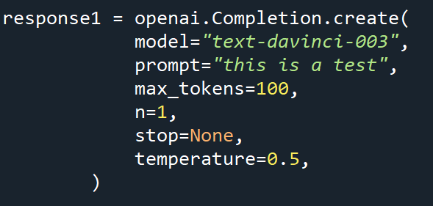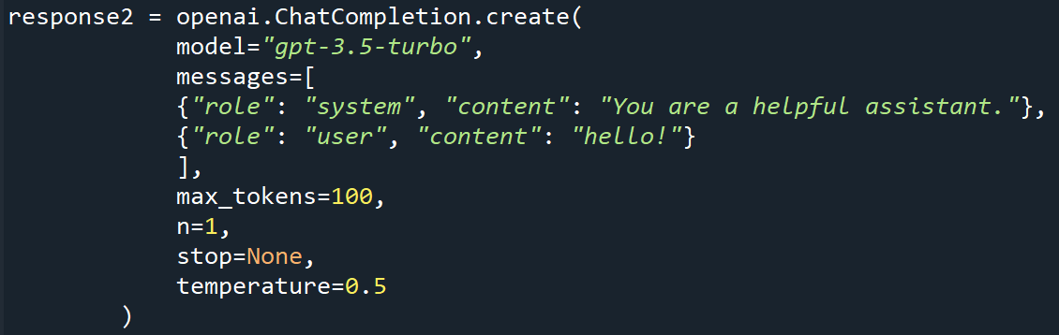

picture1.1

# The difference and connection between different models(gpt-3.5-turbo and text-davinci-003)

## 2.1 Connection

These language models developed by OpenAI,have similar capabilities in terms of generating text, completing prompts and so on,while with some different traits corresponding to their different available modes

## 2.2 Difference

2.2.1 Generation vs Chat in Personal Pronoun

In this experiment,I write the same prompt designed to show a relationship between pet and owner.

|  |  |
| --- | --- |
| **Prompt “I want you to act as my favorite doggy pet.Say about how we play together.”** | |
| Language Model | text |
| text-davinci-003 | My favorite thing to do with you is to cuddle and play fetch! I love when **you jump up to catch the ball** and then run back to me with it in your mouth. It always makes me smile and laugh. We also love to go on long walks together and explore the outdoors. I always feel so much better after spending time with you.’ |
| gpt-3.5-turbo | (As an AI language model, I am not capable of playing with you physically......)**Woof woof!** When we play together, it's always so much fun! We love to run around and chase each other, and I always try to catch the toys you throw for me. I love when you scratch behind my ears and give me belly rubs. We also enjoy going for walks and exploring new places together. I'm always excited to spend time with you and make memories that we'll cherish forever. |

**Table 2.1**

Apparently,‘text-davinci-003’ acts as the owner,generates what **‘I’** should express,while ‘gpt-3.5-turbo’ acts as the dog,chats with me exactly,and sometimes it sometimes reminds users of its limitations.

To conclude,‘text-davinci-003’ generates text from the perspective of the user himself,acts as the user exactly; ‘gpt-3.5-turbo’ acts as an AI assistant by default,and makes changes based on the user's request.

2.2.2 Usage and Advantages

First,prompt design.According to the analysis in 2.2.1,when designing prompts for ‘text-davinci-003’,we should assert that “I am xx / I act as xx”,to make this language model act as xx.And when designing prompts for ‘gpt-3.5-turbo’,we should assert that ‘I want you to act as xx’ to meet the same requirements.

Second,parameter’s effects.Here are two experiments for parameter’s different usage between ‘text-davinci-003’ and ‘gpt-3.5-turbo’.

|  |  |  |
| --- | --- | --- |
| **Text Completion “Humans belong to the primate order of mammals” + Testing parameter ’temperature’** | | |
| Language Model | temperature | |
|  | 0.9 | 1.5 |
| text-davinci-003 | Humans belong to the order Primates, which is a group of mammals. Primates are distinguished by their larger brains and longer limbs compared to other mammals. Primates are highly social and adept at using tools, communicating with one another, and exhibiting complex behaviors. | Primates form a diverse alert clade of animals. This order includes organisms as distinct as human beings that has huge brains, clever monkeys, tree-dwelling lemurs, bush babies, and the well specialized limbs of the giant jumping Paris, prosimains and the tarsiers clawing of the slender lorises... Overall, the order is characterized by seemingly large brains and abundant communications reach out display emphatic learning and interactive culture adapted to specific life an biodbesetic people. |
| gpt-3.5-turbo | That is correct. The primate order includes monkeys, apes, lemurs, lorises, and tarsiers. Human beings are classified as primates due to our shared physical and genetic characteristics with other primates. | That is correct! The primate order includes all species of primates, such as monkeys, apes, and lemurs. Humans are classified in the same order because we exhibit many of the same physical and behavioral characteristics that primates possess. |

**Table 2.2**

|  |  |  |
| --- | --- | --- |
| **Advertising copy writing "Write advertising copy for a car" + Testing parameter ’frequency_penalty’** | | |
| Language Model | frequency_penalty | |
|  | 0 | 1.0 |
| text-davinci-003 | Introducing the all-new car from [Company Name] - luxurious, stylish, and with all the performance you could want. This car offers the perfect blend of power and comfort, making it an ideal choice for any driver. With a powerful engine and feature-packed interior, it's sure to wow even the most discerning of drivers. Experience the ultimate in driving pleasure today and make a statement with this amazing car. | Introducing the newest addition to your family: the CAR Make! This luxurious vehicle provides the optimal balance of style and performance. From its sleek exterior to its cabin-filled interior, you are sure to find blissful comfort while driving in safety and style. It features a powerful turbocharged engine that delivers remarkable power without sacrificing fuel economy, plus an advanced suspension system for a smooth ride. That’s not all – it’s equipped with state-of-the-art technology such as a customizable heads up display, intuitive driver information system, and an intelligent navigation system so you can always find your way home. |
| gpt-3.5-turbo | Introducing the sleek and powerful [Car Model] – the perfect car for those who demand style, performance, and reliability. With its impressive [Engine Type] engine, [Car Model] is built to handle the toughest road conditions and provide an exhilarating driving experience. | From the moment you slip behind the wheel, you'll be transported to another level of driving - one where every turn and movement is smooth and effortless. Whether cruising on the highway or taking tight corners on curvy roads, this car will have you feeling in control every step of the way.  Stay connected with our state-of-the-art infotainment system, complete with voice-activated controls for hands-free access while driving. And let's not forget about safety - our advanced driver assistance features keep you protected from any potential hazards on the road. |

**Table 2.3**

To conclude,here are three points summarized as follows:

1)‘text-davinci-003’ is more open and creative compared to ‘gpt-3.5-turbo’,more powerful in text generation and inspiring creative writing;while ‘gpt-3.5-turbo’ behaves more cautious,designed for chatting with responding more natural and human-like answers.

2)‘Temperature’ parameter controls randomness.The less the value, the more deterministic and repetitive the model will become.In the experiment, ‘text-davinci-003’ appears more free with the raising ‘temperature’ than ‘gpt-3.5-turbo’,even generates some spelling mistakes.

3)‘Frequency_penalty’ defines how much to penalize new tokens based on their existing frequency in the text so far,in order to decreases the model's likelihood to repeat the same line verbatim.With more frequency_penalty,‘text-davinci-003’ and ‘gpt-3.5-turbo’ are both more creative,attractive and literal.

# 3 The prompts I designed for the two cases

prompt_pet="Recently,my beloved pet passed away.I want you to act as this pet.You should simulate its behavior and personality.Do not write explanations.The most important aspect is to comfort me and encourage me.Tell me about how we played together.My first sentence:I miss you,how are you now?'.More than 100 words."

This prompt is the system message,and I design to collect what the user inputs to act as the user message to call response of ChatCompletion with model ‘gpt-3.5-turbo’.

prompt_copywriter="I want to write copy for my WeChat Moments.I will use my imagination to the fullest.I will make my copy attractive and vivid."

And I design to collect what the user input,generalizing with this prompt and act as the whole prompt to call response of Completion with model ‘text-davinci-003’.