首先你需要一个类似于chatgpt4o的ai
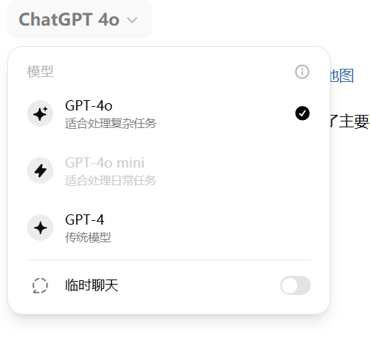
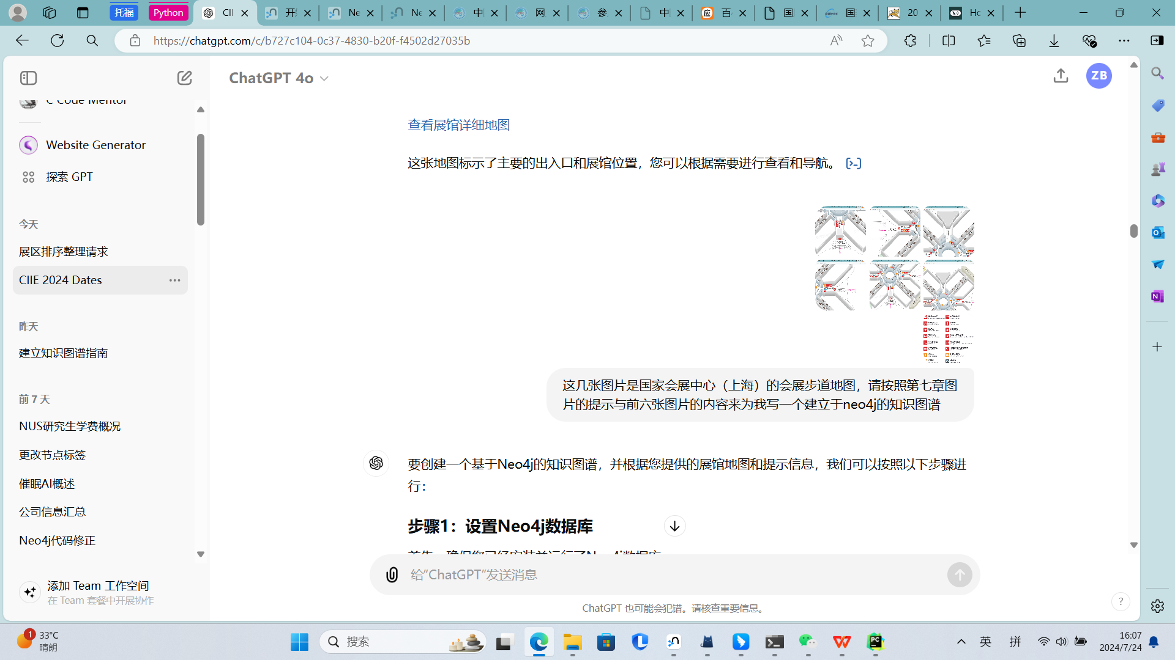
然后看它给的内容
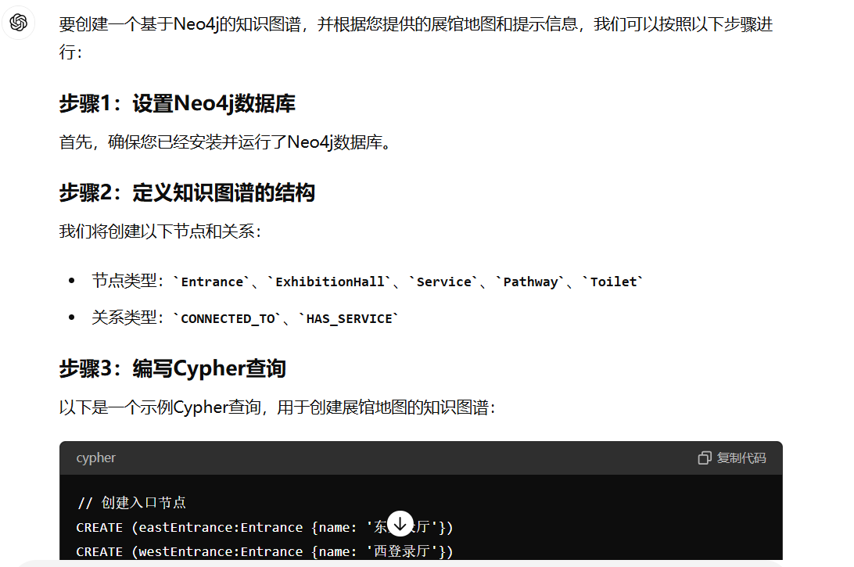
// 创建入口节点CREATE (eastEntrance:Entrance {name: '东登录厅'})CREATE (westEntrance:Entrance {name: '西登录厅'})CREATE (southEntrance:Entrance {name: '南登陆厅'})CREATE (northEntrance:Entrance {name: '北登录厅'})// 创建展馆节点CREATE (hall1:ExhibitionHall {name: '展馆 1'})CREATE (hall2:ExhibitionHall {name: '展馆 2'})CREATE (hall3:ExhibitionHall {name: '展馆 3'})CREATE (hall4:ExhibitionHall {name: '展馆 4'})CREATE (hall5:ExhibitionHall {name: '展馆 5'})CREATE (hall6:ExhibitionHall {name: '展馆 6'})CREATE (hall7:ExhibitionHall {name: '展馆 7'})CREATE (hall8:ExhibitionHall {name: '展馆 8'})CREATE (hall9:ExhibitionHall {name: '展馆 9'})CREATE (hall10:ExhibitionHall {name: '展馆 10'})CREATE (hall11:ExhibitionHall {name: '展馆 11'})CREATE (hall12:ExhibitionHall {name: '展馆 12'})CREATE (hall13:ExhibitionHall {name: '展馆 13'})// 创建服务节点CREATE (vipLounge:Service {name: 'VIP 休息室'})CREATE (mediaLounge:Service {name: '媒体休息区'})CREATE (medicalStation:Service {name: '医疗站'})CREATE (information:Service {name: '咨询处'})CREATE (businessCenter:Service {name: '商务中心'})CREATE (restArea:Service {name: '观众休息区'})CREATE (smokingRoom:Service {name: '吸烟房'})CREATE (currencyExchange:Service {name: '外币兑换点'})// 创建路径节点CREATE (southFootpath:Pathway {name: '南步道'})CREATE (westFootpath:Pathway {name: '西步道'})CREATE (northFootpath:Pathway {name: '北步道'})CREATE (eastFootpath:Pathway {name: '东步道'})CREATE (centralFootpath:Pathway {name: '中央步道'})// 创建厕所节点CREATE (toilet1:Toilet {location: '南步道'})CREATE (toilet2:Toilet {location: '西步道'})CREATE (toilet3:Toilet {location: '北步道'})CREATE (toilet4:Toilet {location: '东步道'})// 连接入口与路径CREATE (southEntrance)-[:CONNECTED_TO]->(southFootpath)CREATE (westEntrance)-[:CONNECTED_TO]->(westFootpath)CREATE (northEntrance)-[:CONNECTED_TO]->(northFootpath)CREATE (eastEntrance)-[:CONNECTED_TO]->(eastFootpath)// 连接展馆与路径CREATE (hall1)-[:CONNECTED_TO]->(southFootpath)CREATE (hall2)-[:CONNECTED_TO]->(southFootpath)CREATE (hall3)-[:CONNECTED_TO]->(westFootpath)CREATE (hall4)-[:CONNECTED_TO]->(westFootpath)CREATE (hall5)-[:CONNECTED_TO]->(northFootpath)CREATE (hall6)-[:CONNECTED_TO]->(northFootpath)CREATE (hall7)-[:CONNECTED_TO]->(eastFootpath)CREATE (hall8)-[:CONNECTED_TO]->(eastFootpath)CREATE (hall9)-[:CONNECTED_TO]->(centralFootpath)CREATE (hall10)-[:CONNECTED_TO]->(centralFootpath)CREATE (hall11)-[:CONNECTED_TO]->(centralFootpath)CREATE (hall12)-[:CONNECTED_TO]->(centralFootpath)CREATE (hall13)-[:CONNECTED_TO]->(centralFootpath)// 连接服务与路径CREATE (vipLounge)-[:HAS_SERVICE]->(southFootpath)CREATE (mediaLounge)-[:HAS_SERVICE]->(westFootpath)CREATE (medicalStation)-[:HAS_SERVICE]->(northFootpath)CREATE (information)-[:HAS_SERVICE]->(eastFootpath)CREATE (businessCenter)-[:HAS_SERVICE]->(centralFootpath)CREATE (restArea)-[:HAS_SERVICE]->(centralFootpath)CREATE (smokingRoom)-[:HAS_SERVICE]->(centralFootpath)CREATE (currencyExchange)-[:HAS_SERVICE]->(centralFootpath)// 连接厕所与路径CREATE (toilet1)-[:HAS_SERVICE]->(southFootpath)CREATE (toilet2)-[:HAS_SERVICE]->(westFootpath)CREATE (toilet3)-[:HAS_SERVICE]->(northFootpath)CREATE (toilet4)-[:HAS_SERVICE]->(eastFootpath)这串是它给的代码，然后根据自己需求选择内容进行导入就行了。
导入后效果在同级的文件名为graph.png的图片中，缺失或者多余的内容需要自行修改。

