Q1.

1. Two cases:
   1. a1 … a3 and b1 … b3 are all \*s: 2^7
   2. at least one of a1 … a3 and b1 … b3 is not \*: 2^7\*(2^3-1)\*2
   3. So total nonempty aggregated cells is a) + b) – 2

= 2^7 + 2^7\*(2^3-1)\*2 – 2 = 1918

1. If count >= 2, then we have to aggregate:

As long as the dim 1, 2, 3 are aggregated to \*, these two cells can be merged and thus count >= 2. So total cells is: 2^7 = 128

Total nonempty aggregated cells

1. Closed cells are:

(\*,\*,\*, b4, …, b10): count= 2

(a1, a2, a3, b4, …, b10): count= 1

(b1, b2, b3, b4, … , b10): count= 1

So the closed cell with count 2 have dimensions = 7.

1. And there are 3 closed cells.

Q2.

1. Number of Cuboids:

According to the formula: $T= \prod_{i=1}^{n}{{(L}_{i}}+1)$

Since we have 4 dimensions (Location, Category, Rating, Price) and Location has 2 layers: City and State. So T = (2+1)\*2\*2\*2 = 24

For the following problem 2.2-2.6, please refer to sql code for details

1. Number of cells: 48
2. 34
3. 23
4. 2



1. 2



Mini MP:

1. Result:

Mountain Bike: most revenue, Trial Bile least revenue

Operation:

* 1. Slice on product: category = sports
  2. Slice on date = 2012-9-1 to 2013-9-30
  3. Slice on country: region = North America
  4. Drill down on product: product

Snapshots of the result:

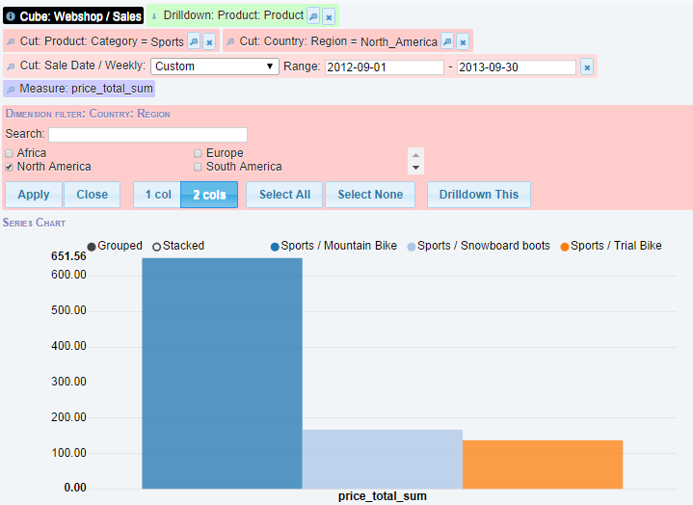

1. (1) Result:

Popular way: Web search (source) + Chrome (browser)

Operation:

1. Slice on country: region = Europe
2. Drill down on browser
3. Drill down on source (horizontal dimension)

Snapshots of the result:

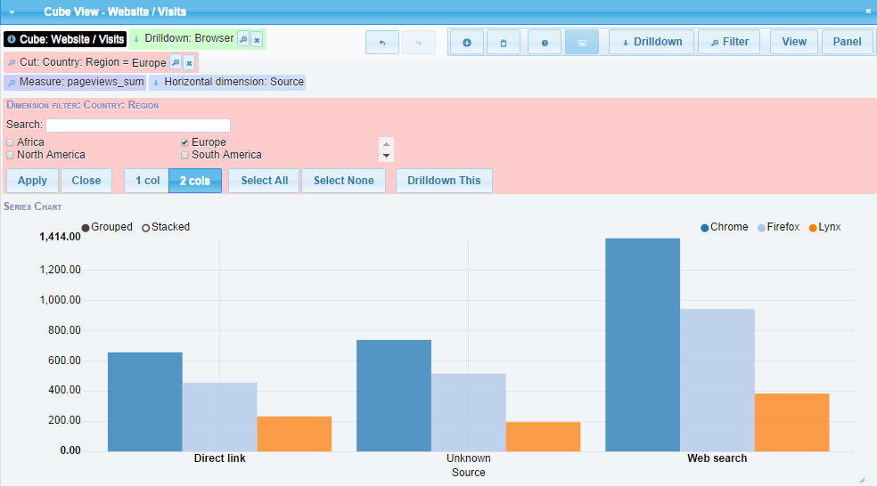

(2) Result:

The visiting counts are changing along time in Europe.

The best granularity of visualization is Quarter based.

Operation:

* 1. Slice on country: region = Europe
  2. Drill down on browser
  3. Drill down on source (horizontal dimension)
  4. View Horizontal dimension: View Data Monthly: Quarter

Snapshots of the result:

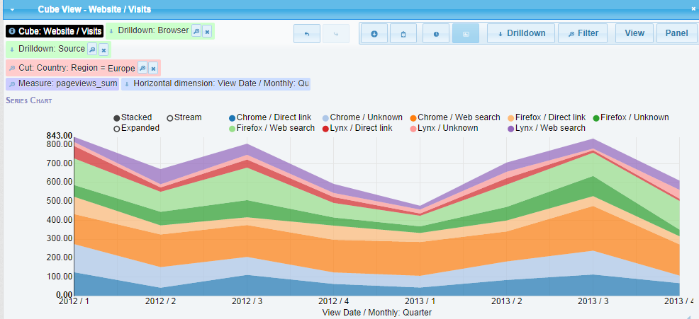

Another version: (without drill down on web browser and source)

I use monthly as granularity for visualization this time.

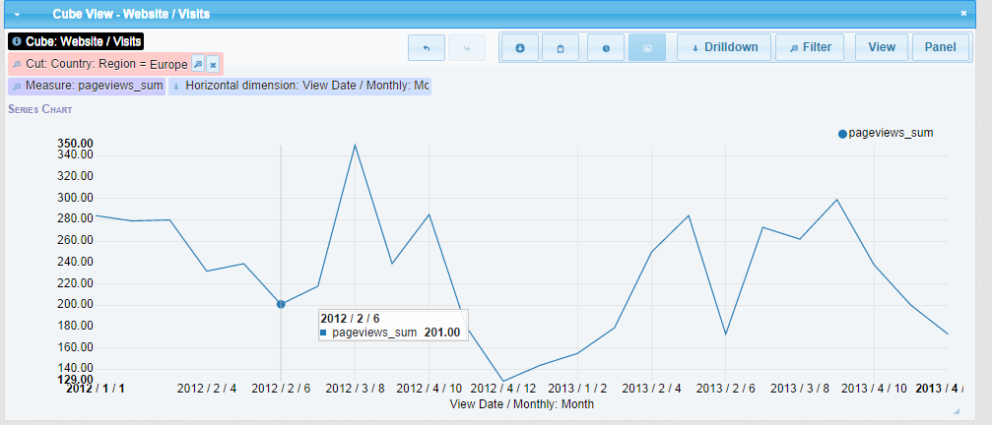

1. Interesting cube for decision making:
   1. For the Webshop/Sales:

I am interested in the cube of the measure of sales quantity for each category of product among each region. This is beneficial because it can help to better understand the strong and weak of market segmentation for different categories of products in each region so as to make specific strategy to maximize the profit and decide whether to explore new markets.

Operation:

* + 1. Drill down on product: category
    2. Drill down on country: region (horizontal dimension)
    3. View the measure of quantity

Snapshots of the result:

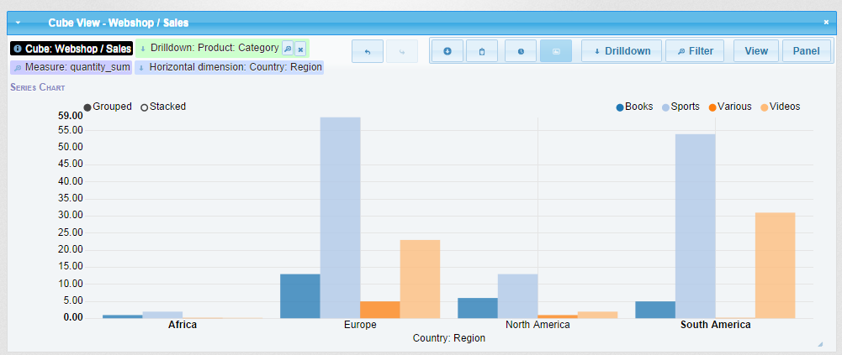

* 1. For the Website/Visits:

For this, I am interested in the cube of the measure of page views with respect to time. By doing this, we can know the major trend of website visits among different regions at different time. It helps us to make decision on when and where is the best time for web searching so as to do promotion or other things during that time for that region.

Based on last question, we know the most popular way is Web search (source) + Chrome (browser). So I focus on this combination and compare this within 3 regions (ignoring Africa since the amount is small).

Operation:

1. Drill down on country: region
2. Slice on source = web search
3. Slice on browser = chrome
4. Dice on country: region = Europe, North America, South America
5. View Horizontal dimension: View Data Monthly: Month
6. View the measure of page views in a line graph

Snapshots of the result:

