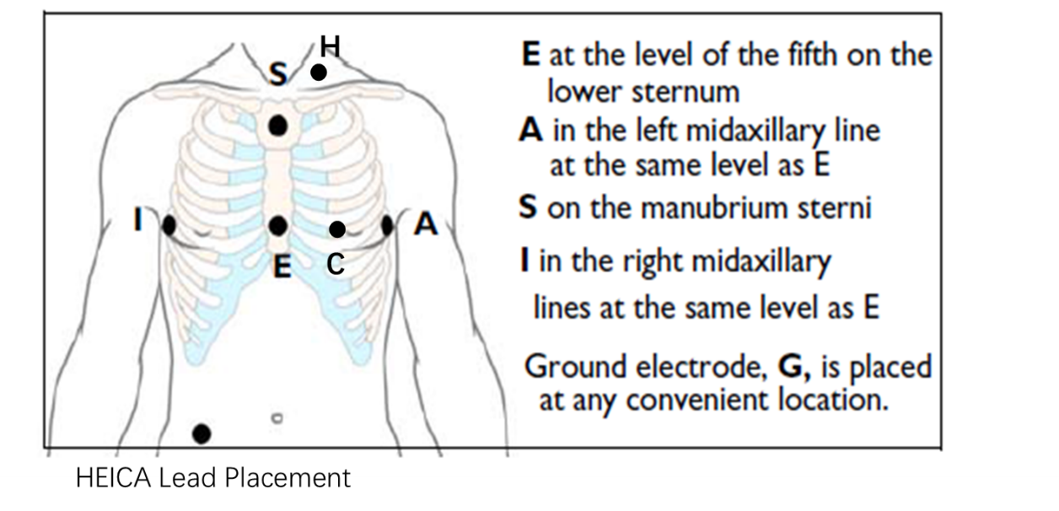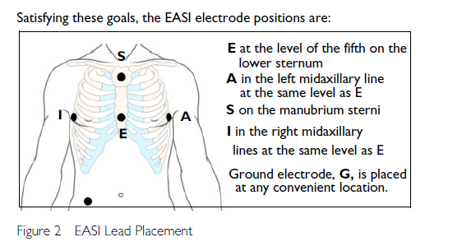

通道顺序对应表：

|  |  |  |  |  |  |  |  |  |  |  |  |  |  |  |
| --- | --- | --- | --- | --- | --- | --- | --- | --- | --- | --- | --- | --- | --- | --- |
| 序号 | 1 | 2 | 3 | 4 | 5 | 6 | 7 | 8 | 9 | 10 | 11 | 12 | 13 | 14 |
| 电极 | R | L | V1 | V2 | V3 | V4 | V5 | V6 | A1 | A2 | A3 | A4 | A5 | A6 |
| 12导定义 | -II | -II | V1 | V2 | V3 | V4 | V5 | V6 | \ | \ | \ | \ | \ | \ |
| HEICA and EISA |  |  |  |  |  | C |  | A | I | E | M | H | S |  |
| 备注 | 电极参考电压全部为左腿F | | | | | | | | | | | |  |  |

|  |  |  |  |  |
| --- | --- | --- | --- | --- |
|  | HEICA | | EASI | |
|  | 站着 | 躺着 | 站着 | 躺着 |
| 受试者1 | 0.987 | 0.986 | 0.960 | 0.944 |
| 受试者2 | 0.986 | 0.971 | 0.940 | 0.951 |
| 受试者3 | 0.957 | 0.957 | 0.949 | 0.954 |
| 受试者4 | 0.963 | 0.979 | 0.951 | 0.981 |
| 受试者5 | 0.913 | 0.954 | 0.883 | 0.941 |
| 受试者6 | 0.961 | 0.969 | 0.937 | 0.954 |