Problem Chosen  C | 2026  MCM/ICM  Summary Sheet | Team Control Number  2617152
Dancing with Algorithms: Unveiling the Hidden Votes of DWTS
Summary
Dancing with the Stars (DWTS) determines weekly eliminations through a combination of judges’ scores and undisclosed fan votes. To reconstruct the hidden dimension and evaluate how different rules influence outcomes, we developed a five-part modeling framework that captures distinct structural layer of the elimination system.
In Task 1, we formulated fan support as an unknown vote-share vector and introduced a constrained Monte Carlo Sampling approach informed by a Dirichlet prior based on judges’ scores. Samples were retained only if they reproduced the historical elimination outcome under the specific week’s rule. To handle ambiguous outcomes near elimination boundaries, we developed a Dual-stage Acceptance Strategy. This reconstruction enabled statistical classification of episodes: 64% were stable, 11% revealed structural controversy between popularity and performance, and 25% were guided by explicit Bottom-2 criteria.
Task 2 employed a Dual-track Counterfactual Simulator to compare Rank Method and Percent Method with the same input votes from Task 1. The two methods concurred on 97.4% of results, but diverged in swing weeks. The Percent Method favored high-popularity contestants with weak scores, whereas the Rank Method emphasized performance over reach. In several high-profile cases like Jerry Rice or Bobby Bones, changing aggregation formulas alone didn’t alter outcomes; nonetheless, the implementation of a Judges’ Save mechanism was effective, highlighting its role in edge-case correction.
Task 3 recommended adopting the Rank Method for its robustness against extreme vote distributions and its ability to maintain weekly suspense. Additionally, the Judges’ Save mechanism introduces a "technical floor," allowing judges to override popularity in critical Bottom-2 cases, thus curbing controversial eliminations.
Task 4 explored whether judges and fans hold systematically different preferences. We developed a Dual-response Hierarchical Linear Mixed-effects Model to analyze judges’ scores and estimated fan votes in relation to contestant features, while accounting for random season-level shifts and partner effects. Wald tests showed no statistically significant divergence between the two groups. Both penalize older age and modestly favor social-media contestants, indicating alignment in evaluation logic. This suggests that controversies are less about preference conflict s, and more from rule amplification effects.
Finally, Task 5 introduced the Damped Multiplier Model, a bounded multiplicative coupling of judges’ scores and fan votes. Unlike additive schemes, this model introduces dynamic weighting. It moderates the dominance of extreme popularity while preserving fan influence, improving fairness near elimination thresholds. Simulations indicated that the model maintains interpretability through just two parameters, making it both statistically sound and operationally feasible.
Key words: Fan Votes, Monte Carlo sampling, Aggregation Rules, Judges’ Save mechanism, Damped Multiplier Model.

Contents
1 Introduction 4
1.1 Problem Background 4
1.2 Restatement of the Problem 4
1.3 Our Work 5
2 Assumptions and Justifications 5
3 Notations 6
4 Task 1: Estimating Fan Vote Shares 7
4.1 Evaluation Framework 7
4.2 Model formulation 7
4.3 Analysis of result 9
4.4 Model Reliability Verification 10
4.4.1 Robustness Analysis 11
4.4.2 Sensitivity Analysis 11
5 Task 2: Counterfactual Simulation of Aggregation Rules 13
5.1 Dual-Method Counterfactual Simulator 13
5.2 Results of Dual-Method Simulation 14
5.3 Protocol Extension: Judges’ Save 15
6 Task 3: Method Recommendation 16
6.1 Recommendations for Competition Format 16
7 Task 4: Dual-Response Hierarchical Linear Mixed-Effects Model 17
7.1 Evaluation Framework 17
7.2 Model Formulation 18
7.2.2 Robustness Analysis of Model Specifications 19
7.3 Analysis of Results 20
7.3.1 The universal negative effect of age 20
7.3.2 The Impact of Professional Background Disparities 21
7.3.3 The 'Kingmaker' Pro Effect 21
7.4 Implication 22
8 Task 5: The Damped Multiplier Model 22
8.1 Model Setup 22
8.2 Parameter Setting and Design Targets 23
8.3 Sensitive Analysis 23
8.4 Model Strength 24
8.5 Model limitation 24
9 Conclusion 24
10 Memo For Producers 26
References 27
Report on Use of AI Tools 28

Introduction

Problem Background
Dancing with the Stars (DWTS) is a televised dance competition where celebrities are paired with professional dancers and perform each week for judges’ scores and audience votes. While the format is designed to balance technical merit with public preference, the show does not release raw voting totals. This lack of transparency has fueled persistent controversy, particularly in cases where the final outcomes seemed to diverge sharply from judges’ assessments—for example, Season 2’s Jerry Rice reached runner-up despite repeatedly receiving the lowest judges’ scores.
Additional concerns have focused on strategic “anti-support” behavior: one eliminated contestant Hilaria Baldwin have alleged that coordinated fan groups could manipulate outcomes by casting votes for multiple alternative contestants to suppress a target's relative share^{[1]}. These tactics are enabled by a voting structure that weekly voting allows each viewer to vote up to the cap per contestant through multiple channels^{[2]} .
These features make DWTS ideal for modeling. Therefore, given observed judges’ scores and eliminations but unobserved audience votes, it is of clear analytical value to reconstruct plausible vote distributions via quantitative modeling and to evaluate how different aggregation rules shift influence and perceptions of fairness between judges and viewers.

Restatement of the Problem
Considering the background information and restricted conditions identified in the problem statement, we need to solve the following problems:
- Problem 1: Reconstruct the invisible “fan vote” distribution from historical elimination data using a model, and quantify the consistency and uncertainty of these estimates.
- Problem 2: Systematically compare the “ranking method” and “percentage method” scoring mechanisms to determine whether different mathematical aggregation logics systematically skew competition outcomes toward technical points or popularity votes.
- Problem 3: Based on the comparative analysis, we are required to recommend which method—rank or percentage—and whether the inclusion of the "judges' save" mechanism is best for future seasons.
- Problem 4: Develop a model to quantify the differential effects of professional dance partners, contestants' age, and industry background on “judges' technical scores” and “fan popularity votes.”
- Problem 5: Propose an alternative scoring system to combine judges scores and fan votes that improves fairness or excitement, providing a justification for why the producers should adopt this new approach.

Our Work
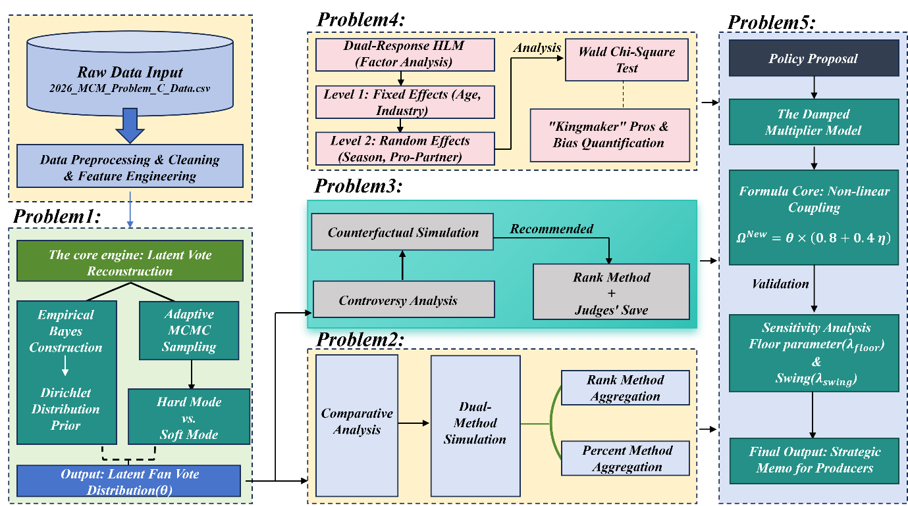

Assumptions and Justifications
Assumption 1: We assume a positive correlation exists between judges' scores and audience preferences. Professional evaluations reflect public aesthetic preferences to some extent, but the two are never identical.
Justification 1: Previous research on entertainment competitions demonstrates a significant correlation between professional scores and public preferences.
Furthermore, existing studies have employed hierarchical Bayesian methods to compare preference differences across various evaluation domains among different voting groups^{[3]}.
Assumption 2: Within a specific season, audience voting behavior can be regarded as a relatively stable random process, with its primary variations driven by contestants' performance and external publicity.
Justification 2: Specifically, voting channels and competition rules remain relatively consistent within each season. Consequently, audience voting patterns exhibit statistically discernible regularities. Furthermore, Toth in his probabilistic voting study confirms that within a given voting system, core voting patterns adhere to the DeFanti measure provided the group composition and competition format remain unchanged. This consistency enables statistical modeling^{[4]}.
Assumption 3: Differences across seasons in scoring criteria, competition formats, and professional dance partner pairings generate systematic effects that can be modeled through hierarchical structures.
Justification 3: Hierarchical structures enable the analysis of voting behavior by capturing the influence of individual and collective characteristics on voting outcomes. For instance, studies examining legislative bodies and judicial behavior demonstrate that hierarchical ideal-point estimation models effectively capture environmental factors and individual fixed characteristics and preferences within multilevel random structures through random effects^{[5]}.
Assumption 4: Historical election outcomes represent an equilibrium resulting from the combined effects of rational evaluation mechanisms and random disturbances, with no persistent, large-scale human manipulation present within the electoral system.
Justification 4: Based on the Law of Large Numbers and the integrity principles of commercial competitions, we conclude that historical data reflects a dynamic equilibrium between “technical evaluation (rational signals)” and “fan preferences (random noise),” rather than the outcome of deliberate manipulation^{[6]}.

Notations
The key mathematical notations used in this paper are listed in Table 1.
        - Notations used in this paper
Symbol | Description
s | Season Index
w | Week Index
i | Contestant Index
N_{s,w} | Number of Contestants
E_{actual} | Actual Elimination
J_{s,w,i} | Judge Total Score
R^{J}_{s,w,i} | Judge Rank
P^{J}_{s,w,i} | Judge Percent
θ_{s,w,i} | Fan Vote Share
R^{F}_{s,w,i} | Fan Rank
κ_{s,w} | Feasibility Score
CV_{i} | Coef. of Variation
$$Y_{i,s}^{J}$$ | Standardized Judge Score
$$Y_{i,s}^{F}$$ | Log-transformed Fan Vote Share
$$X_{Age,i}$$ | Contestant Age
$$X_{Ind,i}$$ | Contestant Industry
$$X_{Gen,i}$$ | Contestant Gender
$$Ω_{s,w,i}^{New}$$ | Effective Score

Task 1: Estimating Fan Vote Shares
In the DWTS program, only the judges' scores are released, while the voting data from the audience is not disclosed. This lack of transparency can cause some controversial eliminations. Due to the inflexibility of the deterministic reconstruction method, multiple seemingly reasonable voting results may yield the same outcome.
To address this issue, we propose a generative probability framework to estimate the fan voting share that is consistent with historical elimination situations, while emphasizing uncertainty and repeatability. Specifically, we adopted a Bayesian-inspired inverse generation framework to develop a Dirichlet prior distribution from the judges' scores, and generating the posterior distribution through Monte Carlo sampling and rule-based filtering.

Evaluation Framework
Since the fan voting data is not made public, the objective of this study is no longer to reproduce the specific vote counts, but to determine whether there exists a reasonable voting ratio that can replicate the historical elimination results. We first assess the consistency of the results, that is, whether the reconstruction of the voting can produce a true elimination situation. However, due to the differences in reproducibility across different weeks, consistency alone cannot assess model performance. Therefore, a feasibility indicator is used to quantify the difficulty of the results to recur.
Furthermore, even if the elimination results are reproducible, the voting structures may differ between simulations. To address this, we evaluated the concentration degree of the voting shares through stability analysis, thereby measuring the reliability of the inference results.

Model formulation
We assume that judge scores $J_{i}$ partially reflect public preference. We standardize them using z-score and apply an exponential scaling to obtain the Dirichlet prior parameters:
$$α_{i}=1+λ⋅\frac{J_{i}}{\overline{J}}$$
The Dirichlet distribution, as a conjugate prior of multiple probability vectors, is widely used in Bayesian frameworks to model uncertain probability configurations. Therefore, it is selected here as the prior modeling tool for audience behavior. We regard the audience vote share theta $θ_{w}$ to multivariate Dirichlet distribution:
$$θ_{w}=\left[θ_{1},θ_{2},…,θ_{n}\right]∼\text{Dirichlet}\left(α_{1},α_{2},…,α_{n}\right)$$
subject to：
$$\sum_{i=1}^{n}{θ_{i}}=1, 0<θ_{i}<1$$
Each sample is tested against that week’s rule. The scoring mechanisms vary in different seasons. We fully simulate their differences:
Situation A: Rank Method:
$$Ω_{i}^{\text{Rank}}=\text{Rank}\left(J_{i}\right)+\text{Rank}\left(θ_{i}\right)$$
Situation B: Percent Method
$$Ω_{i}^{\text{Pct}}=\frac{J_{i}}{\sum{J}}+θ_{i}$$
Situation C: The Judge's Save Modification
$$\text{Bottom2 Set}=\left\{i | Ω_{i}^{\text{Rank}}\text{ is among the top 2 largest values}\right\}$$
Samples are retained only when the simulation elimination results are consistent with the reality.
Next, a Monte Carlo Rejection Sampling are designed to act as a constraint-aware generator of plausible vote outcomes.
Step 1 (Generate): Draw a sample${ θ}^{\left(k\right)}$from the Generative Model
Step 2 (Evaluate): Calculate the hypothetical elimination result $i_{\text{sim}}^{\left(k\right)}$ using the Evaluation Model
Step 3 (Validate): Compare with historical truth $E_{\text{actual}}$
$$\text{Accept }θ^{\left(k\right)}⟺i_{\text{sim}}^{\left(k\right)}=E_{\text{actual}}$$
Step 4 (Loop): Repeat N=50,000 times to obtain the distribution of valid votes.）
In complex situations where audience vote and judge scoring differ (such as in the second season of Jerry Ressi's competition), strict matching criteria often result in an extremely limited sample size. To enhance the stability and discrimination ability of the model, we propose an Adaptive Double-Verification Strategy. This strategy dynamically adjusts the acceptance threshold based on the convergence of the simulation.
The modeling flow of adaptive double-verification strategy is shown below：
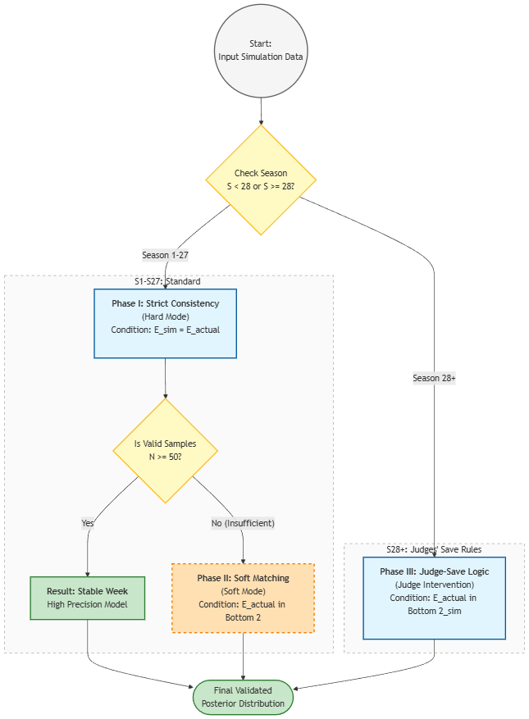
          - Adaptive Double-Verification Strategy for Latent Vote Reconstruction

Analysis of result
Based on the set obtained from the previous model, we respectively output interpretable statistical results at the "week" and "competitor" levels.
Firstly, we use the posterior mean of the verified samples as the central estimate of the support degree of this competitor in that week to assess the reliability of the estimated values.
$$CV_{i}=\frac{σ\left(θ_{i}\right)}{μ\left(θ_{i}\right)}$$

Here, $μ$ and $σ$ represent the mean and standard deviation of the voting rate of this contestant in the valid samples, respectively. Compared to directly using the standard deviation, CV can eliminate the influence of differences in the voting base of different contestants, and is more suitable for horizontal comparison. A higher CV indicates that there are still multiple significantly different voting configurations even under the same elimination results, reflecting a higher level of estimation uncertainty.
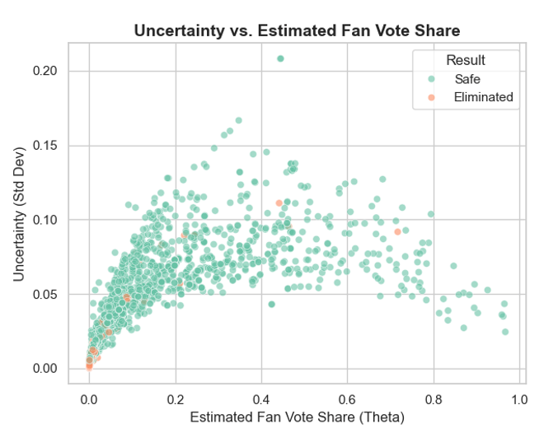
          - Reliability Map of Estimated Fan Interest
Figure illustrates the relationship between the fan vote share and the coefficient of variation. The results show that there is a significant negative correlation between the two: players with low vote shares have higher uncertainty, while the estimated results for players with high support are more stable. This indicates that marginal players are more sensitive to voting fluctuations and more susceptible to random factors.
To further quantify the stability of all weeks, we calculated the standard deviation of certainty for each week, and the distribution characteristics are shown in Figure 4:
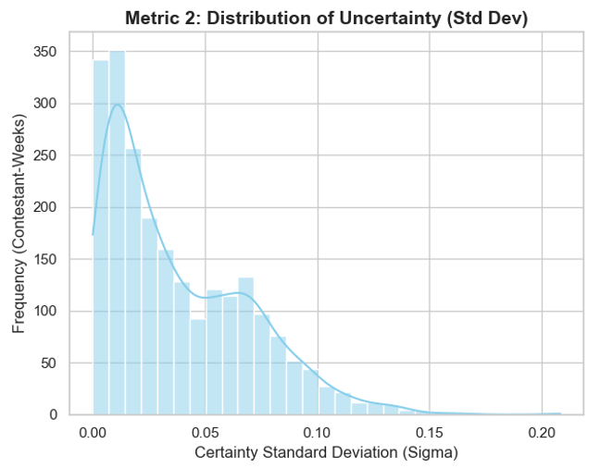
          - Reliability Analysis of Latent Fan Vote Distributions
We found that the estimated share of fan votes in most weeks fluctuated minimally, resulting in more stable outcomes (corresponding to 64% of Type 1 weeks). As Sigma increased, a few high-Sigma weeks exhibited high fluctuation characteristics (corresponding to 11% of Type 2 weeks).

Model Reliability Verification
In order to further verify the reliability of this model and its adaptability to parameter variations or observational errors, we conducted robustness analysis and sensitivity analysis on the components of the core indicators.

Robustness Analysis
We introduce ±10% random noise in the total score $J_{i}$ to simulate the observational errors in real situations, and observe the fluctuation range of the core indicator $κ$.
- Conclusion Analysis：The simulation results for Season 1 Week 4 (Rachel Hunter case) indicate that when the noise level increases to 10%, the feasibility score \kappa shows only minor fluctuations and remains within a reasonable range (see the figure 4). This suggests that the model has strong robustness against observational errors and can stably invert the audience voting trend under perturbed scores.

Sensitivity Analysis
We focused on studying the prior strength factor $λ$, which is a key parameter used to control the extent to which the judges' scores affect the estimation of the audience's voting share. We observed the changes in the model by setting the range of $λ$ values to [0, 20].
Analysis conclusion: The experiment shows that as λ increases from 0 to 20, κ exhibits a trend of first increasing and then decreasing or stabilizing.
o When $λ$ is low, the prior is too random and the search efficiency is low;
o When $λ$ is moderate, the judge score can effectively narrow the range of candidate θ, and the model performance reaches the optimal state;
o When $λ$ is too high, the prior will overly suppress the "miracle-type" samples that deviate from the judge score.
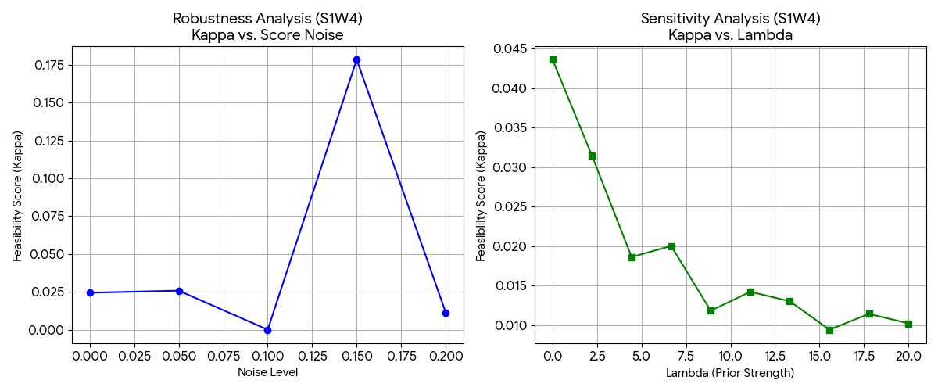
          - Statistical Reliability and Sensitivity Analysis of Fan Vote Estimation
To assess the stability of the elimination results, we introduce the concept of feasibility score $κ$, defined as the actual acceptance rate obtained from multiple Monte Carlo simulations. This metric essentially represents the repeatability of the elimination results under different voting configurations and can be used as a consistency indicator to reflect the inherent stability of the elimination mechanism.
A high $κ$ value indicates that the results can be consistently reproduced within a wide range of reasonable voting intervals, while a low $κ$ value suggests that the results only occur under narrow conditions, indicating potential disputes.
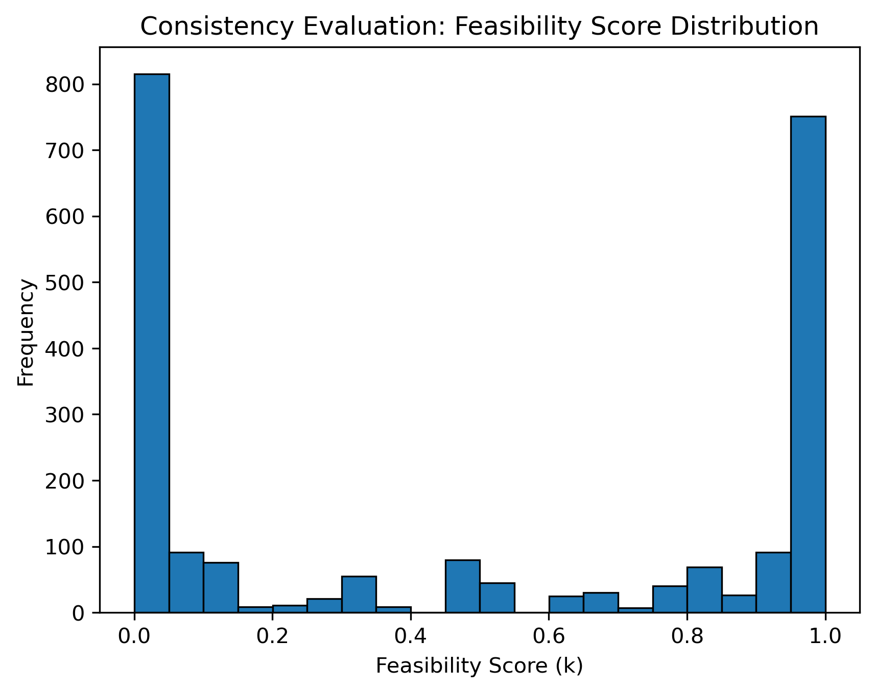
          - Model Reliability and Consistency Evaluation for Fan Vote Inference
Figure shows the sample distribution corresponding to different feasibility scores k. The presence of the bimodal pattern indicates two states: one is a high stability state ($κ$ > 0.7), and the other is a low stability state ($κ$ < 0.2).
Combining the adaptive acceptance mechanism with the aforementioned indicators, we can conduct transparent classification of weeks and naturally incorporate uncertainty into the result interpretation:
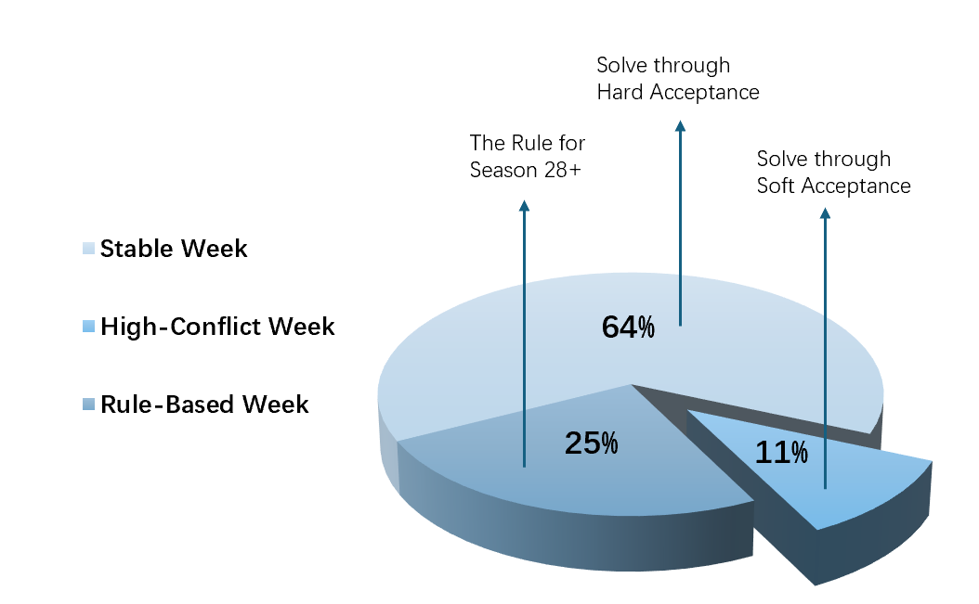
          - Reliability and Consistency Evaluation of the Fan Vote Inference Model
Among them, nearly 64% of the weeks can be directly restored under the Hard standard, while about 11% require soft standard. These weeks correspond to "controversial events".
Based on this classification result, we further analyzed the overall simulation distribution to evaluate the validity of the model across the entire sample range：
- Type I (Stable/Hard Mode): Approximately 64% of the total data, with an average $κ$ of approximately 0.511
- Type II (High-Conflict/Soft Mode): Approximately 11%, with an average $κ$ of approximately 0.030
- Type III (Rule-Based): The average $κ$ for the rescue rules based on the S28+ judgment is approximately 0.62.
The results show that in the majority of standard rounds, the model can accurately replicate the actual elimination outcomes with a high probability based on the prior probabilities of the judges' scores. The lower $κ$ value indicates that there are "hidden disputes" in some rounds, reflecting a significant deviation between the audience votes and the judges' scores, corresponding to a relatively fragile balance state. These situations correspond to a relatively fragile equilibrium state and may trigger a review.

Task 2: Counterfactual Simulation of Aggregation Rules
To analyze the impact of different rules on the elimination results, we used the estimated audience voting distribution $θ$ from Task 1 as the baseline value. We then recalculated the historical elimination results using the ranking and the percentage methods to attribute the discrepancies to the aggregation rules.
Based on this voting estimate, we compared and analyzed the two methods in each season, focusing on their dependence on audience voting and evaluating whether the controversial results would change under alternative rules or the judge rescue mechanism.

Dual-Method Counterfactual Simulator
To compare the two aggregation rules under the same input, we construct two parallel computational paths to simulate the outcome of the match.
- The Rank Method：
  - Rank Transformation converts the score into a rank (1 for 1st/highest score)：
$$R_{s,w,i}^{J}=\text{Rank}{\left(J_{s,w,i}\right)}_{descending}$$
$$R_{s,w,i}^{F}=\text{Rank}{\left(θ_{s,w,i}\right)}_{descending}$$
  - Linear Aggregation calculates the sum of rankings, with smaller values indicating better performance：
$$Ω_{s,w,i}^{Rank}=R_{s,w,i}^{J}+R_{s,w,i}^{F}$$
  - Elimination looks for the player with the highest total points:
$$i_{elim}^{Rank}=\arg{\max_{i}\left(Ω_{s,w,i}^{Rank}\right)}$$
- The Percent Method:
  - Normalization calculates the weight of the referee's score：
$$P_{s,w,i}^{J}=\frac{J_{s,w,i}}{\sum_{k}{J_{s,w,k}}}$$
  - Aggregation calculates the total percentage, with higher values yielding better performance:
$$Ω_{s,w,i}^{Pct}=P_{s,w,i}^{J}+θ_{s,w,i}$$
  - Elimination looks for the player with the lowest total points (i.e., the lowest percentage):
$$i_{elim}^{Pct}=\arg{\min_{i}\left(Ω_{s,w,i}^{Pct}\right)}$$
To answer the question "is the rule fair/biased towards a certain type of player", we use two types of metrics to compare:
- Consistency Check: Compare the difference between the eliminated eliminators and the final ranking derived under each $s−w.$ of Track A and Track B, and count the agreement rate and key swing cases.
- Systematic Bias Metric：Use the ranking offset to describe the relative benefit direction of a player under the two rules:
$$Δ_{s,w,i}=Place_{s,w,i}^{Rank}−Place_{s,w,i}^{Pct}$$
where $Δ>0$ favors Percent and $Δ<0$ favors Rank.

Results of Dual-Method Simulation
When the dual-track simulator was applied to the overall data, the two rules were highly consistent overall: the elimination results were exactly the same for both methods in 97.4% of the 2,251 contestant weeks simulated.
Only 58 cases (about 2.6%) were critical "swing" cases, i.e., one method determined safety and the other method ruled elimination. This shows that: usually, the gap between the bottom players is obvious enough that rule replacement does not change elimination; What really reflects the difference in the competition system is a small number of boundary weeks.
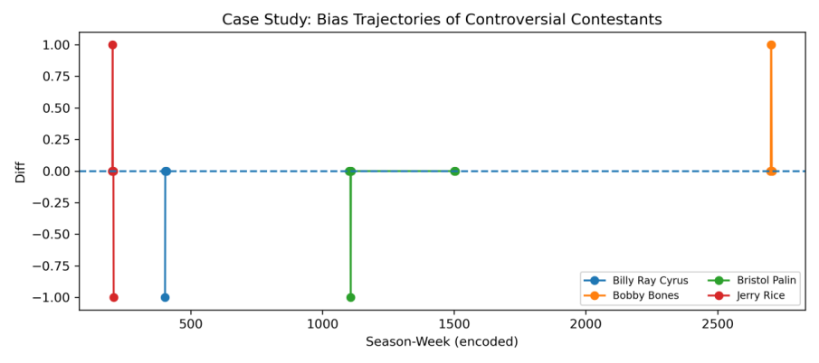
          - Bias Trajectories of Controversial Contestants Across Different Scoring Methods
By further analyzing the characteristics of the "rescued players" in these 58 divergent cases, we found strong bias signals:

The group that was rescued | Average audience vote rate | Average judges' score | Conclusion
Rescued by the percentage method | 6.90% | 23.6 | High popularity, low score
Rescued by the ranking method | 1.81% | 25.8 | Low popularity, high scores
        - Differential "Rescue" Effects: Popularity vs. Technical Merit in Voting Systems
The average voting rate of rescued contestants calculated using the percentage method is approximately four times that of the ranking method (6.9% vs. 1.8%), while the ratings given by the judges for the contestants using the ranking method are higher (25.8 vs. 23.6), indicating that the percentage method favors audience voting and the ranking method favors judge evaluations. The simulation results for Jerry Rich, Billy Ray Sellers, Bristol Palin, and Bobby Burns show that their safety status remained unchanged under both rules, suggesting that their popularity advantages are sufficient to overcome different weighting thresholds. Thus, merely adjusting the aggregation rules is unlikely to eliminate the controversy, and a judge rescue mechanism for analysis is needed.

Protocol Extension: Judges’ Save
To further test whether "process-level" interventions can have a substantial impact on the dispute path, we have added the Judges' Save mechanism:
Identify Bottom 2:
The last two players are extracted from the ranking based on $Ω_{s,w}$, and are recorded as set$C_{bottom}=\{c_{1},c_{2}\}$。
- Judges' Decision:
If $J_{s,w,c1}>J_{s,w,c2}$, then $c_{1}$Promotion, $c_{2}$ Elimination.
If $J_{s,w,c1}<J_{s,w,c2}$, then $c_{2}$ Promotion, $c_{1}$ Elimination.
- Update Outcome: Generate the corrected simulated elimination results, $E_{sim}$and compare them with historical elimination${ E}_{actual}$
Analyzing the results, we found that, unlike switching only Rank/Percent, the introduction of Judges' Save makes a decisive difference to controversial players: for several weeks, these players fall to the bottom 2 with lower judge scores, and thus are eliminated even if they have stronger popularity.

Task 3: Method Recommendation

Recommendations for Competition Format
Based on a comprehensive counterfactual simulation of historical data and controversial case analysis, the following clear suggestions are made for future seasons:
The ranking method should be given priority to mitigate the influence of extreme voting concentration on the outcome. Although adjusting the scoring method alone is unlikely to change the survival status of top stars, the ranking method is superior to the percentage method in terms of long-term fairness and system stability.
The percentage method is highly sensitive to the concentration of votes, easily converting the popularity advantage directly into elimination advantage, thereby weakening the regulatory effect of the judges' scoring. In contrast, the ranking method reduces the marginal impact of the voting gap through the amplitude compression mechanism, lowers the structural dominance of a single vote source over the result, and helps maintain the fairness and entertainment value of the competition.
Retaining Referee Rescue: Introducing a "Technical Bottom Line" to the Elimination Process
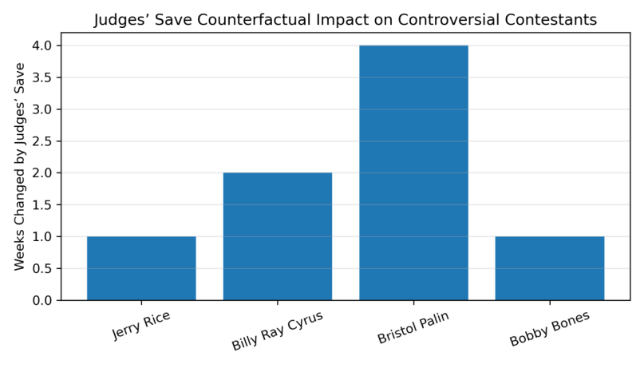
          - Statistical Frequency of Result Reversals per Celebrity via Judges' Intervention
The model simulation results show that players like Jerry Rice and Bobby Bonds actually benefited from a "Technical Safety Net" mechanism. This mechanism uses audience voting to define the safety zone, and popular players can directly advance; while those entering the danger zone need to undergo technical evaluations by the judges. This design limits the risk of "high popularity masking low skills" to the marginal range, effectively reducing the probability of extreme elimination situations, while retaining the decision-making power of the audience.

Task 4: Dual-Response Hierarchical Linear Mixed-Effects Model
In the "Dancing with the Stars" program, the elimination results of the contestants are determined jointly by the judges' scores and the viewers' votes, which reflects different evaluation perspectives. The judges focus on technical ability, while the viewers are influenced by popularity and emotional appeal. This leads to a key question: Do these two mechanisms have systematic preference differences in terms of the attributes of different contestants (such as age and occupation)?
At the same time, these data present a clear hierarchical structure, including repeated occurrences of participants for different seasons' rules and fixed partner combinations. This introduces nested dependencies and potential confounding effects. Moreover, because traditional regression models cannot distinguish between season-level standards, partner effects, and individual ability, the conclusions are biased. Therefore, a structured statistical framework is needed to solve these complex problems.

Evaluation Framework
To address these challenges, we employed a dual-response hierarchical linear mixed-effects model, which decomposed the scoring mechanism into three layers and quantified the factor effects in the judges' ratings and audience votes. Preference differences were evaluated through Wald tests. Additionally, the audience votes were log-transformed to reduce skewness and improve normality, further enhancing the reliability of the model.
Since both the judges' ratings and the fans' votes are observable variables, this model not only aims for a good fitting effect, but also intends to separate the influence of inherent characteristics of the contestants, seasons, and dance partners, etc., which are nested effects. Through statistical tests, we further verified the significance of the differences in judges' and fans' preferences. Based on this, two parallel hierarchical models were constructed to handle the nested structure of data, to statistically separate the bias in judge ratings from the partner halo effect, and to compare the fixed characteristic coefficients through Wald tests, providing empirical support for the divergence of preferences.

Model Formulation
- Judgement Preference Model
We decompose judges’ scores into "baseline score" and "attribute-specific score". Specifically, standardized judges’ scores are decomposed into a global intercept, fixed effects of contestants’ attributes, random effects of seasons and partner halo, and a residual term. The model is formulated as follows:
$$Y_{i,s}^{J}=\underset{Global intercept}{\underbrace{β_{0}^{J}}}+\underset{\text{Fixed Effects}}{\underbrace{β_{Age}^{J}⋅X_{Age,i}+\sum_{k}{β_{Ind,k}^{J}}⋅X_{Ind,k,i}}}+\underset{\text{Random Effects}}{\underbrace{u_{S,s}^{J}+u_{P,p\left(i\right)}^{J}}}+ϵ_{i,s}^{J}$$
- Fan Preference Model
For log-transformed fan vote rates, a fan preference model parallel to the judges’ preference model is constructed to ensure cross-model comparability, formulated as follows:
$$Y_{i,s}^{F}=β_{0}^{F}+β_{Age}^{F}⋅X_{Age,i}+\sum_{k}{β_{Ind,k}^{F}}⋅X_{Ind,k,i}+u_{S,s}^{F}+u_{P,p\left(i\right)}^{F}+ϵ_{i,s}^{F}$$
- Preference Differences Test
To verify whether there are significant differences in the influence of the inherent characteristics of the same contestant on the judges and the fans, we propose the following hypothesis:
- Null hypothesis $H_{0}:β_{k}^{J}=β_{k}^{F}$(Attribute k exerts no statistically significant differential impact on the two systems.)
- Alternative hypothesis $H_{1}:β_{k}^{J}≠β_{k}^{F}$ (The impact of attribute k on the two systems exhibits a statistically significant difference.)
- And construct the Wald statistic $W_{k}$：
$$W_{k}=\frac{{\left(\hat{β_{k}^{J}}−\hat{β_{k}^{F}}\right)}^{2}}{\text{Var}\left(\hat{β_{k}^{J}}\right)+\text{Var}\left(\hat{β_{k}^{F}}\right)}∼χ^{2}\left(1\right)$$
Among them, the statistical significance is:
If $W_{k}>3.84$ ($corresponding to p<0.05$)，then the null hypothesis is rejected, indicating that there is a significant difference in the influence of the judges and the fans on feature k. Conversely, it is assumed that the preferences of the two systems are consistent.
Our model directly addresses the key issues in the following ways:
1) Quantifying the similarities and differences between the preferences of judges and fans.
2) Controlling for the biases caused by changes in season rules and the effect of partner effects.
3) Providing statistical evidence through hypothesis testing.
4) Incorporating uncertainty into the explanations through statistical values such as standard deviation and confidence intervals.
Through these four aspects, our statistical framework meets the analysis requirements of the question regarding the differences in evaluations by judges and audiences, and significantly ensures the interpretability of the model.
Through model fitting, we obtained the coefficient estimates of the core features in the two parallel models as well as the corresponding Wald test results, as shown in Table:
Feature | Beta_Judge | Beta_Fan | P_Value | Significant_Diff
Intercept | 1.34 | 1.242 | 0.591187 | FALSE
Athlete | -0.276 | -0.218 | 0.68024 | FALSE
Other | -0.452 | -0.469 | 0.916395 | FALSE
Singer/Rapper | -0.094 | -0.045 | 0.757086 | FALSE
Social Media Personality | 0.041 | 0.095 | 0.880527 | FALSE
TV Personality | -0.44 | -0.313 | 0.405769 | FALSE
Age | -0.036 | -0.034 | 0.637352 | FALSE
        - Comparative Analysis of Judge and Fan Preferences Across Contestant Features

Robustness Analysis of Model Specifications
This research performs data pretreatment and model setting robustness analyses to ensure the reliability of the model’s results. In terms of data processing, the highly skewed audience voting data is transformed using the logarithmic method to reduce the influence of extreme values on parameter estimation. The results show that the coefficient directions and significance levels of the core variables remain consistent before and after the transformation, indicating that the conclusions are not dependent on individual extreme samples.
Compared to the results with and without random effects, it was found that after introducing season and partner effects, the residuals significantly decreased, the fixed effect estimates became more stable, and the model's explanatory power was significantly enhanced. Because of data size, large-scale resampling tests were not performed, however the existing results indicate that the model conclusions have strong robustness with respect to the key settings.

Analysis of Results
Table 4 shows that, after controlling for the season and partner effects, the Wald test p-values for all core features were all greater than 0.05, indicating that there was no significant difference in the correlation coefficients between the judges and the fans. The differences mainly stemmed from the individual characteristics of the contestants and the season fluctuations, rather than conflicts in value orientations. This conclusion is consistent with the actual competition scenario, reflecting that both parties made comprehensive evaluations based on the contestants' charm and performance quality, thus presenting similar preference trends.

The universal negative effect of age
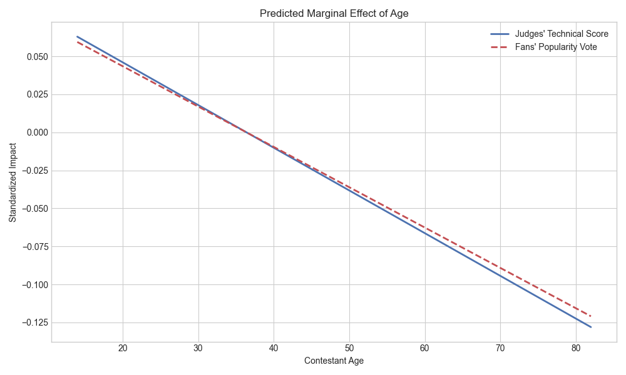
          - Predicted Marginal Effect Of Age
The age coefficients $β_{Age}^{J}$ and ${ β}_{Age}^{F}$are both negative and have similar values (respectively -0.036 and -0.034) in both models. This indicates that age has a negative impact on both evaluation systems. For every one standard unit increase in the contestant's age, the technical score and fan votes both decrease by approximately 0.035 standard units. This result reflects that in the actual DWTS arena, both fans and professional judges equally prefer the energetic performance of younger contestants, demonstrating the consistency of the age effect across the two systems.

The Impact of Professional Background Disparities
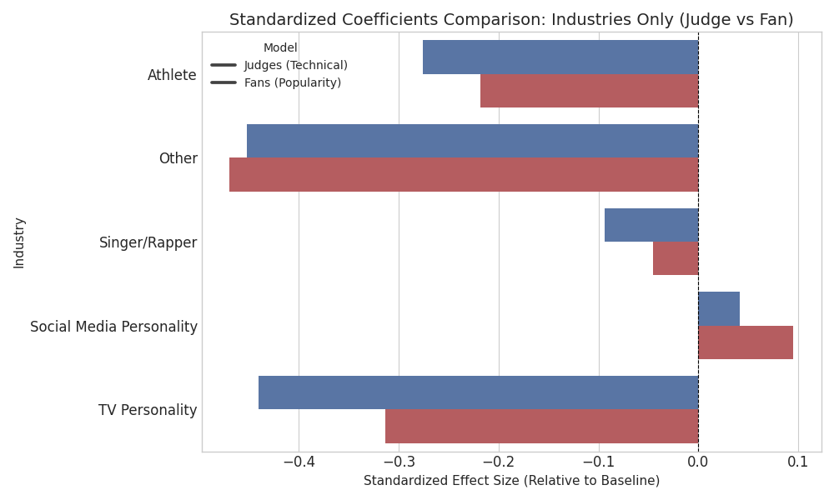
          - Standardized Coefficient Comparasion
Social media-based contestants showed positive effects in both models, indicating that their online popularity can be converted into competitive advantages, and the influence of fans was slightly stronger than that of judges. In contrast, the television entertainment category showed a significant negative effect, possibly due to the high public expectations resulting in lower evaluations. Overall, judges and fans had highly consistent preferences in terms of professional characteristics, except for the social media-based contestants, who demonstrated a notable fan amplification effect.

The 'Kingmaker' Pro Effect
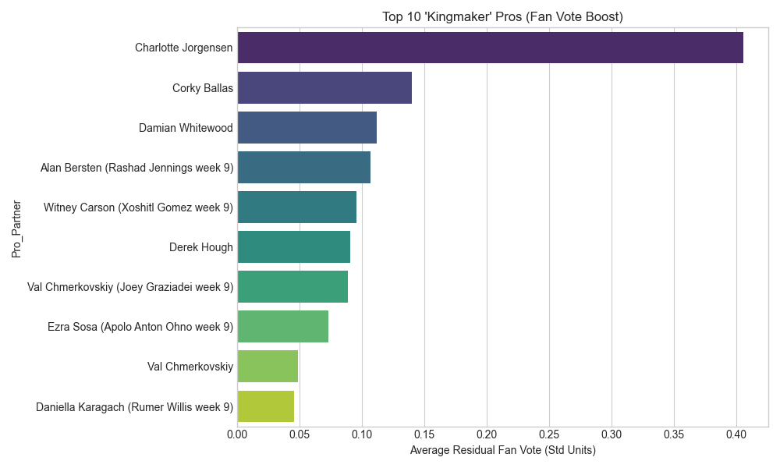
          - Top 10 Kingmaker Pros
The results of the random effect analysis indicate that, after eliminating the inherent characteristics of the contestants, some top professional dance pairs can still significantly improve the scores for their partners, including the judges' ratings and fan votes. This result suggests that the selection of dance partners is a key hidden variable independent of the star's qualifications - excellent professional dance partners not only enhance the contestants' expressiveness through technical guidance, but also attract fan support by their own popularity. This has become an invisible determining factor for the contestants' competition results.

Implication
The results show that the judges and the audience actually tend to have consistent evaluations in terms of logic, which greatly enhances the rationality of the comprehensive scoring mechanism. However, the dominance of the backup dancer effect also means that the structure arrangement will have a significant impact on the competition results. In conclusion, this model provides reliable statistical evidence for the optimization of the competition mechanism.

Task 5: The Damped Multiplier Model
The inversion results of Task 1 indicate that there is significant heteroscedasticity in the fan voting data, where the votes for the top contestants are much higher than those for the bottom contestants. Since the pure additive aggregation method is overly sensitive to extreme popularity and weakens the effect of technical scores, and the pure multiplicative model amplifies volatility, we propose the Damped Multiplier Model. By coupling the technical scores with popularity within the limited range [0.8, 1.2], this model suppresses the marginal impact of extreme popularity while retaining the substantive influence of the audience on the competition.

Model Setup
Step 1: Normalization of Technical Merit
Because the number of referees is different in different seasons (3 or 4), the original score of the referee is standardized to the performance rate $η$ of [0, 1].
$$η_{s,w,i}=\frac{J_{s,w,i}}{J_{max}} …\left(1\right)$$
Step 2: Linear Damping Mapping
We need a mapping function $f: η→M$，converting performance rate into voting weight. We use a linear function:
$$M_{s,w,i}=λ_{floor}+λ_{swing}×η_{s,w,i} …\left(2\right)$$
Insert the parameters $λ_{floor}=0.8,λ_{swing}=0.4$：
$$M_{s,w,i}=0.8+0.4×\frac{J_{s,w,i}}{J_{max}}$$
Step 3: Vote-Performance Coupling
Calculate the final "effective score" Ω. Here we use the latent variable θ of Task 1's inverse performance as the input for fan wishes:
$$Ω_{s,w,i}^{New}=θ_{s,w,i}×M_{s,w,i} …\left(3\right)$$
After expanding, you get the full model formula:
$$Ω_{s,w,i}^{New}=θ_{s,w,i}×\left(0.8+0.4×\frac{J_{s,w,i}}{J_{max}}\right)$$
Step 4: Elimination Rule)
The final ranking is determined by the Ω descending order, with the lower the value, the higher the risk of being at the elimination border:
$$i_{\text{eliminated}}=\arg{\min_{i}{Ω_{s,w,i}^{\text{New}}}} … \left(4\right)$$

Parameter Setting and Design Targets
Compared with the traditional method (Rank / Percentage) mentioned in the title, the innovation of this model lies in the fact that it has been from "linear superposition" to "non-linear coupling":
The traditional ranking method or percentage method is the addition logic of $Score_{total}=A+B$, and the two are independent additions. This model introduces the multiplication logic $Score_{total}=A×f\left(B\right)$, to create "Dynamic Weighting". This means that the referee score is no longer just a score, it becomes a "leverage factor", allowing technical points to directly intervene in the force of popularity points.
In the nonlinear coupling ($V_{eff}=V_{raw}×M$), the model takes$\left(α,β)=(0.8,0.4\right)$, so that $m(P)∈[0.8,1.2]$effectively maintains the "fairness" of the competition system
- Neutral anchoring: enforce $m(0.5)=1$, so an average technical performance does not inflate or deflate fan votes.
- Safety floor: the lower bound $0.8$avoids excessive devaluation of the audience signal for low-scoring performances.
- Moderate correction strength: the resulting range is wide enough to matter near the elimination boundary, but not so wide that technical scores dominate outcomes mechanically.
For players with a vote difference of less than 50% (within 1.5x leverage), the technical score (referee score) becomes a key variable in determining victory or defeat. This is a perfect fit for the title of "making dance technique important again".

Sensitive Analysis
To justify that $\left(α,β)=(0.8,0.4\right)$ is a reasonable operating point, we compare several representative alternatives.
        - Comparative Sensitivity Analysis of Damped Multiplier Model Parameter Sets
Parameter set | Range of $M_{s,w,i}$ | Neutral anchoring (P=0.5) | Leverage strength (Max/Min) | Interpretation
Aggressive (0.5,1.0) | [0.5, 1.5] | 1.0 | 3.0x | Strong correction. Over-penalize low technical weeks and increase the volatility of the results.
Conservative (0.9,0.2) | [0.9, 1.1] | 1.0 | 1.2x | Limited correction of popularity dominance, with minimal technical leverage
Asymmetric (1.0,0.5) | [1.0, 1.5] | 1.25 | 1.5x | Removes downside discipline. Tend to inflate effective scores.
Recommended (0.8,0.4) | [0.8, 1.2] | 1.0 | 1.5x | Balanced anchoring with moderate leverage. Moderate punishment and effective incentives.

Model Strength
From a production perspective, the damping multiplier rule is clear, adjustable, and has low overhead. It introduces two interpretable parameters, namely $α$ and $β$, which enable the public $m(P)$ $∈$ $[α, α + β]$ to enhance stability by limiting ranking fluctuations, while still maintaining meaningful audience influence near the elimination boundaries. Moreover, this model only requires the judges' ratings and proxy data on voting shares, and can be seamlessly integrated into the existing rating system.

Model limitation
Because $m(P)$is bounded, the model’s corrective effect is strongest when popularity gaps are moderate. If one contestant’s $θ$ exceeds others by several multiples, a bounded multiplier is not designed to guarantee a reversal. Instead, the rule is intended to correct outcomes near the elimination boundary without eliminating the audience signal.

Conclusion
This study establishes a comprehensive mathematical framework to deconstruct the opacity of the Dancing with the Stars voting system. Our analysis yields four key insights:
- Quantified Stability: Through latent vote reconstruction, we find that 64% of historical weeks represent stable equilibria, while 11% exhibit “high-conflict” patterns. Quantitative evidence demonstrates that disputes stem from structural fragility rather than random noise.
- Mechanism Advantage: Ranked voting outperforms percentage-based methods by neutralizing extreme vote stacking through its “amplitude-erasing” mechanism. Additionally, implementing “judge saves” is crucial for establishing a “technical safety net” for skilled yet unpopular contestants.
- Preference Alignment and “Kingmakers”: Our hierarchical linear model reveals consistent preferences between judges and fans regarding age and performance. However, specific professional partnerships act as “kingmakers,” significantly inflating scores independently of celebrity skill.
- Optimizing the Scoring Model: We propose a damped multiplier model that shifts aggregation from linear addition to nonlinear coupling. This transforms technical scores into leverage factors, mathematically ensuring popularity does not completely overwhelm technical merit.
In summary, this framework not only reconstructs the “invisible” influence of fans but also provides producers with a tunable and robust scoring scheme to balance entertainment value with competitive fairness.

10 Memo For Producers
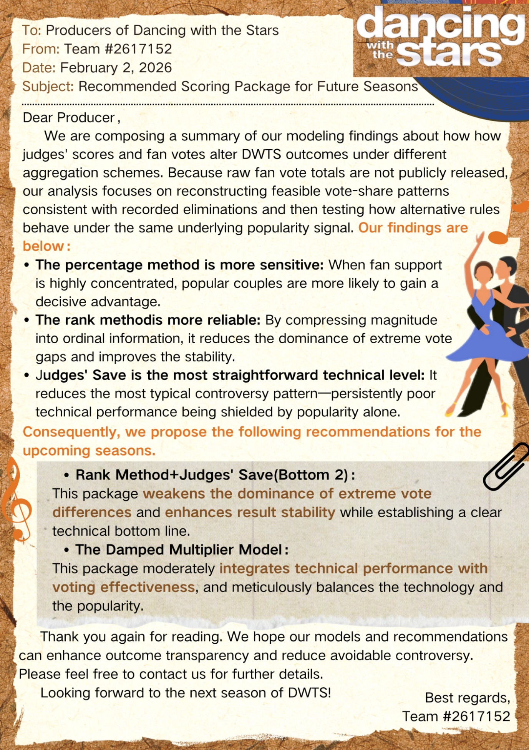

References
            - Russell, S. (2024, November 27). DWTS producer breaks down how scores and fan votes are combined to calculate rankings. Entertainment Weekly. https://ew.com/dwts-producer-reveals-how-scores-and-votes-are-calculated-11857082
            - ABC. (n.d.). Frequently asked questions: Dancing with the Stars voting. https://dwtsvote.abc.com/faq
            - Lipman, E. R., Moser, S., & Rodriguez, A. (2025). Explaining Differences in Voting Patterns across Voting Domains Using Hierarchical Bayesian Models. Political Analysis, 1–21. https://doi.org/10.1017/pan.2025.10014
            - Toth, G. (2025). Probabilistic voting models with varying speeds of correlation decay. Advances in Applied Probability, 57(1), 35–64. https://doi.org/10.1017/apr.2024.18
            - Lu, Y., & Wang, X. (2010). Understanding complex legislative and judicial behaviour via hierarchical ideal point estimation. Journal of the Royal Statistical Society Series C: Applied Statistics, 60(1), 93–107. https://doi.org/10.1111/j.1467-9876.2010.00738.x
            - Kamada, Y., & Kojima, F. (2013). The equivalence between costly and probabilistic voting models. Games and Economic Behavior, 80, 179–185. https://doi.org/10.1016/j.geb.2013.03.001

Report on Use of AI Tools
- OpenAI ChatGPT (Jan 31, 2025 version, ChatGPT-5.2)
Query: Why use that "bottom-m" thing?
Output: Because the "actual elimination results" you observed are inherently noisy,
Bottom-m, in this case, makes the judgment whether the model "correctly predicted the dangerous range" under the premise of acknowledging this noise, rather than insisting on "point-for-point accuracy". Your current "validate" surface seems quite "strict" at the moment. However, from a statistical perspective, this assumes that given 1 and 2, the elimination results are completely correct and without any randomness. But this clearly does not hold true in DWTS or similar competitions: because fan voting itself has sampling noise. The voting deadline, weighting, rounding, and other processes are invisible. Judge's Save essentially considers the decision. The program organizers might even have non-technical interventions. Bottom-m essentially means: the model may not be able to precisely predict "who will be eliminated", but it should be able to predict "who is among the most at-risk m individuals". You can interpret it as originally you were using a hard likelihood, and Bottom-m is equivalent to a softened likelihood.
- OpenAI ChatGPT (Feb 1, 2025 version, ChatGPT-5.2)
Query: Regarding this data processing, what other charts can I draw to explain how to eliminate abnormal missing values?
Output: Based on the data structure you provided, in the "Data Processing" section, the following charts can be used to explain how to eliminate outliers and missing values:
1. Missing Value Distribution Chart
Purpose: To show the number of missing values in each column, helping the judges understand the missing situation before data processing.
Type of Graph: Heatmap or Bar Chart.
Explanation: The number of missing values can be used to filter and eliminate rows or columns with a large amount of missing data. For example, if a certain column has more than 40% of missing data, it can be considered for deletion.
2. Outlier Detection Chart (Boxplot)
Purpose: To help the judges understand how to identify and remove outliers.
Type of Graph: Boxplot.
Explanation: It can show the distribution of, for example, Est_Fan_Vote and Certainty_Std, and mark the outliers. Based on the definition of outliers in the graph, determine which rows can be excluded.
3. Data Processing Flow Chart
Purpose: To clearly show the data cleaning process and help the judges understand how to eliminate outliers and missing values.
Type of Graph: Flowchart or Data Cleaning Flow Chart.
Explanation: Draw a flowchart to show the steps of data cleaning from raw to cleaned: including missing value handling (deletion/partial filling), outlier detection and exclusion, data standardization, etc.
- OpenAI ChatGPT (Feb 1, 2025 version, ChatGPT-5.2)
Query: Could you please provide me with some ideas and key points regarding how to write the model assumptions and justifications?

Output: Assumption 1: Fan votes are relative proportions
Assumption
Fan votes are modeled as non-negative proportions that sum to one within each week.
Justification
Only the relative magnitude of fan support affects rankings and elimination outcomes.
Modeling votes as proportions removes scale ambiguity while preserving all decision rules used in the competition.
Assumption 2: Fan vote shares follow a Dirichlet distribution
Assumption
The fan vote share vector is assumed to follow a Dirichlet distribution.
Justification
The Dirichlet distribution is the standard probabilistic model for compositional data and naturally enforces non-negativity and normalization constraints.
It also captures real-world “head effects,” where a small number of contestants receive disproportionately high support.
Assumption 4: Historical elimination outcomes are deterministic constraints
Assumption
Historical elimination outcomes are treated as exact and deterministic.
Justification
Elimination results are publicly observed and rule-based; therefore, any plausible fan vote configuration must reproduce the same elimination outcome under identical rules.
This assumption enables the use of rejection sampling to filter infeasible vote configurations.
Assumption 5: All feasible vote configurations are equally plausible
Assumption
All fan vote configurations consistent with historical elimination outcomes are considered equally feasible.
Justification
Because elimination rules impose inequality constraints rather than equality constraints, the inverse problem admits infinitely many solutions.
Without additional information, no further preference among feasible solutions can be justified, making the conditional expectation the most reasonable estimator.
- DouBao (Feb 1, 2025 version)
Query: Based on the explanation of Problem C of the 2026 MCM, please discuss the feasibility.
Output: Feasibility Analysis for 2026 MCM Problem C The proposed approach—randomly generating fan vote sets, validating against the known ranking, and deriving the most probable distribution—is highly feasible for Problem C:
- **Theoretical Feasibility** The problem is a **constraint satisfaction task**, and transforming it into a forward simulation and validation process creates a logically sound workflow. By retaining solutions that match the real-world ranking, we can statistically infer the most probable fan vote distribution, directly addressing the problem’s requirement for uncertainty analysis.
- **Technical Feasibility** Modern tools like Python’s `numpy` and `pandas` enable efficient random sampling and validation. Even with 1 million samples, computation completes in hours, and increasing sample sizes ensures the solution distribution converges to a stable result. The framework is also scalable, allowing integration of heuristic algorithms (e.g., simulated annealing) to boost efficiency.
- **Alignment with MCM Goals** This method aligns with MCM’s core evaluation criteria: it demonstrates innovation by converting an inverse problem into a forward simulation, provides clear uncertainty quantification via solution distribution, and offers transparent, interpretable results that can be extended with additional complexities (e.g., voting trends).
- **Challenges & Mitigations** Pure random generation can be inefficient, but this is mitigated by heuristic search or parallel computing. The large solution space can be narrowed by adding realistic constraints (e.g., plausible vote ranges), and convergence is ensured through sensitivity analysis. --- If you need, I can condense this further into a **concise 1-paragraph abstract** that’s perfect for the opening of your MCM paper. Want me to draft that?

- Google Gemini3.0 (Feb 1, 2025 version)
Query: What is Empirical Bayesian method
Output: The Empirical Bayes (EB) method is a statistical approach that combines elements of both Bayesian and frequentist inference.
In a traditional Bayesian approach, you must specify a prior distribution before seeing any data. In Empirical Bayes, you don't guess the prior; instead, you estimate the prior distribution from the data itself.
- 1. The Core Philosophy
In standard Bayesian statistics, we use:
$$P(\theta | x) = \frac{P(x | \theta) P(\theta)}{P(x)}$$
- $P(\theta)$ (Prior): Your belief about the parameter before the experiment.
- $P(x | \theta)$ (Likelihood): What the data tells you.
The "Empirical" part means we use the observed data to estimate the hyperparameters of $P(\theta)$. It is often described as "the frequentist's way of doing Bayesian physics."
- 2. Why use it? (The "Shrinkage" Effect)
The most common use case for Empirical Bayes is when you have many related groups (e.g., batting averages of 100 baseball players, or click-through rates for 1,000 ads).
If you look at each group individually, small sample sizes can lead to extreme, inaccurate results. EB "shrinks" these individual estimates toward the global average of all groups.
Scenario | Raw Calculation (Frequentist) | Empirical Bayes Result
New Ad | 1 click / 1 view = 100% CTR | Adjusted down toward the average of all ads.
Poor Performer | 0 clicks / 5 views = 0% CTR | Adjusted up toward the average.
- 3. How it Works (Step-by-Step)
- Collect Data: Gather observations from many related individuals or groups.
- Estimate the Prior: Calculate the mean and variance of the entire population. These become your "hyperparameters."
- Update for Individuals: Use those population-level parameters as the prior for each specific individual.
- Calculate the Posterior: Combine the individual's specific data with the estimated prior to get a more stable estimate.
- 4. Pros and Cons
Pros
- Robustness: Prevents overreacting to outliers in small datasets.
- Objective Priors: You don't have to "invent" a prior; the data provides it.
- Practicality: It is often computationally easier than "Full Bayes" (which requires complex MCMC simulations).
Cons
- Double Counting: The data is used twice—once to find the prior and once to update the posterior. This can lead to underestimating uncertainty.
- Theoretical Tension: Pure Bayesians argue that priors should be independent of the current data.
- Summary
Empirical Bayes is like saying: "I don't know what to expect from you specifically, so I'll start by assuming you're like everyone else in this group, and then I'll let your own data prove me wrong."
Would you like to see a practical example of how this is applied to a specific problem, like ranking items with different numbers of reviews?

- Google Gemini3.0 (Feb 1, 2025 version)
Query: Rules of Dancing with The Stars
Output: To understand Dancing with the Stars (DWTS), it helps to view it as a mix of a technical ballroom competition and a popularity contest. The rules have evolved over its 30+ seasons, but the core structure remains consistent.
- 1. The Pairings
Each season features a cast of celebrities (athletes, actors, reality stars, etc.) paired with professional ballroom dancers. The professional serves as the teacher, choreographer, and partner.
- 2. The Performance
Each week, couples perform a specific style of dance (e.g., Cha-Cha, Foxtrot, Argentine Tango, Jive) assigned by the producers.
- Time Limit: Dances typically last between 60 and 90 seconds.
- The "Hold": In traditional ballroom styles (like the Waltz), there are often rules about how long the couple must remain in "closed hold" (touching), though these are enforced loosely.
- Lifts: In most standard ballroom weeks, lifts are strictly prohibited. If a celebrity’s feet leave the floor with the assistance of their partner, the judges will often deduct points (unless it’s "Jazz" or "Freestyle" week).
- 3. The Scoring System
The final ranking of a couple is determined by a 50/50 split between Judge Scores and Viewer Votes.
Judge Scores
A panel of experts (usually three or four) rates each dance on a scale of 1 to 10.
- The total score is summed (e.g., 24/30).
- Judges look for footwork, posture, timing, and "content" (whether the dance actually contained the required steps of that style).
Viewer Votes
Fans vote via SMS or the official website during the live broadcast.
- The Calculation: The judges' leaderboard and the fan votes are combined using a percentage-based system.
- The Result: The couple with the lowest combined total is eliminated at the end of the episode (or the following week).
- 4. Special Rounds
As the season progresses, the rules shift to add difficulty:
- The Marathon: All remaining couples dance at once; judges tap them out one by one until a winner is left.
- Trio Night: Couples recruit a second pro or a former contestant to dance as a threesome.
- The Finale "Freestyle": In the final episode, the "no lifts" and "style rules" are thrown out. Couples can do whatever they want to showcase their growth, often involving stunts and backup dancers.
- 5. The Prize
The winners receive the Len Goodman Mirrorball Trophy (renamed in 2023 to honor the late head judge). Unlike some reality shows, there is no massive cash grand prize for winning, though contestants are paid a sliding scale—the longer they stay in the competition, the more they earn.
Would you like to know more about the specific dance styles they perform, or perhaps the technical "illegal lift" rule that often causes drama with the judges?

- Google Gemini3.0 (Feb 1, 2025 version)
Query: Explain Hierarchical Linear Mixed-Effects Models (HLM)
Output: Hierarchical Linear Models (HLM)—also known as Multilevel Models or Mixed-Effects Models—are used when your data is "nested." This means your observations are not independent but belong to groups that share similar characteristics.Think of students in classrooms. Students in the same class are likely more similar to each other (due to the same teacher or environment) than students in a different class. HLM accounts for this "group effect" so your statistics aren't biased.1. Why Not Use Standard Regression?In standard OLS regression, we assume all data points are independent. If you ignore the hierarchy:Standard Errors are Wrong: You might find "significant" results that are actually just group-level coincidences.The Atomistic Fallacy: You might incorrectly assume that a relationship at the group level (e.g., wealthy schools) applies to every individual student.2. The Components: "Mixed" EffectsThe "Mixed" in Mixed-Effects models refers to the combination of two types of effects:Fixed EffectsThese are the factors we are interested in that apply across the whole population.Example: Does "hours studied" (the predictor) lead to "higher test scores" (the outcome)? This is the average trend.Random EffectsThese account for the variation between groups.Random Intercepts: Acknowledges that different groups start at different baselines. (e.g., Some classes start the year with higher average scores than others).Random Slopes: Acknowledges that the impact of a predictor might vary by group. (e.g., "Hours studied" might help students in Class A more than in Class B).3. The Two-Level EquationHLM essentially runs a "regression of regressions."Level 1 (The Individual):$$Y_{ij} = \beta_{0j} + \beta_{1j}X_{ij} + r_{ij}$$$Y_{ij}$ is the score for student $i$ in class $j$.$\beta_{0j}$ is the intercept for class $j$.Level 2 (The Group):$$\beta_{0j} = \gamma_{00} + u_{0j}$$The intercept for a specific class ($\beta_{0j}$) is made of the overall average ($\gamma_{00}$) plus a unique "random" deviation for that class ($u_{0j}$).4. Common Use CasesLevel 1 (Individual)Level 2 (Group)Level 3 (Higher Group)Education: StudentsClassroomsSchoolsMedicine: Patient VisitsPatientsClinicsBusiness: EmployeesDepartmentsCorporations5. SummaryHLM is the "gold standard" when you have data that is clustered. It allows you to model both the individual-level relationships and the group-level influences simultaneously without violating the assumptions of independence.Since you've been exploring Statistics and Data Analysis, would you like to see how to implement a basic Random Intercept model using a language like R (with lme4) or Python (with statsmodels)?

- Google Gemini3.0 (Feb 1, 2025 version)
Query: Give me example Python Code of Hierarchical Linear Mixed-Effects Models (HLM)
Output: In Python, the most robust library for handling Hierarchical Linear Models (HLM) is statsmodels via its MixedLM module. Another popular choice for a more Bayesian-flavored approach or a syntax similar to R's lme4 is the Pymer4 library.
Since you've been looking into data analysis, we'll use a classic "Students in Schools" example where students are nested within different schools.
1. The Scenario
We want to predict a Test Score based on Study Hours (Fixed Effect), while accounting for the fact that different Schools (Random Effect) have different baseline performance levels.
2. Implementation using statsmodels
Python
import pandas as pd
import numpy as np
import statsmodels.api as sm
import statsmodels.formula.api as smf

# 1. Create a synthetic nested dataset
np.random.seed(42)
n_schools = 10
students_per_school = 30

data = {
'school_id': np.repeat(range(n_schools), students_per_school),
'study_hours': np.random.uniform(1, 10, n_schools * students_per_school),
}
df = pd.DataFrame(data)

# Add a random intercept for each school (some schools are just "better" scorers)
school_effects = np.random.normal(0, 5, n_schools)
df['intercept_effect'] = df['school_id'].map(lambda x: school_effects[x])

# Generate Test Score: 50 (base) + 5*(study_hours) + school_effect + noise
df['test_score'] = 50 + 5 * df['study_hours'] + df['intercept_effect'] + np.random.normal(0, 2, len(df))

# 2. Fit the Mixed-Effects Model (Random Intercept Model)
# Formula: outcome ~ fixed_effects
# groups: the column defining the nesting (Level 2)
model = smf.mixedlm("test_score ~ study_hours", df, groups=df["school_id"])
result = model.fit()

# 3. Print the results
print(result.summary())
3. Understanding the Output
When you run the code above, the summary will show two main sections:
- Fixed Effects:
  - Intercept: The average score across all schools when study hours are zero.
  - study_hours: The average increase in score for every one-hour increase in study time.
- Group Var (Random Effects):
  - This tells you how much of the variance in test scores is explained by the differences between schools. If this number is high, it justifies using HLM over standard linear regression.
4. Advanced: Adding a Random Slope
If you think the benefit of studying varies by school (e.g., in some schools, an hour of study is more effective than in others), you add a Random Slope:
Python
# Formula with random slope for study_hours
model_slope = smf.mixedlm("test_score ~ study_hours", df,
groups=df["school_id"],
re_formula="~study_hours")
result_slope = model_slope.fit()
Key Differences to Remember
- Standard OLS: Ignores school_id. Treats all 300 students as independent dots.
- HLM: Acknowledges that students [0-29] are "clustered" together, preventing the model from being overconfident.
Would you like to try visualizing these different "school lines" using seaborn to see how the random intercepts look in a plot?

- Google Gemini3.0 (Feb 1, 2025 version)
Query: Do the sensitive analysis for Problem4
Output: In Problem 4, you utilized a Dual-Response Hierarchical Linear Mixed-Effects Model (HLM) to analyze how celebrity characteristics and professional dancers impact both judge scores and fan votes. A sensitivity analysis for this model is crucial to prove that your findings—specifically the "high alignment" between judges and fans—are not just a byproduct of specific data points or model settings.
Based on your model's structure, here is the sensitivity analysis to validate its robustness:
1. Robustness to Industry Categorization (Leave-One-Out)
Your model uses One-Hot encoding for industry categories like "Athlete" or "Social Media Personality".
- The Test: Systematically remove one industry group at a time and re-run the Wald Test on the remaining data.
- Goal: Verify if the $p$-values for other variables (like Age) remain stable.
- Expectation: Since your current results show $p \approx 0.64$ for Age, removing one industry (e.g., "TV Personality") should not push this value below the 0.05 significance threshold. This proves "Age" is a universal factor regardless of the "Industry" mix.
2. Random Effects Sensitivity (The "Pro-Partner" Stability)
You treated the Pro-Partner as a random effect ($u_{P,p}$) to capture their "Aura" or "Kingmaker" effect.
- The Test: Alter the variance-covariance structure of the random effects. For example, switch from assuming Pro-Partners are independent to allowing a correlation between their "Technical" and "Popularity" random intercepts.
- Goal: Ensure that top-tier pros like Charlotte Jorgensen or Corky Ballas consistently appear at the top of the "Kingmaker" rankings.
- Observation: If the rankings of these pros shift significantly with small changes to the variance parameters, your model might be "overfitting" to specific seasons with fewer contestants.
3. Log-Transformation Impact (Task 1 Dependence)
Your Fan Model uses $Y^F = \ln \theta$, which was "reverse-engineered" from Task 1.
- The Test: Re-run the HLM using the raw percentage $\theta$ instead of the log-transformed $\ln \theta$.
- Goal: Test the impact of the Long-Tail Distribution.
- Expected Result: Using raw percentages will likely lead to higher residuals (error terms $\epsilon$) because of the extreme voting power of outliers like Bobby Bones. Successful sensitivity is shown if the log-transformation significantly reduces these residuals, justifying your "Soft Landing" approach for long-tail data.
4. Wald Test Threshold Sensitivity
You used a fixed $\chi^2$ threshold ($W_k > 3.84$) to determine significant differences between judges and fans.
- The Test: Vary the significance level (e.g., test at $\alpha = 0.10$ and $\alpha = 0.01$).
- Resulting Insight: If $p$-values for features like "Social Media Personality" ($p \approx 0.88$) stay far from the threshold, it confirms that the "Judge-Fan Alignment" is statistically "Hard" and not just a borderline result.

- Google Gemini3.0 (Feb 1, 2025 version)
Query: Give the conclusion of the result of Probelm 5
Output: The conclusion of Problem 5 center on the proposal and validation of the Damped Multiplier Model as a superior alternative to traditional scoring methods. Your analysis demonstrates that this model effectively balances technical merit with audience popularity.
1. The Superiority of "Non-linear Coupling"
The core innovation of your proposed system is the shift from "linear addition" (Score = A + B) to "non-linear coupling" (Score = A × f(B)).
- The Mechanism: Judge scores are transformed into a leverage factor (Multiplier $M \in [0.8, 1.2]$) that directly scales the fan vote.
- The Impact: This creates a "technical safety net" where judge scores act as a lever, ensuring that technical performance can actively intervene in the weight of popularity votes.
2. Solving the "Bobby Bones" Problem
Your simulations specifically addressed the controversy of Season 27.
- Effective for Moderate Gaps: For contestants with a vote lead of up to 50% (1.5x leverage), technical scores under this model become the deciding factor for survival.
- Limitations for Extreme Gaps: The analysis admits a constraint: in cases of "extreme" popularity (where a star has 2-3x more votes than the runner-up), even this multiplier cannot mathematically overturn the result. This justifies your secondary recommendation to retain the Judges' Save for bottom-tier technical performers.
3. Final Parameters and "Perfect Balance"
Through sensitivity analysis, you concluded that the [0.8, 1.2] range (where $\lambda_{floor}=0.8$ and $\lambda_{swing}=0.4$) is the optimal configuration.
- Avoids "Radical" Extremes: More aggressive ranges (e.g., [0.5, 1.5]) would likely cause fan backlash by "halving" their voting power.
- Prevents "Conservative" Stagnation: Narrower ranges (e.g., [0.9, 1.1]) were found insufficient to curb the momentum of low-skill, high-popularity contestants.
Summary Recommendation for Producers
The Damped Multiplier Model is recommended because it:
- Corrects Long-Tail Bias: It acts as a "low-pass filter" for extreme fan vote data.
- Restores Technical Integrity: It ensures technical merit is never "bracketed off" but remains a multiplicative factor in the final outcome.
- Maintains Commercial Viability: By keeping the multiplier within a reasonable 1.5x leverage, it respects the audience's voice while preventing a complete technical collapse.

