Report For the Final Project
- Problem and Motivation
This project investigates how client data heterogeneity and privacy mechanisms affect federated representation learning for clustering. I used the Digits dataset and five simulated clients, it compares centralized, local-only, and federated AE methods and VAE methods under IID and non-IID partitions. Update clipping and Gaussian noise are introduced to examine their effects on clustering quality, without claiming a formal differential privacy guarantee.

- Related concepts
  - Representation learning: Transforms raw inputs into features suitable for clustering.
  - Autoencoder (AE): Learns compact representations by reconstructing input data.
  - Variational autoencoder (VAE): Learns probabilistic representations using reconstruction loss and KL regularization.
  - K-means: Groups samples by minimizing squared distances to cluster centers.
  - Federated learning: Trains a shared model through collaboration between clients.
  - FedAvg: Aggregates client model parameters, weighted by local training sample counts.
  - IID / non-IID: Similar or heterogeneous data distributions across clients.
  - Update clipping: Limits the L2 norm of each client’s model update.
  - Gaussian noise: Adds random perturbations to the aggregated update.

- Dataset and client partition
The scikit-learn Digits dataset contains 1,797 grayscale images of size 8 × 8. Each image is flattened into 64 features and normalized to [0, 1]. The data are split into 1,437 training samples and 360 test samples. Five clients are simulated: IID partitions distribute shuffled samples approximately evenly, while non-IID partitions assign two digit classes to each client. Both the split and partition seeds are fixed at 47.

- Methods
I compare raw features, PCA, and centralized AE/VAE representations using K-means. The local-only baseline trains an independent AE and K-means model on each client. Federated AE and VAE models alternate between local training and data-size-weighted FedAvg aggregation. AEs minimize reconstruction loss, while VAEs additionally use a weighted KL term and use posterior means as clustering features. K-means is fitted on training representations and evaluated on test representations. Privacy variants clip individual client updates and add Gaussian noise to the aggregated update.

- Threat model and privacy mechanism
I assume honest clients and an honest-but-curious server that follows the protocol but may inspect uploaded model parameters and sample counts to infer information about client data. The server clips each client’s model update before weighted aggregation and adds Gaussian noise to the aggregated update. Because the server receives individual parameters before these operations, the mechanism does not hide them from the server. Secure aggregation and privacy accounting are not implemented, so the experiment evaluates the utility effects of clipping and noise without establishing a formal differential privacy guarantee.

- Experimental setup
Experiments run on the CPU using Adam with a learning rate of 0.001 and batch size of 64. AE and VAE models use 128-unit hidden layers and a 16-dimensional latent space, with VAE KL weight β = 0.01. Centralized and local-only models train for 50 epochs; federated models run for 200 rounds, with all five clients participating and one local epoch per round. Stage 6 uses clipping threshold C = 0.5 and noise multipliers of 0.00, 0.01, 0.05, and 0.10. The ablation’s full method uses C = 0.3 and noise standard deviation 0.005. Mean ARI, NMI, and Silhouette scores are reported across seeds 47, 48, and 49.

- Results
Results are averaged across three training seeds.
Methods | Partition | ARI | NMI | Silhouette
Raw + K-means | Centralized | 0.6994 | 0.7800 | 0.1764
PCA + K-means | Centralized | 0.6975 | 0.7756 | 0.2206
AE + K-means | Centralized | 0.6750 | 0.7623 | 0.2187
VAE + K-means | Centralized | 0.7195 | 0.7909 | 0.1685
Federated AE | IID | 0.6918 | 0.7727 | 0.2443
Federated AE | Non-IID | 0.7129 | 0.7852 | 0.2169
Federated VAE | IID | 0.6066 | 0.7189 | 0.2237
Federated VAE | Non-IID | 0.6818 | 0.7635 | 0.2257
Federated AE + clipping/noise | Non-IID | 0.6506 | 0.7484 | 0.2180
Centralized VAE achieved the highest ARI and NMI, whereas centralized AE remained below Raw despite L2 normalization. Non-IID partitioning reduced federated performance, with VAE outperforming AE under both partitions.

- Visualization and discussion
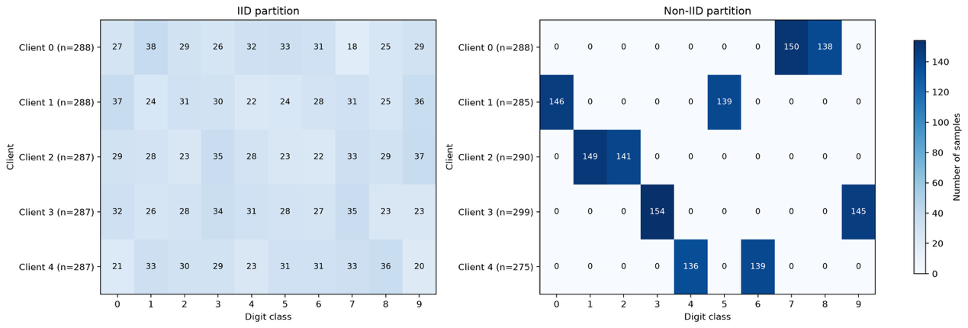
IID clients contain samples from all ten classes, while each Non-IID client contains only two classes. This confirms substantial label heterogeneity despite similar client sizes.
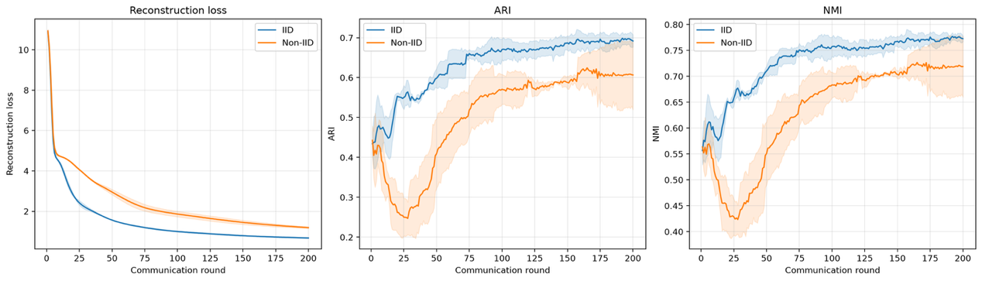
Reconstruction loss decreases under both partitions. However, Non-IID ARI and NMI initially decline before recovering, showing that better reconstruction does not necessarily produce better clustering. IID achieves higher final ARI (0.6918 vs 0.6066). Shaded bands represent variability across three seeds
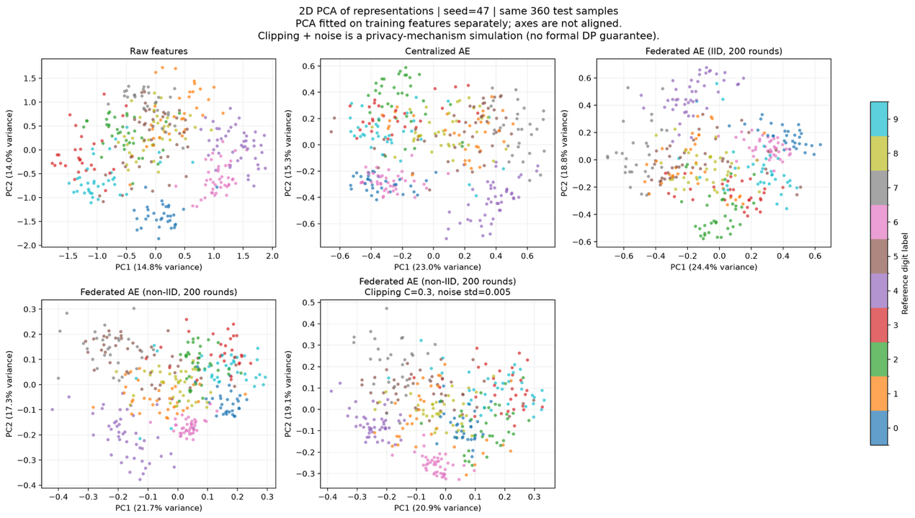
The plots show two-dimensional PCA projections of the same 360 test samples for seed 47, coloured by true labels. Some classes form distinct groups, while substantial overlap remains. Federated training and clipping/noise change the geometry without clearly separating every class. Because PCA is fitted separately for each representation and retains only two dimensions, panel positions and apparent separation cannot directly determine the ranking of full-dimensional clustering performance.

- Limitations
Federated training runs in a single process and does not evaluate network costs, client dropout, or hardware differences. Clipping and noise provide a mechanism simulation; without privacy accounting or secure aggregation, the experiments do not establish a formal differential-privacy guarantee or hide individual updates from the server.

