[1]在ubuntu打开Remmia Remote Desktop Client
[2]点击新建，Protocol选择VNC-Virtual Network Computing
[3]name :lab2_domestic_5910
[4]password:openstack
[5]server:114.119.4.74:5910
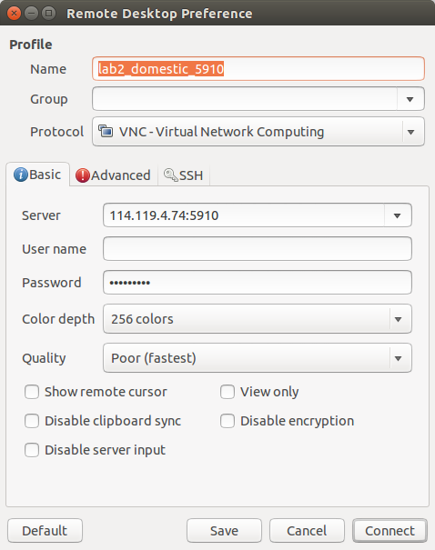
[6]点击connect

