docker run -it bvlc/caffe:cpu ipython

docker run -it bvlc/caffe:cpu

caffe --version

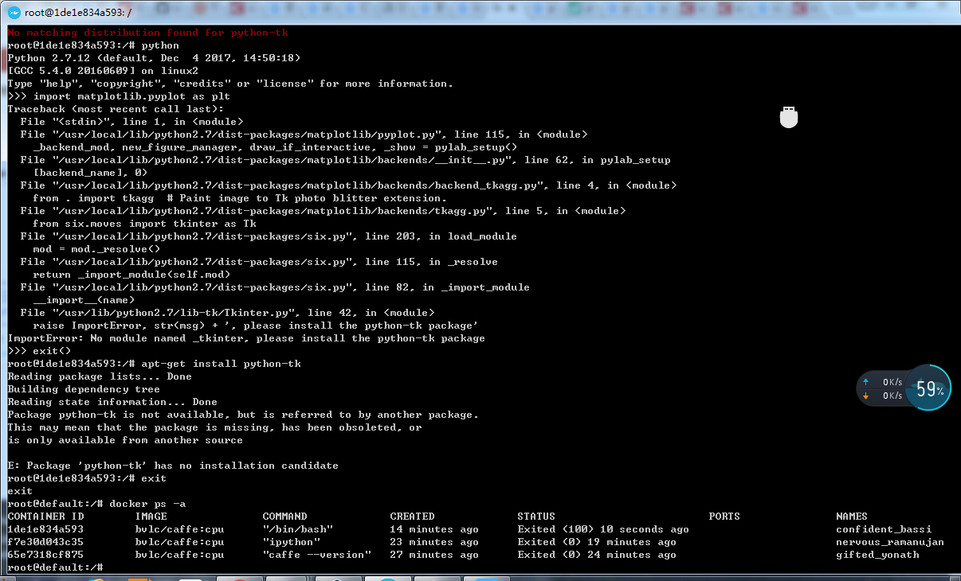

安装python3.6

<https://www.jb51.net/article/123678.htm>

移动disk.vmdk：<https://www.cnblogs.com/canger/p/9028723.html>

ImportError: No module named _tkinter, please install the python-tk package

解决：sudo apt-get install python-tk

Caff 分类：http://www.cnblogs.com/denny402/p/5111018.html