目录

一.数据集 1

二.队伍构成 1

三.性能测量指标 1

四.卷积神经网络结构图（利用tensorboard绘制） 2  
五.其他参数变化图  
 1.交叉熵 3

2.第一层神经网 weight、baises和output 3  
3.第二层神经网 weight、baises和output 5

源码在第六页  
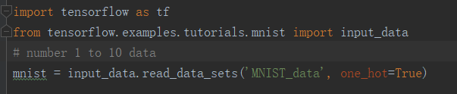一.数据集  
tensorflow自带的手写体数字数据集，通过一下语句下载并导入调用

二.队伍构成  
管胡昊（队长） 班级：计1708 学号：20174725

## 三.性能测量指标 数据集名称：MNIST

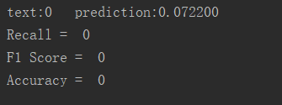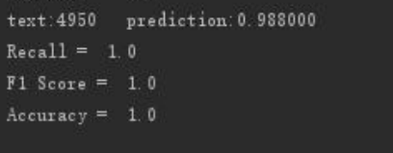

未训练时的各项参数 100个数据为一组5000组后的参数  
PS：recall和F1会在前100次内迅速提到1.0，并很少波动，不知是否哪里设置出现了问题

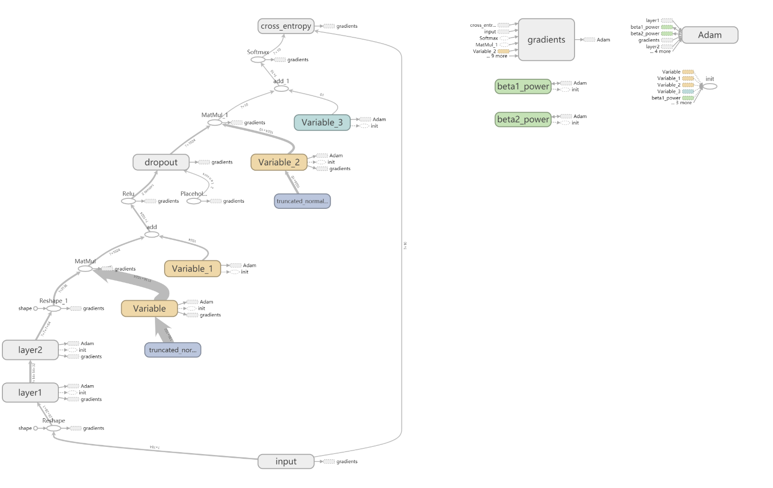四.卷积神经网络结构图（利用tensorboard绘制）

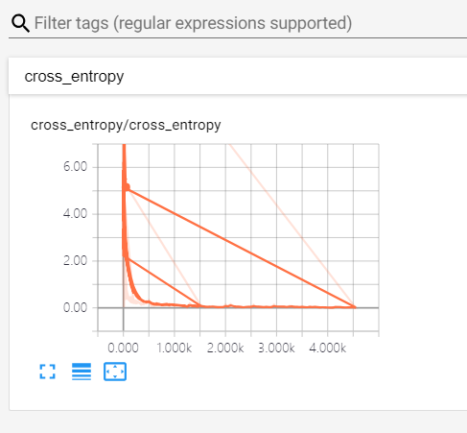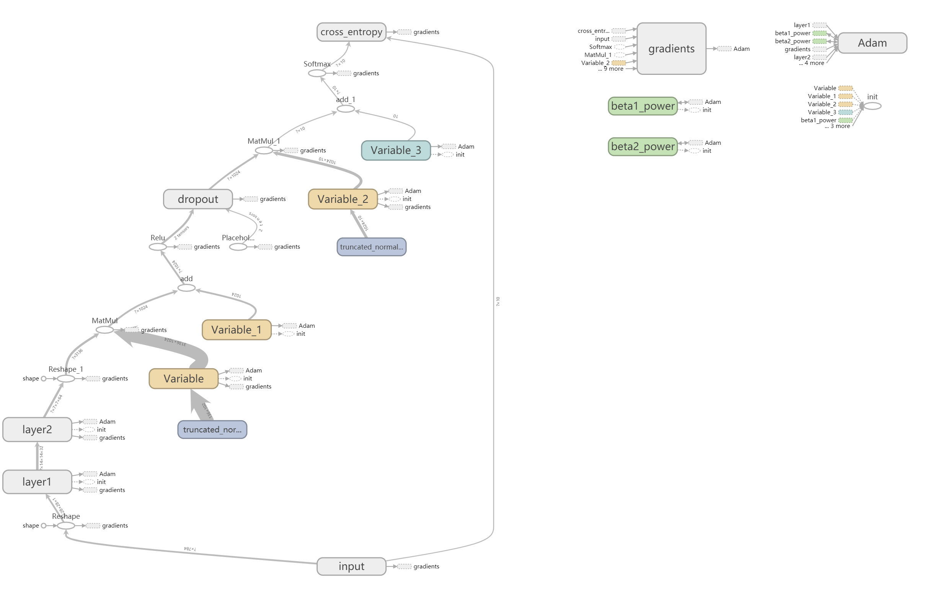  
  
  
  
  
  
  
  
  
  
  
  
五、其他参数变化  
  
1.交叉熵

2.第一层神经网 weight、baises和output  
  
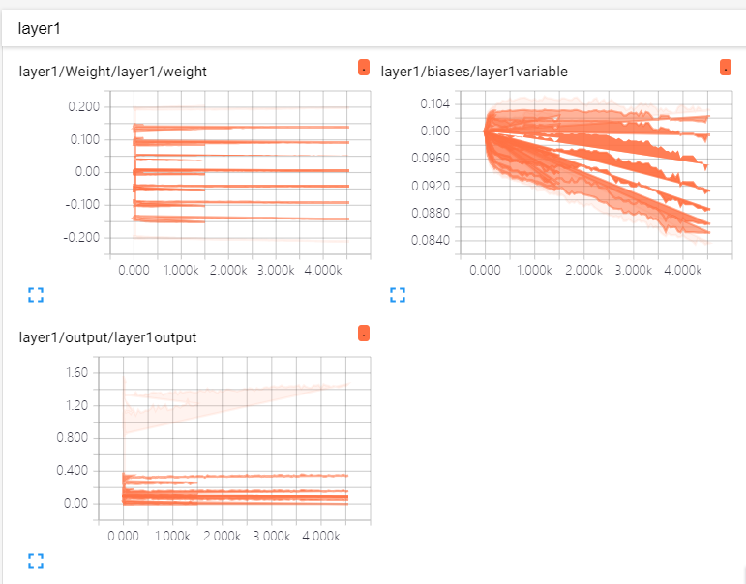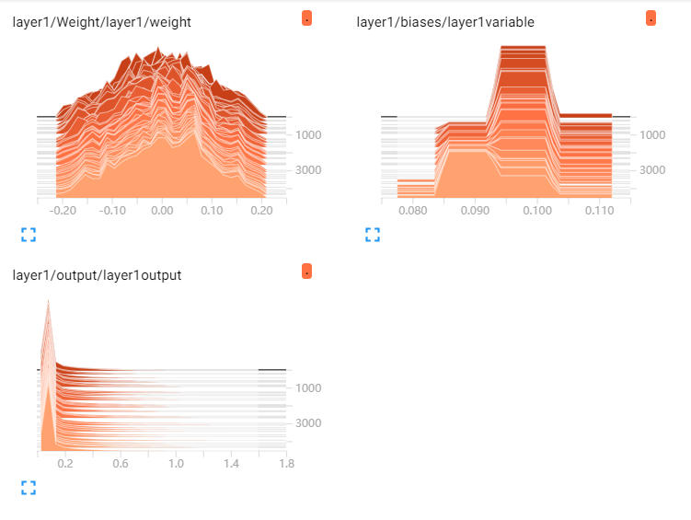  
  
  
  
  
  
  
  
  
  
  
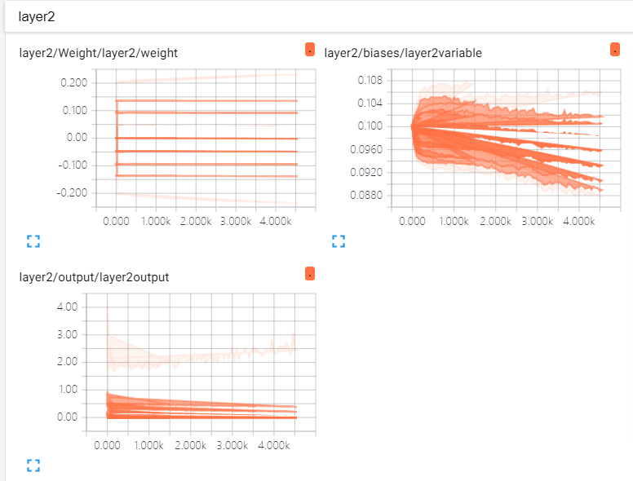3.第二层神经网 weight、baises和output  
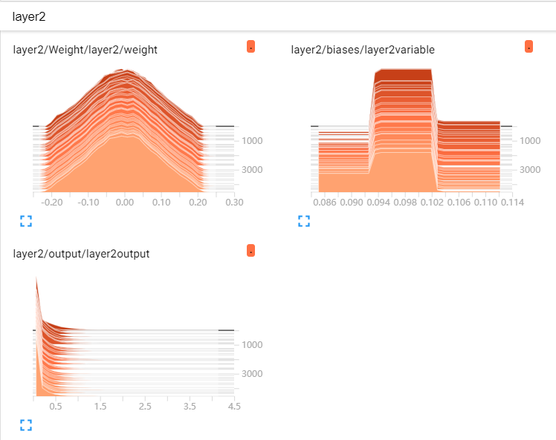

**六.源码**https://paste.ubuntu.com/p/BgXVQWPzjT/  
  
import tensorflow as tf  
from tensorflow.examples.tutorials.mnist import input_data  
# number 1 to 10 data  
mnist = input_data.read_data_sets('MNIST_data', one_hot=True)  
  
  
# tem  
def tf_confusion_metrics(model, actual_classes, session, feed_dict):  
 predictions = tf.argmax(model, 1)  
 actuals = tf.argmax(actual_classes, 1)  
  
 ones_like_actuals = tf.ones_like(actuals)  
 zeros_like_actuals = tf.zeros_like(actuals)  
 ones_like_predictions = tf.ones_like(predictions)  
 zeros_like_predictions = tf.zeros_like(predictions)  
  
 tp_op = tf.reduce_sum(  
 tf.cast(  
 tf.logical_and(  
 tf.equal(actuals, ones_like_actuals),  
 tf.equal(predictions, ones_like_predictions)  
 ),  
 "float"  
 )  
 )  
  
 tn_op = tf.reduce_sum(  
 tf.cast(  
 tf.logical_and(  
 tf.equal(actuals, zeros_like_actuals),  
 tf.equal(predictions, zeros_like_predictions)  
 ),  
 "float"  
 )  
 )  
  
 fp_op = tf.reduce_sum(  
 tf.cast(  
 tf.logical_and(  
 tf.equal(actuals, zeros_like_actuals),  
 tf.equal(predictions, ones_like_predictions)  
 ),  
 "float"  
 )  
 )  
  
 fn_op = tf.reduce_sum(  
 tf.cast(  
 tf.logical_and(  
 tf.equal(actuals, ones_like_actuals),  
 tf.equal(predictions, zeros_like_predictions)  
 ),  
 "float"  
 )  
 )  
 tp, tn, fp, fn = \  
 session.run(  
 [tp_op, tn_op, fp_op, fn_op],  
 feed_dict  
 )  
 if float(tp) + float(fn) == 0:  
 tpr = 0  
 fpr = 0  
 accuracy1 = 0  
 f1_score1 = 0  
 else:  
 tpr = float(tp) / (float(tp) + float(fn))  
 fpr = float(fp) / (float(tp) + float(fn))  
 accuracy1 = (float(tp) + float(tn)) / (float(tp) + float(fp) + float(fn) + float(tn))  
 f1_score1 = (2 * float(tp)) / (2 * float(tp) + float(fp) + float(fn))  
  
 recall1 = tpr  
 # precision1 = float(tp) / (float(tp) + float(fp))  
  
 # print('Precision = ', precision1)  
 print('Recall = ', recall1)  
 print('F1 Score = ', f1_score1)  
 print('Accuracy = ', accuracy1)  
  
  
# tem  
  
  
def compute_accuracy(v_xs, v_ys):  
 global prediction  
 y_pre = sess.run(prediction, feed_dict={xs: v_xs, keep_prob: 1})  
 correct_prediction = tf.equal(tf.argmax(y_pre, 1), tf.argmax(v_ys, 1))  
 accuracy = tf.reduce_mean(tf.cast(correct_prediction, tf.float32))  
 result = sess.run(accuracy, feed_dict={xs: v_xs, ys: v_ys, keep_prob: 1})  
 print('text:%d prediction:%f' % (i, result))  
 tf_confusion_metrics(y_pre, v_ys, sess, feed_dict={xs: v_xs, ys: v_ys, keep_prob: 1})  
 return result  
  
  
def weight_variable(shape):  
 initial = tf.truncated_normal(shape, stddev=0.1)  
 return tf.Variable(initial)  
  
  
def bias_variable(shape):  
 initial = tf.constant(0.1, shape=shape)  
 return tf.Variable(initial)  
  
  
def conv2d(x, W):  
 return tf.nn.conv2d(x, W, strides=[1, 1, 1, 1], padding='SAME')  
  
  
def max_pool_2x2(x):  
 return tf.nn.max_pool(x, ksize=[1, 2, 2, 1], strides=[1, 2, 2, 1], padding='SAME')  
  
  
# define placeholder for inputs to network  
with tf.name_scope('input'):  
 xs = tf.placeholder(tf.float32, [None, 784])  
 ys = tf.placeholder(tf.float32, [None, 10])  
keep_prob = tf.placeholder(tf.float32)  
x_image = tf.reshape(xs, [-1, 28, 28, 1])  
  
  
# conv1 layer  
n_layer = 1  
layer_name = 'layer%s' % n_layer  
with tf.name_scope(layer_name):  
 with tf.name_scope('Weight'):  
 W_conv1 = weight_variable([5, 5, 1, 32])  
 tf.summary.histogram(layer_name + '/weight', W_conv1)  
 with tf.name_scope('biases'):  
 b_conv1 = bias_variable([32])  
 tf.summary.histogram(layer_name + 'variable', b_conv1)  
 with tf.name_scope('output'):  
 h_conv1 = tf.nn.relu(conv2d(x_image, W_conv1) + b_conv1)  
 tf.summary.histogram(layer_name + 'output', h_conv1)  
 h_pool1 = max_pool_2x2(h_conv1)  
  
# conv2 layer  
n_layer = 2  
layer_name = 'layer%s' % n_layer  
with tf.name_scope(layer_name):  
 with tf.name_scope('Weight'):  
 W_conv2 = weight_variable([5, 5, 32, 64])  
 tf.summary.histogram(layer_name + '/weight', W_conv2)  
 with tf.name_scope('biases'):  
 b_conv2 = bias_variable([64])  
 tf.summary.histogram(layer_name + 'variable', b_conv2)  
 with tf.name_scope('output'):  
 h_conv2 = tf.nn.relu(conv2d(h_pool1, W_conv2) + b_conv2)  
 tf.summary.histogram(layer_name + 'output', h_conv2)  
 h_pool2 = max_pool_2x2(h_conv2)  
  
# func1 layer  
W_fc1 = weight_variable([7*7*64, 1024])  
b_fc1 = bias_variable([1024])  
  
h_pool2_flat = tf.reshape(h_pool2, [-1, 7*7*64])  
h_fc1 = tf.nn.relu(tf.matmul(h_pool2_flat, W_fc1)+b_fc1)  
h_fc1_drop = tf.nn.dropout(h_fc1, keep_prob)  
# func2 layer  
W_fc2 = weight_variable([1024, 10])  
b_fc2 = bias_variable([10])  
prediction = tf.nn.softmax(tf.matmul(h_fc1_drop, W_fc2)+b_fc2)  
  
  
  
# the loss between prediction and real data  
with tf.name_scope('cross_entropy'):  
 cross_entropy = tf.reduce_mean(-tf.reduce_sum(ys*tf.log(prediction), reduction_indices=[1]))  
 tf.summary.scalar('cross_entropy', cross_entropy)  
  
train_step = tf.train.AdamOptimizer(1e-4).minimize(cross_entropy)  
  
sess = tf.Session()  
  
# important step  
sess.run(tf.global_variables_initializer())  
  
# show graph  
merged = tf.summary.merge_all()  
writer = tf.summary.FileWriter('logs', sess.graph)  
  
  
for i in range(5000):  
 batch_xs, batch_ys = mnist.train.next_batch(100)  
 sess.run(train_step, feed_dict={xs: batch_xs, ys: batch_ys, keep_prob: 0.5})  
 if i % 50 == 0:  
 result = sess.run(merged, feed_dict={xs: batch_xs, ys: batch_ys, keep_prob: 1})  
 writer.add_summary(result, i)  
 compute_accuracy(mnist.test.images, mnist.test.labels)