151 T2

#include<iostream>

#include<algorithm>

using namespace std;

int main()

{

int arr[11];

for (int i = 0; i < 10; i++)

cin >> arr[i];

for (int i = 0; i < 10; i++)

{

int minPos = i;

for (int j = i + 1; j < 9; j++)

{

if (arr[j] < arr[minPos])

minPos = j;

}

swap(arr[i], arr[minPos]);

}

cout << endl;

for (int i = 0; i < 10; i++)

cout << arr[i] << " ";

return 0;

}

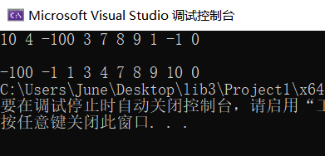

#include<iostream>

#include<algorithm>

using namespace std;

//p151 T2

int main()

{

int arr[1000];

int insertNum;

int n;

cin >> n;

for (int i = 0; i < n; i++)

cin >> arr[i];

sort(arr, arr + n);

cout << "请输入要插入的数：" << endl;

cin >> insertNum;

if (insertNum < arr[0])

{

for (int i = n; i >= 1; i--)

arr[i] = arr[i - 1];

arr[0] = insertNum;

}

else if (insertNum <= arr[n-1] && n>=1)

{

for (int i = 0; i < n; i++)

{

if (insertNum >= arr[i] && insertNum < arr[i + 1])

{

for (int j = n; j >= i + 2; j--)

arr[j] = arr[j - 1];

arr[i + 1] = insertNum;

break;

}

}

}

else

{

arr[n] = insertNum;

}

cout << endl;

for (int i = 0; i <= n; i++)

cout << arr[i] << " ";

return 0;

}

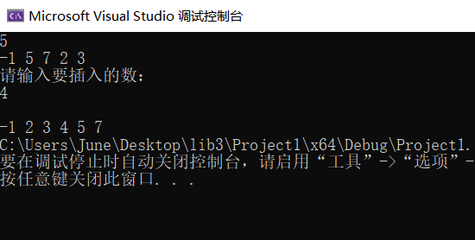

151 T10

#include<iostream>

using namespace std;

#include<string>

int main()

{

string s1, s2, s3;

getline(cin, s1);

getline(cin, s2);

getline(cin, s3);

string s = s1 + s2 + s3;

int bigWord=0, smallWord=0, Num=0, Blank=0, Other=0;

for (int i = 0; i < s.size(); i++)

{

if (isupper(s[i]))

bigWord++;

else if (islower(s[i]))

smallWord++;

else if (s[i] >= '0' && s[i] <= '9')

Num++;

else if (s[i] == ' ')

Blank++;

else

Other++;

}

cout << "英文大写字母：" << bigWord << " 英文小写字母：" << smallWord << " 数字：" << Num << " 空格： " << Blank << " 其它字符：" << Other << endl;

return 0;

}

