Taylor Cowley

CS 312 Lab 1 Fermat Project September 13, 2016

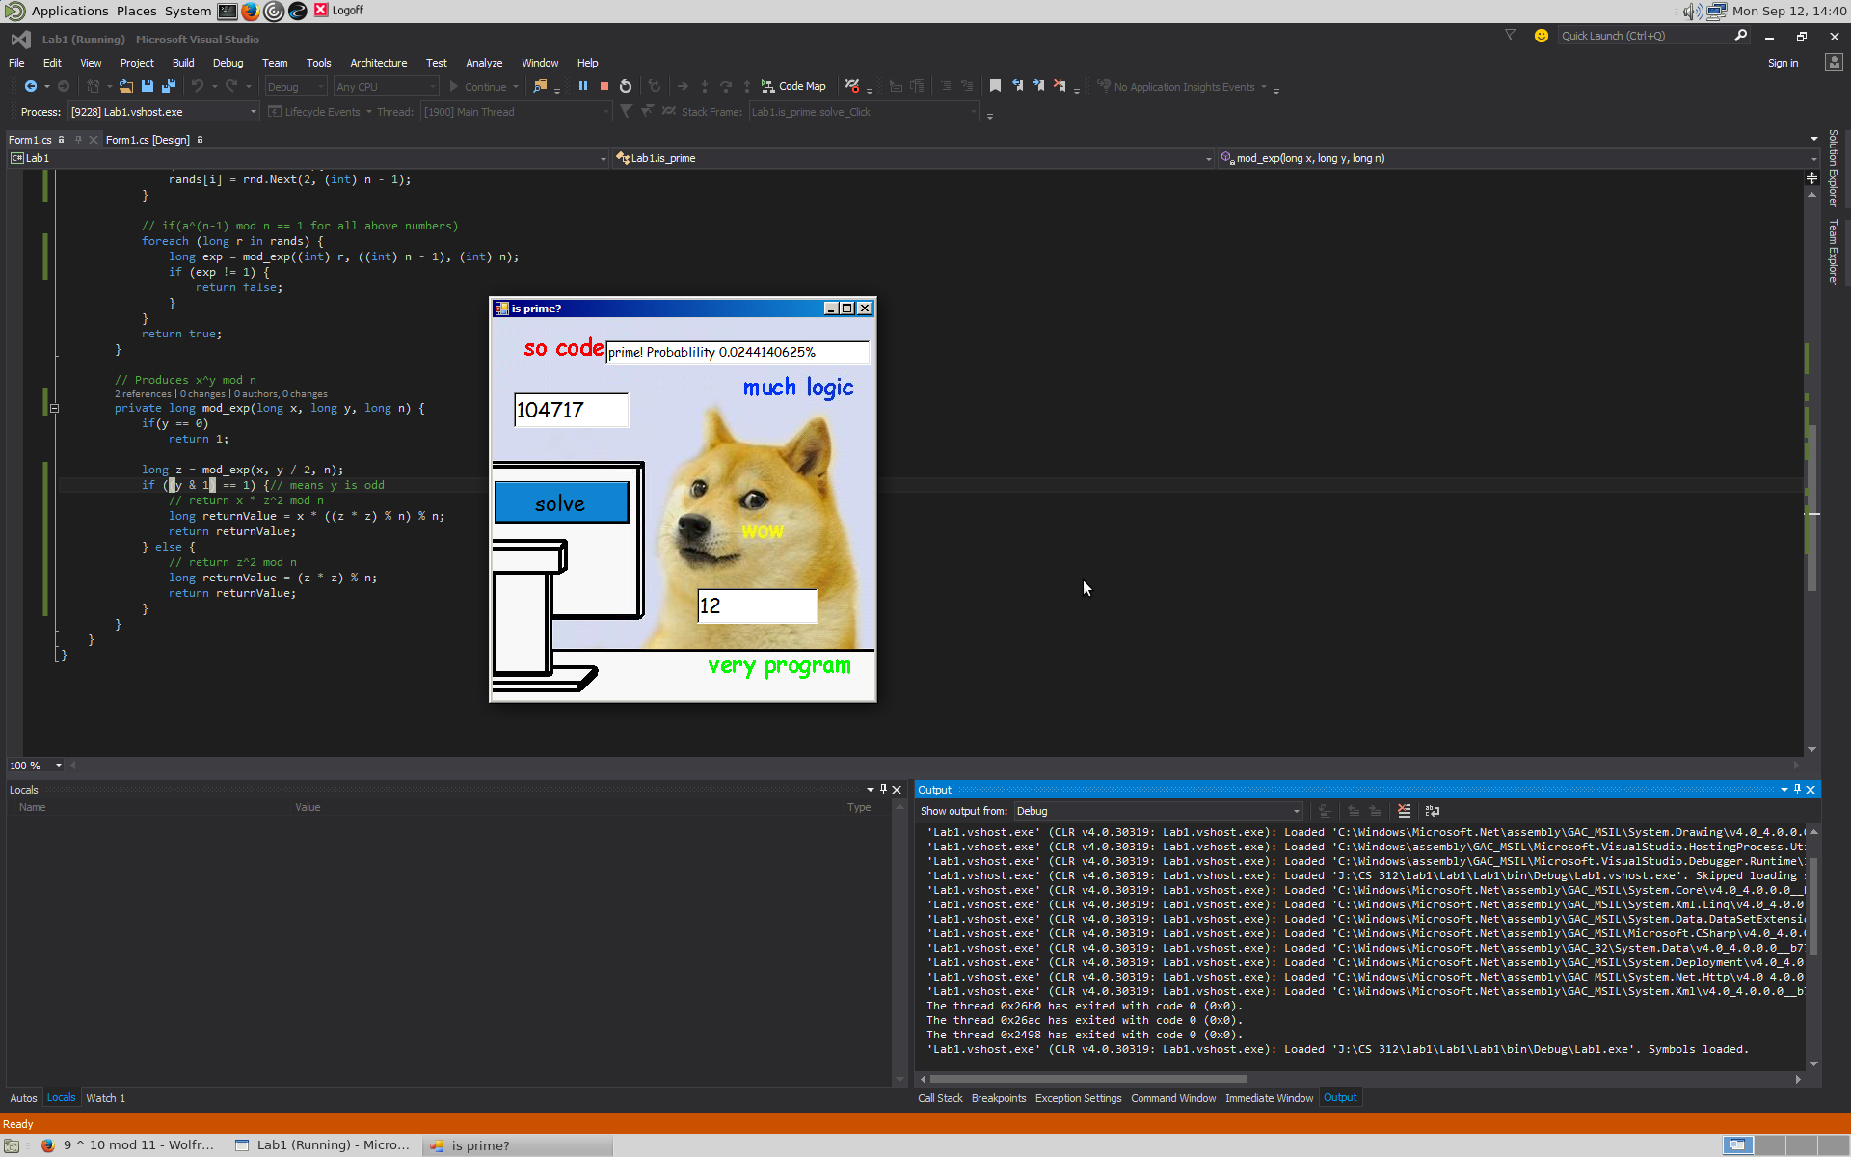

Working example!

Notice the 3 text boxes and the solve button

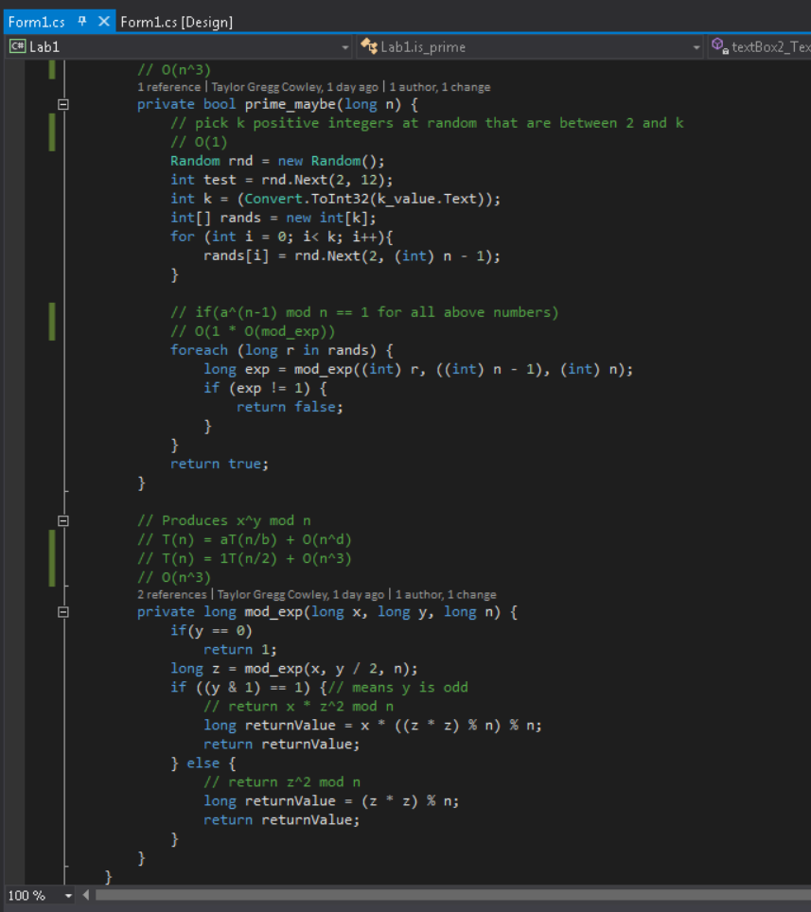

Beautiful code ☺

Time and space complexity-

For the random number creation and cycling through them – O(n)

For the modular exponent – O(n^3)

Making the overall O(n^3)

The probability of error is 1/(2^k) where k is the number of random numbers that we use with the modular exponent algorithm.