Taylor Cowley and Andrew Okazaki

ECEN 427 9/15/2016

Lab 2

In total we spent four hours on this lab. Lab two consisted of using the interrupts on the Microblaze to create a clock that displayed the time via the terminal emulator through the UART. The clock could be set using the five buttons on the Microblaze. With the buttons you are able to increment and decrement the hours, minutes and seconds.

Throughout lab 2 we used the interrupts on the Microblaze to control timing. To enable interrupts by:

1. XGpio_Initialize() – this gave us the address for the GPIO
2. XGpio_SetDataDirection() – register the buttons as inputs
3. XGpio_InterruptGlobalEnable() – set the GPIO to be able to interrupt
4. XGpio_InterruptEnable() – set the buttons to be able to use GPIO interrupt
5. microblaze_register_handler() – the microblaze to call our interrupt handler function
6. XIntc_EnableIntr() – Enable the interrupt controller to receive from the FIT and GPIO
7. XIntc_Master_Enable() – Enable the interrupt controller to send interrupts to the microblaze
8. microblaze_enable_interrupts – Now the microblaze can receive interrupts properly.

In our interrupt handler we created three different timers. One to increment the clock every second and the other two were used to de-bounce the buttons. In our interrupt handler we implemented a simple state machine.

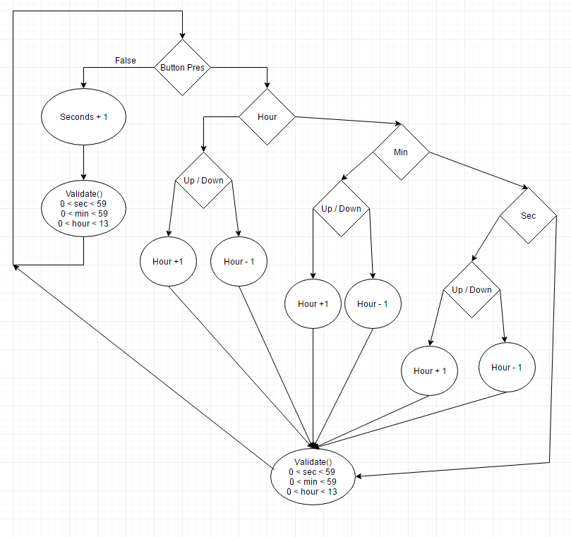

If you did not push a button the clock would continue to increment. But if you held the hour/minute/second button then continued to press the up or down button the clock would increment/decrement the hour/minute/second. If you held both buttons the clock would rest for a second and then start incrementing/decrementing at a rate of one per half second.