Taylor Cowley

EE 220 May 03 2016

Hw02

Chapter 4 Homework

1. Create an inverter (NOT gate) using a single 2-input NOR gate.



1. Create an OR gate using only NAND gates.

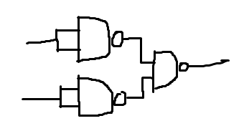

1. Draw the gate-level schematic for this equation: *F* = (*AB* + *A'B'*)*'*. Use only AND, OR, and NOT gates.

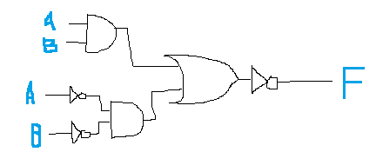

1. Write the boolean equation for the circuit shown below. Write it using parentheses so that the structure of the equation exactly matches the structure of the circuit. Is this circuit equivalent to the circuit in Question 3?

*A’B + AB’*

Yes the two circuits are equivalent



A



B



F

1. Write a 2-level OR-AND equation for the circuit shown below. This will require that you do some algebraic manipulations first. Draw the resulting circuit.

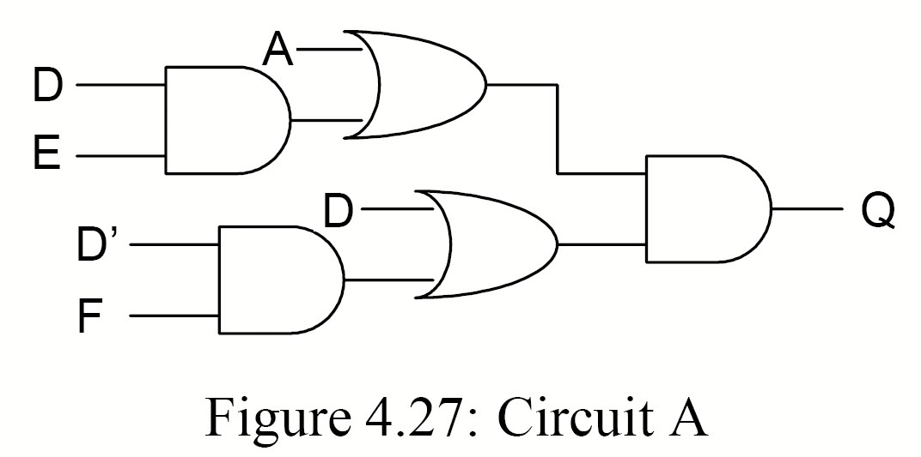

(A+D)(A+E)(D+F) = Q

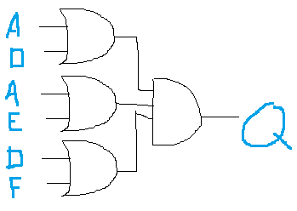

1. Write the truth table for the circuit shown below.



A

B

C

’

B

’



F

|  |  |  |  |
| --- | --- | --- | --- |
| **A** | **B** | **C** | **F** |
| 0 | 0 | 0 | 1 |
| 0 | 0 | 1 | 1 |
| 0 | 1 | 0 | 1 |
| 0 | 1 | 1 | 1 |
| 1 | 0 | 0 | 1 |
| 1 | 0 | 1 | 1 |
| 1 | 1 | 0 | 1 |
| 1 | 1 | 1 | 1 |

1. Evaluate the circuit of Figure 4.27 using the metrics of Table 4.1 (see text book). Do this by summarizing its levels of logic, delay, etc.

**Logic Levels**  3

**Delay** tand2 *2 + tor2

**Gate Count**  5

**Gate Inputs**  10

**Largest Gate**  2

1. Prove or disprove the following proposed boolean theorem:

A(B⊕C) = AB⊕AC

|  |  |  |  |  |
| --- | --- | --- | --- | --- |
| A | B | C | A(B⊕C) | AB⊕AC |
| 0 | 0 | 0 | 0 | 0 |
| 0 | 0 | 1 | 0 | 0 |
| 0 | 1 | 0 | 0 | 0 |
| 0 | 1 | 1 | 0 | 0 |
| 1 | 0 | 0 | 0 | 0 |
| 1 | 0 | 1 | 1 | 1 |
| 1 | 1 | 0 | 1 | 1 |
| 1 | 1 | 1 | 0 | 0 |

They are the same

# Chapter 5 Homework

1. Write the minterm expansion for the function shown below.

|  |  |  |  |
| --- | --- | --- | --- |
| **A** | **B** | **C** | **F** |
| 0 | 0 | 0 | 1 |
| 0 | 0 | 1 | 0 |
| 0 | 1 | 0 | 0 |
| 0 | 1 | 1 | 1 |
| 1 | 0 | 0 | 0 |
| 1 | 0 | 1 | 0 |
| 1 | 1 | 0 | 1 |
| 1 | 1 | 1 | 1 |

F = ∑m(0,3,6,7)

1. Write the maxterm expansion for the function in the previous problem.

F = ∏M(1,2,4,5)

1. Take the inverse of following expression (do not further minimize):

[(AB’+C)D’+E]

[(AB’+C)D’+E]‘

[((AB’ + C)’+D’)E’]

**[((A’+B)C’+D’)E’]**

1. Convert the following minterm expansion to an equivalent maxterm expansion: F = Σm(2,3,5)

F = ∏M(0,1,4,6,7) (assuming 3 variables)

1. Write the maxterm expansion for the following function: F = A + A’B’ + B’C.

|  |  |  |  |
| --- | --- | --- | --- |
| A | B | C | A+A’B’ + B’C |
| 0 | 0 | 0 | 1 |
| 0 | 0 | 1 | 1 |
| 0 | 1 | 0 | 0 |
| 0 | 1 | 1 | 0 |
| 1 | 0 | 0 | 1 |
| 1 | 0 | 1 | 1 |
| 1 | 1 | 0 | 1 |
| 1 | 1 | 1 | 1 |

F = ∏M(2,3)

1. Minimize the expression below using boolean theorems.

F(A,B,C) = Σm(0,1,2,3,5,6)

|  |  |  |  |
| --- | --- | --- | --- |
| A | B | C | F |
| 0 | 0 | 0 | 1 |
| 0 | 0 | 1 | 1 |
| 0 | 1 | 0 | 1 |
| 0 | 1 | 1 | 1 |
| 1 | 0 | 0 | 1 |
| 1 | 0 | 1 | 1 |
| 1 | 1 | 0 | 1 |
| 1 | 1 | 1 | 0 |

A’B’C’ + A’B’C + A’BC’+A’BC+AB’C’+AB’C+ABC’

(A’B’C’ + A’B’C + A’BC’+A’BC+AB’C’+AB’C+ABC’)’’ Demorgan’s in process

((A’B’C’)’ * (A’B’C)’ * (A’BC’)’*(A’BC)’*(AB’C’)’*(AB’C)’*(ABC’)’)’ demorgan’s still

((A+B+C)(A+B+C’)(A+B’+C)(A+B’+C’)(A’+B+C)(A’+B+C’)(A’+B’+C))’ And finishing

**F = (ABC)’**