Taylor Cowley

EE220 May 25 2016

HW 08 ch11



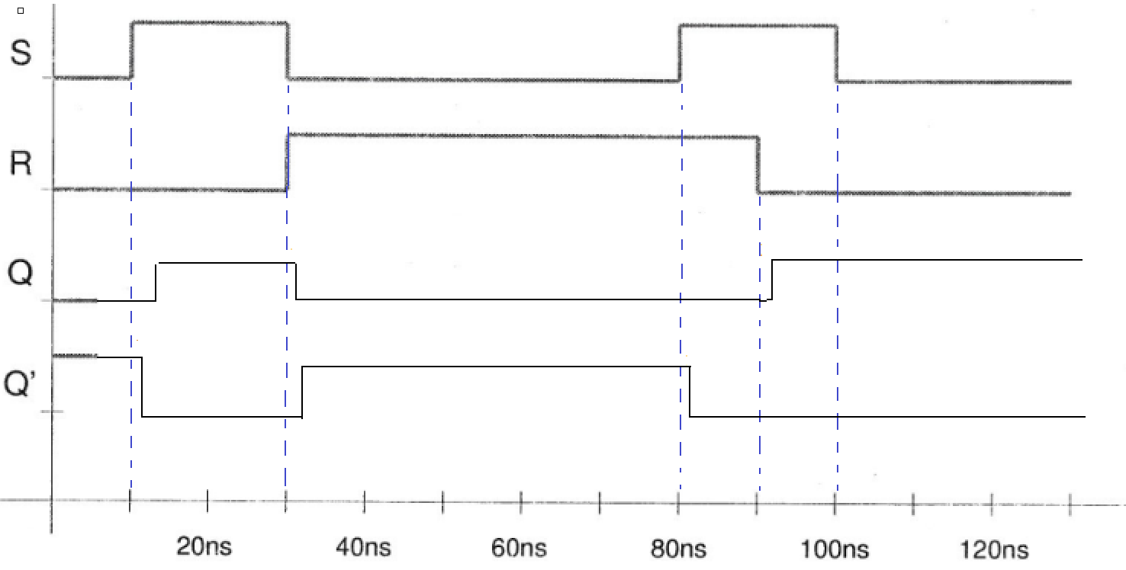



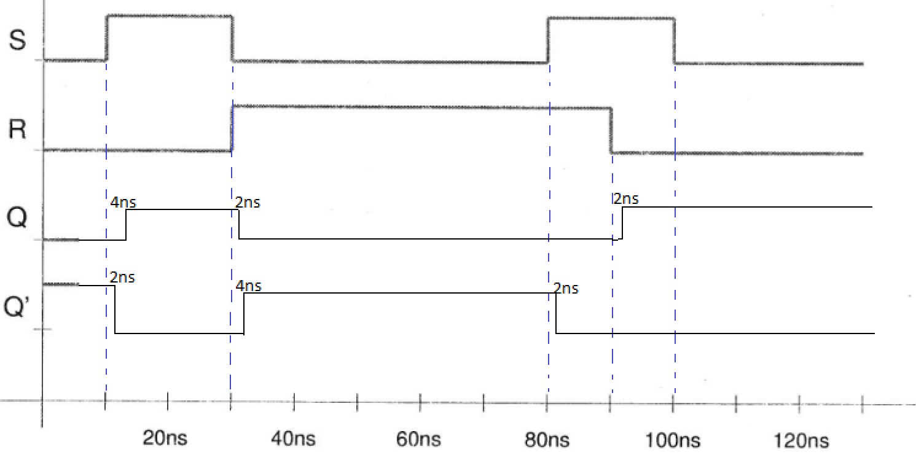

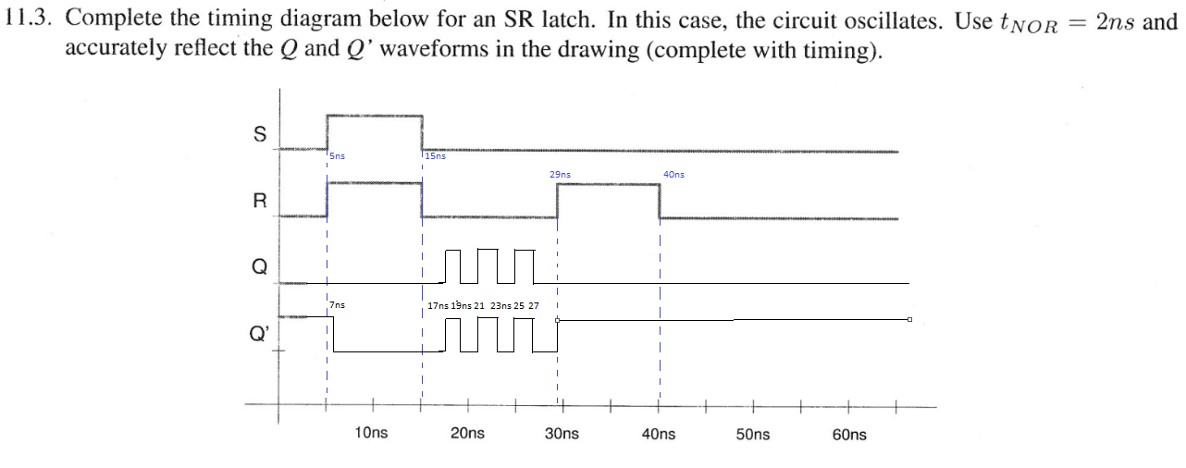

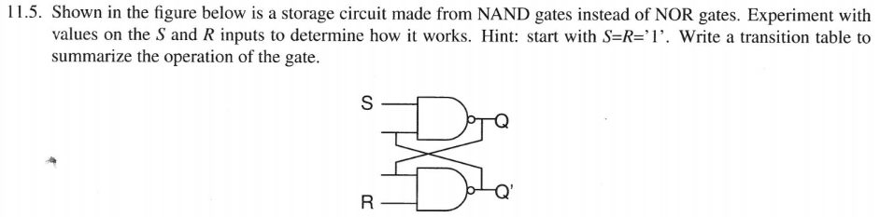

|  |  |  |  |  |
| --- | --- | --- | --- | --- |
| S | R | Q | Q+ | Comment |
| 1 | 1 | 1 | 1 | Stable |
| 1 | 1 | 0 | 0 |
| 1 | 0 | 1 | 0 | Reset |
| 1 | 0 | 0 | 0 |
| 0 | 1 | 1 | 1 | Set |
| 0 | 1 | 0 | 1 |
| 0 | 0 | 1 | n/a | unstable |
| 0 | 0 | 0 | n/a |

