F74046022 陳冠仁

**F74046022_Prob1.m :**

Converts decimal into single binary representation.

Converts single binary representation into decimal.

TEST RESULT :

The binary representation of 123.456789 is [00111101101110100111100000001111];

The decimal respresentation of [00111101101110100111100000001111] is 123.456789;

The binary representation of -111.111111 is [10110111100011100011100011100010];

The decimal respresentation of [10110111100011100011100011100010] is -111.111111;

The binary representation of 0.062500 is [00000000000010000000000000000000];

The decimal respresentation of [00000000000010000000000000000000] is 0.062500;

**F74046022_Prob2.m :**

Draws the direction and relative magnitude of a point field

Use line() to draw the magnitude and direction of the electric field on the point

TEST RESULT :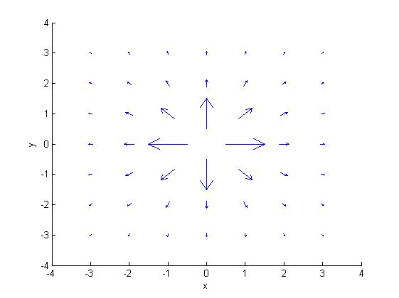

**F74046022_Prob3.m :**

Find roots for polynomials

Use Newton’s/Bisection method to find the root

Use plots to confirm the result

TEST RESULT :

The smallest positive root of Prob.3(a) is 0.82449858529113884000

The largest negative root of Prob.3(a) is -0.82449858529113884000

The smallest positive root of Prob.3(b) is 1.30149800419375740000

The largest negative root of Prob.3(b) is -3.37759142029333950000

The smallest positive root of Prob.3(c) is 0.91003417968750000000

The largest negative root of Prob.3(c) is -0.45896244841060307000

**F74046022_Prob4.m :**

Acquire the radius ratio of Lagrangian points and the earth

Considering that earth and the object have the same angular velocity

w : angular velocity

a : acceleration

r : radius

* a/r = w^2
* use a/r to acquire the equation

TEST RESULT :

The distance ratio of L1: 0.99003043171225014000

The distance ratio of L2: 1.01003627440572650000

The distance ratio of L3: 1.00000025022751030000