**F74046022 陳冠仁**

**Prob1. Differentiation : Central Difference**

**Integration : Simpson’s Method**

**(a)**

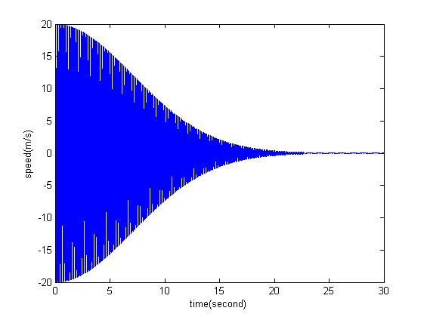

**(b)**

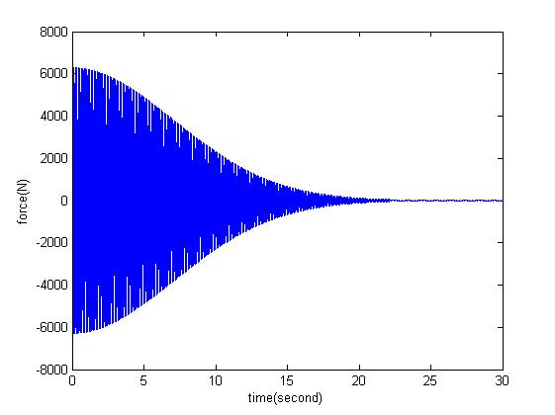

**(c) F(8) = -1015.773034 N**

**(d) x(10) = -0.06182356 m**

**(e) The total travel length from t = 0 to 10 is 95.110505957 m**

**Prob2. Integration : Simpson’s Method**

**(i) 0.78539805**

**(ii) 2.15652299**

**(iii) 0.32179354**

**Prob3. Integration : Monte Carlo**

**A total of 10000000 random points are used and the volume of the ellipsoid is 25.1451024.**

**Prob4. Integration : Simpson’s Method**

**(1) The total flux is 113097335529.226300 (Volt*m).**

**(2) The total flux is 113097335529.232150 (Volt*m).**

**(3) The total flux is 113097335529.232210 (Volt*m).**

**(4) The total flux is 0.000046 (Volt*m).**