**F74046022 陳冠仁**

**Prob1.**

**Euler’s Method**

**step length = 10^-3**

**Up is positive**

1. **a(t) = g + (-k*x(t) – c*v(t))/m**

**a(t) -> 加速度**

**v(t) -> 速度**

**x(t) -> 位移**

**m -> 質量 -> 1200(kg)**

**g -> 重力加速度 -> -9.8(m/s^2)**

**k -> 彈力係數 -> 58000(N/m)**

**c -> 阻尼係數 -> 4000(kg/s)**

**(2)**

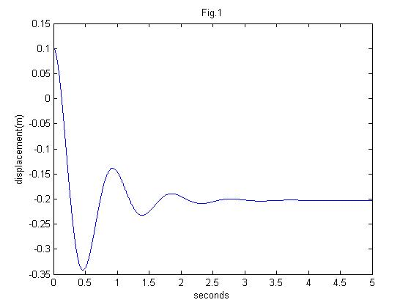

**(3) 0.930 (1/s)**

**Prob2.**

**Fourth Order Runge-Kutta**

**step length = 10^-4**

1. **Vc(t) = $ε\left(t\right)$** – R*C $\frac{d}{dt}$*Vc(t)

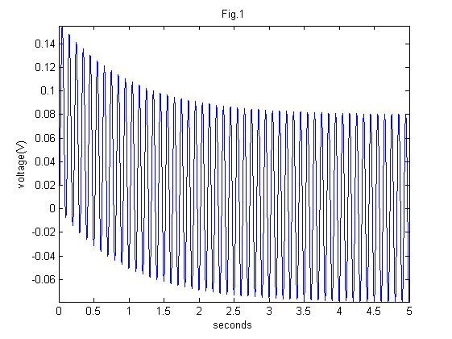



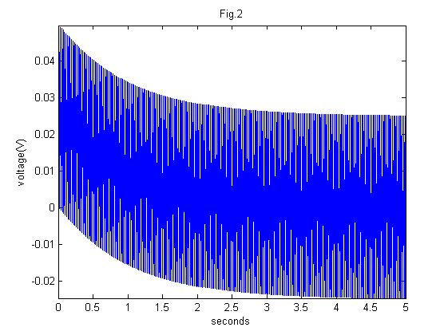



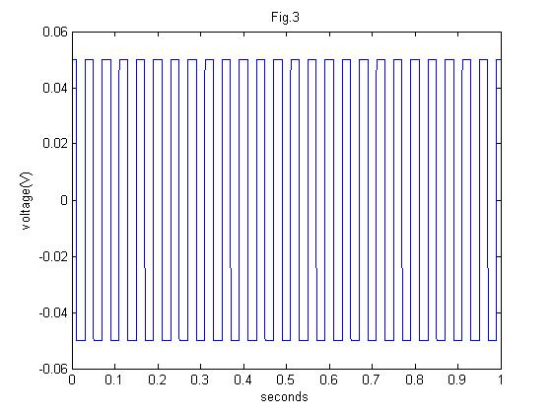

**Prob3.**

**Euler’s Method**

**step length = 10^-6**

**blue -> VS(t)**

**green -> VR(t)**

1. **VS(t) = VL(t) + VR(t) + VC(t)**

* **VS(t) = L $\frac{d}{dt}$*I(t) + R*I(t) + Q(t)/C**
* $\frac{d}{dt}$**VS(t) = L $\frac{d^{2}}{dt^{2}}$*I(t) + R $\frac{d}{dt}$*I(t) + I(t)/C**



