Homework 3

**Due Date**

***2016/06/8 (Wednesday), 23:59***。Late submission will not be accepted.

In this assignment, you should be able to accomplish an algorithm to solve differential equation numerically with specified initial conditions. Please be advised that no grade will be given if any MATLAB’s embedded function for solving differential equation is found.

**Problem 1: Numerical Solution for a Damped Harmonic Oscillator**[ Principal m-file name: F<your student id >_hw3_prob1.m ]

A $1.200×{10}^{3}$*kg* brick is mounted on a spring of constant *k = $58.00×{10}^{3}$ N/m* then submerged into an oil container. The damping constant for the oil is $4.000×{10}^{3}$ kg/s.

1. Refer to “DAMPED HARMONIC OSCILLATIONS (BENSON Ch.15.5)” for the resistive force and write down the differential equation of motion. Note: there are several forces in the system and please specify the coordinate to describe the brick’s motion. I.e. what does “x(t)” stand for, the location, the displacement or any other meaning?
2. [Fig.1] At t = 0, the system is at rest and is compressed by 10.00 cm from its equilibrium. Plot the temporal change of brick’s displacement from the equilibrium point.
3. Based on the result of (2), find the oscillation frequency of the system.



Fig. 1. A damped harmonic oscillator

**Problem 2: an RC circuit with a source / Integrator / Differentiator** [ Principal m-file name: F<your student id >_hw3_prob2.m ]

There is a RC circuit with elements in series. Assume that the voltage source provides time-varying electric potential $ε(t)$

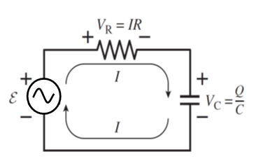

1. Write down the loop equation in terms of $V_{c}\left(t\right), ε \left(t\right), R and C$ for the circuit.
2. [Fig.1] If R = $10kΩ$, C = $100μF$, the source input $ε\left(t\right)$ becomes $ε\left(t\right)=5sin⁡(20πt)$ with the same resistor and capacitor, plot $V_{c}(t)$.
3. [Fig.2] Suppose R = $10kΩ$, C = $100μF$ and the source input $ε\left(t\right)$ changes as the depicted square wave. Plot $V_{c}(t)$.   
   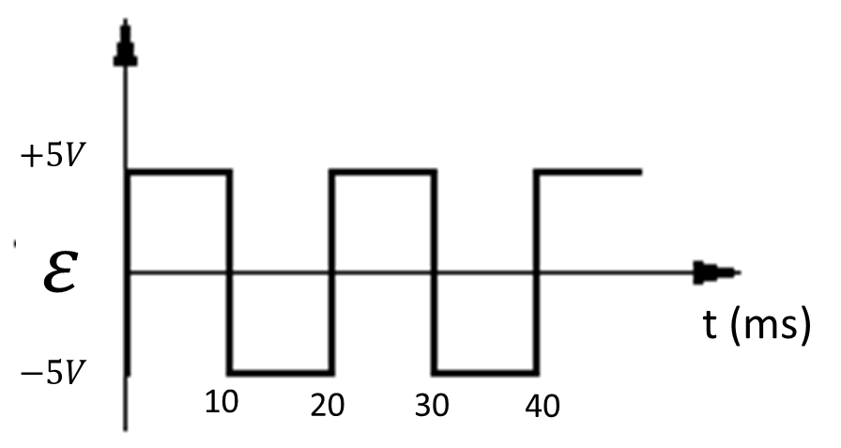
4. [Fig.3] Suppose R = $100Ω$, C = $1μF$ and the source input $ε\left(t\right)$ changes as the depicted triangular wave. Plot $V_{R}(t)$, the voltage wave across the resistor. 

**Problem3: an RLC circuite with a source to look for resonant frequency.**

[ Principal m-file name: F<your student id >_hw3_prob3.m ]

In the following figure, there is an RLC circuit with elements in series. Assume that the voltage provided is a function of time $V_{s}(t)$ with $L=2mH , R=8 Ω, and C=5μF$. Before the voltage source is turned on, there is no charge stored in the capacitor and there is no current flowing on the circuit.

1. Prove that the current of the loop, $I(t)$, can be described by $\frac{d}{dt}V_{s}\left(t\right)=L\frac{d^{2}}{dt^{2}}I\left(t\right)+R\frac{d}{dt}I\left(t\right)+\frac{1}{C} I(t)$
2. [Fig. 1] If $V_{s}\left(t\right)= cos(6000 t)$, solve the differential equation numerically and plot $V_{R}\left(t\right) and V_{s}(t)$ on the same figure, for $0≤t≤10ms$
3. [Fig. 2] If $V_{s}\left(t\right)= cos(10000 t)$, solve the differential equation numerically and plot $V_{R}\left(t\right) and V_{s}(t)$ on the same figure, for $0≤t≤10ms$
4. [Fig. 3] If $V_{s}\left(t\right)= cos(20000 t)$, solve the differential equation numerically and plot $V_{R}\left(t\right) and V_{s}(t)$ on the same figure, for $0≤t≤10ms$

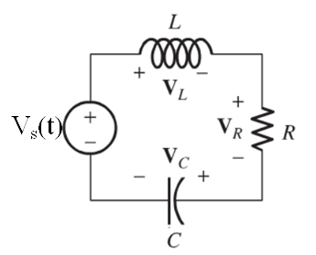

**Contents to submit:**

1. All the m-files you compose for the assignment.
2. All the m-files should include proper COMMENTS.   
   (No comment, no score)
3. A word document or a PDF includes Your Name, Your Student ID Number,   
   In the document, you will need to include all the written answers, plots and the following contents: (1) Which method do you use to solve the differential problem. (2) The step length you choose for each problem. (3) Which coordinate do you use to analyze the system ( Which direction is the “POSITIVE” direction )?

**Notice:**

1. DO NOT PLAGIARIZE. You are encouraged to ask and to discuss the homework content with your fellow classmates, the TAs and the instructor. But identical core program wording is NEVER ACCEPTABLE.
2. Upload all the files without archiving. Do not upload files that don’t work well. Any missing file or function that leads to fail of the execution will be regarded as a program that never works.