F74046022 陳冠仁 資訊108乙班

Prob1.

1. G = 6.67384*10^-11

Ms = 2*10^30

x”(t) = -G*Ms/(x(t)^2+y(t)^2)^(1.5)*x(t);

y”(t) = -G*Ms/(x(t)^2+y(t)^2)^(1.5)*y(t);

1. Vc = 29830.275448 m/s

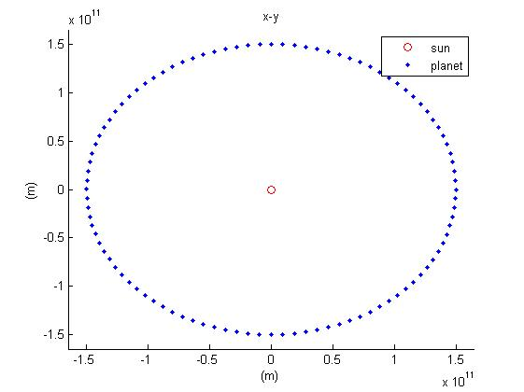

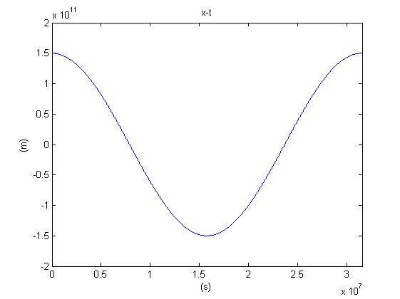

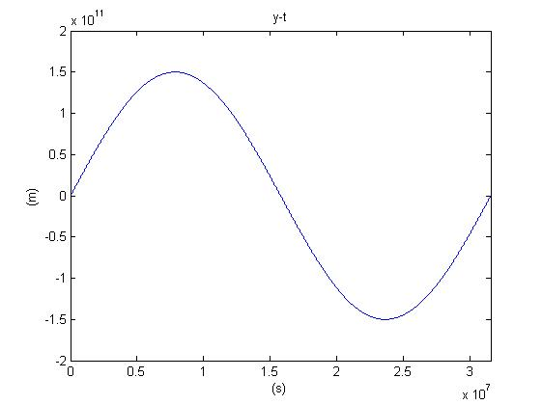

period = 31594940 s

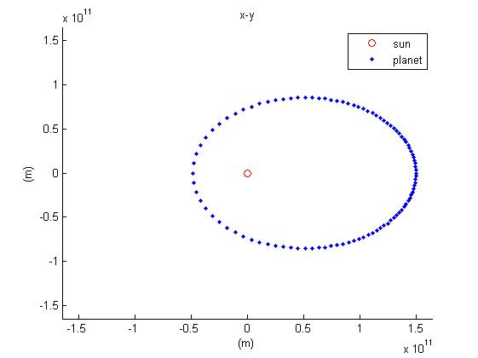

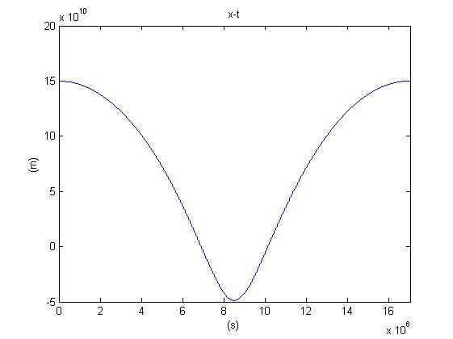

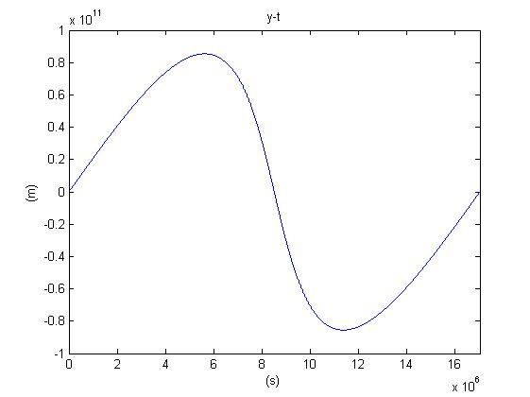

1. period = 17027540 s

semi-major axis = 9.933841E+10 m



|  |  |  |
| --- | --- | --- |
| k | period(s) | semi-major axis(m) |
| 0.2 | 11514220 | 7.653212E+10 |
| 0.3 | 11969300 | 7.853508E+10 |
| 0.4 | 12658780 | 8.152258E+10 |
| 0.5 | 13647740 | 8.571501E+10 |
| 0.6 | 15043620 | 9.146409E+10 |
| 0.7 | 17027540 | 9.933841E+10 |
| 0.8 | 19920900 | 1.102948E+11 |
| 0.9 | 24338660 | 1.260512E+11 |
| 1.0 | 31594940 | 1.500009E+11 |

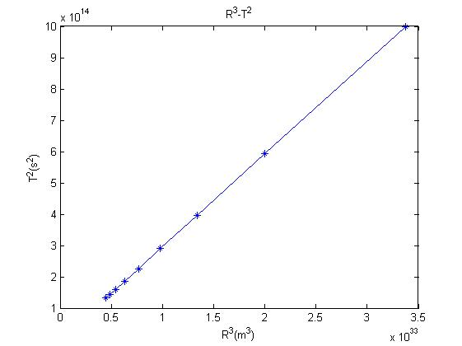

Prob2.

1. gas

time step = 10^-15 (s)

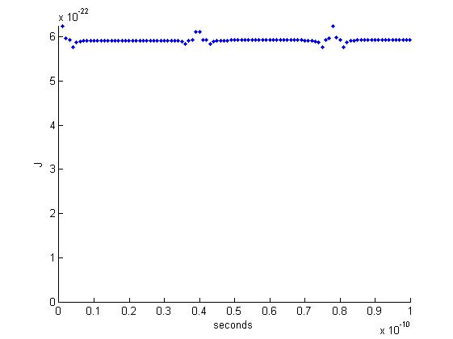

1. time step = 10^-15 (s)

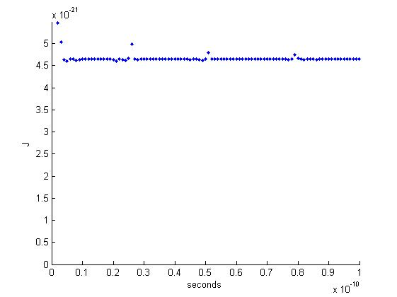

1. time step = 10^-15 (s)

