F74046022 陳冠仁 資訊108乙班

**課堂能力測驗訂正上傳**

小美的加法器

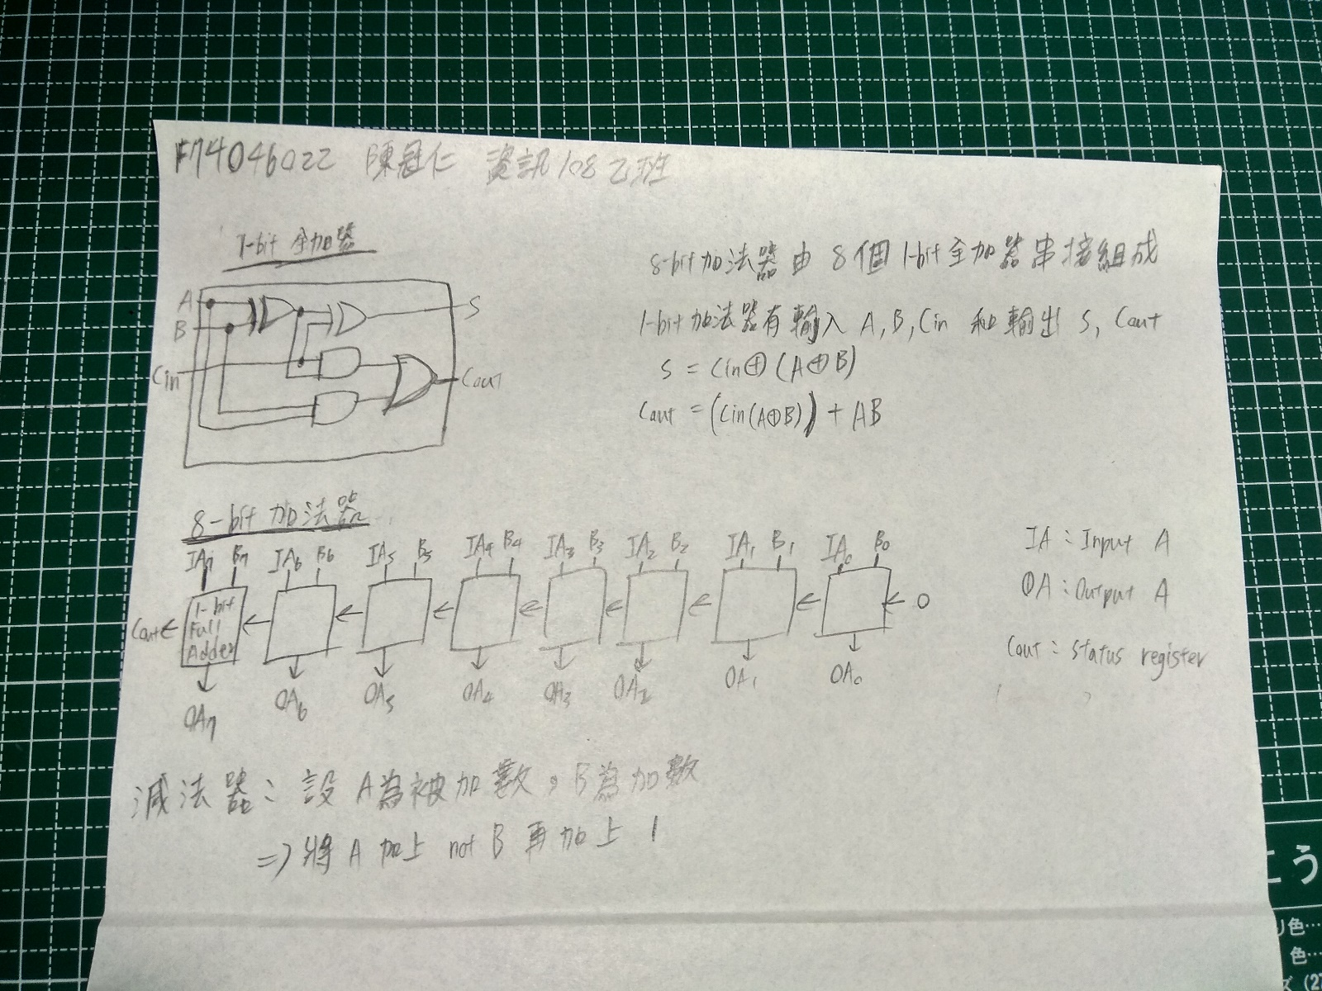

小明的CPU

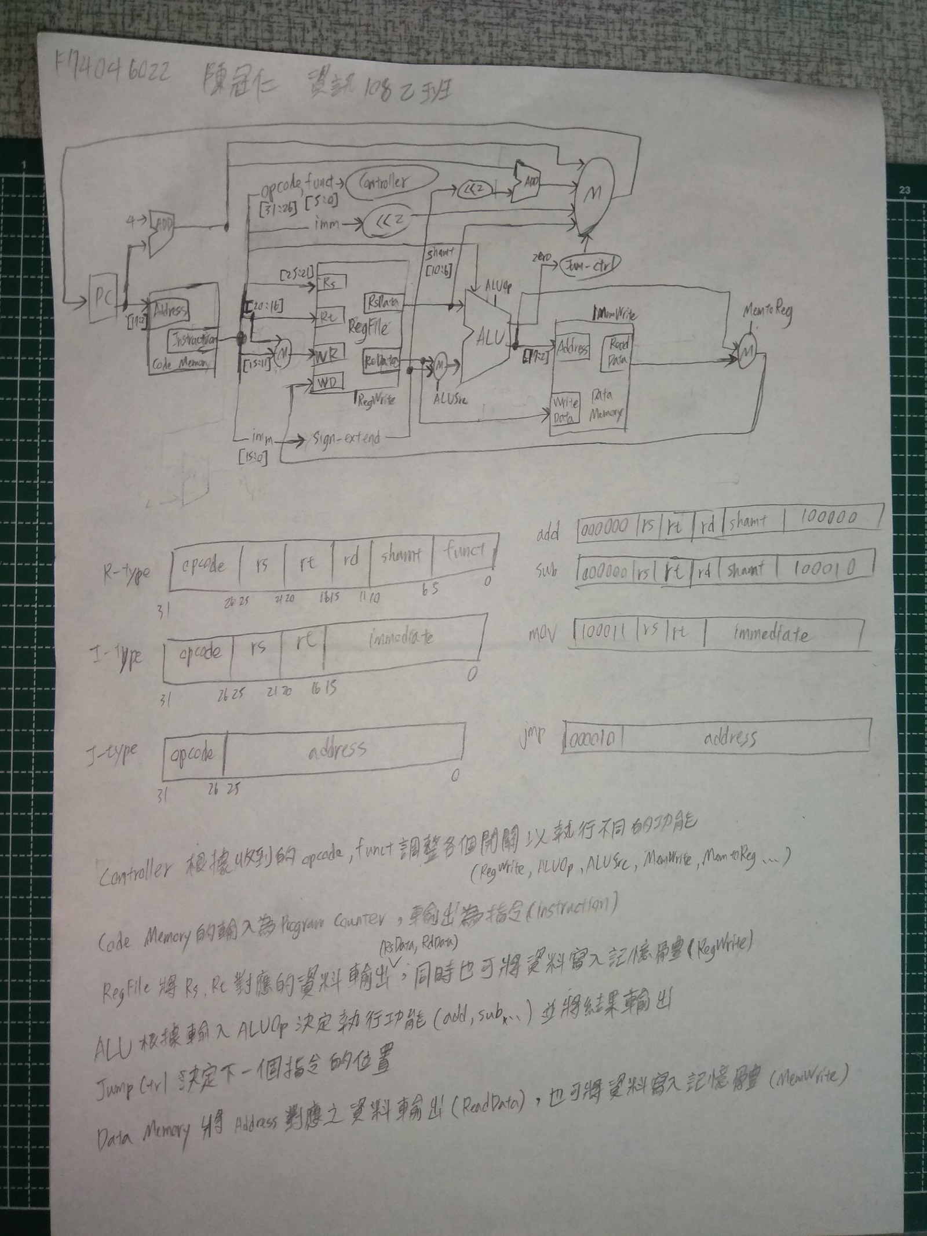

小西的C程式

#include <stdio.h>

#include <stdlib.h>

typedef struct Node{

char ch;

struct Node* next;

}Node;

typedef struct Stack{

char data[256];

int pos;

}Stack;

char remove_from_llist(Node **llist, int n){

Node *cur=*llist, *prev=NULL;

char ch;

if(n==0 && cur!=NULL){

ch = (*llist)->ch;

*llist = (*llist)->next;

return ch;

}

while(cur->next!=NULL && n>0){

prev = cur;

cur = cur->next;

--n;

}

if(n>0){

printf("Index out of bound\n");

return '\0';

}else{

prev->next = cur->next;

ch = cur->ch;

free(cur);

return ch;

}

}

void push_to_stack(Stack *stack, char ch){

if (stack->pos>=255){

printf("StackError: Stack is full\n");

return;

}

stack->data[++stack->pos] = ch;

}

char pop_from_stack(Stack *stack){

if (stack->pos<0){

printf("StackError: Stack is empty\n");

return '\0';

}

return stack->data[stack->pos--];

}

void print_stack(Stack *stack){

int i;

for(i=0; i<=stack->pos; ++i)

printf("%c", stack->data[i]);

printf("\n");

}

void print_llist(Node *llist){

Node *cur;

for(cur=llist; cur!=NULL; cur=cur->next)

printf("%c", cur->ch);

printf("\n");

}

int main(int argc, char* argv[]){

char ch = (char)('a'-48);

Stack *stack = (Stack*) malloc(sizeof(Stack));

stack->pos=-1;

Node *llist = (Node*) malloc(sizeof(Node));

llist->ch = ch;

Node *cur = llist;

int i;

for(i=0; i<50; ++i){

cur->next = (Node*) malloc(sizeof(Node));

cur = cur->next;

cur->ch = ++ch;

}

printf("\nInitial State : (50 nodes in linked list, empty stack)\n");

printf("Linked list:\t"); print_llist(llist);

printf("Stack:\t\t"); print_stack(stack);

printf("\nRemove 1st node from linked list and push it to stack\n");

push_to_stack(stack, remove_from_llist(&llist, 0));

printf("Linked list:\t"); print_llist(llist);

printf("Stack:\t\t"); print_stack(stack);

printf("\nRemove 10th node from linked list and push it to stack\n");

push_to_stack(stack, remove_from_llist(&llist, 9));

printf("Linked list:\t"); print_llist(llist);

printf("Stack:\t\t"); print_stack(stack);

printf("\nPop from stack\n");

pop_from_stack(stack);

printf("Linked list:\t"); print_llist(llist);

printf("Stack:\t\t"); print_stack(stack);

return 0;

}

stack以C語言中的struct實作

其中包含由256個char組成的array和一個integer代表stack現在的位置

當push時朝高記憶體位置移動，pop時朝低記憶體位置移動