Report of Deep Learning for Natural Langauge Processing

Zengchang Qin
zengchang.qin@gmail.com

Abstract

This is a Report of Deep Learning for Natural Langauge Processing

Introduction

ChatGPT is so popular and everyone is talking about it, all are talking about it but not coding for it …

Methodology

There are models of my research.

M1: DL Model

The description of the first model.

M2: NLP Model

The description of the second model.

M3: DL-NLP Model

The description of the third model.

Experimental Studies
The figures shows it works so well

Table 1: this is the table 1

New Table
M1
M2
M3

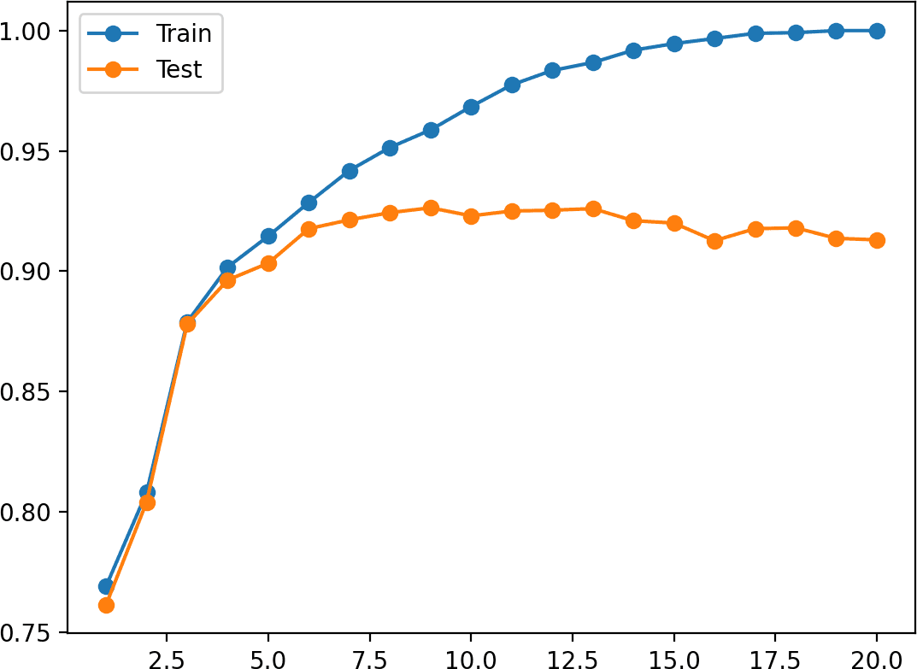

Figure 1：this is obviosuly overfit

Conclusions

By good scientific writing in right format, it can express you idea of research clearly to others, therefore, we need to learn how to write a good report and even a paper.

References

[1] Zenchang Qin and Lao Wang (2023)，How to learn deep learning? Journal of Paper Writing, Vol. 3: 23: pp. 1-12.
[2] ….

