**2020301928敖冠舒**

1.用Matlab命令函数分别绘出抽样信号、矩形脉冲信号、周期矩形脉冲信号、三角波脉冲信号、三角波周期信号的波形，理解其中参数的意义。

**1）抽样信号：**

源码：

|  |
| --- |
| t = -2*pi:0.01:2*pi;  f_sinc = sinc(t);  plot(t,f_sinc);  title('抽样信号');  axis([-10,10,-1.5,1.5]); |

各参数意义：

|  |  |
| --- | --- |
| 函数 | 参数 |
| plot(t,f_sinc) | t为自变量，f_sinc为因变量 |
| axis(a,b,c,d) | a,b 自变量区间 c,d 因变量区间 |

运行结果：

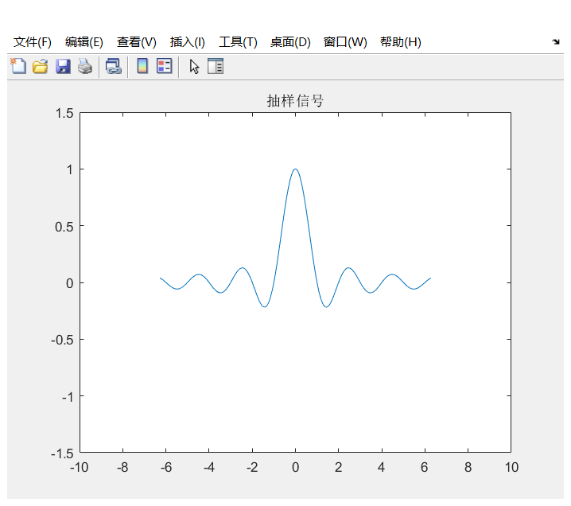

**2）矩形脉冲信号：**

源码：

|  |
| --- |
| t = -5:0.01:5;  f_sign = sign(t);  f_u = 1/2*f_sign + 1/2;  f_sign2 = sign(t-2);  f_u2 = 1/2*f_sign2 + 1/2;  f_wave = f_u - f_u2;  plot(t,f_wave);  axis([-3,3,-2,2]);  title('脉冲信号'); |

各参数意义：

|  |  |
| --- | --- |
| 函数 | 参数 |
| plot(t,f_sinc) | t为自变量，f_sinc为因变量 |
| axis(a,b,c,d) | a,b 自变量区间 c,d 因变量区间 |

运行结果

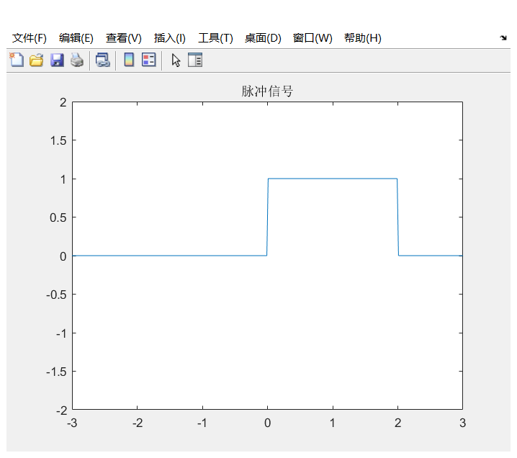

**3）周期矩形脉冲信号：**

源码：

|  |
| --- |
| t = -5:0.01:5;  f = square(0.5*pi*t,50);  plot(t,f);  axis([-5,5,-2,2]);  title('周期脉冲信号');  grid on; |

各参数意义：

|  |  |
| --- | --- |
| 函数 | 参数 |
| sqare(a,b) | a为角频率，b为占空比 |
| grid on | 显示网格线 |

运行结果：

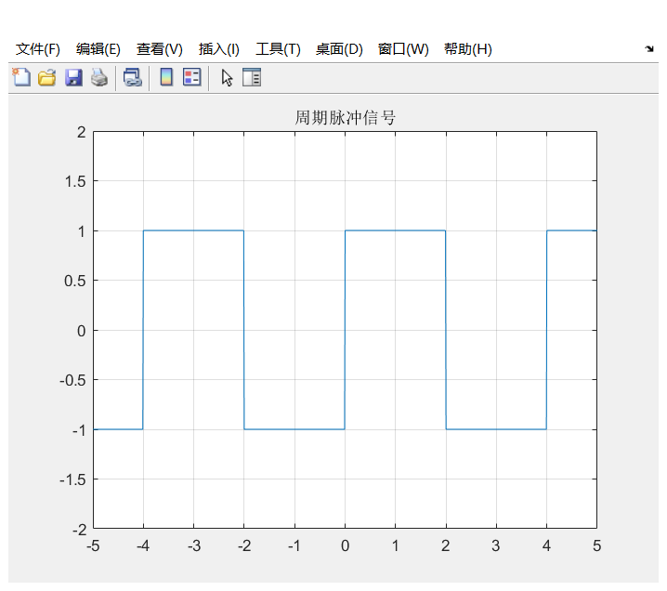

**4）三角波脉冲信号：**

源码：

|  |
| --- |
| t = -2:0.01:2;  f_u1 = 0.5*sign(t) + 0.5;  f_u2 = 0.5*sign(-1*t)+0.5;  y = f_u2.*(t+2)+f_u1.*(-1*t+2);  plot(t,y); axis([-3,3,0,3]);  title('三角波信号');  grid on; |

各参数意义：

|  |  |
| --- | --- |
| 函数 | 参数 |
| plot(t,f_sinc) | t为自变量，f_sinc为因变量 |
| grid on | 显示网格线 |

运行结果：

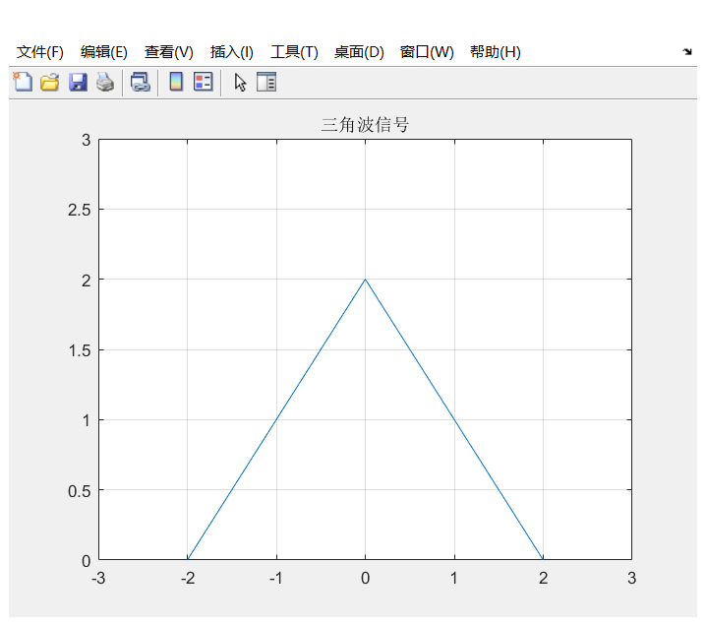

**5）三角波周期信号：**

源码：

|  |
| --- |
| t = -2:0.01:2;  f = sawtooth(4*pi*t,0.5);    plot(t,f);  axis([-2,2,-2,2]);  title('周期三角波');  grid on; |

各参数意义：

|  |  |
| --- | --- |
| 函数 | 参数 |
| plot(t,f_sinc) | t为自变量，f_sinc为因变量 |
| sawtooth(a*t,x) | 生成周期为2pi/a , 峰值出现在x（0~1，0.5为中央）的三角波 |

运行结果：

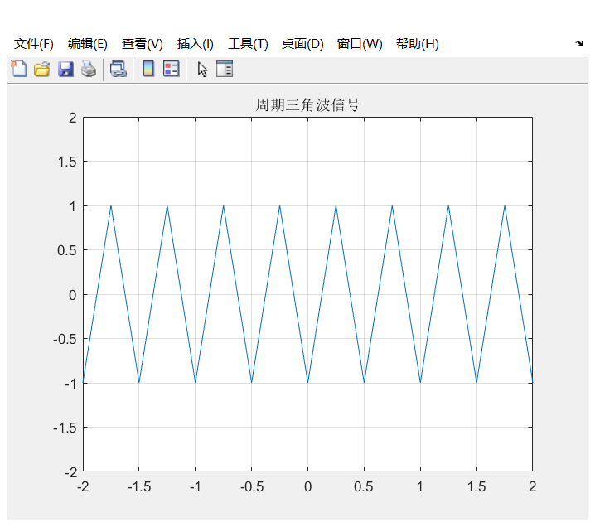

1. 分别用MATLAB的数字运算和符号运算功能，绘出下列连续时间信号的波形。

$$\left(1\right) f\left(t\right)=\left(2−e^{−2t}\right)u\left(t\right) \left(2\right) f\left(t\right)=\cos\left(\frac{πt}{2}\right)\left[u\left(t\right)−u\left(t−4\right)\right]$$

$$\left(3\right) f\left(t\right)=e^{t}\cos\left(t\right)u\left(t\right) \left(4\right) f\left(t\right)=\frac{2}{3}t u\left(t+2\right)$$

**1） $f\left(t\right)=\left(2−e^{−2t}\right)u\left(t\right)$**

**符号法：**

源码：

|  |
| --- |
| t = sym('t');  f = (2-exp(-2*t))*heaviside(t);  fplot(f,[-5,20]);  axis([-5,20,-1,3]);  grid on; |

运行结果：

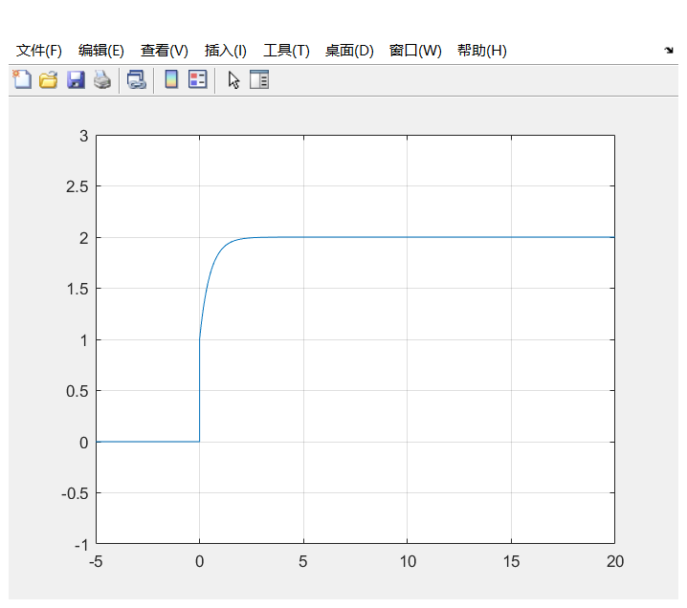

**数值法：**

源码：

|  |
| --- |
| t = -5:0.1:20;  f = (2-exp(-2*t)).*stepfun(t,0);  plot(t,f);  axis([-5,20,-1,3]);  grid on; |

运行结果：

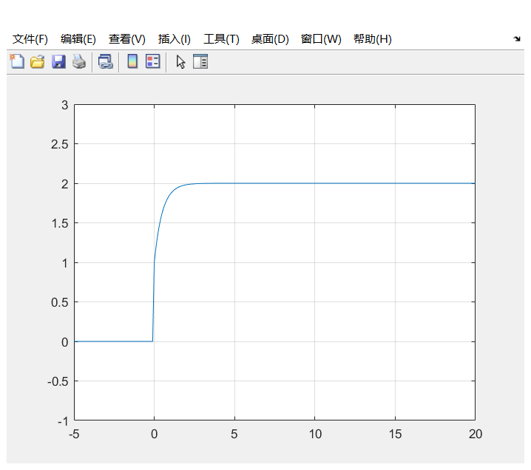

**2） $f\left(t\right)=\cos\left(\frac{πt}{2}\right)\left[u\left(t\right)−u\left(t−4\right)\right]$**

**符号法：**

源码：

|  |
| --- |
| t = sym('t');  f = cos(0.5*pi*t)*(heaviside(t)-heaviside(t-4));  fplot(f,[-1,6]);  axis([-1,6,-1.5,1.5]);  grid on; |

运行结果：

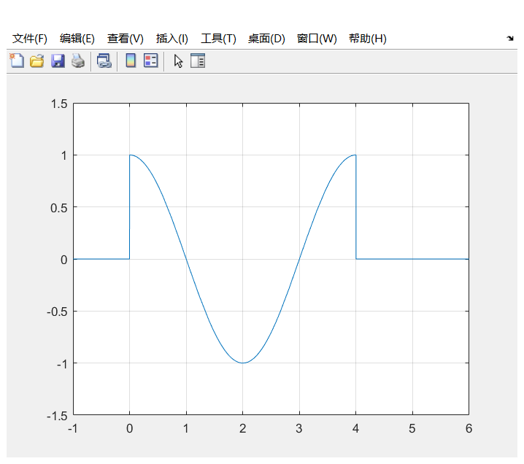

**数值法：**

源码：

|  |
| --- |
| t = -1:0.1:6;  f = cos(0.5*pi*t).*(stepfun(t,0)-stepfun(t,4));  plot(t,f);  axis([-1,6,-1.5,1.5]);  grid on; |

运行结果：



**3） $f\left(t\right)=e^{t}\cos\left(t\right)u\left(t\right)$**

**符号法：**

源码：

|  |
| --- |
| t = sym('t');  f = exp(t)*cos(t)*heaviside(t);  fplot(f,[-2,10]);  axis([-2,10,-100,900]);  grid on; |

运行结果：

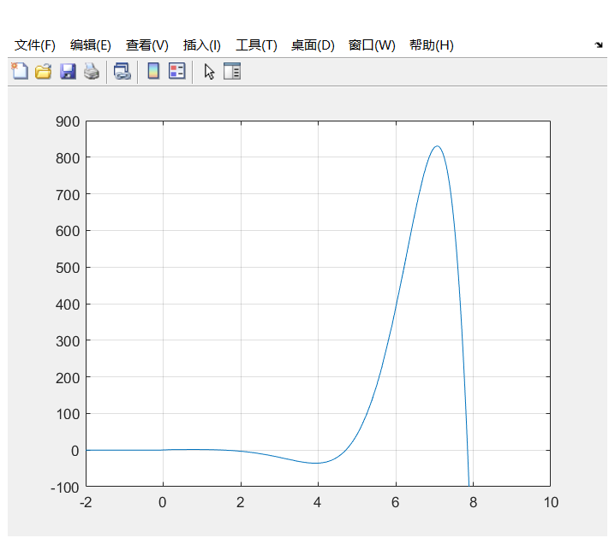

**数值法：**

源码：

|  |
| --- |
| t = -2:0.1:10;  f = exp(t).*cos(t).*stepfun(t,0);  plot(t,f);  axis([-2,10,-100,900]);  grid on; |

运行结果：

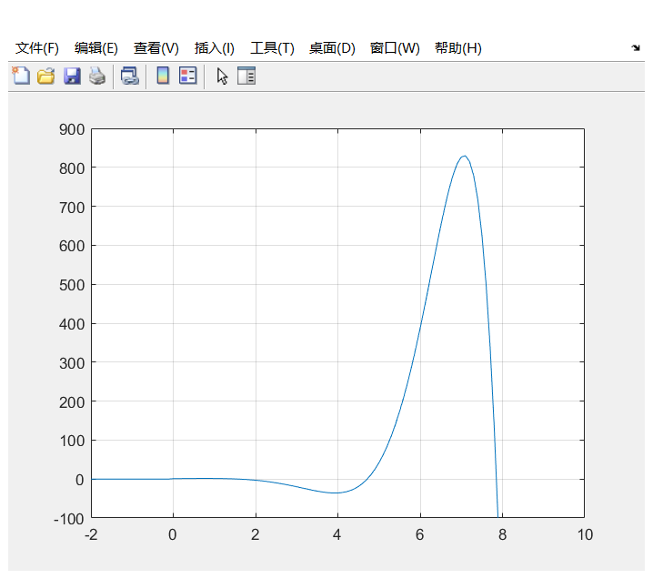

**4） $f\left(t\right)=\frac{2}{3}t u\left(t+2\right)$**

**符号法：**

源码：

|  |
| --- |
| t = sym('t');  f = (2/3)*t*heaviside(t+2);  fplot(f,[-10,10]);  axis([-10,10,-10,10]);  grid on; |

运行结果：

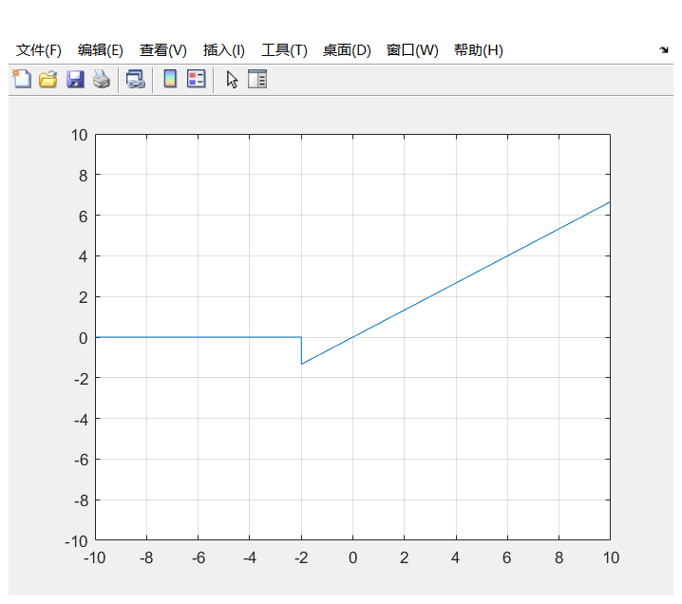

**法二：数值法**

源码：

|  |
| --- |
| t = -10:0.1:10;  f = (2/3)*t.*stepfun(t,-2);  plot(t,f);  axis([-10,10,-10,10]);  grid on; |

运行结果：

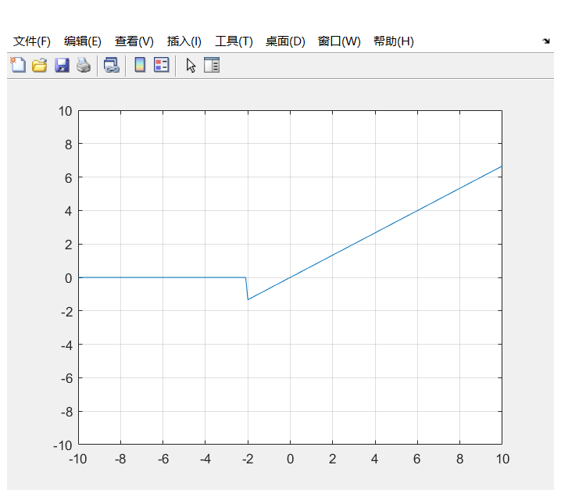

3、已知信号 $f\left(t\right)$ 的波形如右图所示，绘出满足下列要求的信号波形。

**f(t)**

**t**

**2**

**2**

**1**

**1**

$$\left(1\right) f\left(−t\right)$$

$$\left(2\right) f\left(t−2\right)$$

$$\left(3\right) f\left(at\right) (其中a的值分别取0.5和2)$$

$$\left(4\right) f\left(0.5t+1\right)$$

**1） $f\left(−t\right)$**

源码：

|  |
| --- |
| t = sym('t');  ft = 2*heaviside(-t)-1*heaviside(-t-1)-1*heaviside(-t-2);  fplot(ft,[-3,3]);  axis([-3,3,-3,3]);  grid on; |

运行结果

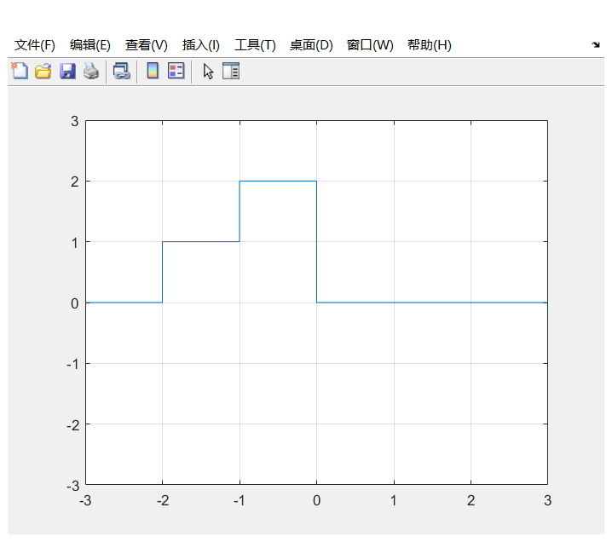

**2） $f\left(t−2\right)$**

源码：

|  |
| --- |
| t = sym('t');  ft = 2*heaviside(t-2)-1*heaviside(t-1-2)-1*heaviside(t-2-2);  fplot(ft,[-10,10]);  axis([-10,10,-5,5]);  grid on; |

运行结果

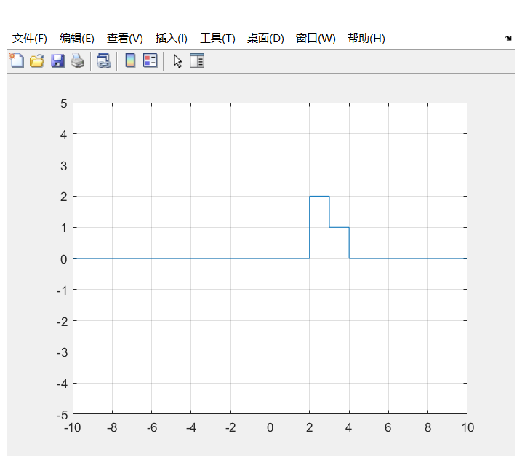

$$\left(3\right) f\left(at\right) (其中a的值分别取0.5和2)$$

**a =0.5**

源码：

|  |
| --- |
| t = sym('t');  a = 0.5;  ft = 2*heaviside(a*t)-1*heaviside(a*t-1)-1*heaviside(a*t-2);  fplot(ft,[-10,10]);  axis([-10,10,-5,5]);  grid on; |

运行结果

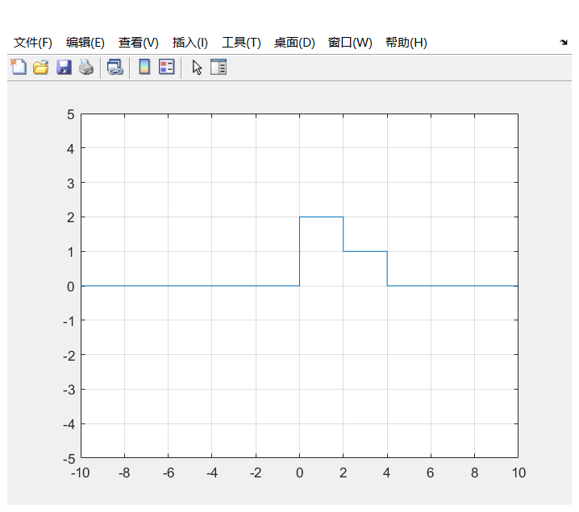

**a=2**

源码：

|  |
| --- |
| t = sym('t');  a = 2;  ft = 2*heaviside(a*t)-1*heaviside(a*t-1)-1*heaviside(a*t-2);  fplot(ft,[-10,10]);  axis([-10,10,-5,5]);  grid on; |

运行结果

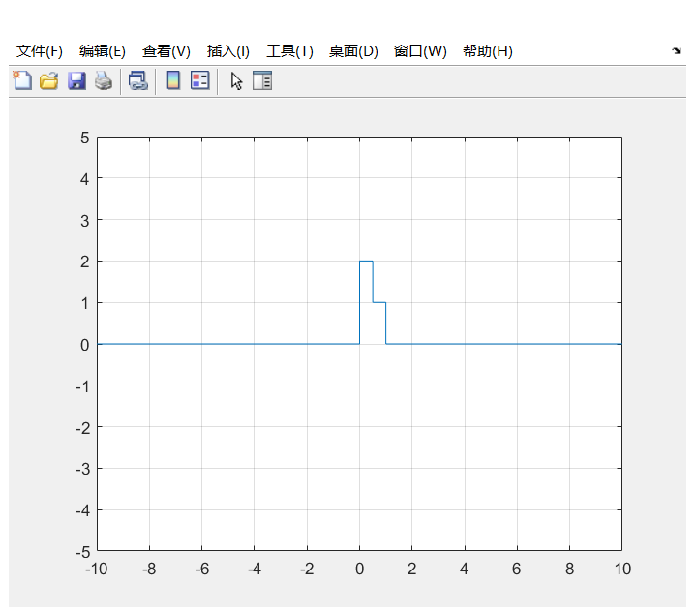

$$\left(4\right) f\left(0.5t+1\right)$$

源码：

|  |
| --- |
| t = sym('t');  a = 0.5;  ft = 2*heaviside(a*t+1)-1*heaviside(a*t+1-1)-1*heaviside(a*t+1-2);  fplot(ft,[-10,10]);  axis([-10,10,-5,5]);  grid on; |

运行结果

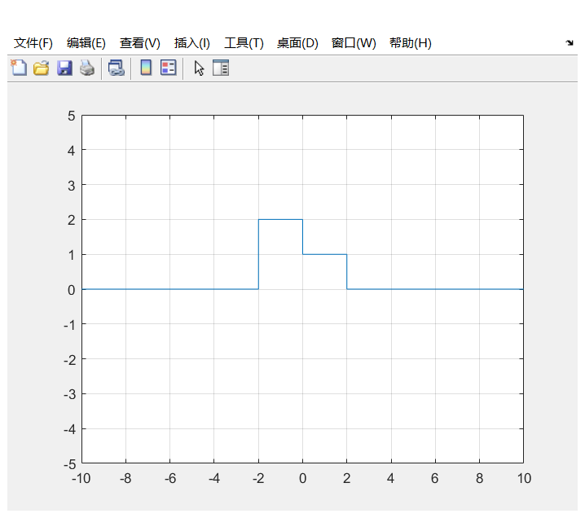

4、利用Matlab画出复信号 $f\left(t\right)=2e^{j(t+\frac{π}{4})}$ 的实部、虚部、模和辅角。

**实部：**

源码：

|  |
| --- |
| t = sym('t');  ft = real(2*exp(1i*(t+pi/6)));  fplot(ft,[-10,10]);  axis([-10,10,-5,5]);  grid on; |

运行结果

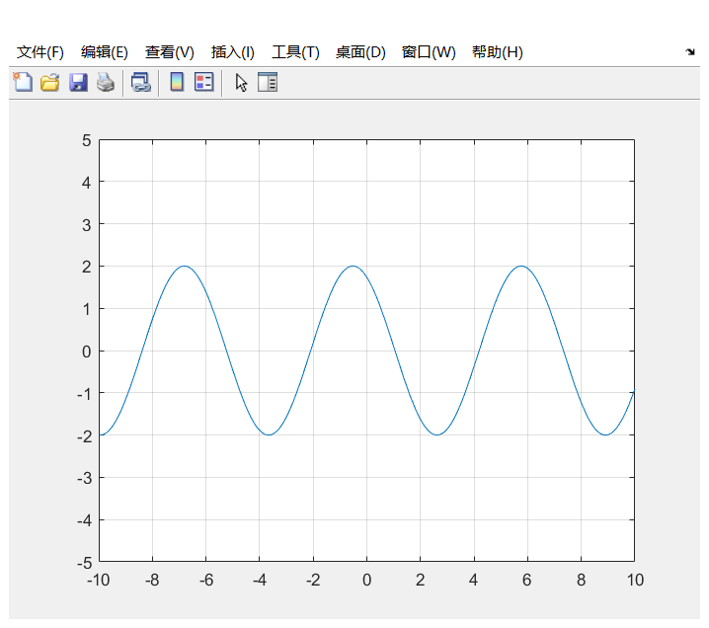

**虚部：**

源码：

|  |
| --- |
| t = sym('t');  ft = imag(2*exp(1i*(t+pi/6)));  fplot(ft,[-10,10]);  axis([-10,10,-5,5]);  grid on; |

运行结果

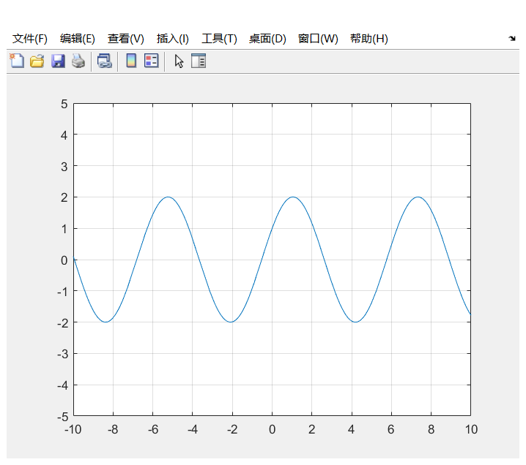

**模：**

源码：

|  |
| --- |
| t = sym('t');  ft = abs(2*exp(1i*(t+pi/6)));  fplot(ft,[-10,10]);  axis([-10,10,-5,5]);  grid on; |

运行结果

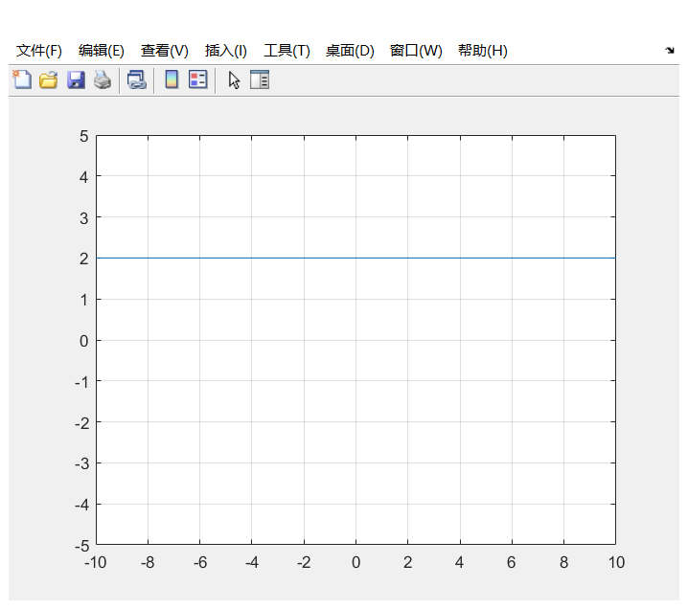

**辐角：**

源码：

|  |
| --- |
| t = sym('t');  ft = angle(2*exp(1i*(t+pi/6)));  fplot(ft,[-10,10]);  axis([-10,10,-5,5]);  grid on; |

运行结果

