1. 求解求信号的傅里叶变换，并绘出其幅度谱。

源码：

N=100;

t_length=40;

T=t_length/N;

t=(0:N-1)*T-t_length/2;

x=(sin(2*pi*(t-1)))./(pi*(t-1));

plot(t,x)

w_length=2*pi/T;

W=w_length/N;

X=T*fft(x,N);

X=fftshift(X);

w=(0:N-1)*W-w_length/2;

plot(w,abs(X));axis([-10,10,-0.5,1.5]);

title('FFT幅度谱');grid on;

运行结果：

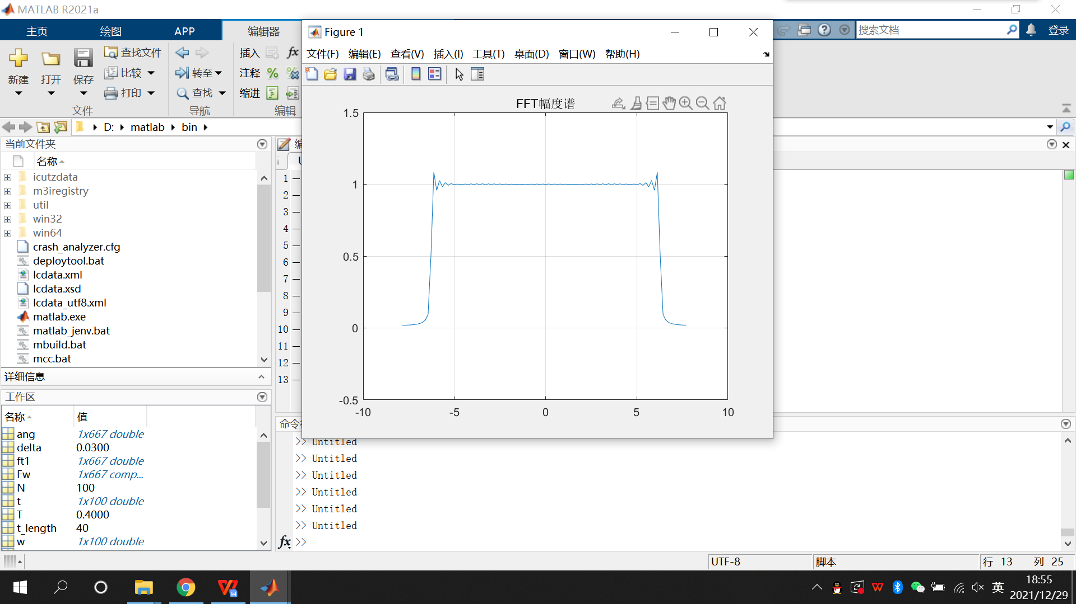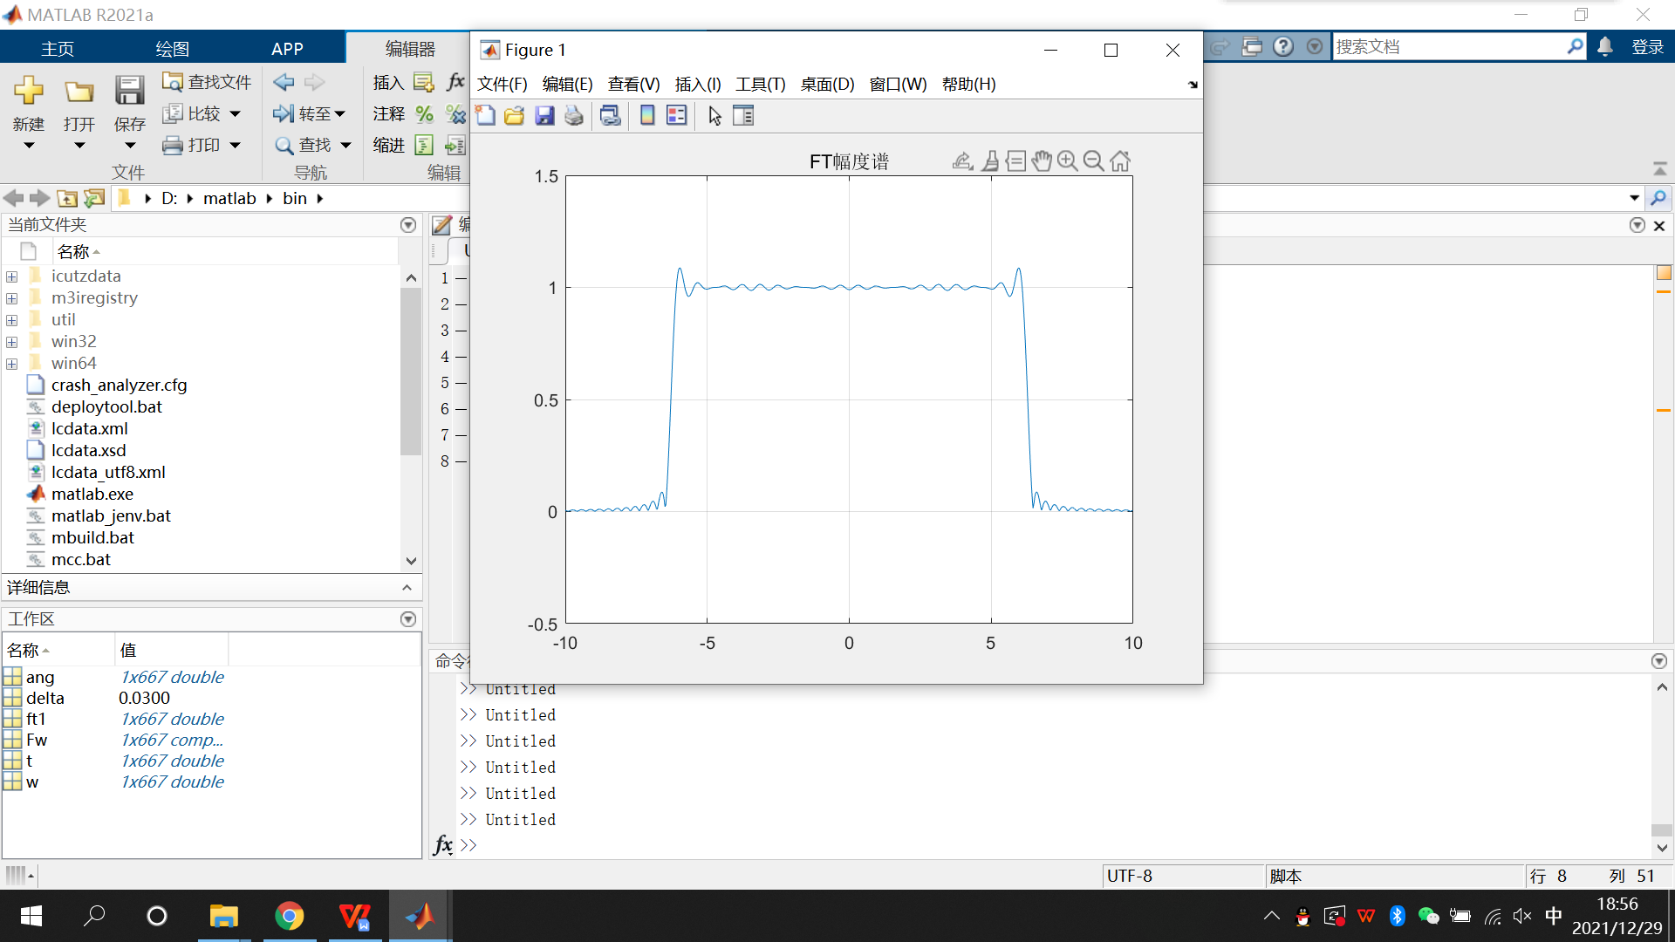

2、求下面所示信号的傅立叶变换幅度谱；

**t**

**-1**

**1**

**2**

**0**

**-2**

**1**

源码：

clear all ;

N=1000;

t_length=40;

T=t_length/N;

t=(0:N-1)*T-t_length/2;

w_length=2*pi/T;

W=w_length/N;

w=(0:N-1)*W-w_length/2;

x=(t+2).*(stepfun(t,-2)-stepfun(t,-1))+stepfun(t,-1)-stepfun(t,1)+(2-t).*(stepfun(t,1)-stepfun(t,2));

X=T*fft(x,N);

X=fftshift(X);

plot(w,abs(X));axis([-10,10,-0.5,4]);

title('FFT幅度谱'); grid on;

运行结果：

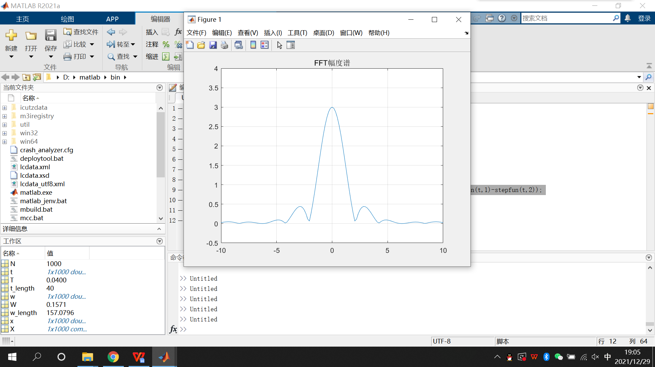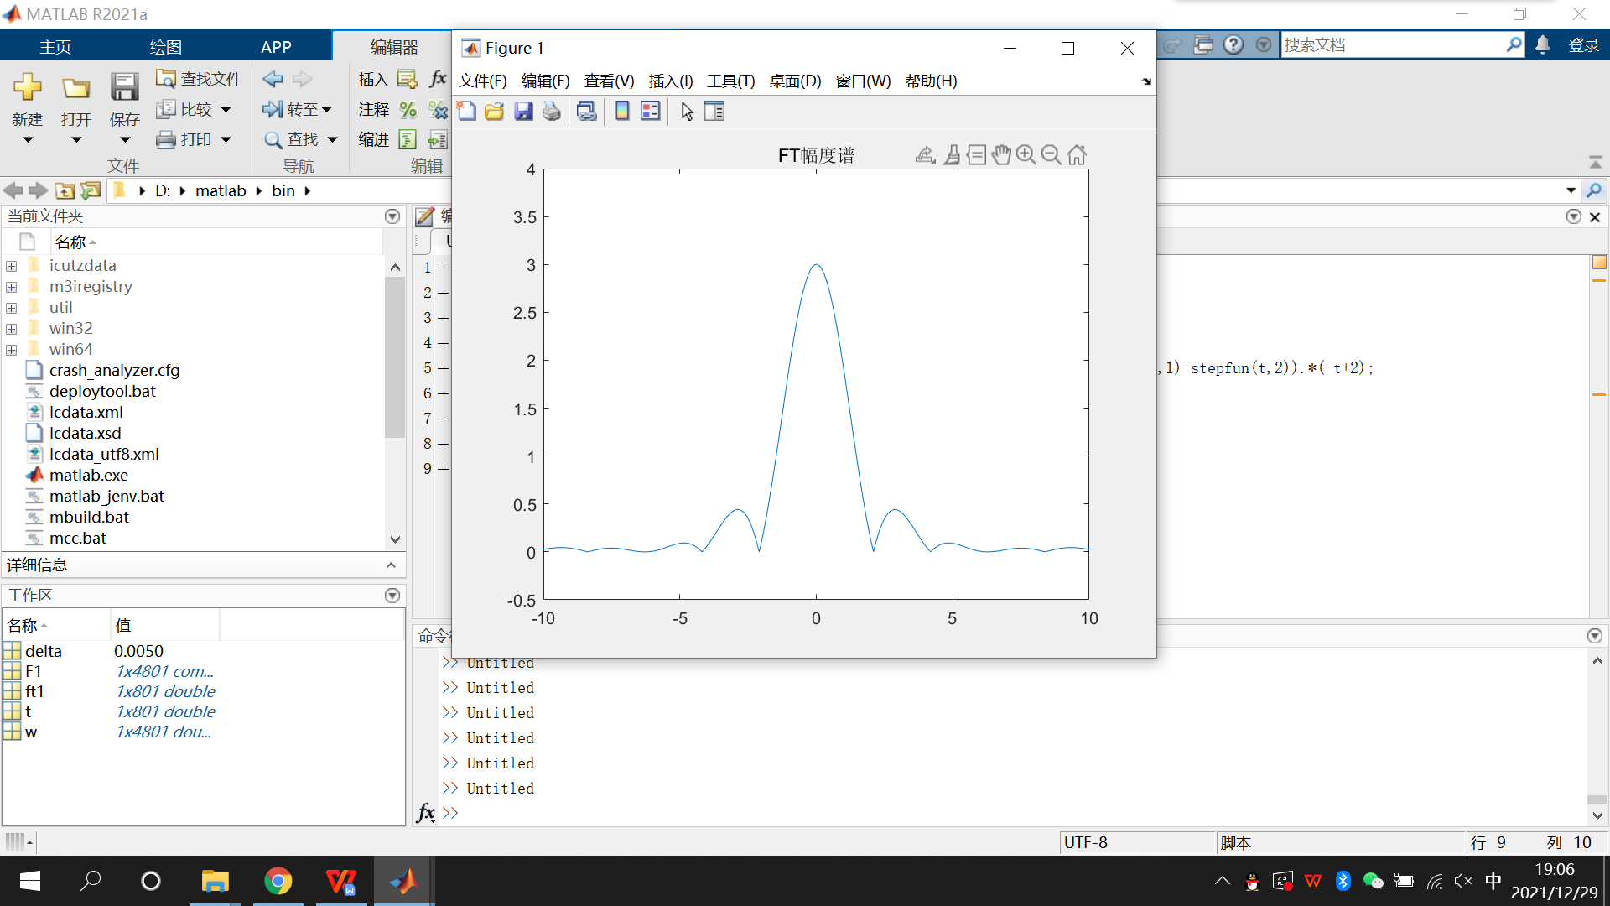

3、设矩形信号，利用Matlab命令绘出该信号及其频谱图。同时绘出的频谱图。

1. f(t)

源码：

clear all；

N=1024;

t_length=40;

T=t_length/N;

t=(0:N-1)*T-t_length/2;

x=heaviside((t+0.5))-heaviside((t-0.5));

plot(t,x)

w_length=2*pi/T;

W=w_length/N;

X=T*fft(x,N);

X=fftshift(X);

w=(0:N-1)*W-w_length/2;

abs=abs(X);

ang=angle(X);

subplot(411);

plot(t,x),title(' f(t)时域图') , grid on ;

subplot(412);

plot(w,X),title('f(t)频域图') , grid on ;

subplot(413);

plot(w, abs), title('f(t)频谱图'),grid on;

subplot(414) ;

plot(w, ang), title('f(t)相位图'),grid on;

运行结果：

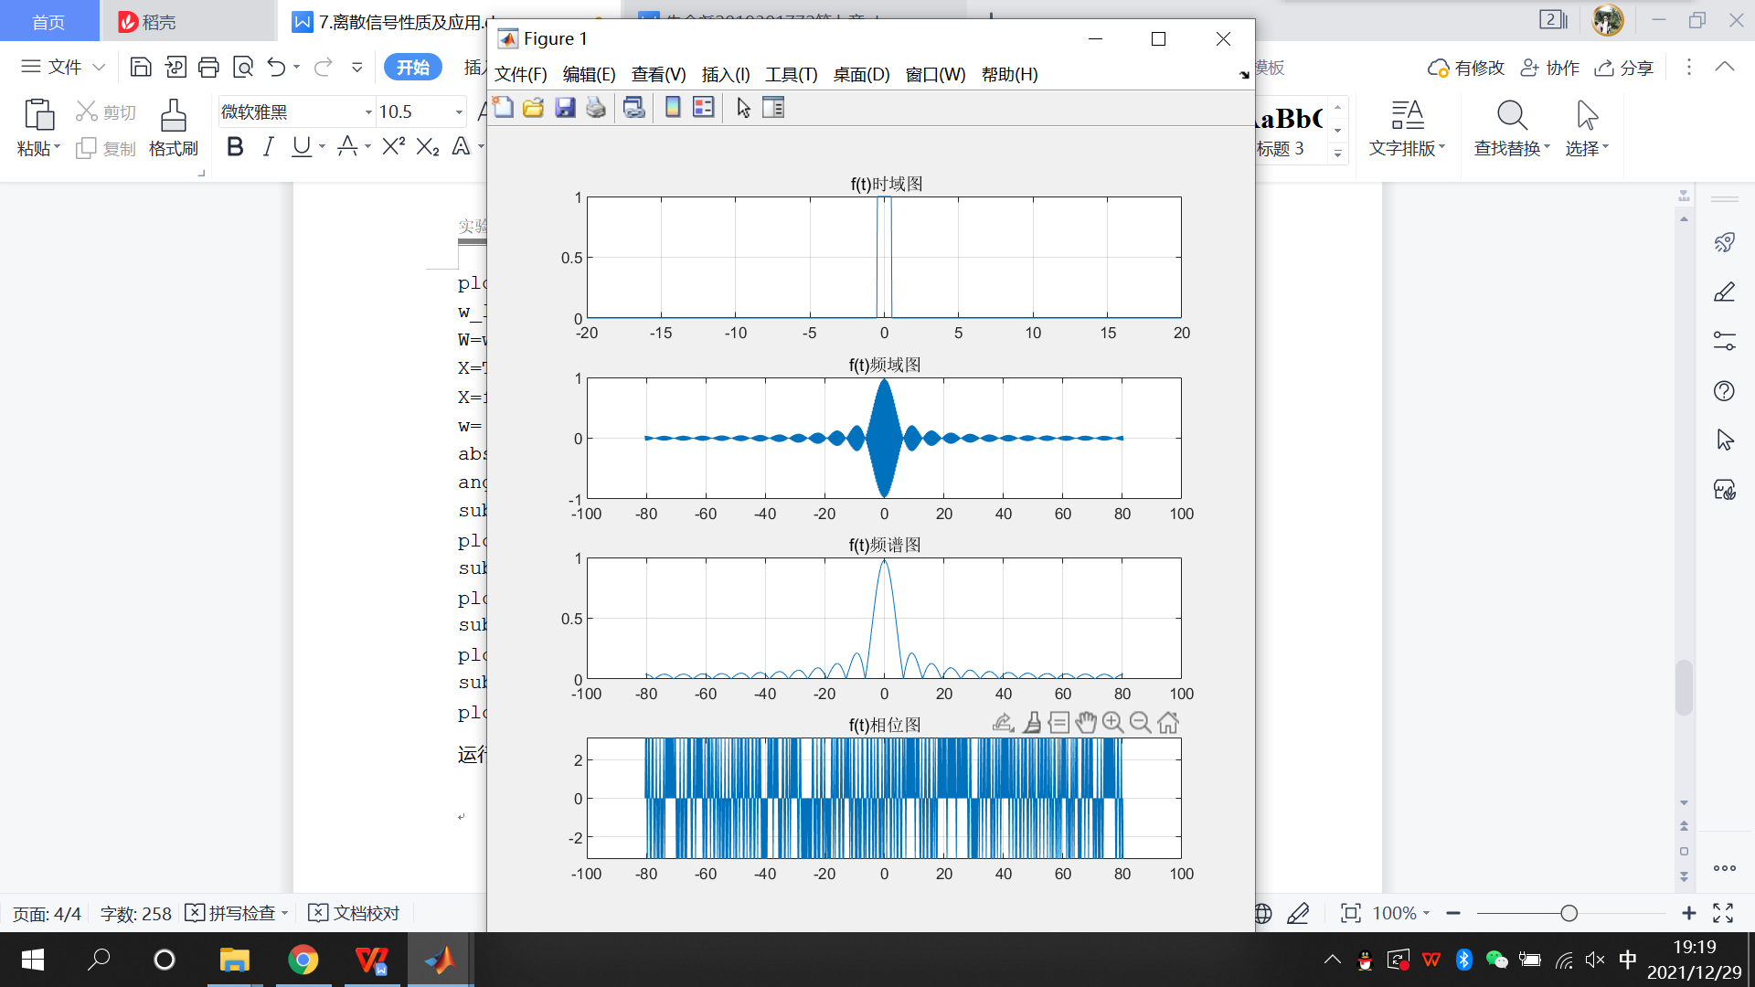

1. f(0.5t)

源码：

clear all

N=1024;

t_length=40;

T=t_length/N;

t=(0:N-1)*T-t_length/2;

x=heaviside((t/2+0.5))-heaviside((t/2-0.5));

plot(t,x)

w_length=2*pi/T;

W=w_length/N;

X=T*fft(x,N);

X=fftshift(X);

w=(0:N-1)*W-w_length/2;

abs=abs(X);

ang=angle(X);

subplot(411);

plot(t,x),title(' f(0.5t)时域图') , grid on

subplot(412);

plot(w,X),title('f(0.5t)频域图') , grid on

subplot(413);

plot(w, abs), title('f(0.5t)频谱图'), grid on

subplot(414) ;

plot(w, ang), title('f(0.5t)相位图'), grid on

运行结果：

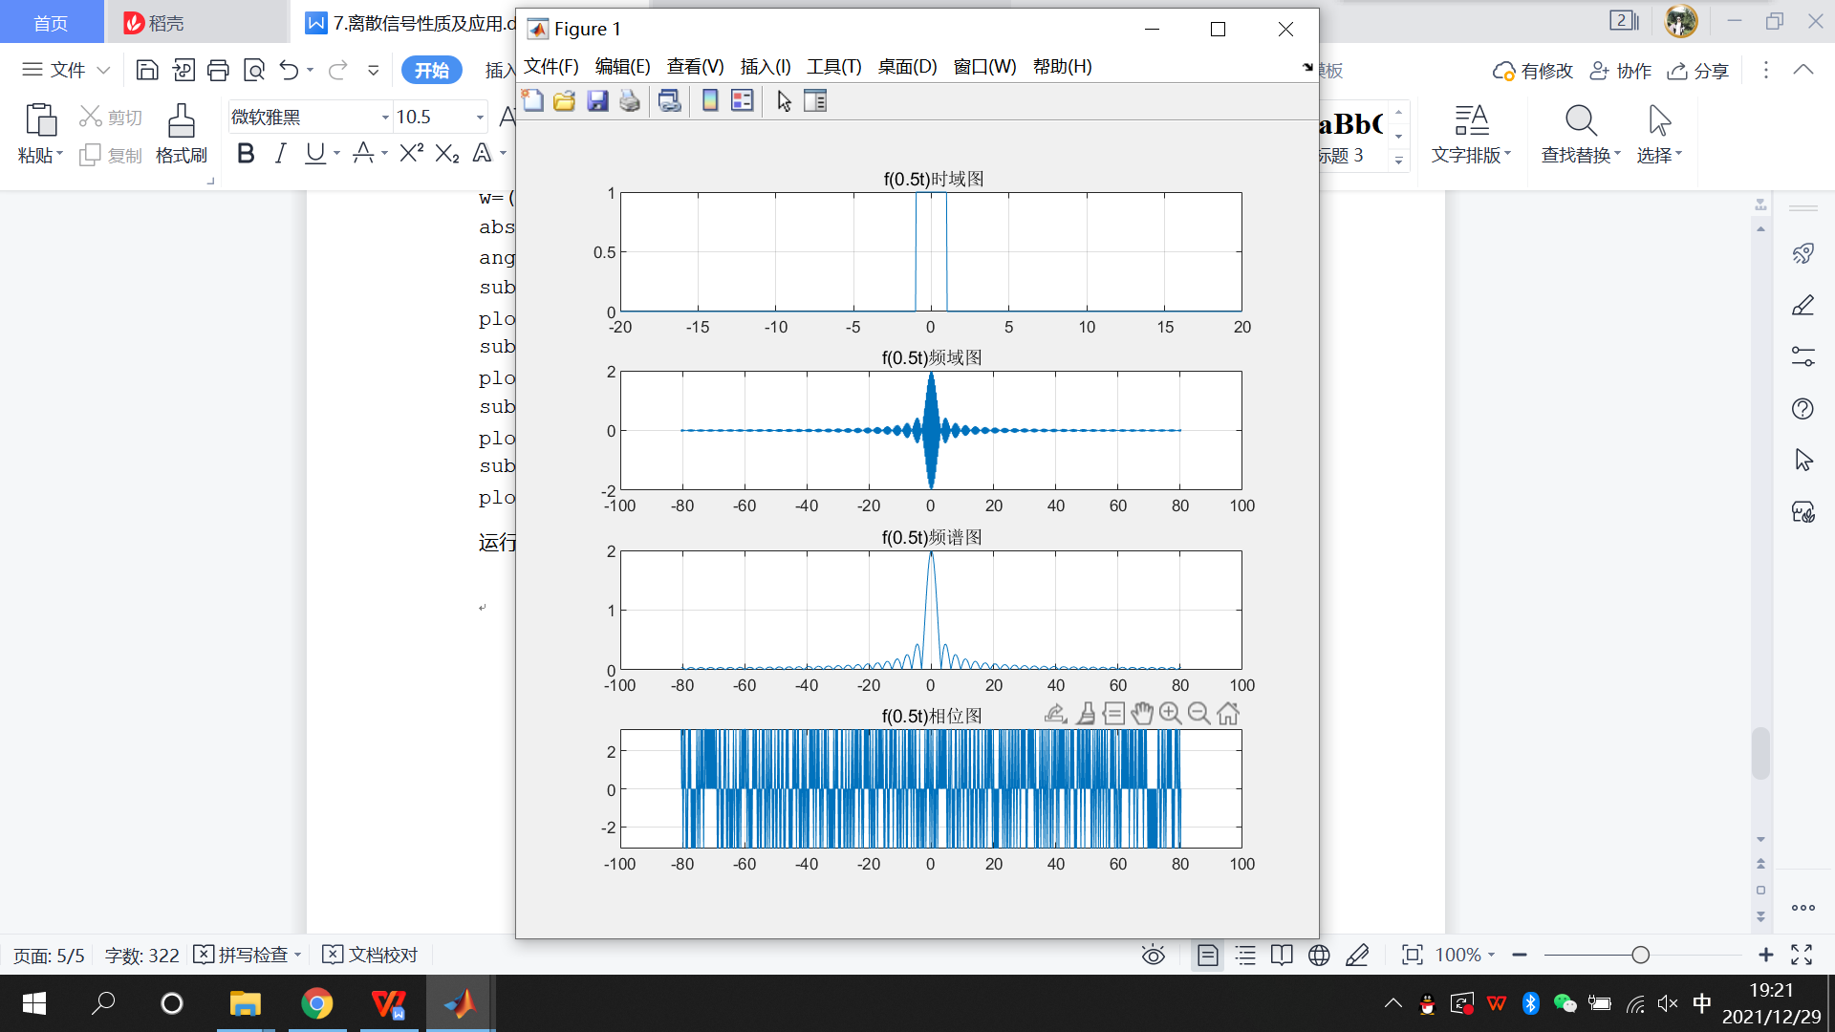

1. f(2t)

源码：

clear all

N=1024;

t_length=40;

T=t_length/N;

t=(0:N-1)*T-t_length/2;

x=heaviside((t*2+0.5))-heaviside((t*2-0.5));

plot(t,x)

w_length=2*pi/T;

W=w_length/N;

X=T*fft(x,N);

X=fftshift(X);

w=(0:N-1)*W-w_length/2;

abs=abs(X);

ang=angle(X);

subplot(411);

plot(t,x),title(' f(2t)时域图') , grid on

subplot(412);

plot(w,X),title('f(2t)频域图') , grid on

subplot(413);

plot(w, abs), title('f(2t)频谱图'), grid on

subplot(414) ;

plot(w, ang), title('f(2t)相位图'), grid on

运行结果：

