毕业设计（论文）
译文及原稿

译文题目： | 利用机器学习进行电影推荐与情感分析
原稿题目： | Movie recommendation and sentiment analysis using machine learning
原稿出处： | N. Pavitha, Vithika Pungliya and Ankur Raut al  Global Transitions Proceedings 3 (2022) 279–284 (Proceedings of the 6th International Conference on Intelligent Computing and Control Systems - ICICCS 2022)

利用机器学习进行电影推荐与情感分析
摘要：在当今现代社会，技术创新已然成为推动各行各业发展的核心驱动力。然而，随之而来的数据爆炸式增长导致了严重的“信息过载”现象，使得用户难以在海量数据中快速定位所需信息。在此背景下，推荐系统作为一种智能化的信息过滤工具，在处理大规模数据集并为用户筛选出与其兴趣高度相关的信息方面，展现出了不可替代的价值。本文深入探讨并提出了一种基于余弦相似度算法的电影推荐系统架构，该方法旨在根据用户历史偏好的电影，精准推荐与之特征相似的其他影片。

尽管现有的推荐系统在通过相似性匹配完成基本推荐任务方面表现尚可，但它们往往存在一个显著的缺陷：无法向用户证明被推荐的电影是否具有高质量，即是否值得用户花费宝贵的时间去观看。为了有效解决这一“推荐准确但质量未知”的痛点，我们在传统推荐系统的基础上创新性地引入了情感分析模块。该模块通过网络爬虫技术从 IMDb（互联网电影数据库）获取海量的真实用户评论，并利用 朴素贝叶斯 和支持向量机等先进的监督式机器学习算法进行深度挖掘。这一过程能够根据既往观众的反馈将电影口碑分类，并提供关于电影情节、演技及制作水准的客观分析，从而极大地节省了用户的筛选时间，提升了用户体验。本文还通过准确率（Accuracy）、精确率（Precision）、召回率（Recall）和 F1 分数（F1 Score）等关键性能指标，对朴素贝叶斯和支持向量机两种算法进行了详尽的对比实验。实验结果表明，SVM 模型的准确率达到了 98.63%，而朴素贝叶斯模型的准确率为 97.33%。由此可见，在处理电影评论的情感分类任务中，支持向量机表现出了更优越的性能和稳定性。

关键词：余弦相似度；电影推荐系统；朴素贝叶斯分类器；情感分析；支持向量机；机器学习

1 引言
自发明以来，互联网发展迅速，且每一天都在持续增长。在线可用信息的丰富性使得快速、轻松地获取正确信息成为一项艰巨的任务[1]。幸运的是，这个问题可以通过推荐系统的帮助来解决。
如今，推荐系统被广泛使用，并已在电子商务、零售、银行、娱乐等多个行业中找到了应用场景。这些系统收集并自动分析用户数据，以便为用户生成个性化的推荐[2]。实现推荐系统最常见的方法是基于内容的过滤（Content-based Filtering, CBF）、协同过滤（Collaborative Filtering, CF）和混合过滤（Hybrid Filtering）[3]。CBF 是一种用于分析每个物品的内容并推荐具有相似特征的其他物品的方法。CF 解决了 CBF 的一些局限性，通过比较用户和物品之间的相似性来提供推荐。它利用用户先前的偏好以及其他相似用户的偏好知识来生成推荐。许多推荐系统也因使用结合了 CBF 和 CF 方法特征的混合过滤技术而闻名[4]。
电影的受欢迎程度取决于它从观众那里获得的评论类型。这些评论也负责影响其他用户的选择。用户更有可能选择大多数人喜欢的电影，而不是大多数人厌恶的电影[5]。分析这些评论，同时忽略包含误导性信息的评论，也增加了决策的难度[6]。情感分析为这一问题提供了解决方案。
情感分析提供了一种利用 NLP（自然语言处理） 从文本源中提取信息，并将语句、单词或文档分类为正面或负面的方法。这对于理解作者的观点和指示用户体验非常有用。
意见挖掘（Opinion Mining）利用数据挖掘的概念，提取和分类在各种在线论坛或平台上表达的意见。这使得能够更好地理解用户对特定主题的情感或感觉[7]。
本文提出了一个系统，该系统不仅向用户推荐电影，还分析并将评论分类为正面或负面。电影推荐部分使用余弦相似度（Cosine Similarity）执行，并在 SVM 和 NB（朴素贝叶斯） 算法之间进行了比较，以执行评论的情感分析。
本研究的目标是处理海量数据并过滤有用信息，根据用户的选择推荐相似电影，并对所选电影的评论进行情感分析。
本文遵循以下结构：第 2 节涵盖文献综述。第 3 节讨论方法论，其中包括数据集、数据预处理、用于电影推荐的数据挖掘、用于情感分析的机器学习，最后是性能报告。第 4 节包含结果和讨论。最后，结论可以在第 5 节中找到。

2 相关著作
本节将详细讨论现有各种方法及其不足之处。
本文提出一种混合方法，将基于内容的推荐方法与类型相关性相结合，以实现推荐系统。该系统在向用户推荐时，同时考虑用户对电影的评分及其所属类型[4]。
本文提出了一种新型相似性算法，称为用户画像相关性相似度（UPCSim）。该算法允许其他用户行为数据影响推荐结果的准确性，通过计算基于用户评分和行为值的相似度权重，并采用K近邻算法对用户偏好进行分类。虽然这种方法使平均绝对误差（1.64%）和均方根误差（1.4%）有所下降，但需要消耗更多计算时间[8]。
作者探讨了基于余弦相似度和K近邻算法的电影推荐系统实现。电影推荐采用余弦相似度算法，通过归一化流行度评分构建距离计算函数，并运用K近邻算法提升推荐精度[9]。
本文提出一种混合推荐系统，该系统利用用户对电影推文的情感分析来获取情感评分，并采用加权融合评分方法[10]对用户推荐结果进行优化。
本文采用五种机器学习分类器——多项式朴素贝叶斯、 SVM 、决策树、伯努利朴素贝叶斯和最大熵，对包含特征向量的预处理数据进行分类，以对电影评论数据[11]进行分类。

3方法论
本节讨论了研究执行及算法实施所采用的方法。下图展示了该方法学的流程图。
图1展示了本项目采用的方法论。研究首先使用数据集训练余弦相似度模型，该模型用于电影推荐；随后通过另一数据集，分别采用朴素贝叶斯（NB）和支持向量机（SVM）分类器进行情感分析。
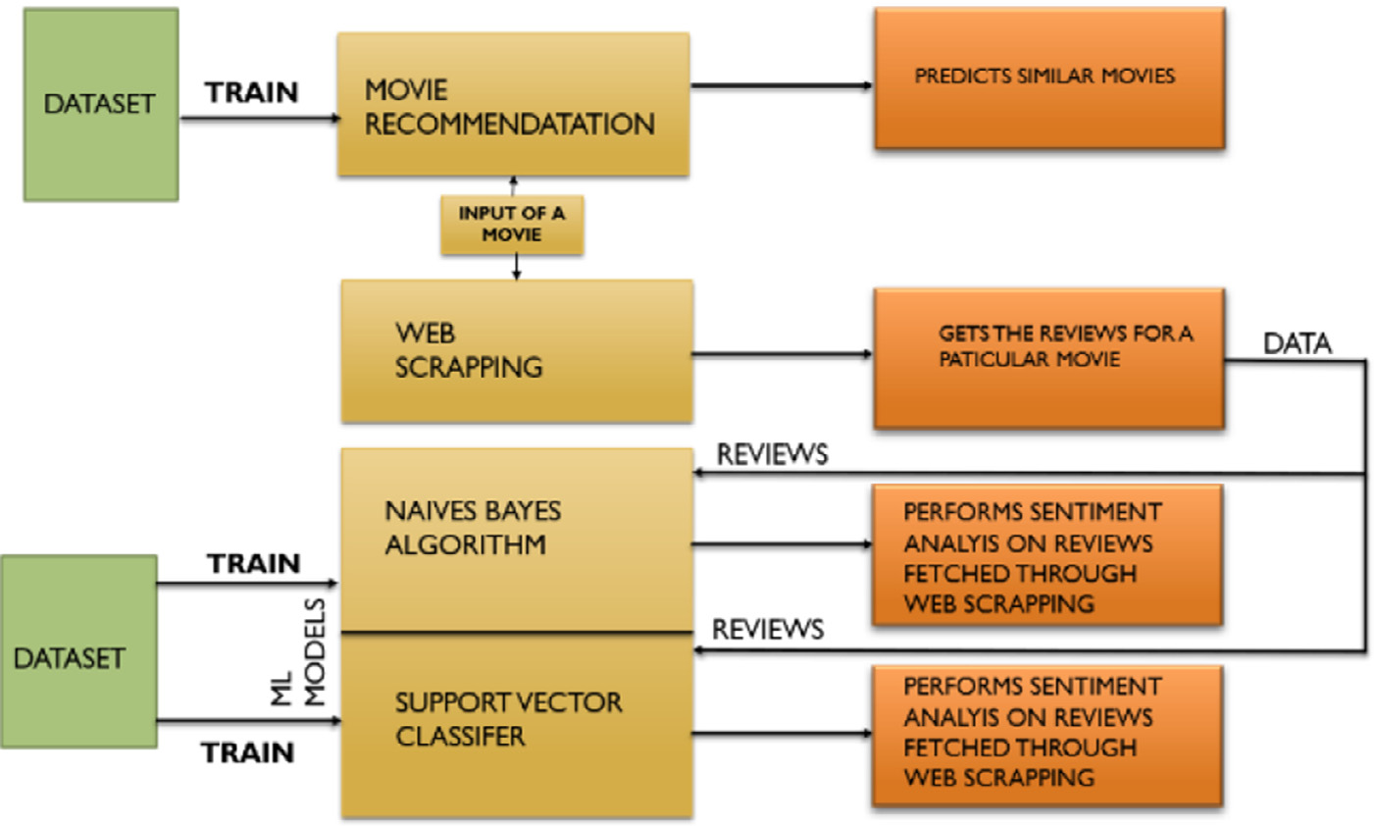
图1 流程图
分析模型已完成训练。现在以电影名称作为输入，输入到电影推荐模型中预测相似电影。通过从 IMDB 网站抓取，获取该电影的评论，并输入情感分析模型，对评论进行正负分类。

3.1 数据集
本研究使用了三个数据集，其中两个用于电影推荐，一个用于情感分析。推荐数据集包括tmdb_5000_movies .csv和 tbmd_5000_credits . csv ，情感分析数据集为 Ireviews.txt。随后将两个电影推荐数据集合并为一个数据集,保留的列包括 Imovie_id 、 Ititle和 Itags。
该评论数据集仅包含2列，一列用于记录 I评论 ，另一列用于记录意见。其中，正面意见被标记为1 ，负面意见被标记为0 。数据集中共有3943条正面评论和2975条负面评论。

3.2 数据预处理
将 两 个 数 据 集 合 并 为 单 一 数 据 集 后 ， 仅 保 留 Imovie_id、Ititle 、 Ioverview 、 Igenres 、 Ikeywords 、 Icast 和 Icr- ew等关键列，其余数据均被移除。然后利用抽象语法树对“类型” 、“关键词” 、“演员” 、“工作人员”等列进行了细化。
此外，这些列被归类到“标签”下。随后通过计数向量化器，对“标签” 列进行分词处理。分词即指将句子拆分为单词。至此， 电影推荐的预处理流程完成。
情感分析的预处理需要使用自然语言工具包（NLTK）。该 NLTK 是构建Python程序处理人类语言数据的领先平台。
这是Python语言中用于自然语言处理和计算语言学的标准库。通过该库可下载停用词表，停用词指任何语言中常规使用的词汇，例如 Ia、Ian 、 Ithe 、 Iif、 Ior 等 。 在 文 本 挖 掘 和 自 然 语 言 处 理（NLP） 中，这类词汇常被剔除，因其携带的信息量微乎其微。随后通过TF-IDF向量器对评论列进行分词处理。
至此，数据集的预处理工作告一段落。
图2展示了电影推荐所用的数据集，该数据集包含 I 电影ID、 I片名和 I标签三个字段。
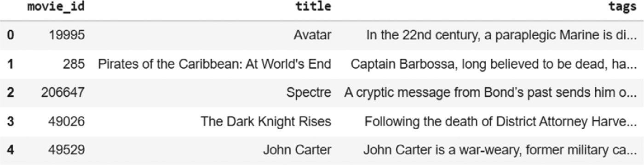
图2 电影推荐的最终数据集

图3展示了情感分析的数据集，包含两列，一列用于 I评论 ，另一列用于 I评价。
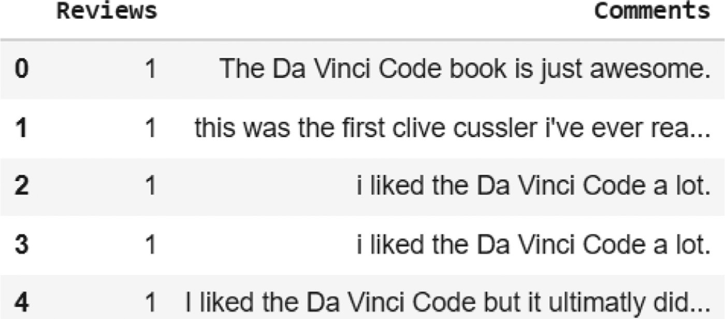
图3 情感分析数据集

3.3 电影推荐中的数据挖掘
采用Python语言中的sklearn库，运用余弦相似度算法。
当系统提示用户输入一部电影后，算法会推荐5部与用户输入电影相似的其他影片。
在余弦相似度中，向量作为数据集中的数据对象，当在乘积空间中定义时，相似度即由此计算得出。距离越小，相似度越高；距离越大，相似度越低。余弦相似度是一种度量方法，有助于发现数据对象之间的相似程度，且不受数据规模影响。从数学角度而言，它是两个向量在多维空间中投影后所成夹角的余弦值[9]。
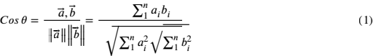
两个向量之间的夹角决定了其方向， 以‘θ’为单位进行测量。该夹角θ可通过使用公式(1)计算得出。
当θ=0°时，‘x’和‘y’向量重叠且证明相似。
当θ=90°时，‘x’和‘y’向量因此不相似。

3.4 机器学习在情感分析中的应用
如前所述,已采用两种算法：支持向量机和神经网络
该数据集被划分为测试集和训练集，测试集占比为0.20 ，训练集占比为0.80。
随后对两个模型进行拟合。为提高两个模型的准确性，对两个模型均实施超参数调优。
SVC是机器学习领域中用于分类和回归的监督算法。它通过在N维空间中寻找超平面来对信息点进行分类[12] 。当输入特征数量为2时，该超平面仅是一条直线；而当输入特征数量为3时，则为二维超平面。
模型中采用了径向基函数核，这是一种非线性SVM[13]。
该方法被称为 RBF 核。采用度量平方欧氏距离作为距离度量，用于绘制完全非线性的超平面。

等式（2）计算两个点X 和 X’的函数，计算它们之间的相似度或彼此接近程度。
σ 是方差和超参数 。||X – X‘ || 表示两点 X 和 X’ 之间的欧几里得（L2范数）距离。
NB算法利用条件概率对给定数据集进行分类。该算法采用贝叶斯定理进行计算，并将分类结果表示为特征值或预测变量向量。[12].
P 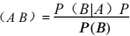（A） (3)

等式（3）计算事件 A 的条件概率，即 B 已经发生，该概率用于 NB分类器中的计算。
NB算法下模型的类型:
1高斯分布
2 项多项式分布
3项伯努利分布。
该系统采用多项式朴素贝叶斯（NB）模型，用于预测文本（如电子邮件或报纸文章） 的标签。针对给定样本，计算每个标签的概率，最终输出概率最高的标签。
由于该算法主要用于自然语言处理和文本数据分析，因此成为电影评论情感分析的理想选择。

4 结果
利用余弦相似度算法，可以对用户输入的电影进行预测。
图4展示了数据集中数值的余弦相似度矩阵。
图5显示，NB分类器将一条负面评论归类为0。
图6显示，SVC将一条负面评论归类为0。
本研究的一个重要组成部分是对两种算法进行比较。
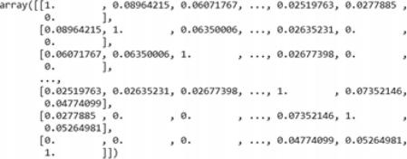

图4 数据集上拟合余弦相似度后的数组值

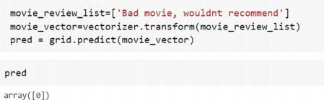

图5 NB算法的输出

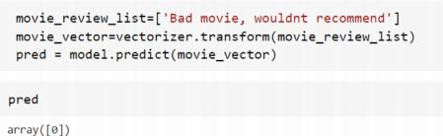

图6 SVC的输出

表1展示了两种提出的模型与[11]中研究的三种现有模型（伯努利朴素贝叶斯、多项式NB 、SVM）、[5]中研究的三种现有模型（SVM 、NB 、随机森林） 、[14]中研究的两种现有模型（堆叠 LSTM 、最小RNN） 以及[15]中研究的两种现有模型（CNN 、 LSTM）在不同准确率、精确率、召回率和AUC分数上的比较。
所提出的 SVM 模型在所有参数上均优于NB模型。

表1 模型比较
算法 | 精度 | 准确率 | 召回率 | AUC
朴素贝叶斯（建议） | 0.9733 | 0.96940 | 0.9850 | 0.970
SVM（建议） | 0.9863 | 0.98278 | 0.9937 | 0.984
伯努利朴素贝叶斯（现有）[11] | 0.875 | 0.884 | 0.8633 | 0.8735
多项式NB（现有）[11] | 0.885 | 0.9294 | 0.8333 | 0.8787
SVM（现有）[11] | 0.8733 | 0.859 | 0.8933 | 0.8753
NB（现有）[5] | 0.8183 | 0.84 | 0.79 | 0.82
SVM（现有）[5] | 0.8745 | 0.87 | 0.88 | 0.88
随机森林（现有）[5] | 0.9601 | 0.93 | 1.00 | 0.96
堆叠 LSTM（现有）[14] | 0.9365 | 0.94 | 0.94 | -
最小 RNN（现有）[14] | 0.8564 | 0.86 | 0.86 | -
CNN（现有）[15] | 0.8915 | 0.8259 | 0.8246 | 0.8253
LSTM（现有）[15] | 0.9550 | 0.9087 | 0.8228 | 0.8636

图7显示了两种算法之间的ROC曲线。
本研究选取的案例之一是电影《幽灵党》。
通过余弦相似度算法，对另外5部电影——《量子危机》、《永不言弃》 、《天幕杀机》 、《雷霆球》 、《来自俄罗斯的爱情》 进行了预测。
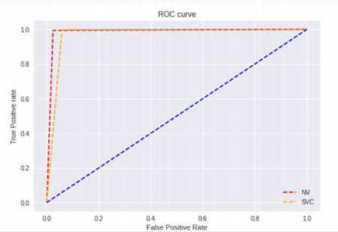

图7 ROC曲线

图8展示了用户输入的电影《幽灵党》影评。通过网络爬虫从 IMDB
网站抓取影评标题，并采用NB和SVC算法进行情感分析。
完成情感分析后（图9 、10），就能判断这部电影是否优秀。
因此，影评《邦德系列中令人愉悦的篇章，充满喧闹的行动、惊险刺激、情感张力与壮观场景》被赋予1分，这正是对影片好评的诠释。
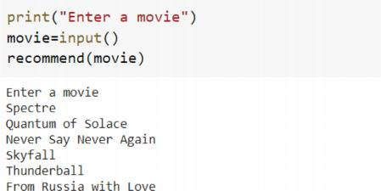
另一篇题为《007系列本该几十年前就完结》的影评被评分为0分，这反映了该片在影评界口碑不佳。

图8 基于余弦相似度算法的电影预测
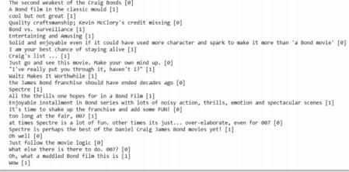

图9 基于NB算法的评论情感分析
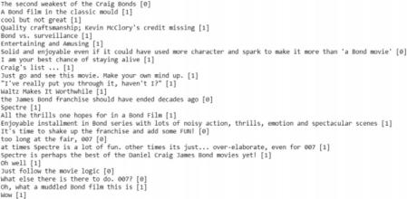

图10 基于支持向量机（SVC）的评论情感分析

5 结论
本文主要分为两大核心部分： 电影推荐系统与情感分析。研究对这两个系统进行了深入探讨，并得出了重要结论。在电影推荐系统方面，我们采用余弦相似度算法，根据用户输入的电影类型、剧情简介、演员阵容及评分等多维度因素，推荐与之相关的最佳影片 。经过多次测试验证，该算法始终表现稳定，推荐效果相当精准。
情感分析在本研究中同样发挥着重要作用，其核心目标是将评论划分为正面或负面两类。研究采用了两种算法：朴素贝叶斯（NB）和支持向量分类器（SVC） 。之所以选用两种算法，主要是为了找出最适合分类评论的算法——由于评论内容具有高度多样性，选择合适的分类算法至关重要。实验结果表明，支持向量分类器（SVC） 的准确率仅以微弱优
势优于朴素贝叶斯（NB）。
本研究的部分展望如下所述：
1 提高情感分析的准确性， 以更好地对讽刺或反讽评论进行分类。
2 非英语语言评论的情感分析
3 根据用户偏好（演员阵容、类型、上映年份等）进行电影推荐。
尽管该系统准确度极高，但仍存在若干局限。其一，若用户输入的电影未收录于数据集，或输入方式与数据集不符，系统将无法推荐相关影片。另一局限在于情感分析时的语言障碍——目前仅支持英文评论的处理。
Sentimental分析也会对讽刺或反讽的评论进行错误分类。

Movie recommendation and sentiment analysis using machine learning
Abstract：In the modern world, where technology is at the forefront of every industry, there has been an overload of information and data. Thus, a recommendation system comes in handy to deal with this large volume of data and filter out the useful information which is fast and relevant to the user’s choice. This paper describes an approach to a movie recommendation system using Cosine Similarity to recommend similar movies based on the one chosen by the user. Although the existing recommendation systems get the job done, it does not justify if the movie is worth spending time on. To enhance the user experience, this system performs sentiment analysis on the reviews of the movie chosen using machine learning. Two of the supervised machine learning algorithms Naïve Bayes (NB) Classifier and Support Vector Machine (SVM) Classifier are used to increase the accuracy and efficiency. This paper also gives a comparison between NB and SVM on the basis of parameters like Accuracy, Precision, Recall and F1 Score. The accuracy score of SVM came out to be 98.63% whereas accuracy score of NB is 97.33%. Thus, SVM outweighs NB and proves to be a better ﬁt for Sentiment Analysis.

Keywords: Cosine similarity Movie recommendation Naïve Bayes Sentiment analysis Support vector machine

- Introduction
Since its invention, the Internet has grown rapidly and continues to grow each day. The abundance of information available online, has made it a strenuous task to access the right information quickly and easily [1] . Fortunately, this problem can be solved with the help of recommendation systems.
Recommendation systems are used extensively today and have found applications in multiple industries such as e-commerce, retail, banking, entertainment etc. These systems collect and auto-analyse the user data to generate personalised recommendations for the users [2] . The most common approaches to implement recommendation systems are Content-based Filtering (CBF), Collaborative Filtering (CF) and Hybrid Filtering [3] . CBF is an approach that is used to analyse the content of each item and recommend other items that have similar characteristics . CF addresses some of the limitations of CBF and provides recommendations by comparing the similarities between the users and the items. It uses the knowledge of the user’s previous preferences as well as the preferences of other similar users to generate a recommendation. Many recommendation systems are also known to use the Hybrid-ﬁltering technique combining the features of both CBF and CF methods [4] .
A movie’s popularity is based on the type of reviews it gets from the audience . These reviews are also responsible for aﬀecting the choice of other users. Users are more likely to choose a movie that was preferred by most people rather than a movie that was largely disliked [5] . Analysing these reviews, ignoring the reviews that contain misleading information also adds to the diﬃculty of decision-making [6] .
Sentiment Analysis provides a solution to this problem. Sentiment Analysis facilitates a way to use NLP (natural language processing) to extract information from a textual source and classify the statement or word or document as positive or negative . It is very useful to understand the opinion of the author and indicate the user experience.
Opinion mining uses the concepts of data mining to extract and classify the opinions expressed in various online forums or platforms. This enables better understanding of the user’s sentiment or feeling towards a particular subject matter [7] .
The paper presents a system that not only recommends movies to the users but also analyses and classiﬁes the reviews into positive or negative. The movie recommendation part is performed using Cosine Similarity and a comparison is drawn between SVM and the NB algorithm to perform the Sentiment Analysis of the reviews.
The objective of the study is to deal with the large volume of data and ﬁlter useful information, recommend similar movies based on user’s choice and perform Sentimental Analysis on the reviews of the movie chosen.
The paper follows the given structure; Section 2 covers the Literature Review.Section3,discusses the Methodology which includes the dataset, the pre-processing of data, mining of data for movie recommendation, machine learning for sentiment analysis and ﬁnally,the performance report.Section 4 comprises the results and discussions. Finally, the conclusion can be found in Section 5 .

- Related
works In this section, the various existing methods and the drawbacks of the existing work are discussed in detail. In this paper, the authors propose a hybrid approach that combines a content-based approach with genre correlation to implement a recommendation system. This system takes into account both the user ratings of the movie as well as their genres while making recommendations to the user [4] .
In this paper, a new similarity algorithm is introduced. This is called User Proﬁle Correlation-based Similarity (UPCSim) and it allows other user behavioural data to inﬂuence the accuracy of the recommendation. It calculates the weights of similarity which depend on the user’s rating and the user’s behaviour value and classiﬁes the preferences of the user using K-nearest Neighbours algorithm. While this approach shows a decrease in the Mean Absolute Error (1.64%) and the Root Mean Square Error (1.4%), it requires more computation time [8] .
The authors discuss the implementation of a movie recommendation system using two algorithms, Cosine Similarity and K-Nearest Neighbours. The movie recommendation is done using the cosine similarity algorithm. A normalised popular score is used to obtain the function for computing distance and the K-Nearest Neighbours algorithm is applied to enhance the accuracy [9] .
In this paper, a hybrid recommendation system is proposed that uses sentiment analysis of user tweets for movies to obtain a sentiment score to improve the recommendation made to the users using a weighted fusion score method [10] .
This paper implements ﬁve machine learning classiﬁers – Multinomial Naïve Bayes, SVM, Decision Tree, Bernoulli Naïve Bayes, Maximum Entropy are applied on the pre-processed data containing feature vectors to classify the movie reviews data [11] .

- Methodology
Under this section, the methods used for the execution of the study and implementation of the algorithms have been discussed. The diagram below shows the ﬂowchart of the methodology.
Fig. 1 explains the methodology that has been used in the project. The study has used a dataset to train the cosine similarity model which is used for recommending movies. Then using another dataset, Naïve Bayes (NB) and Support Vector Machine (SVM) Classiﬁer for Sentiment Analysis has been trained. Now a movie name is taken as an input and sent to the movie recommendation model to predict similar movies. Through web scraping from the IMDB site, the reviews of that movie are obtained and sent to the Sentiment Analysis model for classifying the reviews as positive or negative.
Figure 1 Flowchart of proposed method.

3.1 Dataset
Three datasets have been used for study. 2 of them are for Movie Recommendation and 1 is for Sentiment Analysis. The ones used for recommendation are ‘tmdb_5000_movies.csv’, ‘tbmd_5000_credits.csv’ and the one used for sentiment analysis is ‘reviews.txt’. The 2 datasets used in movie recommendation are then merged to form a single data set and the columns kept under it are ‘movie_id’, ‘title’ and ‘tags’.
The reviews data set has only 2 columns, one for the ‘reviews’ and other for the ‘comments’. The positive comments have been labelled as 1 and the negative ones have been labelled as 0. There are 3943 positive comments and 2975 negative comments .

3.2 Data pre- processing
After merging the 2 datasets into a single dataset, only the essential columns such as ‘movie_id’, ‘title’. ‘overview’, ‘genres’, ‘keywords’,’ cast’ and ‘crew’ are kept, rest are removed from the dataset .
Then using Abstract Syntax trees, the columns of ‘genres’, ‘keywords’, ‘cast’, ‘crew’ have been reﬁned.
Furthermore, these columns have been combined under ‘tags’. Then using the count vectorizer, the column ‘tags’ is tokenised. Tokenising means to divide the sentences into words. Here the pre-processing for Movie Recommendation comes to an end.
The pre-processing for Sentiment Analysis requires Natural Language Tool Kit (NLTK). The NLTK is a leading platform for building Python programs to work with human language data.
This is a standard python library used for natural language processing and computational linguistics. Using this library, the stop words are downloaded. Stop Words are the usually used words in any language. Examples of such words include ‘a’, ‘an’, ‘the’, ‘if’, ‘or’. They are used in Text Mining and Natural Language Processing (NLP) to eliminate such words as they carry very little useful information. Then using the TﬁdfVectoriser, the column of Comments is tokenised. Now the Data Pre-processing of the datasets ends here.
The Fig. 2 shows the dataset used for Movie Recommendation, which has the ‘movie_id’, ‘title’ and ‘tags’.
Figure 2 Final dataset being used for movie recommenation.

The Fig. 3 shows the dataset for sentiment analysis, has 2 columns, one for the ‘comments’ and other for the ‘reviews’.
Figure 3 Dataset for sentiment analysis.

3.3 Data mining for movie recommendation
Using the sklearn library in Python, the Cosine Similarity algorithm is used. After the user is prompted to enter a movie, the algorithm provides 5 other movies like the one used as an input by the user. In cosine similarity, vectors are taken as the data objects in data sets, when deﬁned in a product space, the similarity is ﬁgured out. The smaller this distance, the higher the similarity, but the larger the distance, the lower the similarity. Cosine similarity is a measure that helps to ﬁnd out how similar data objects are, regardless of size. Mathematically, it is the cosine of the angle between two vectors projected in a multi-dimensional space [9] .

The angle between two vectors determines its direction and is mea- sured in ‘θ’. This angle θ can be calculated by usingEq. (1).
When θ = 0 °, the ‘x‘ and‘ y‘ vectors overlap and prove to be similar.
When θ = 90 °, the ‘x‘ and‘ y‘ vectors are therefore dissimilar.

1 Machine learning for sentiment analysis
As discussed earlier, 2 algorithms have been used, SVC and NB.
The data set is split into testing set and training set, the testing set is 0.20 and training size is 0.80.
After this the 2 models are ﬁtted. To increase the accuracy of both the models, hyperparameter tuning is applied on both the models.
SVC is a supervised algorithm in the machine learning domain used for both classiﬁcation and regression. It classiﬁes the info points by ﬁnd- ing a hyperplane in an N-dimensional space [12]. The hyperplane is simply a line if the amount of input features is 2, however it’s 2-D hy- perplane if the amount of input features is three.
Radial Basis Function Kernel was used in the model which is a type of Non-linear SVM [13].
It is referred to as RBF kernel. Metric squared Euclidean distance is used for distance. It is used to draw completely non-linear hyperplanes.

Eq. (2) calculates function for two points X and X’ computes the similarity or how close they are to each other.
‘σ ’ is the variance and the hyperparameter. ||X – X’|| is the Euclidean (L2 -norm) Distance between two points X and X’.
The NB Algorithm uses conditional probability to classify the given data set. Bayes theorem is used for the computation and used class levels represented as feature values or vectors of predictors for classiﬁcation [12].

P （A） (3)

Eq. (3) calculates the conditional probability of event A such that B has already occurred and this is used to for calculation in the NB classiﬁer.
Types of models under NB algorithm
1 Gaussian
2 Multinomial,
3 Bernoulli.
The proposed system uses the multinomial NB model, which pre- dicts the badge of a text such as a piece of email or newspaper article. The probability of each badge is calculated for a given sample and then badge with the highest probability is given as output.
Since this algorithm is mainly used for natural language processing and text data analysis it was a perfect choice for sentiment analysis of movie reviews

- Results
Using the Cosine Similarity algorithm, prediction of movies like the ones input by the user can be made.

The Fig. 4 shows the Cosine Similarity matrix of the values in the dataset.

Figure 4 数据集上拟合余弦相似度后的数组值

The Fig. 5 shows that a negative comment has been classiﬁed as 0 by the NB classiﬁer.

Figure 5 NB算法的输出

The Fig. 6 shows that a negative comment is classiﬁed as 0 by the SVC.

Figure 6 SVC的输出

An integral part of the study was comparison between the 2 algo- rithms as well.

The Table 1shows the comparison between diﬀerent Accuracy, Pre- cision, Recall and AUC scores of the 2 proposed models and 3 existing models (Bernoulli’s Naïve Bayes, Multinomial NB, SVM) studied in [11], 3 existing models (SVM, NB, Random Forest) studied in [5] 2 existing models (Stacked-LSTM, Minimal-RNN) studied in [14] and 2 existing models (CNN, LSTM) studied in [15].
Proposed SVM model is better than NB in all parameters.

Table 1 Comparison of models
算法 | 精度 | 准确率 | 召回率 | AUC
朴素贝叶斯（建议） | 0.9733 | 0.96940 | 0.9850 | 0.970
SVM（建议） | 0.9863 | 0.98278 | 0.9937 | 0.984
伯努利朴素贝叶斯（现有）[11] | 0.875 | 0.884 | 0.8633 | 0.8735
多项式NB（现有）[11] | 0.885 | 0.9294 | 0.8333 | 0.8787
SVM（现有）[11] | 0.8733 | 0.859 | 0.8933 | 0.8753
NB（现有）[5] | 0.8183 | 0.84 | 0.79 | 0.82
SVM（现有）[5] | 0.8745 | 0.87 | 0.88 | 0.88
随机森林（现有）[5] | 0.9601 | 0.93 | 1.00 | 0.96
堆叠 LSTM（现有）[14] | 0.9365 | 0.94 | 0.94 | -
最小 RNN（现有）[14] | 0.8564 | 0.86 | 0.86 | -
CNN（现有）[15] | 0.8915 | 0.8259 | 0.8246 | 0.8253
LSTM（现有）[15] | 0.9550 | 0.9087 | 0.8228 | 0.8636

The Fig. 7 shows the ROC Curves between the 2 algorithms.
One of the examples that taken for the study is the movie Spectre.
Through the Cosine Similarity algorithm, predictions of 5 other movies - Quantum of Solace, Never Say Never Again, Skyfall, Thunder- ball, From Russia with Love were made.

Figure 7 ROC Curve

Fig. 8, shows the reviews about the movie - Spectre, entered by the user. Web scraping is used to get the taglines of the reviews. Web scrap- ing is performed from the IMDB website and perform Sentiment Analysis on it using the NB and SVC algorithm.
After performing Sentiment Analysis, (Figs. 9, 10), one can tell whether it is a good movie or not.So, the review ‘Enjoyable installment in Bond series with lots of noisy action, thrills, emotion and spectacular scenes’ gets assigned a value 1 which is the interpretation of a good review to the movie.Another review ‘the James Bond franchise should have ended decades ago’ gets assigned a value 0 which is the interpretation of a bad review to the movie.

Figure 8 Prediction of movies using the cosine similarity algorithm.

Figure 9 Sentiment analysis on reviews using NB algo- rithm.

Figure 10 Sentiment analysis on reviews using SVC.
- Conclusion
This paper is basically divided into two major parts. One of which focuses on Movie Recommendation system and the other on the Sentiment analysis. The study discusses both the systems in detail and has come to some important conclusions. For the Movie Recommendation System, the Cosine Similarity algorithm has been used to recommend the best movies that are related to the movie entered by the user based on diﬀerent factors such as the genre of the movie, overview, the cast as well as the ratings given to the movie. Cosine Similarity has given fair results even after running several tests on it and has been quite accurate at recommending the movies.
Sentiment analysis also plays an important role in this study. It basically aims to classify the reviews into positive or negative. Two algorithms have been used for the same. One of which is NB and other is SVC. The main reason behind using two algorithms is to ﬁnd out what which is the best algorithm to classify the reviews because the reviews have huge diversity in them, so it is very important to choose the right algorithm for classiﬁcation. Finally, the experimental results show that SVM Algorithm has better accuracy than NB by a very small margin.
Some prospects of this study have been mentioned below:
1 Increasing the Accuracy of both Sentiment Analysis for better classiﬁcation of sarcastic or ironic reviews.
2 Sentiment Analysis of the reviews in diﬀerent languages other than English.
3 Movie recommendation according to users’ preference (cast, genre, year of release, etc.).
Although the system is very accurate, it does have some limitations. One of which is, if the movie entered by the user isn’t present in the dataset or if the user does not enter the name of the movie in the similar manner as that of in the dataset, then the system fails to recommend movies. One more limitation is the linguistic barrier while doing the sentimental analysis. As of now only reviews written in English can beanalyzed. The Sentimental analysis also gives wrong classiﬁcation if the reviews are sarcastic or ironic.

References
[1] N. Nassar, A. Jafar, Y. Rahhal, A novel deep multi-criteria collaborative ﬁltering model for recommendation system, Knowl. Based Syst. 187 (2020) 104811 .
[2] A. Beheshti, S. Yakhchi, S. Mousaeirad, S.M. Ghafari, S.R. Goluguri, M.A. Edrisi, Towards cognitive recommender systems, Algorithms 13 (8) (2020) 176 .
[3] S. Sharma, V. Rana, M. Malhotra, Automatic recommendation system based on hybrid ﬁltering algorithm, Educ. Inf. Technol. 27 (2021) 1–16 .
[4] S.R.S. Reddy, S. Nalluri, S. Kunisetti, S. Ashok, B. Venkatesh, Content-based movie recommendation system using genre correlation, in: Smart Intelligent Computing and Applications, Springer, Singapore, 2019, pp. 391–397 .
[5] M. Yasen, S. Tedmori, Movies reviews sentiment analysis and classiﬁcation, in: Proceedings of the IEEE Jordan International Joint Conference on Electrical Engineering and Information Technology, JEEIT, 2019, pp. 860–865, doi: 10.1109/JEEIT.2019.8717422 .
[6] N. Rajput, S. Chauhan, Analysis of various sentiment analysis techniques, Int. J. Comput. Sci. Mob. Comput. 8 (2) (2019) 75–79 .
[7] Z. Shaukat, A.A. Zulﬁqar, C. Xiao, M. Azeem, T. Mahmood, Sentiment analysis on IMDB using lexicon and neural networks, SN Appl. Sci. 2 (2) (2020) 1–10 .
[8] T. Widiyaningtyas, I. Hidayah, T.B. Adji, User proﬁle correlation-based similarity (UPCSim) algorithm in movie recommendation system, J. Big Data 8 (2021) 52 .
[9] R.H. Singh, S. Maurya, T. Tripathi, T. Narula, G. Srivastav, Movie recommendation system using cosine similarity and KNN, Int. J. Eng. Adv. Technol. (IJEAT) 9 (5) (2020) 2–3 ISSN: 2249 –8958VolumeIssueJune .
[10] S. Kumar, K. De, P.P. Roy, Movie recommendation system using sentiment analysis from microblogging data, IEEE Trans. Comput. Soc. Syst. 7 (4) (2020) 915–923 .
[11] A. Rahman, M.S. Hossen, Sentiment analysis on movie review data using machine learning approach, in: Proceedings of the International Conference on Bangla Speech and Language Processing (ICBSLP), IEEE, 2019, pp. 1–4 .
[12] S. Uddin, A. Khan, M.E. Hossain, M.A. Moni, Comparing diﬀerent supervised machine learning algorithms for disease prediction, BMC Med. Inf. Decis. Mak. 19 (1) (2019) 1–16 .
[13] S. Ghosh, A. Dasgupta, A. Swetapadma, A study on support vector machine based linear and non-linear pattern classiﬁcation, in: Proceedings of the International Conference on Intelligent Sustainable Systems (ICISS), IEEE, 2019, pp. 24–28 .
[14] K. Dashtipour, M. Gogate, A. Adeel, H. Larijani, A. Hussain, Sentiment analysis of Persian movie reviews using deep learning, Entropy 23 (5) (2021) 596 .
[15] S. Soubraylu, R. Rajalakshmi, Hybrid convolutional bidirectional recurrent neural network based sentiment analysis on movie reviews, Comput. Intell. 37 (2) (2021) 735–757

