Operation manual for Hangjiang Interface

SK7712 CNC worm grinding machine

2017

Version：1.0

HANJIANG MACHINE TOOL CO.,LTD.

May. 2017

**Preface**

**Dear customer：**

**We feel greatly honored of you to choose our products.**

**Before proceeding with machine installation and operation of the machine, the operator should have a through understanding of this manual.**

**Safety Alarm**

**If any safety problem are arising, the operator or the person who in charge can smooth it away on this interface.**

Contents

[Chapter 1 interface introduction & parameter input 1](#_Toc507056859)

[一、introduction for interface 1](#_Toc507056860)

[1、How to enter the interface 1](#_Toc507056861)

[2、To query the information for products 2](#_Toc507056862)

[二、Parameter output 2](#_Toc507056863)

[1、Definition for grinding parameter 2](#_Toc507056864)

[1-1、Machining moudle 3](#_Toc507056865)

[1-2、Handedness 4](#_Toc507056866)

[1-3、Screw 4](#_Toc507056867)

[1-4、Module 4](#_Toc507056868)

[1-5、Grinding left & grinding right 4](#_Toc507056869)

[1-6、Measure start 5](#_Toc507056870)

[1-7、Grinding start 5](#_Toc507056871)

[1-8、Safe position 5](#_Toc507056872)

[1-9、Compensation 6](#_Toc507056873)

[1-10、Thread angle 6](#_Toc507056874)

[1-11、Medium-D adjust 6](#_Toc507056875)

[1-12、Manual alignment 7](#_Toc507056876)

[1-13、Initial point 7](#_Toc507056877)

[2、Setting technological parameter 8](#_Toc507056878)

[2-1、（Mode） 9](#_Toc507056879)

[2-2、（Grind Times） 9](#_Toc507056880)

[2-3、（Feed Rate） 9](#_Toc507056881)

[2-4、（Grind Speed） 9](#_Toc507056882)

[2-5、（Dress Set） 10](#_Toc507056883)

[2-6、（Line Speed） 10](#_Toc507056884)

[3、Setting dressing parameter 11](#_Toc507056885)

[3-1、Program for tooth profile 11](#_Toc507056886)

[3-2、New/old grinding wheel 12](#_Toc507056887)

[3-3、Dressing time(Rough) 12](#_Toc507056888)

[3-4、Dressing amount(Rough) 12](#_Toc507056889)

[3-5、Dressing speed(Rough) 12](#_Toc507056890)

[3-6、Dressing time(Fine) 13](#_Toc507056891)

[3-7、Dressing amount(Fine) 13](#_Toc507056892)

[3-8、Dressing speed(Fine) 13](#_Toc507056893)

[3-9、Diameter for new wheel 13](#_Toc507056894)

[3-10、Current diameter for grinding wheel 14](#_Toc507056895)

[3-11、Peripherial speed for grinding wheel 14](#_Toc507056896)

[3-12、Min. diameter for grinding wheel 14](#_Toc507056897)

[4、Setting roller parameter 14](#_Toc507056898)

[4-1、Dressing center 15](#_Toc507056899)

[4-2、Wheel space 15](#_Toc507056900)

[4-3、Height gap 16](#_Toc507056901)

[4-4、Vertical coordinate for wheel center 16](#_Toc507056902)

[4-5、Current contact position 17](#_Toc507056903)

[4-6、End of W axis 17](#_Toc507056904)

[4-7、End of V axis 17](#_Toc507056905)

[4-8、Arc radius 17](#_Toc507056906)

[4-9、Trimming offset 18](#_Toc507056907)

[5、Parameter setting for auto-alignment 18](#_Toc507056908)

[5-1、Probe-switch dis. 18](#_Toc507056909)

[5-2、Probe-switch ref.. 19](#_Toc507056910)

[Chapter 2 Introduction for grinding process 19](#_Toc507056911)

[一、dressing grinding wheel 19](#_Toc507056912)

[1、Dressing for a new wheel 19](#_Toc507056913)

[1-1、Enter main program in grinding 20](#_Toc507056914)

[1-2、Start dressing 21](#_Toc507056915)

[2、Dressing for an old wheel 22](#_Toc507056916)

[二、workpiece alignment 22](#_Toc507056917)

[1、Manual alignment 22](#_Toc507056918)

[1-1、Start alignment switch 22](#_Toc507056919)

[1-2、End alignment program 23](#_Toc507056920)

[2、Auto alignment 23](#_Toc507056921)

[三、workpiece grinding 23](#_Toc507056922)

[6-1、Setting grinding technology 24](#_Toc507056923)

[6-2、Start grinding 24](#_Toc507056924)

# Chapter 1 Interface introduction & Parameter input

# I. Interface Introduction

# 1、How to enter user’s interface

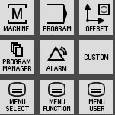 Fig. 3-1

In the controlling zone of machine system (Fig 3-1), depress the soft key of 2016-08-11_141227, and it can enter the homepage of users’ interface.（Fig.3-2）.

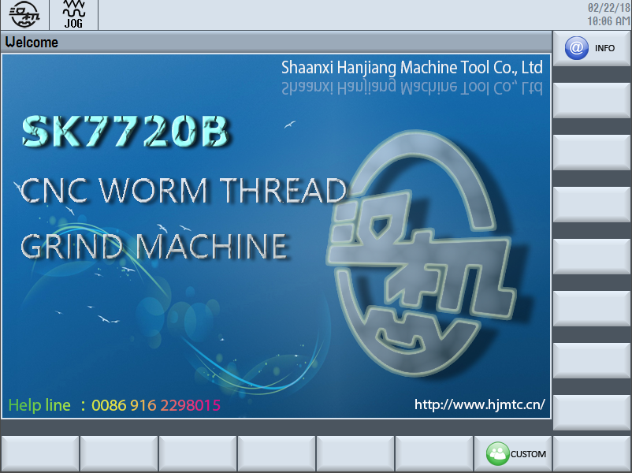

Fig. 3-2

Then depress the button of soft key of C:\Users\ADMINI~1\AppData\Local\Temp\1519265248(1).png on the bottom right corner, and it can enter the zone of parameter setting.

### 2、Serial No. query

Depress the soft key of C:\Users\ADMINI~1\AppData\Local\Temp\1519265280(1).png，enter into the detail of serial No. of the machine（Fig. 3-3 is for reference only.）

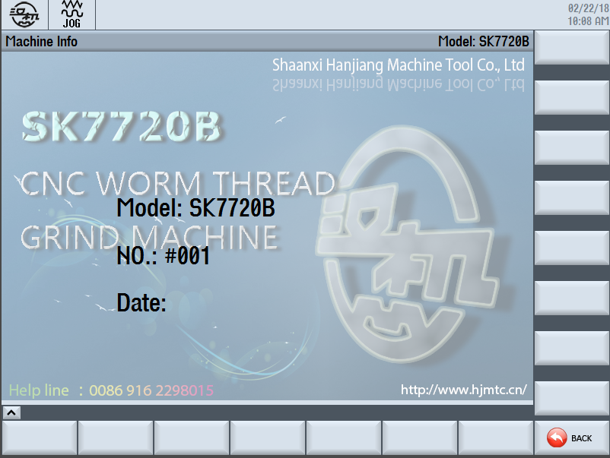

图3-3

Depress the button ofC:\Users\ADMINI~1\AppData\Local\Temp\1519265331(1).png， it will return to homepage of user’s interface。

## II、Parameter input

### 1、Definition of grinding parameter

The parameter setting is shown in Fig.3-9.

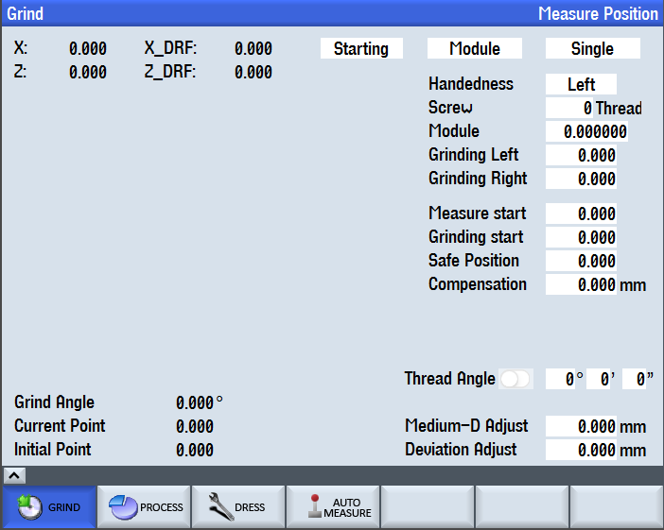

图3-9

#### 1-1、Machining mode

One is ***C:\Users\ADMINI~1\AppData\Local\Temp\1519265460(1).png***mode, and the other is ***C:\Users\ADMINI~1\AppData\Local\Temp\1519265423(1).png***mode.

Description：When selecting ***C:\Users\ADMINI~1\AppData\Local\Temp\1519265423(1).png*** mode and starting program, it will continue grinding following by the last coordinate that have finished the program。

When selecting ***C:\Users\ADMINI~1\AppData\Local\Temp\1519265460(1).png*** mode and starting program, it will restart grinding from the initial contact position for the first alignment.

For example：Supposing the tooth depth to be ground is 0.81mm, so for the first time, setting the relevant parameter and starting the program until the program finished, the tooth depth of 0.08mm can be measured. At this time, set the machining mode to***C:\Users\ADMINI~1\AppData\Local\Temp\1519265423(1).png*** mode***,*** and set the total technological feeding amount to 0.01mm, restarting program and grinding down for 0.01mm. And then start the program and execute grinding process. The “mass” mode should be selected for large batch. If changing a new work piece with the same specification for grinding, it should set the machining mode to ***C:\Users\ADMINI~1\AppData\Local\Temp\1519265460(1).png*** mode. The work piece is ground from a same starting point. And then start the program and execute grinding process. After finishing grinding for a new work piece, the tooth depth is measured for 0.81mm.

#### 1-2、 (Handedness)

There are two different modes for handedness:C:\Users\ADMINI~1\AppData\Local\Temp\1519265549(1).png & C:\Users\ADMINI~1\AppData\Local\Temp\1519265541(1).png.

Description：Select the proper handedness according to the thread of work piece. If you modify the parameter, its handedness will be changed.

Default value：R.H

Selection of parameter: by drawing

#### 1-3、 (Screw)

Description：This parameter refers to the NO. of starts, if you change parameter it may cause any risk. So set the proper parameter following by drawing.

Default value：1

#### 1-4、 (Worm Module)

Description：Set the proper parameter following by drawing.

Default value：0

Input range of parameter：by drawing

#### 1-5、 (Grinding Left, Grinding Right)

Description：Mount the work piece to centers of work head & tailstock, starting axis Z and making wheel align to the far left & right bottom, and then record the coordinate of axis Z.

Default value：0

Parameter requirement：right bottom > left bottom

Input range of parameter：within the scope of limit switch(axis Z) for safety

#### 1-6、 (Measure Start)

Description：Mount the work piece to the centers of workhead & tailstock, starting axis X, approaching with work piece and stopping at the safety position of top circle surface, record the coordinate of axis X. Select manual alignment and start program. Start alignment until the axis X reach this position firstly.

Default value：0

Input range of parameter：within the scope of limit switch

Note: The coordinate of grinding wheel must be far away from the outside of the thread groove.

#### 1-7、 (Grinding Start)

Description：When the multi-cycle of grinding be set in technology interface, the axis X will retreat to this coordinate after each cycle finished, so move axis Z and return to starting point of grinding process. If dressing is necessary during grinding process, we can execute dressing until the axis X retreat to this position.

Note: The coordinate of grinding wheel must be far away from the outside of the thread groove.

#### 1-8、 (Safe Position)

Description：depress the button of 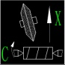 on the panel，the axis X will be away from the work piece to its coordinate position. The axis X will retreat this coordinate position after the grinding program finished.

Default value：0

Input range of parameter：within the scope of limit switch

The coordinate of grinding wheel must be far away from the outside of the thread groove.

Note: Safe position >Grinding start>Measure start.

When the machine reach three positions of axis X, the grinding wheel must be far away from the outside of the thread groove.

#### 1-9、 (Compensation)

Description：This parameter is used for pitch correction after the work piece has been checked for grinding. If the pitch needs to be increased, input the positive value. If the pitch needs to be reduced, input the negative value. It is not necessary to give an assignment in text box without any compensation.

Default value：0

#### 1-10、 (Thread Angle)

Description：It is only input the angle. The program can divide the handedness automatically.

Note：Input the angle until the switch in the following figure is closed .

C:\Users\ADMINI~1\AppData\Local\Temp\1519266000(1).png

#### 1-11、 (Medium-D Adjust)

For batch grinding, measure the pitch diameter for one of the work piece and compare the value to the last work piece. Then, input the deviation value to adjust the diameter for the next work piece.

For example：Supposing that the size to be ground is 30mm, the size become 29.98mm after the first work piece has been ground, and the size of second one should increase by 0.02mm. Therefore, input 0.02 as its parameter before the second one to be ground. If the size of first one is 30.02, input -0.02 as its parameter.

Note: Here 30 refers to medium diameter, and adjusting amount is following by the amount in diameter direction.

#### 1-12、Manual Alignment

Depress the button of manual alignment on panel, the alignment can be realized.

C:\Users\ADMINI~1\AppData\Local\Temp\1519266129(1).png is used for selecting the alignment on starting point, midpoint or arbitrary point. If the length of work piece is short, wait for the end of the program but not depressing the retreat key after having finished the alignment.

#### 1-13、 (Current Point) & (Initial Point)

For a new work piece, the value for two positions are the same after the first alignment.

For example: Supposing that the valve of two positions are -100 after the first alignment, the total grinding amount in technology is 0. 81 , without dressing while grinding. Start the grinding program and wait for the end of program. The value of current point is -100.81，the value for initial point is still -100. If you select “Mass” mode and restart program, the “current point” for starting is still -100 in the next grinding process. If you select “Single” mode and restart program, the “current point” is -100.81. (If dressing in grinding, the “current point” & “initial point” vary in the same degree.

### 2、Setting for technological parameter

Enter the interface following figure, and set the parameter.

The value in figure is only an example.

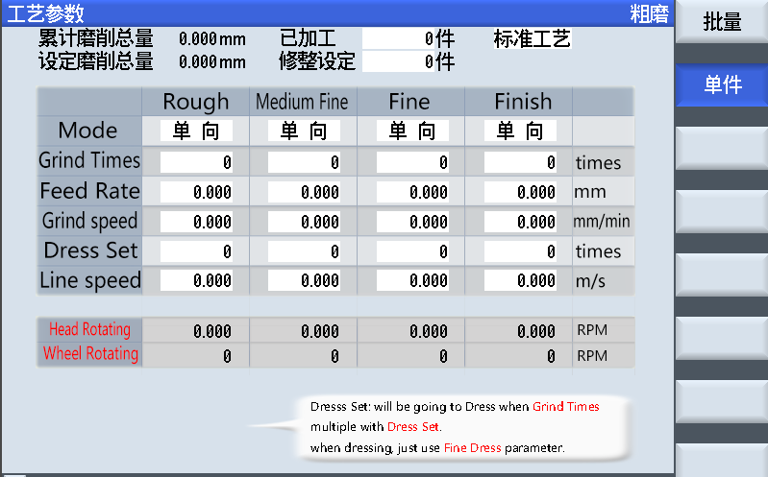

Fig 3-10

Input the relevant value following the characteristic of work piece to be ground in the frame of figure 3-10.

Note：When selecting **C:\Users\ADMINI~1\AppData\Local\Temp\1519266264(1).png** in grinding interface, it can be selected the parameter on the interface of **C:\Users\ADMINI~1\AppData\Local\Temp\1519266288(1).png** after the program has been started. When selecting**C:\Users\ADMINI~1\AppData\Local\Temp\1519266278(1).png**, it can be selected the parameter on the interface of **C:\Users\ADMINI~1\AppData\Local\Temp\1519266298(1).png**.

#### 2-1、（Mode）

Description：It refers to one-way & two-way grinding. You can use the button of SELECT.png to choose.

Default value：one-way grinding

#### 2-2、（Grind Times）

Description：It refers to cycle times in each step while grinding.

Default value：0

Input range of parameter：It depends.

#### 2-3、（Feed Rate）

Description：It refers to feeding amount in each step while grinding It is up to the remains of the work piece to be ground. (Here the value is in the radial direction , for example : Here 0.01means to grind 0.02 in diameter direction)

Default value：0

Input range of parameter：It depends.

#### 2-4、（Grind Speed）

Description：It refers to the feed speed of axis Z & axis C in each step in grinding. It usually depends on the remains of work piece to be ground, the materials and grains of grinding wheel.

Calculation formula: grind speed=speed of workhead×lead of work piece

Default value：0

Input range of parameter：

Recommended value：

#### 2-5、（Dress Set）

Description：It refers to the cycle times for dressing in each step during grinding. When the dressing is not necessary, this value is zero.

Foe example：Supposing 2 refers to in 2 times of cycle grinding with one wheel dressing. The parameter for dressing is selected directly from the interface of parameter.

When grinding several work piece in one dressing, it is better to modify the value of dress set to zero in form and input the dressing program on the frame of “dress set” of top right corner.

Default value：0

Input range of parameter：It depends on the material and grinding time.

#### 2-6、（Line Speed）

Description：It refers to the real peripheral speed in each step. The parameter is matched with the grinding speed.

Default value：0

Input range of parameter：It is within the scope of limited peripheral speed.

Recommended value：It depends.

#### 3、Setting for dressing parameter

On the interface of figure 3-11, the value in figure are only examples.

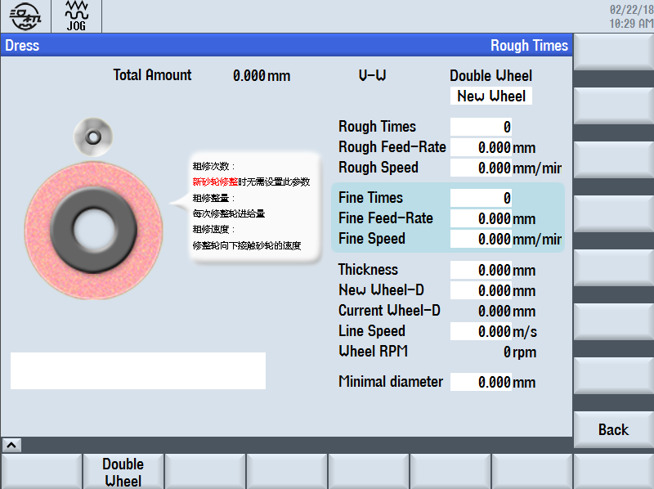

Figure 3-11

#### 3-1、Program for tooth profile

Input the program of tooth profile according to the specific tooth profile of work piece.

Note: The first character of work piece for the named program is only alphabet.

#### 3-2、New/Old grinding wheel

Description：Modify it to new wheel if a new grinding wheel is mounted.

Default value：New grinding wheel

#### 3-3、Dressing time (rough)

Description：It refers to the cycle time for rough grinding.

Default value：0

#### 3-4、Dressing amount(rough)

Description：Feeding amount in rough dressing

Default value：0

Input range of parameter：It depends.

Recommended value：0.02

#### 3-5、Dressing speed(rough)

Description ：Feeding speed in rough dressing

Default value：0

Input range of parameter：It depends.

Recommended value：

#### 3-6、Dressing times(finish)

Description：It refers to the cycle times for finish dressing.

Default value：1(The program set dressing times so it can not be modified. )

#### 3-7、Dressing amount(finish)

Description：Feeding amount for finish dressing

Default value：0

Input range of parameter：It depends.

Recommended value：0.01~0.02

#### 3-8、Dressing speed(finish)

Description：Feeding speed for finish dressing

Default value：0

Input range of parameter：It depends.

Recommended value：

#### 3-9、Diameter for new grinding wheel

If change another grinding wheel , this value needs to be set again. If the specification of grinding wheel is not changed, this value needn’t to be set. The permissible diameter of this machine is not more than 400mm.

#### 3-10、Current wheel diameter

The program can automatically calculated by itself during dressing period.

Note：For a new wheel, this value in the first dressing step may be greater than the new wheel diameter described in fig. 3-8. It is normal, but when the grinding wheel has finished dressing, this value will be less than the new wheel diameter described in fig. 3-8.

#### 3-11、Line speed

Matched with the material of work piece.

#### 3-12、Min. grinding diameter

Change another grinding wheel if the current diameter is less than the min. grinding wheel.

### 4、Setting for roller

Follow the order of “Custom”→“Dress”→“Double wheel” to enter the interface for setting roller parameter. See the bellowing figure.



Fig. 3-12

#### 4-1、Dressing center

Description：It refers to the horizontal coordinate when the two centers(roller center & wheel center) along the direction of width coincide.

Calculation formula：Z=(Z(left)+Z(Right))/2. Firstly use the right of roller contacts to the left of grinding wheel and record the value of Z(left). Secondly use the left of roller contacts to the right of grinding wheel and record the value of Z(right). And then calculate the parameter by this formula.

#### 4-2、Wheels space

Description：It refers to the distance between two dressing wheel of arc center.

Calculation formula：Z(Right)-Z(left)+Wheel width +2\*Corner radius of roller, (The meaning of Z(left) & Z(Right) are the same as the below. )

The accuracy of the parameter has an impact on the thickness of tooth profile for wheel, and influence the normal tooth thickness of work piece. We usually follow the deviation of standard and real tooth thickness when the operator debugs the machine. But the value can not be modified usually once the value is determined.

The thickness of tooth profile became greater and normal tooth profile is reduced by increasing absolute value of the “wheel space”, and vice versa. The value can be set zero when using the single roller.

Default value： （by measuring）  
This parameter must be measured precisely after the grinding test period firstly, and then it can be modified.

#### 4-3、Height Gap (left dressing wheel)

Description：This value is set to zero usually. When the right & left heights dressed are different this value can be adjusted.

Default value：0

Note：The scope of adjusted value should be suitable. Adjust the current contacting position to the direction of axis X(+) before dressing wheel in order to prevent a large dressing amount in the first dressing process.

#### 4-4、Vertical coordinate of wheel center

Description ：It refers to the vertical coordinate when the two centers(dressing center & wheel spindle) coincide.

Calculation formula：X1-Wheel radius- Corner radius of roller

(X1 refers to the contacting coordinate between roller and external round surface. It can not be modified usually.)

#### 4-5、Contacting position

Description：It refers to the X-coordinate when the roller contacts with the external circular of wheel. When selecting “New wheel”, the program can calculate the current contacting position that has been raising.

The formula: Vertical coordinate of wheel center + radius+width/2. If the wheel diameter is more than 400mm, it is in danger for safety. For dressing a new wheel, firstly set the rough dressing times as 1. After the program finished, adjust the current contacting position manually and set the proper dressing times.

#### 4-6、End of W axis

Description：it refers to the stopping position in horizontal axis after the dressing process is finished.

Default value：

Input range of parameter：With in the limited switch

#### 4-7、End of V axis

Description：it refers to the stopping position in vertical axis after the dressing process is finished.

Default value：

Input range of parameter：With in the limited switch

#### 4-8、Arc radius

Description：It refers to the arc radius of dressing wheel.

#### 4-9、Trimming offset

Description：When the thickness of wheel is bigger, the raising distance for new wheel is not enough. At this time, the operator can set the value of trimming offset, and the diamond roller will offset to left/ right according to this value in dressing.

### 5、Parameter setting(auto alignment)

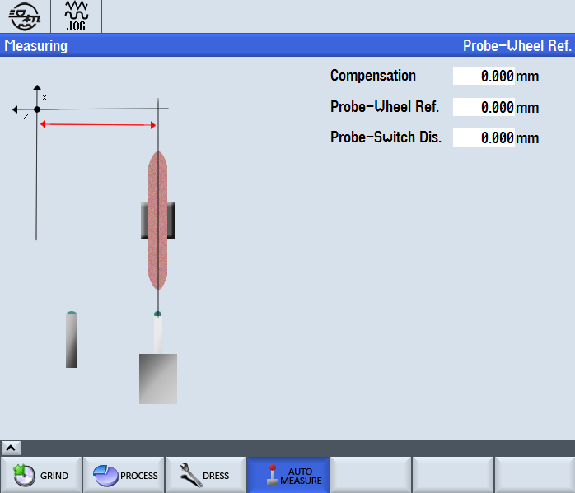

#### 5-1、Probe -switch dis.

Description：it refers to the distance between the sensor center on approach switch and probe-switch distance. It is used for calculating the angle of axis C for probe approaching after the rough positioning for approach switch, in order to prevent the collision with probe and outer diameter of work piece.

#### 5-2、Probe-wheel ref.

Description：It refers to input the coordinate axis Z when the wheel center is coincide with the probe center.

Note：The precision of this parameter have an influence on the auto alignment directly.

For the first alignment, make a rough measuring for Z1 and input this value. Secondly, make alignment manually and record the angle C1. Thirdly, make auto alignment and record the angle C2. Contrast the difference value of two angles and convert the pitch error. And then modify the value of Z1, make the two values of C1&C2 be converged.

For multi starts work piece, set 4 starts as an example: If the manual alignment is on the 1st thread starts, and auto alignment is on the 2nd thread starts. Supposing C1=30°, the indexing is 360/4=90 because of the 4 starts, and C2 should be corrected as 30°+90°=120°.

# Chapter 2 Introduction for grinding process

## 一、Wheel dressing

### 1、Dressing for a new wheel

Set the relevant parameter following the description in above text. When selecting “New wheel”, the program can calculate the current contacting position that has been raising. If the wheel diameter is more than 400mm, it is in danger for safety. For dressing a new wheel, firstly set the rough dressing times as 1. After the program finished, adjust the current contacting position manually and set the proper dressing times.

After finished parameter setting, the next step is dressing new wheel:

1. Check the precision of parameter
2. Enter the main program for grinding

3. depress the cycle start button and start dressing process

#### 1-1、Enter the main program for grinding

Depress the button of AUTO，selecting the main program of grinding in the following interface：SK7712.MPF

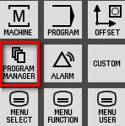 Depress button2016-08-13_135927 and enter the interface on Fig.11 and select the proper interface（Fig.4-11、4-12、4-13）

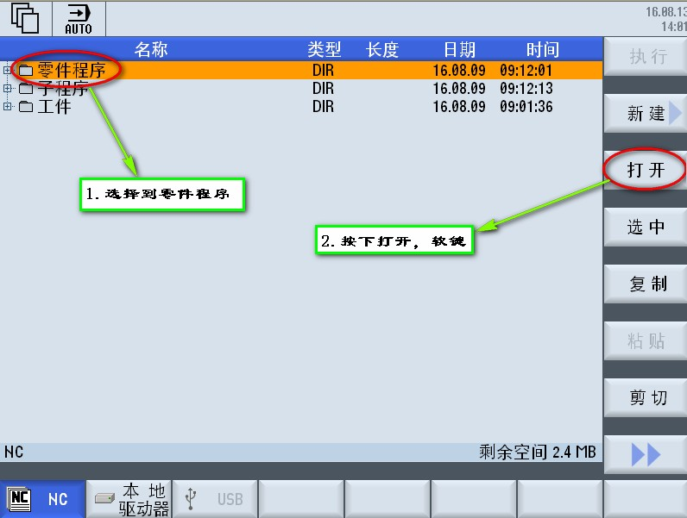

Fig.4-11

#### 1-2、Starting dressing

Depressing the button of wheel dressing on the panel.

Firstly, set the override switch to zero position and open feed enable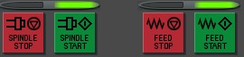. Secondly, depress the button of2016-08-13_142844，start the dressing program.

Release the switch of override to a proper position in the first dressing process.

Check the reminder message，and wait for the end of dressing process.

### 2、Dressing for an old wheel



图4-17

It is only set the parameter with rough and finish grinding for an old grinding wheel.(Fig.4-17)

## 二、Alignment

### 1、Manual alignment

#### 1-1、starting alignment switch

Depress the button of  after having set the related parameter. Then activate the switch of manual alignment and start program.

#### 1-2、End alignment program

As the length of work piece is short, the operator should close the DRF after alignment and wait for the ending of the program.

Depress the button  for withdrawal (axis X). Until the program execute in end, it can reset otherwise the alignment value can not be calculated.

Observe the alignment result after having finished the alignment：

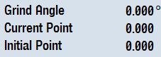

### 2、Auto-alignment

Correct related parameter following fig. 5-1 and fig.5-2. Then depress the button of “auto alignment” and the program can be execute in auto alignment.

Description：The starting angle C is available in grinding only for auto alignment. The X value of initial contacting position can only identified by manual alignment. The initial contacting position for grinding can be compensated automatically after the grinding wheel have finished dressing.

## 三、Workpiece grinding

* Setting parameter for grinding technology
* Starting grinding

#### 6-1、Process

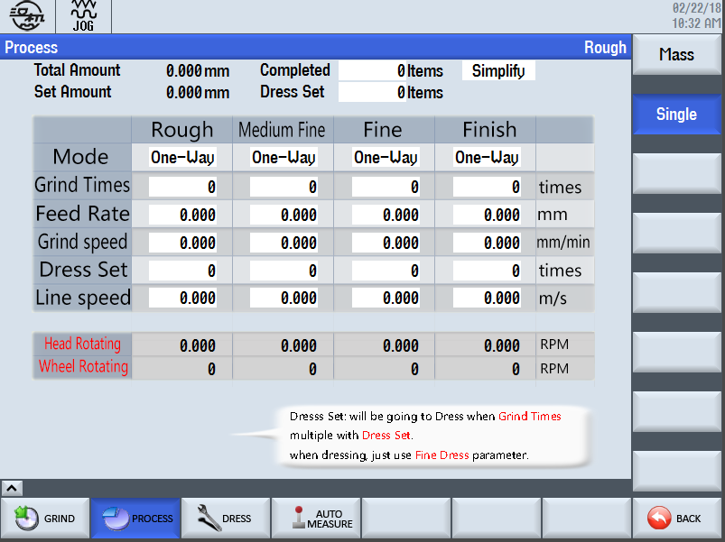

图4-22

#### 6-2、Grinding starting

Firstly, set the override switch to zero position and open feed enable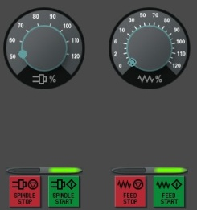. Secondly, depress the button of2016-08-13_142844，start the dressing program.