**Bonus:**

For the trinomial tree, it is very similar to the binomial tree, however we need to discount three value at the next step and we need to calculate the probability of each way of the price process in order to get a more accurate price.

All we need to change is the tree class, we write a new tree class which is called “SimpleTrinomialTree”. Since there are three possible way the price will go along, we need to modify the index of original loop and get the price in a similar way. The source file is like this:

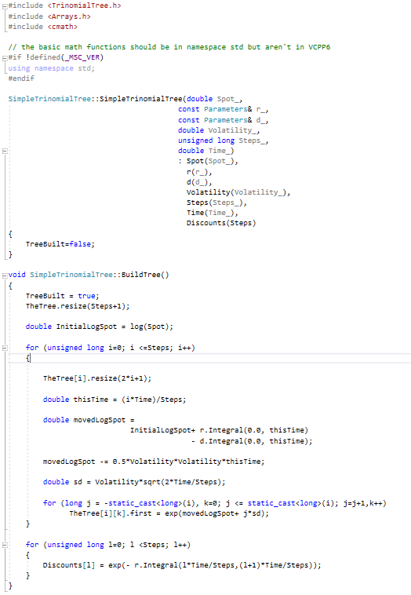

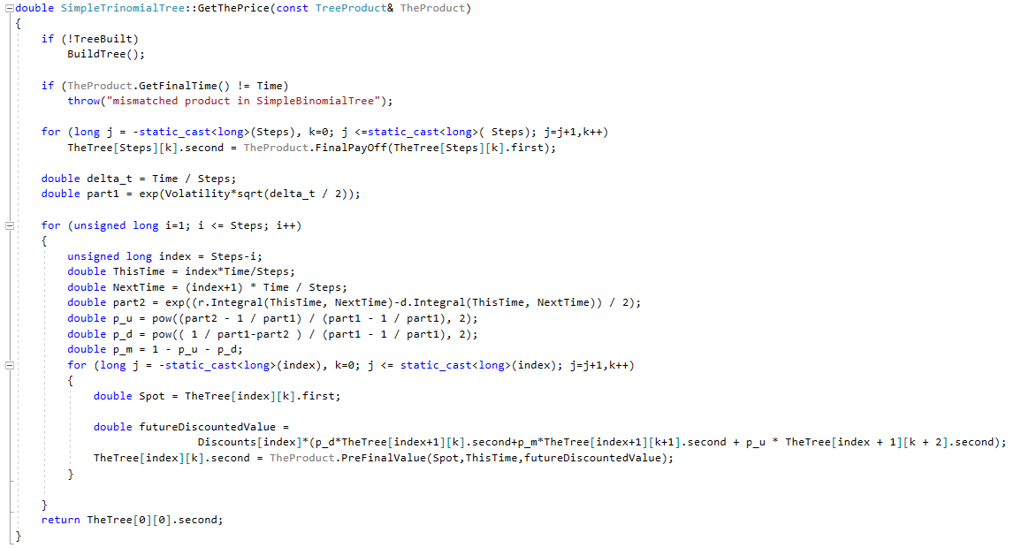

In the “GetThePrice()” function, we need to calculate the probabilities of three ways which is p_u, p_d and p_m. Note that in the textbook, the author uses 0.5 as the probability of two ways in binomial tree, this way in trinomial tree is more accurate. When we calculate the probability, we need to consider the influence of the dividend and we need use the integral method of these two parameters.

After a little modification on the main function, we can get the price by using trinomial tree:

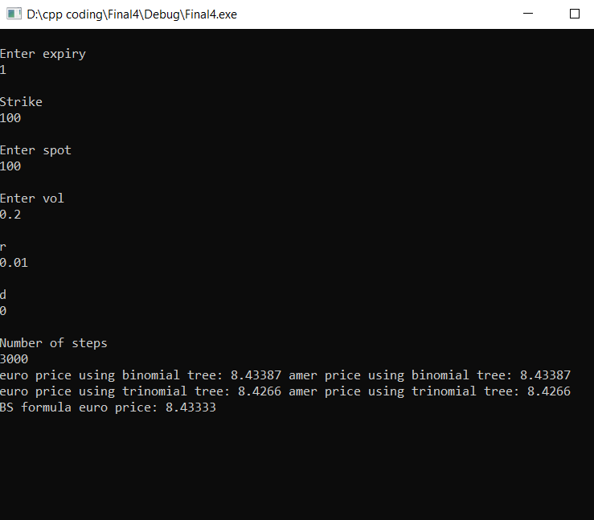

We can find that the price using trinomial tree is less than those using binomial tree and they are not very close to the theorem price which is $8.4333.