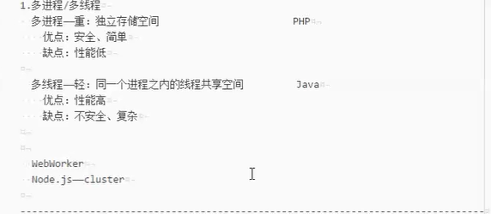





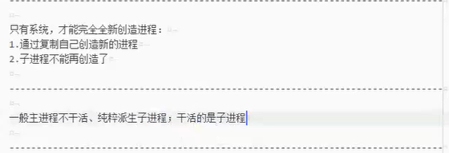

let process = require('process');//进程，可以获取进程的信息

let cluster = require('cluster');//集群，多进程主要模块

let os = require('os');

let http = require('http');

let fs = require('fs');

let url = require('url');

if(cluster.isMaster){

for(let i=0;i<os.cpus().length;i++){

cluster.fork();

}

}else{

http.createServer((req,res)=>{

let {pathname,query} = url.parse(req.url,true);

let rs = fs.createReadStream(`www${pathname}`);

rs.pipe(res);

rs.on('error',err=>{

res.writeHeader(404);

})

console.log(`当前工作进程：${process.pid}`);

}).listen(8080);

}

Cluster.isMaster 主进程

Cluster.isWoker 工作进程/子进程

