*2nd year lab ‘Thermal and Electrical Waves experiment’ - 2020-2021*

*Imperial College London – Department of Physics*

**Instructions to set up and use the Excel Bessel solver  
‘BESSEL.xlsm’**

*Instructions made by Bob Forsyth, Francisco Suzuki-Vidal and Carolina de Almeida Rossi.*

This Excel solver outputs values of thermal diffusivity using a cylindrical model, which involves the use of Bessel functions.

***Note:* Make sure you download the file BESSEL.xlsm to your own system before you start using it!**

This solver is a ‘*black box*’, i.e. you do not see how it does any of the calculations**1**. Thus, if you decide to use it, **we strongly suggest** that you go through the description of the cylindrical model using Bessel functions provided in the Appendix of the ‘Thermal and Electrical Waves lab script’.

The input data required in the spreadsheet are:

1. Inner radius of the cylinder
2. Outer radius of the cylinder
3. Period of the thermal wave
4. **Measured transmission factor for that period**
5. **Measured phase lag for that period**

**You should have already measured the transmission factor and phase lag by performing Fourier analysis of your data**. **Bessel is just a more precise model for performing the diffusivity calculations using the same input data!**

**When you first open ‘BESSEL.xlsm’…**

You should see something like Fig. 1

*Fig. 1: Screenshot of BESSEL.xlsm*

**1***If you do want to access the Visual Basic code underlying the spreadsheet, you can do that via   
“Tools” -> “Macro” -> “Visual Basic Editor”.*

When first opening the Excel file, click “Enable macros” if this request appears on your screen (Fig.2). The macro is where all the Visual Basic code for the spreadsheet is stored.

*Fig. 2: Screenshot of pop-up window that may appear when opening BESSEL.xlsm (MacOS). For Windows, a similar message will appear in a yellow built-in note.*

The main problem you might encounter when opening BESSEL.xlsm is that the ‘Solver add-in’ feature in Excel might not be enabled by default.

For Mac, this is not usually an issue. The enablement procedure (for a Windows machine) is as follows:

1. Click on “File” -> “Options”
2. Click on “Customize Ribbon” and in the right-hand drop-down list select “Main Tabs”
3. In the list below, make sure that the checkbox labelled “Developer” is ticked, then click OK
4. The “Developer” tab will now have appeared on the menu ribbon

Fig. 3 illustrates the steps above

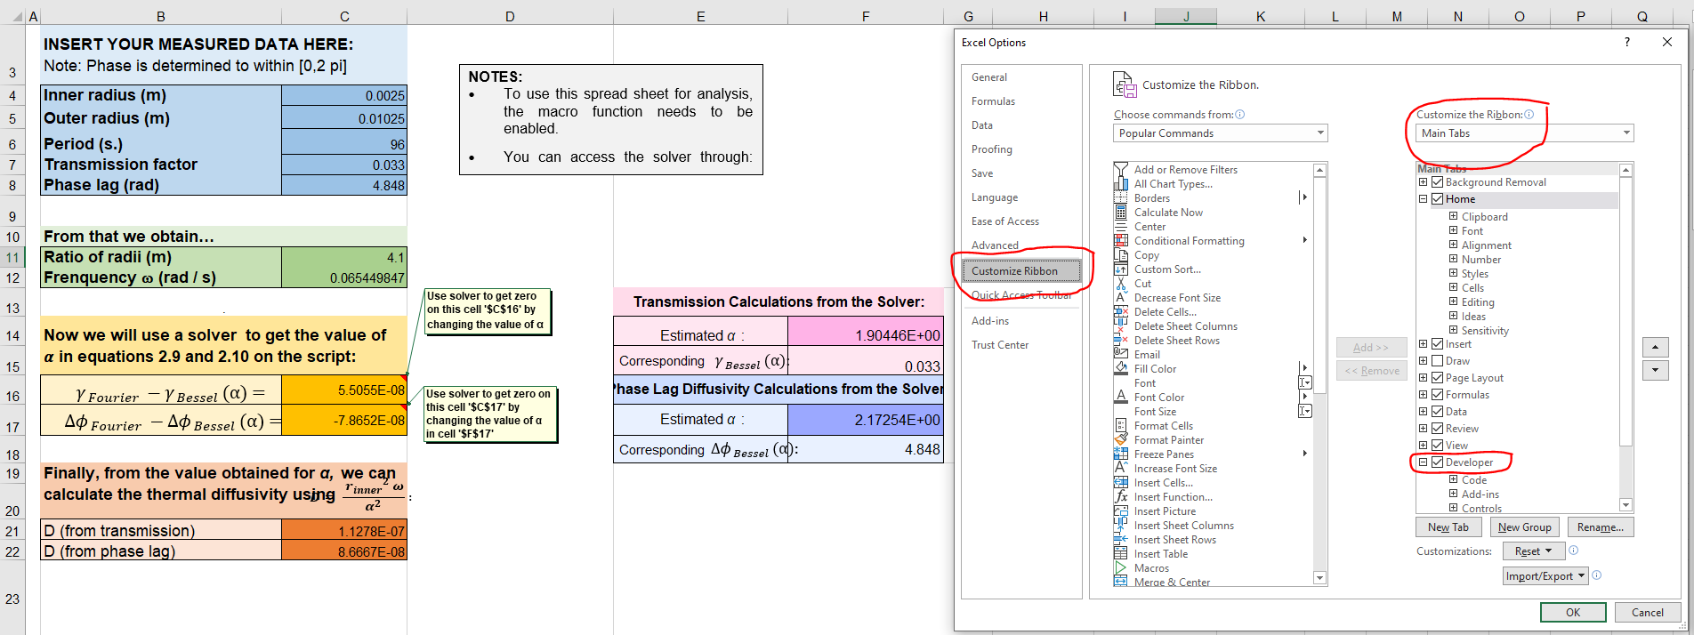

*Fig. 3: Instructions to activate the “Developer” tab.*

Then, you should proceed to activate the solver tool:

1. Under the “Developer” tab -> “Add-ins”, click on “Excel Add-ins”
2. Tick the check box that is labelled Solver Add-in, then click OK

Fig. 4 illustrates the steps above.

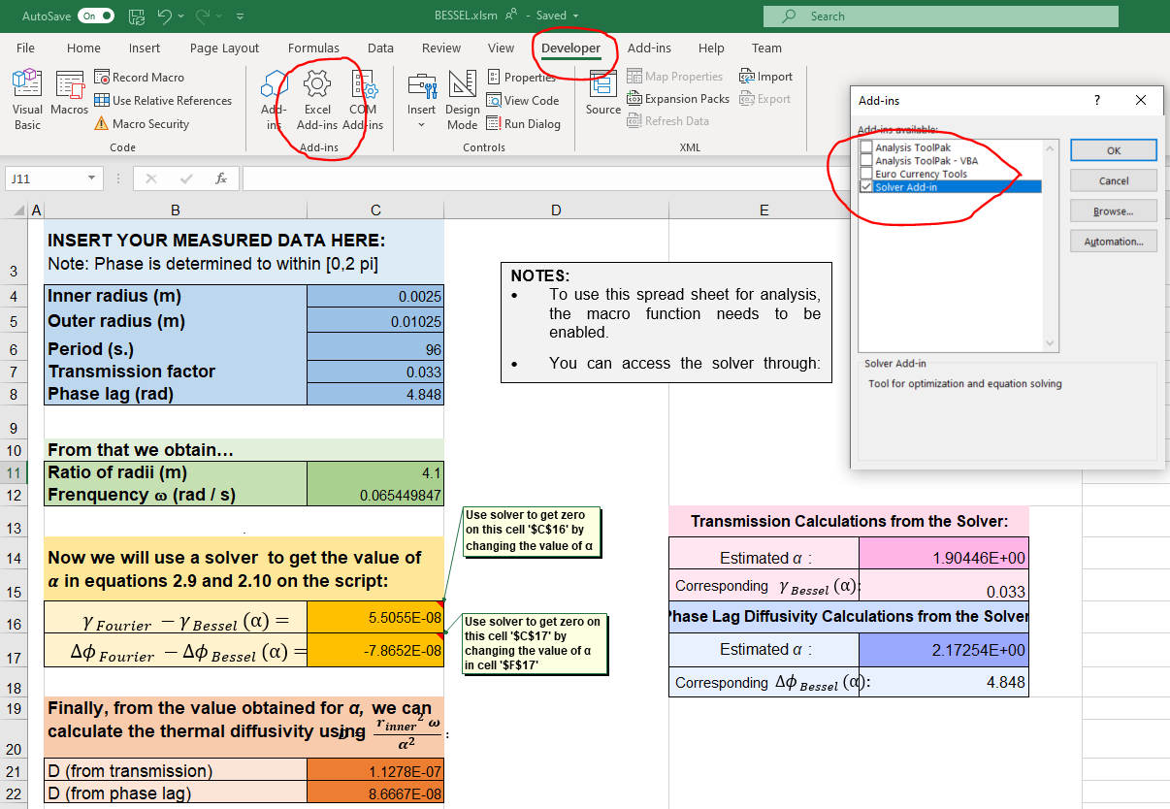

*Fig. 4: Instructions to activate the “Solver” tool.*

**Using the ‘BESSEL.xlsm’ solver**

Now your solver should be ready to use. The solver tool can be accessed through “Data” on the menu tab, by selecting “Data” -> “Solver”, as shown in Fig. 5. (Sometimes “Solver” can be found under the subtab “Analysis” or “Analyse”).

*Fig. 5:* *Accessing the Solver tool via the Data tab*

Then, a pop-up window should appear for the solver. A figure of what this window looks like will be shown in the context of an example. Text instructions on the Excel spreadsheet tell you what to do and how to fill in each box. If you’ve read the script carefully, it should be straightforward for you to understand the logic behind the parameters we use for the solver tool.

Essentially the solver searchers through a parameter space, trying different values of a parameter to find the one which gives the roots of the equations given in cells B16 and B17 above. More on this is found on the Script and the Script’s appendix.

***Test example***

I will run the solver using a “Transmission factor” of 0.015 for a period of 60 seconds

***Note:***I don’t yet know if 0.015 is a realistic value, the value I get for Diffusivity should be a good indicator of that!

Parameters:

1. Inner radius = 0.0025 m
2. Outer radius = 0.01025 m
3. Period = 60 s
4. Transmission factor = 0.015
5. Phase lag = ? (not using phase lag for this example)

**Step 1:** Set up parameters

**Step 2:** With the cursor on any cell, go to “Data” -> “Solver”. The “Solver Parameters” window that appears in shown in Fig. 6. You have to fill in the parameters as indicated in the instruction boxes depending on whether you want to solve for transmission or phase lag. IN our can, we want transmission and the parameters are as follows:

1. “Set Objective” = **CELL $C$16**
2. “To -> Value of” = **0** (zero)
3. “By Changing Variable Cells” = **$F$14**
4. Press “Solve” (and then “Keep Solver Solution” if this option shows up when solver window closes)

*Fig. 6. Shows the steps outlined above for defining the Solver Parameters*

What this essentially means is: we want to solve the equation shown in B16 with the right-hand-side (C16) being set 0. **The solver will do this by adjusting the parameter until the Bessel transmission factor (which is a function of ) equals the provided Fourier transmission factor, hence solving the equation**.

From the estimated value of and its definition, the diffusivity can be calculated. This is done automatically and shown in the orange cell C21.

The answer in this case is D = 1.29e-7 (in which units?), which seems reasonable!

**Step 3:** Repeat this procedure but for phase lag 😊

**IMPORTANT:** You only need to change the cells in **BLUE**. Do **NOT** change the value of the other ones, they should be updated automatically. For instance, if you change the cells “Estimated :” to zero or some other value that is far away from the real one, the solver might not work (might diverge).

Good luck!

Your demonstrators.