**EcoMart – E-Commerce Web Application**

**1. INTRODUCTION**

**1.1 Project Overview**

EcoMart is a simple, user-friendly e-commerce website designed using **ReactJS** for the frontend and styled using **Tailwind CSS**. It is a fully responsive website, meaning it looks good and works well on all devices—mobile, tablet, and desktop.  
Users can easily browse different categories of products such as **clothes, food, toys, and pet-related items**.  
Although this is a **frontend-only** project (with no backend or payment systems), it shows a good example of how a clean and responsive e-commerce frontend should look.  
The project is hosted live using **Vercel**, so anyone can access and explore it online.

**1.2 Purpose**

The main goal of building EcoMart is to practice and demonstrate **frontend development skills**. It gives users a feel of an online shopping website and helps developers learn how to build a scalable, reusable, and organized frontend project.  
In the future, this frontend can be connected to a backend system with real-time data, making it a complete full-stack application.

**2. IDEATION PHASE**

**2.1 Problem Statement**

Many e-commerce websites are often overloaded with too many elements, popups, and poor navigation. This can make the user experience frustrating.  
EcoMart focuses on solving this problem by providing a clean, simple, and responsive interface, where users can easily find and view products without confusion.

**2.2 Empathy Map Canvas**

* **User Needs:**  
  Users want a fast, simple, and visually clear shopping website where they can easily find and view products.
* **Pain Points:**
  + Too many popups or ads
  + Hard to find categories
  + Slow loading pages
* **Goals:**
  + Easy browsing experience
  + Clean design
  + Mobile-friendly layout

**2.3 Brainstorming Ideas**

During the planning stage, several ideas were considered to make the website user-friendly:

* Use a **grid layout** to display products neatly.
* Add **category-wise filtering** to help users navigate easily.
* Make sure the website works perfectly on mobile devices.
* Build **modular components** to reuse code and keep it organized.

**3. REQUIREMENT ANALYSIS**

**3.1 Customer Journey Map**

Here's a simple journey of how a user interacts with EcoMart:

1. User visits the **Home Page**.
2. They explore different **product categories**.
3. They **click on a product** to view details.
4. They go to the **Contact Page** for any queries or feedback.

**3.2 Solution Requirements**

To achieve this smooth experience, the project includes:

* Fully **responsive and interactive UI**
* Separate pages for each **category**
* **React Router** for easy navigation
* **Reusable components** for elements like NavBar, Footer, Cards, etc.

**3.3 Data Flow Diagram**

text

CopyEdit

[User] → [React Router Navigation] → [Product Component] → [UI Display]

**3.4 Technology Stack**

* **Frontend Framework:** ReactJS
* **Styling:** Tailwind CSS
* **Routing:** React Router DOM
* **Hosting Platform:** Vercel

**4. PROJECT DESIGN**

**4.1 Problem-Solution Fit**

The main aim of the design is to solve the problem of messy UI in many online shopping websites. EcoMart provides a clean, responsive, and minimal interface that helps users focus on the products.

**4.2 Proposed Solution**

The idea is to use **ReactJS** to build reusable components like the product card, navbar, and footer, and use **Tailwind CSS** to give it a clean look.  
Navigation between pages is handled by **React Router**, allowing users to move between home, category, and contact pages easily.

**4.3 Solution Architecture**

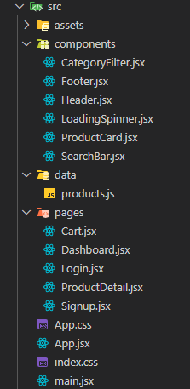

**5. PROJECT PLANNING & SCHEDULING**

**5.1 Weekly Plan**

| **Week** | **Tasks to be Completed** |
| --- | --- |
| 1 | Plan UI layout and draw wireframes |
| 2 | Create basic components (Navbar, Footer, etc.) |
| 3 | Set up routing and individual pages |
| 4 | Add styles, test responsiveness, deploy to Vercel |

**6. FUNCTIONAL AND PERFORMANCE TESTING**

**6.1 Performance Testing**

To make sure the site works well:

* All pages and routes were tested to load properly.
* The layout was tested on **mobile, tablet, and desktop screens**.
* Developer tools in the browser were used to check how fast and responsive the design is.

**7. RESULTS**

**7.1 Output Screenshots**

You can include screenshots in your report from the actual app. Suggested screenshots:

* Home Page with product categories

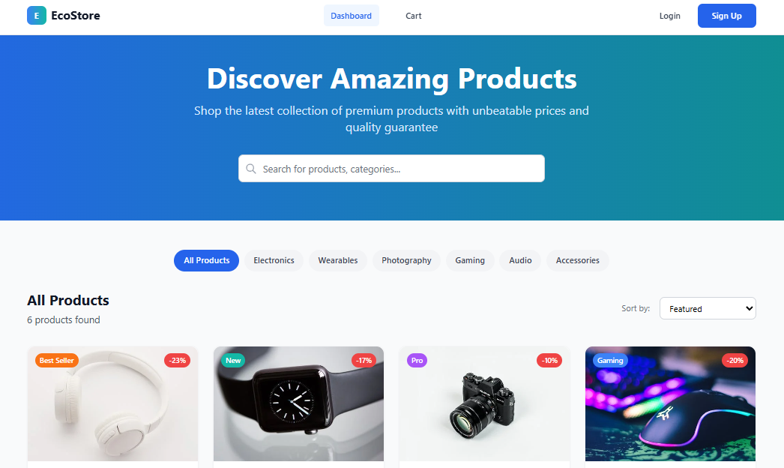

* A category page (e.g., clothes or food)

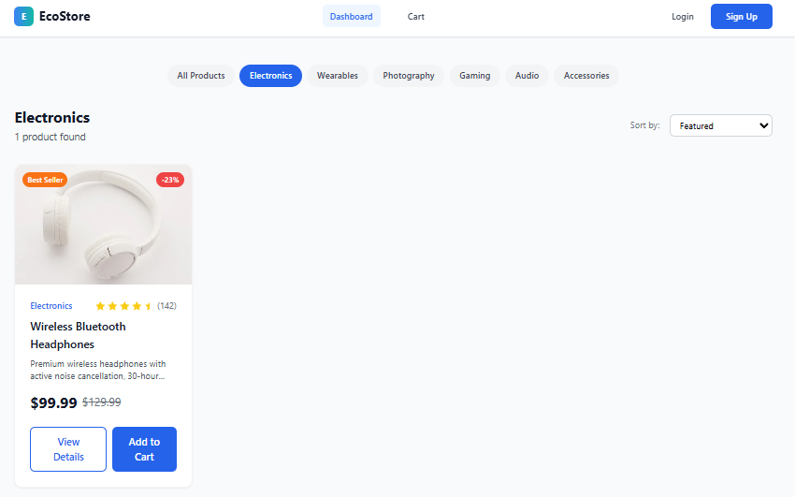

* A single product card

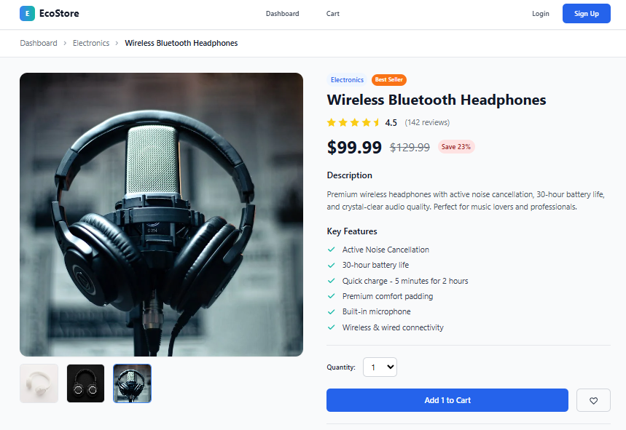

**8. ADVANTAGES & DISADVANTAGES**

**Advantages**

* Clean and **fully responsive** design for all devices
* **Modern UI** using Tailwind CSS
* Easy to add backend functionality later
* **Reusable components** save time and reduce code duplication

**Disadvantages**

* No cart, login, or real-time shopping experience
* Static data only, no database or API
* No payment or checkout process

**9. CONCLUSION**

EcoMart is a great example of a frontend-only e-commerce application. It demonstrates good design practices using **ReactJS** and **Tailwind CSS**.  
Though it currently lacks backend features, it provides a strong base that can easily be expanded into a full-stack application in the future.

**10. FUTURE SCOPE**

This project can be extended by:

* Adding **Sign in / Sign up** functionality
* Creating a **shopping cart** and **checkout system**
* Connecting to a **backend** using Node.js and MongoDB
* Adding an **admin dashboard** to manage products
* Integrating a **payment gateway** (like Razorpay or Stripe)

**11. APPENDIX**

* **Source Code (GitHub):** <https://github.com/gubbala-santosh-kumar/EcoMart>
* **Live Demo:** <https://eco-mart-six.vercel.app>