HTML
(Hyper Text Markup Language)

-HTML means HyperText Markup Language
-It is not a Programming language
-It is a language used to structure webpages

HTML used to:
- Add headings
- Write paragraphs
- Insert images
- Create links
- Make tables
- Build forms
- Structure a full website

It works together with:
- CSS -> for styling
- JavaScript -> for functionality

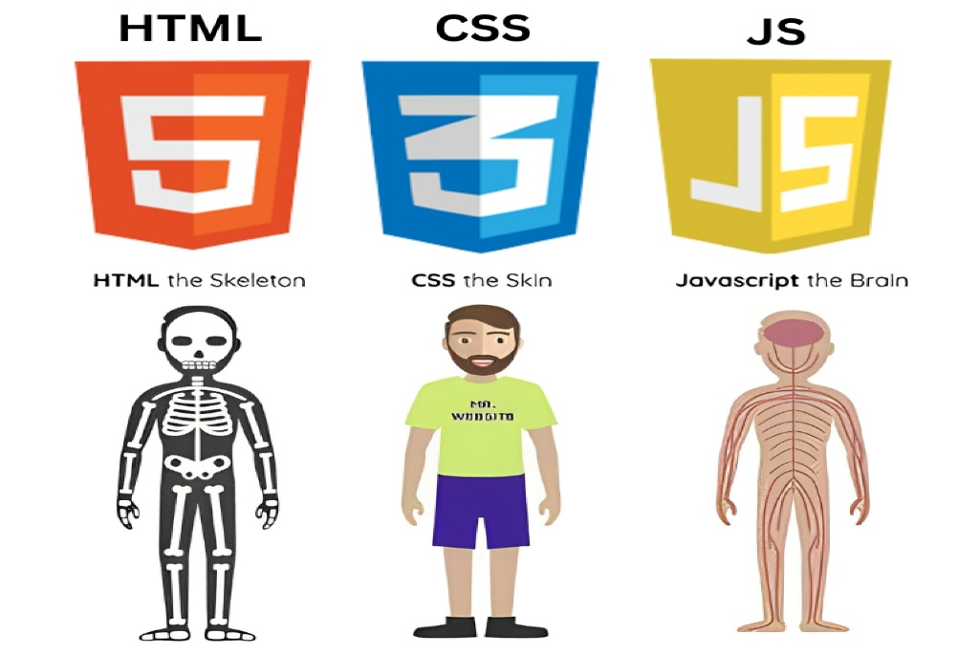
HTML Tags

<tagname>content</tagname>

-Tags are the building blocks of a web page
-Tags are used to structure content
-Most have an open and closing tag

Common Tags:
- <html> - Root of the webpage
- <head>- contains document information such as title, meta tags, etc
- <title> - Title of the document
- <body> - Body /content of the document
- <h1>-<h6> - Headings
- <p> - Paragraphs
- <a> - links to other pages or resources
- <img> -images
- <ul><ol> - Unordered and Ordered lists
- <table> - Tables
- <div><span> - Generic container
- <form><input> - Forms and Inputs

Types of tags:
- Container tags:
it has an <opening tag> content and <closing tag>

- Self-closing tags:
Do not have a closing tag
They perform a single action

- Block-level tags:
Take a full width and on a new line
- Inline tags:
Take only the required width
Do not start on a new line

- Semantic tags:
Semantic clearly describe their meaning

<header>
<nav>
<main>
<section>
<article>
<footer>

HTML Tag Attributes

<tagname attributename = “value”>content<tagname>
<tagname attributename = “value”> (self closing tag)

-Attributes provide additional information.
-Some tags do not include content and only include attributes
-slash (/) is optional on self-closing tags.

Example:

<a href = ” about.html”>about page </a>
<img src = “image path” alt = “alternative text”>

Document Structure

<!DOCTYPE html>
<html>
<head>
<title>page title</title>
</head>
<body>
Content goes here
</body>
</html>

<!DOCTYPE html>:
-Tells the browser it’s an HTML5 document
-It must be the first line
-it’s not a tag

<html>:
-HTML tag is a root element
-Everything must go inside this tag

<head>:
-contains meta information, titles, links to other resources
-Users usually do not see this content

<title>:
-Page title
-Appears on browser tab, Google search results

<body>:
-everything visible goes here
-Content of the pages

