

<Company Name>
HR Policy

Employee Benefits plan

Policy Effective Date: <DD/MM/YY>

No part of this documentation may be reproduced or transmitted in any form or by any means, electronic or mechanical, including photocopying or recording, for any purpose without express written permission of the CEO of <Company Name Here>.

© 2021, <Company Name Here>. All Rights Reserved

Revision History

Ver No. | Change Description | Prepared By | Reviewed By | Approved By | Date

1
1. Objective 4
2. Scope and Applicability 4
3. Definition/Interpretation 4
4. Policy / Process 4
4.a. Mandatory Employee Benefits 4
4.a.i. Employees’ Provident Fund 4
4.a.ii. Employee State Insurance Scheme 5
4.a.iii. Statutory leaves 5
4.a.iv. Gratuity 6
4.a.v. Maternity Leave 6
4.a.vi. Bonus
4.b. Supplementary Employee Benefits 7
4.b.i. Group Medical Insurance 7
4.b.ii. Subsidized transportation 7
4.b.iii. Subsidized cafeterias 7
4.b.iv. Loans 8
4.b.v. Service Awards 8
5. Special Circumstance and Exception 8
6. Non-compliance and Consequence 8

- Objective
The purpose of <Company Name here>'s Employee Benefit plan policy is to provide an overview of the primary benefits and their regulation that govern compensation and benefits to employees.

Scope and Applicability
This policy applies to all employees of <Company Name here>.

This policy is owned by <Name of the Person> and reachable @ <Contact Number> and <email address>

Definition/Interpretation

Term / Abbreviation | Definition / Expansion

Policy / Process

Mandatory Employee Benefits

Employees’ Provident Fund
Employees’ Provident Fund (PF), Employee Pension Scheme (EPS) and Employees’ Deposit Linked Insurance (EDLI) come under the purview of Employees’ Provident Funds and Miscellaneous Provisions Acts, 1952. These are funded by employees and employers monthly contributions but governed and managed by the Employee Provident Fund Office (EPFO).

- Companies employing more than 20 employees must implement PF for their employees
- PF is a retirement fund of the employee
- Employers are mandated to contribute 12% on the Basic pay of employees upto a maximum threshold of Rs.15,000/- per month. This is called ‘Regular PF’
- Employee also contributes 12% of their Basic Pay towards their own PF Account
- From employer’s contribution, 3.67% goes to the PF Account and 8.33% goes to Pension Scheme (EPS) of the employee
- Employer contributes 0.5% of employees basic pay towards Employee Deposit Linked Insurance of the employee
- Employer contributes 0.5% of employees basic pay towards PF Admin charges
- Employers and employees are allowed to contribute 12% on actual Basic pay earned by the employee, i.e., more than the max threshold of Rs.15K. This is called ‘Excess PF’
- Moreover, employees are allowed to contribute in excess of 12% towards their own PF account, which is called ‘Voluntary PF (VPF)’
- Employers need not contribute to employee’s VPF
- Companies having their own PF trusts are called ‘Exempt Organisations’
- PF can be withdrawn only upon retirement or permanent relocation abroad
- PF advance can be availed only under certain circumstances or occasions as per the Act

Employee State Insurance Scheme
Employees' State Insurance Corporation (ESIC) manages the ESI Scheme under ESI Act, 1948. This is a comprehensive benefit scheme covering medical costs for the family, including parents and dependent siblings, disability compensation, STD and LTD benefits, widow’s and children’s pension and other medical benefits. It is funded by employer and employee contributions as well as Government contributions.
- Employees' State Insurance Corporation (ESIC) is managed under ESI Act, 1948
- ESI is a health insurance scheme for employees & their family members
- Employees earning a Gross Income of less than Rs.21,000/- pm (Rs.25,000/- pm for disbabled persons) are to be covered mandatorily
- Employee contributes 0.75% of their gross income towards the scheme
- Employer contributes 3.25% of employees gross income towards the scheme
- ‘Family members’ for the purpose of the scheme means self, spouse, children, parents, unmarried sisters and unemployed brothers upto the age of 21 years

Statutory leaves
Leaves are regulated by each State’s Shops & Establishments Acts or by the Factories Act (depending on which Act the company has registered under). These cover sick leave, casual leave, privilege/earned leave, national holidays, State Founding Day, and other leaves such as bereavement leave.
<Company Name> has adopted the following leave policy. Please also refer to the Employee Leave policy for eligibility and other detailed information.
- Annual Leave year: <Calendar year / Financial year>
- Privilege / Annual Leaves: <No. of days per year>
- PL Carry forward: <No. of days per year> upto a maximum accumulation of <No. of days>
- PL Encashment: <No. of days per year> upto a maximum <No. of days> leaves
- Casual Leaves: <No. of days per year>
- Sick Leaves: <No. of days per year>
- Bereavement Leave: <No. of days per year>

Gratuity
Gratuity is a gratuitous payment due to an employee after 4 years 8 months continuous years of service in the same organisation and only upon termination, resignation or retirement or earlier in case of death.
- Standard formula for gratuity is ‘half a month’s pay for each year completed by employee’
- Formula: Last paid Basic pay / 26 days x 15 days x number of years served
- Gratuity is non-taxable upto INR 20 lakhs during the entire career cycle of an employee

Maternity Leave
Paid maternity leave of 26 weeks is mandatory for women employees for upto 2 children. For the third child onwards, it is 12 weeks of paid maternity leave. Of the 26 weeks, employees have to proceed on leave at least 8 weeks prior to the estimated delivery date. Post the 26 weeks, employees can avail of another month’s leave based on medical reasons only and upon certification by a medical practitioner.
In addition, the Maternity Benefits (Amendment) Act, 2017, requires employers having more than 50 employees to provide a paid creche for children up to the age of 6 years.

Bonus
The Company adheres to the the Payment of Bonus Act of 1965 (POBA) where all employees are eligible for an annual bonus each year
- Employees earning Basic Pay of less than Rs.21,000/- per month and having worked for minimum 30 days in a financial year are eligible
- Contract employees / Consultants / Interns, etc are not eligible
- Bonus must be paid within 8 months from close of books of accounts
- Companies can choose to pay a percentage between minimum 8.33% to maximum 20% on a threshold base amount of Rs.7,000/- per month or as per Minimum Wages Act of that State, whichever is higher

Supplementary Employee Benefits

Group Medical Insurance
<Company Name Here> provides Group medical insurance which provides hospitalization coverage with a waiver for waiting periods and pre-existing diseases exclusions, maternity benefits, newborn baby cover, and add-on hospitalization benefits such as new types of treatment for cancer, cyber-knife or robotic treatment and infertility or fertility treatment. The sum assured is based on the grade the employee is currently in.

Subsidized transportation
<Company Name Here> offers transportation facilities for its employees.
Company transport is mandatory for employees working in the night shift, especially women employees. Employees working in night shift will be picked and dropped from their respective homes for their safety and security. Additionally, when women employees have to be picked up first and / or dropped last, a security guard or a male employee must accompany the vehicle without fail.
Transport facility is optional for employees working in general shifts but provided at subsidized costs. Employees must opt for transport on a monthly basis and not as and when required. Employee monthly share will be deducted from their monthly pay whether the transport has been utilised or not. Pick and drop will be from designated points only. Employees are not allowed to deviate the vehicle from the pre-assigned route for their personal work or any other reason or ask to be picked from / dropped at alternate destinations.

Subsidized cafeterias
<Company name Here> offers Subsidized cafeteria for their benefit. Employees can <utilise Sodexho coupons / swipe their employee badge / swipe cafetaria card / pay cash or by card> at the counter to avail of food items or any beverage.

Loans
<Company Name Here> offers loans to permanent employees for housing, automobile purchase, education, marriage, medical expenses and other personal exigencies. The loans are offered at <a subsidised interest rate of (xx%) / interest-free upto a maximum amount of Rs.xxxxx>

Service Awards
<Company Name Here> offers long service awards on designated tenure anniversaries and upon retirement.

Special Circumstance and Exception
Any Deviation to this policy has to be approved by Management. Any change to the policy has to be approved by HR.

Non-compliance and Consequence
Violation of this policy is subject to disciplinary action, up to and including termination.

This template is brought to you by

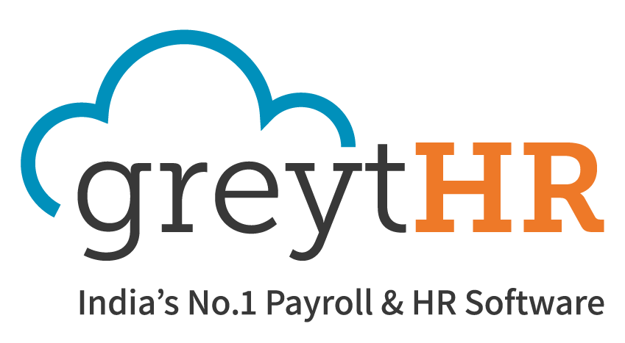

www.greythr.com

