

**SOEN 6471: Advanced Software Architectures**

**Winter 2014**

BUDDI – Personal Budget

# 

# Team Members

Amer Al-Mahdawi (6411754)

Khalid Altoum (6413439)

Gustavo Barbieri Pereira (6273033)

Nikita Parashar (6766994)

Vishnu Vardhan Rajmohan (6688799)

Contents

Team Members 1

Our Repository: 3

Refactoring 1 3

Patchset for <<Conditional Complexity>> Code Smell 3

Refactoring 2 6

Patchset for <<Feature Envy>> Code Smell 6

Refactoring 3 10

Patchset for <<Duplicated Code>> Code Smell 1 10

Patchset for <<Duplicated Code>> Code Smell 2 10

BUDDI JUnit TestSuite 12

Our Repository: <https://github.com/gubp81/BUDDI>

# Refactoring 1

# Patchset for <<Conditional Complexity>> Code Smell

**Change 0/2:**

Created junit testcases for BudgetCategoryImpl classes

**Change 1/2:**

We created two new methods from getAmount(Date periodDate) and named them as

sameStartDateBudgetPeriod() and overlapStartDateBudgetPeriod().

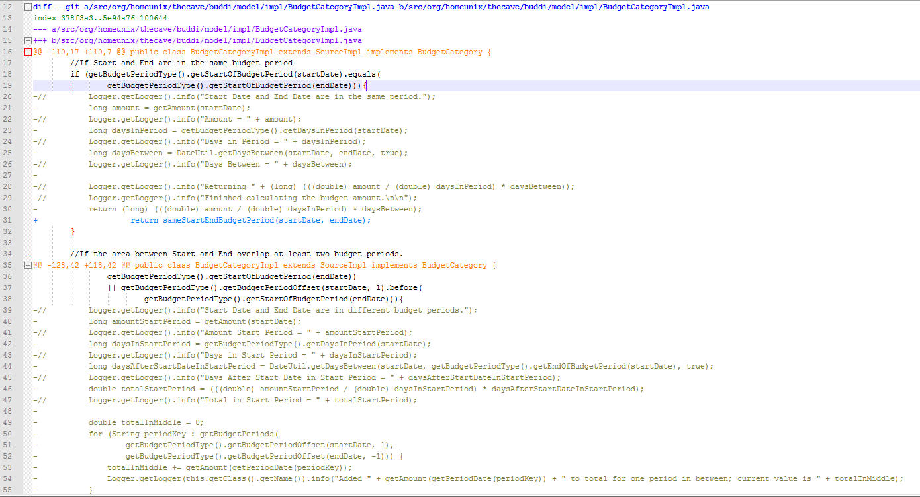

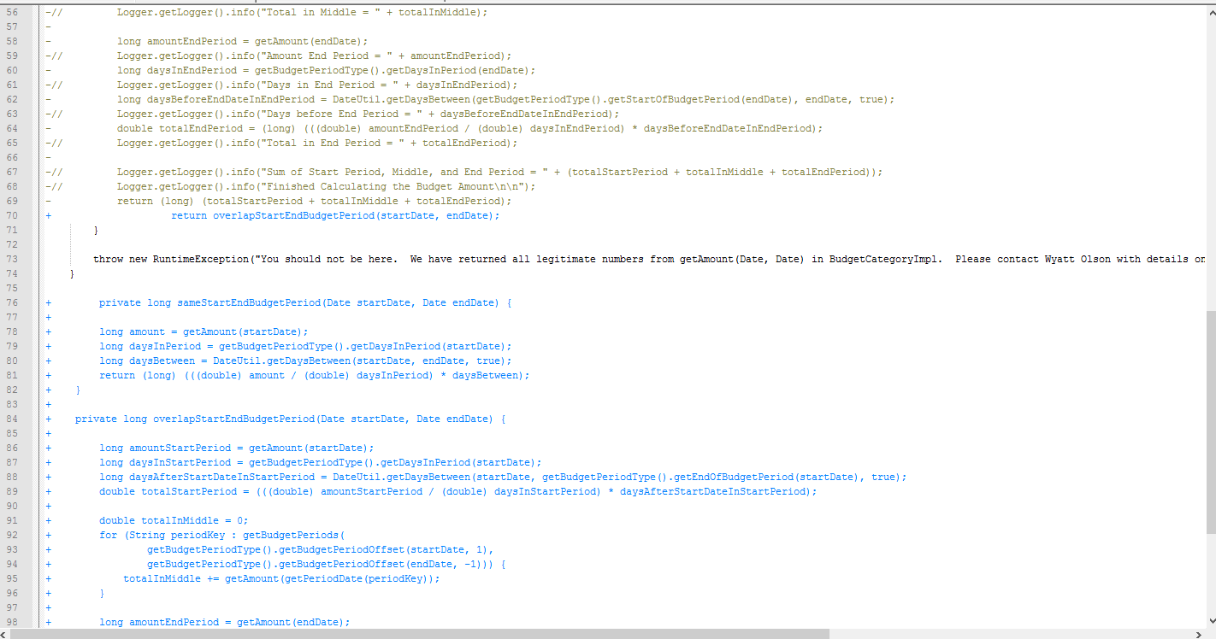

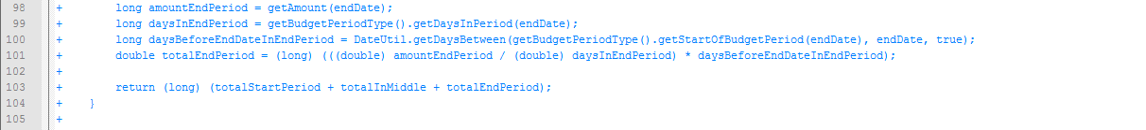

**Change2/2:**

Introduced 3 Explaining Variables to public long getAmount() to simplify the complexity of the conditional expression.

final Date startDateOfBudgetPeriod = getBudgetPeriodType().getStartOfBudgetPeriod(startDate);

final Date endDateOfBudgetPeriod = getBudgetPeriodType().getStartOfBudgetPeriod(endDate);

final Date startBudgetPeriodOffset = getBudgetPeriodType().getBudgetPeriodOffset(startDate, 1);

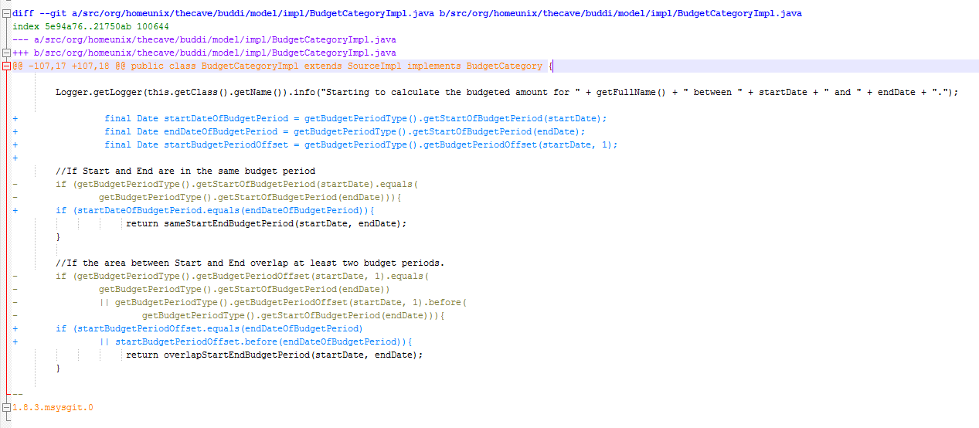

# Refactoring 2

# Patchset for <<Feature Envy>> Code Smell

**Change 0/2:**

We extracted a new method named updateTheBalance() from updateBalance() declared in AccountImpl.

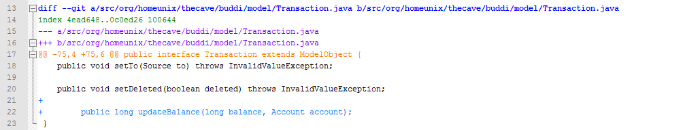

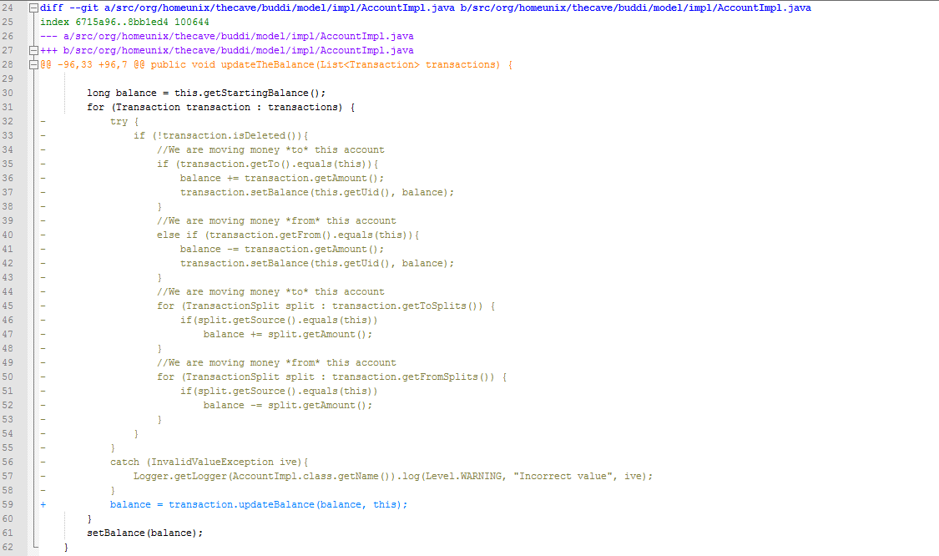

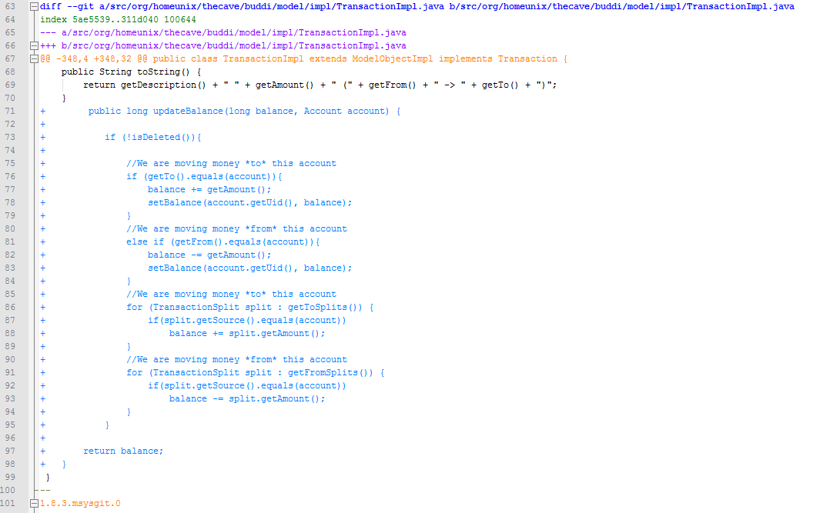

**Change 1/2**

We moved updateTheBalance() method from AccountImpl to TransactionImpl.

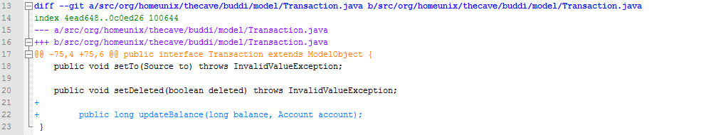

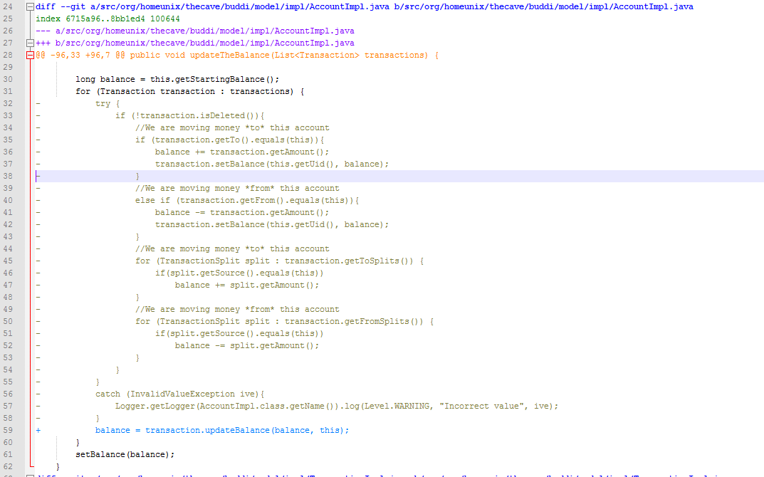

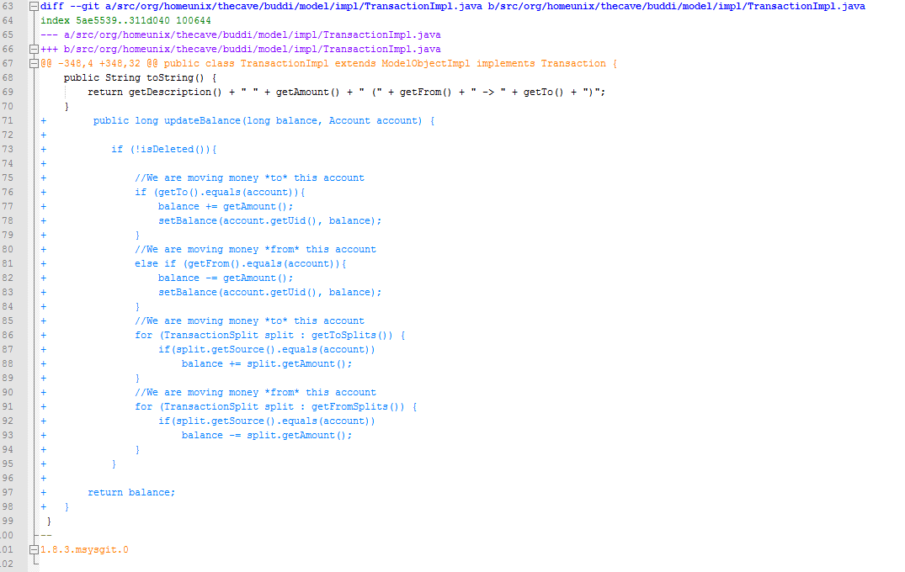

**Change 2/2**

Extracted 4 new methods from updateBalance() and named them as updateDestinationAccountBalance(), updateSourceAccountBalance(), updateBalanceFromDestinationAccount(),updateBalanceFromSourceAccount().

# 

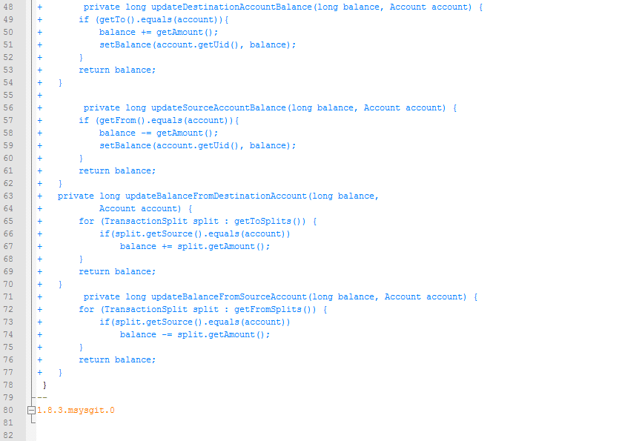

# Refactoring 3

# Patchset for <<Duplicated Code>> Code Smell 1

Change 0/2: Refactor class TransactionImpl removing duplicated code.

The methods setReconciledFrom and setReconciledTo of class TransactionImpl were using same conditions on IF statement. The duplicated code was moved to a new method called setReconcil.

Change 1/2: Create new method setReconcil

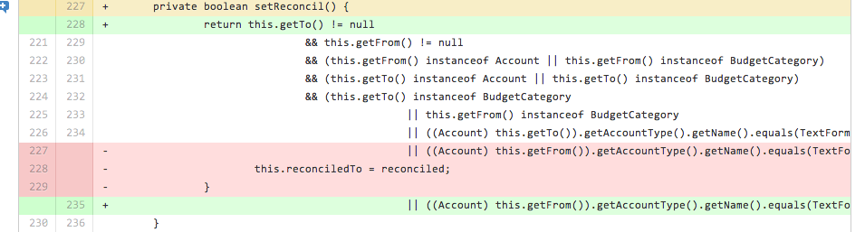

Change 2/2: Change IF statements

New IF statements will use new method setReconcil to validate same conditions.

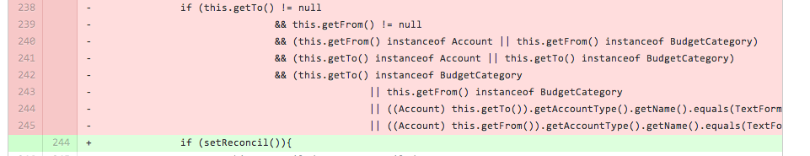

# Patchset for <<Duplicated Code>> Code Smell 2

Change 0/2: Refactor class TransactionImpl removing duplicated code.

The methods setClearedFrom and setClearedTo of class TransactionImpl were using same conditions on IF statement. The duplicated code was moved to a new method called setCleared.

Change 1/2: Create new method setCleared

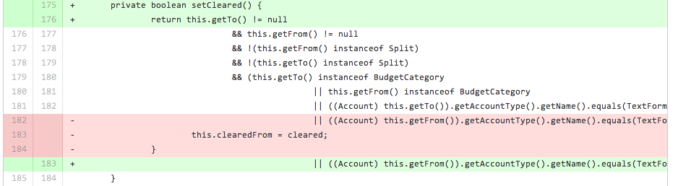

Change 2/2: Change IF statements

New IF statements will use new method setCleared to validate same conditions.

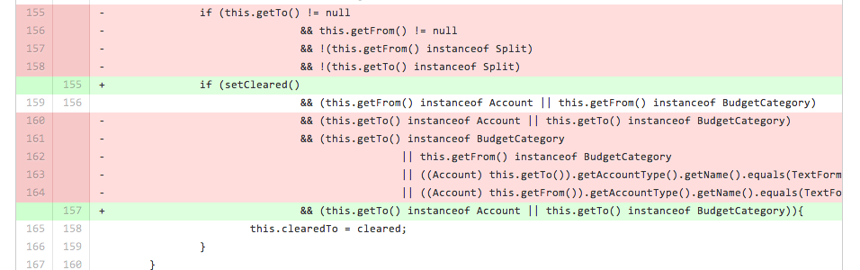

# BUDDI JUnit TestSuite

Running Buddi JUnit TestSuite on MasterBranch (before Refactorings):

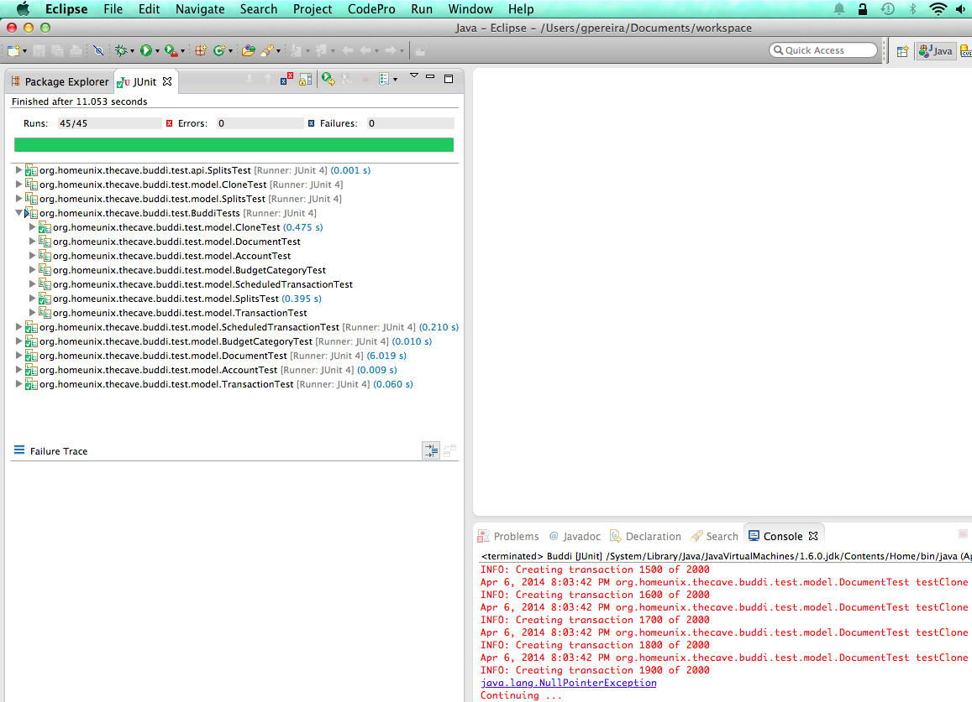

Running Buddi JUnit TestSuite on Conditional Complexity branch:

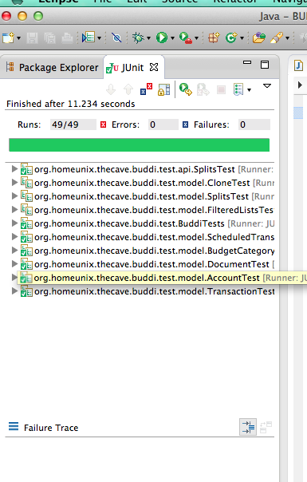

Running Buddi JUnit TestSuite on Feature Envy branch: 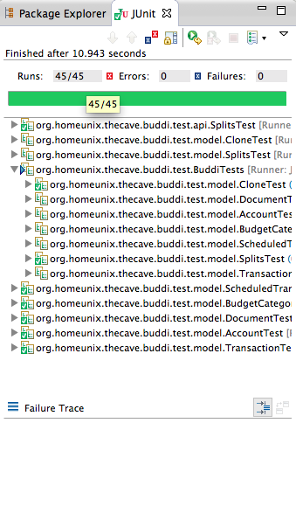

Running Buddi JUnit TestSuite on Duplicate Code branch:

