**Project Setup**

**Sensoponics**

1. Create an account in ThingSpeak.com and create a new channel or go to this link <https://thingspeak.com/channels/new> login and replicate the fields shown in the below image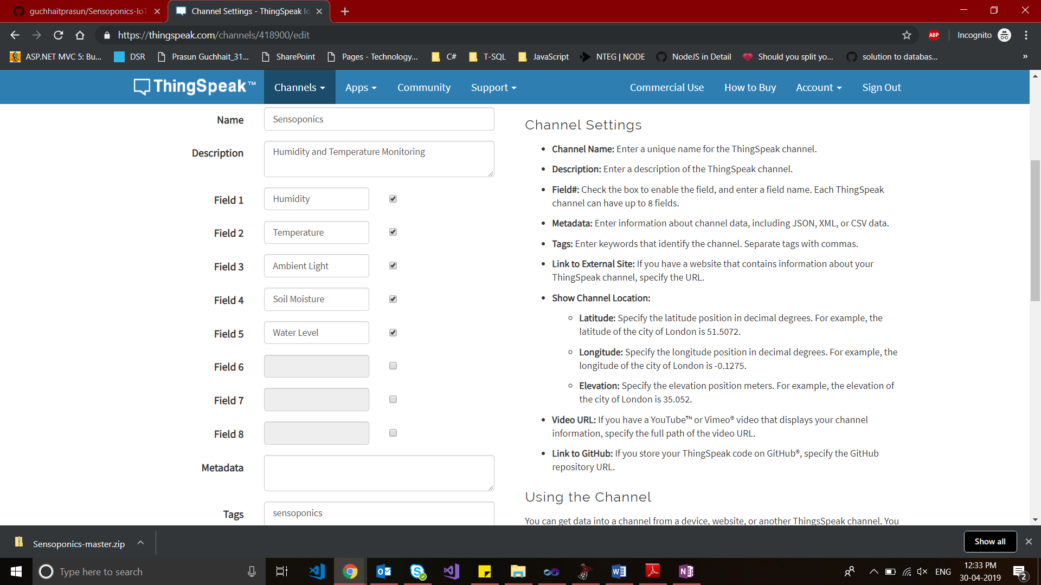
2. Select the newly created channel and then go to the API Keys and copy Read and write Key for future purpose
3. Open Project.ino and update line 39 and 40 with your default wifi user Id and password and also update the api key in line 151 with your Write Api Key. After that connect the Arduino to the ArduinoIDE in you computer and burn the Modified Project.Ino code on to the Arduino Uno
4. Now we have done on the coding and software setup end now jump to hardware setup end. Replicate the hardware setup shown in below image



1. After the hardware setup now Run the hardware setup and enjoy your newly created sensoponics

*************************Project Test*****************************************

If you want to test my project the

1. Do the changes on line 39 and 40 of Project.ino file for your Wi-Fi SSID and Password.
2. Burn the project in Arduino.
3. Do the hardware setup mention in step 4 above.
4. Supply 5V to the Arduino and start the model
5. Go to https://thingspeak.com/channels/418900 and check the data updating on the thingspeak server.