**Task 1**

**Correlation plot**

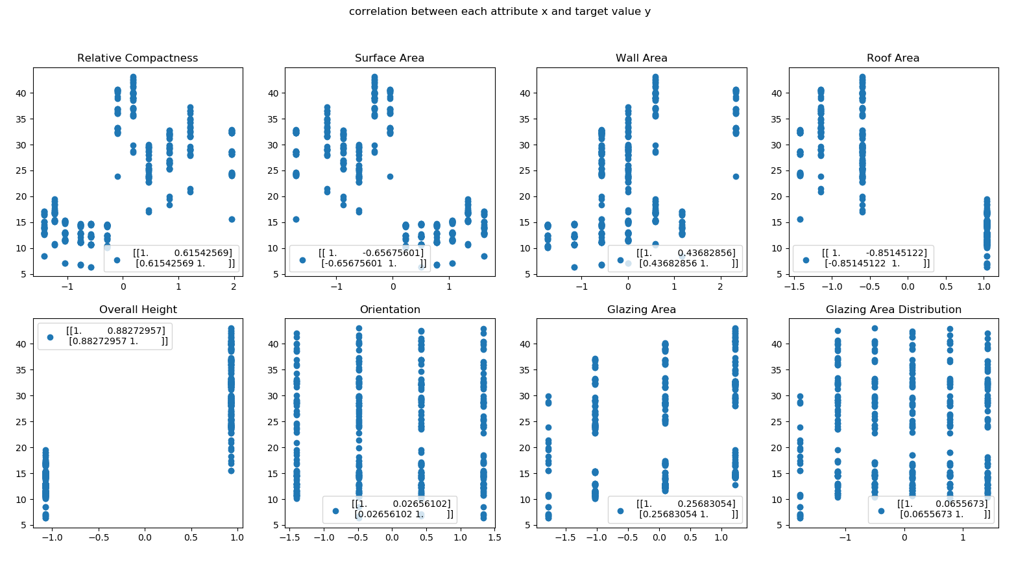

**Backward elimination (significant level of 0.05)**

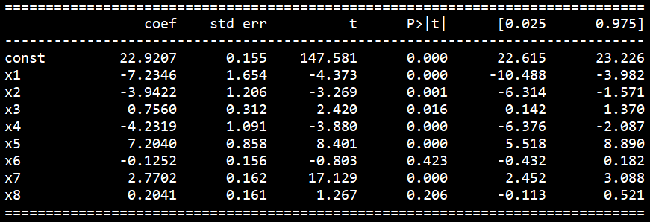

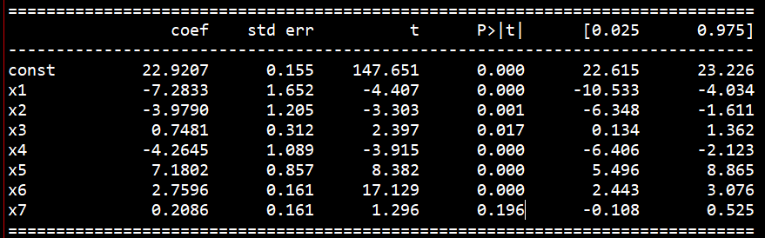

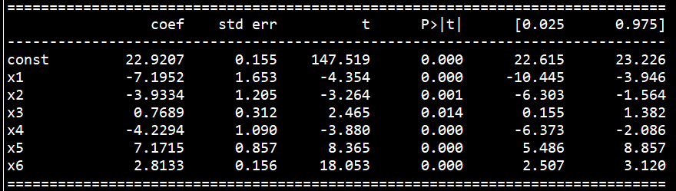

**Regression result (consider all input variable)**

train error : 3.0115517876503612

test error : 3.0958865845448686

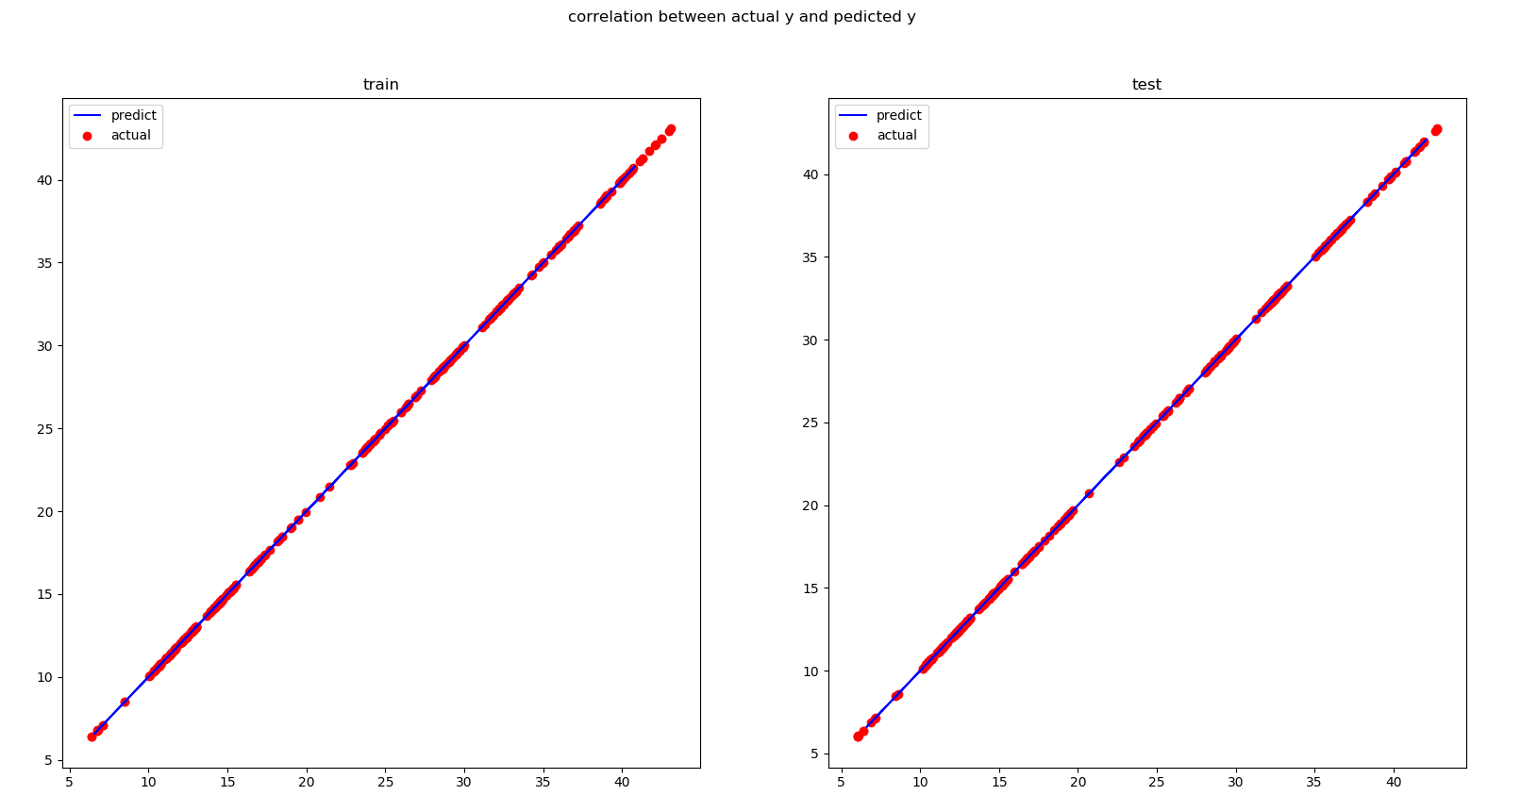

**Task 2**

**Type 2 maximum likelihood**

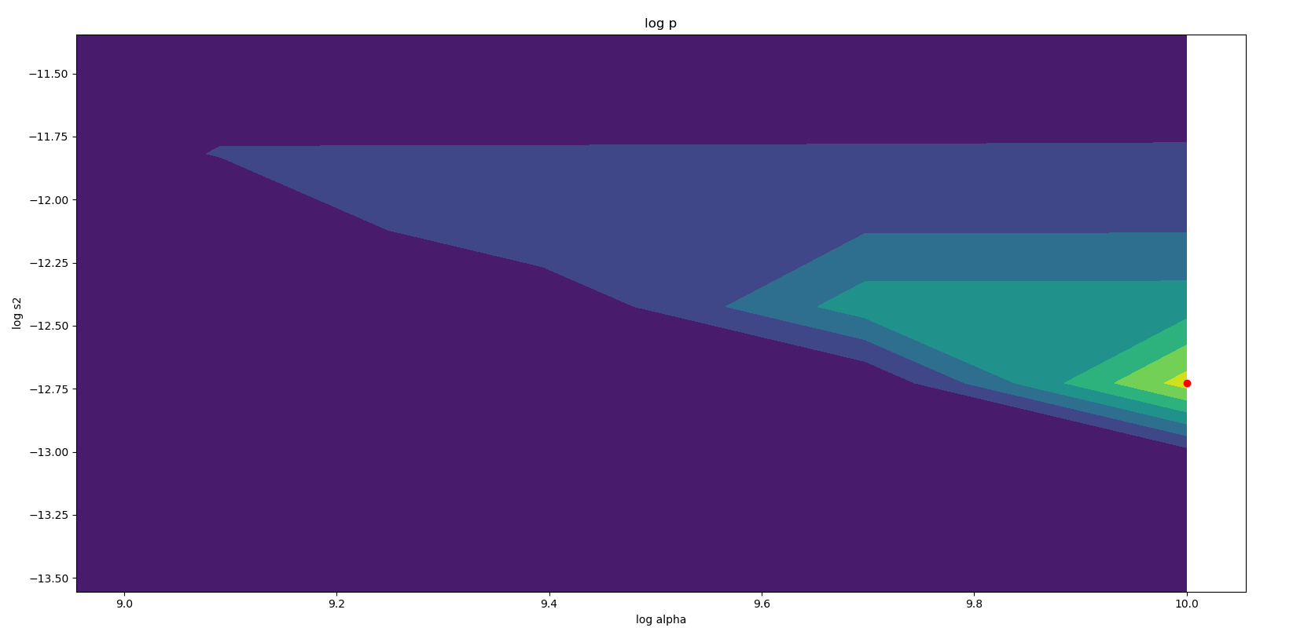

RMSE train : 3.049863814741146

RMSE test : 2.883094591217404

Best log alpha : 10.0

Best log s2 : -12.727272727272727

**Variational inference**

MSE train : 3.1184503170879347

RMSE test : 2.897192908948821

Best alpha : 0.01717282815682375

Best beta : 0.01717282815682375

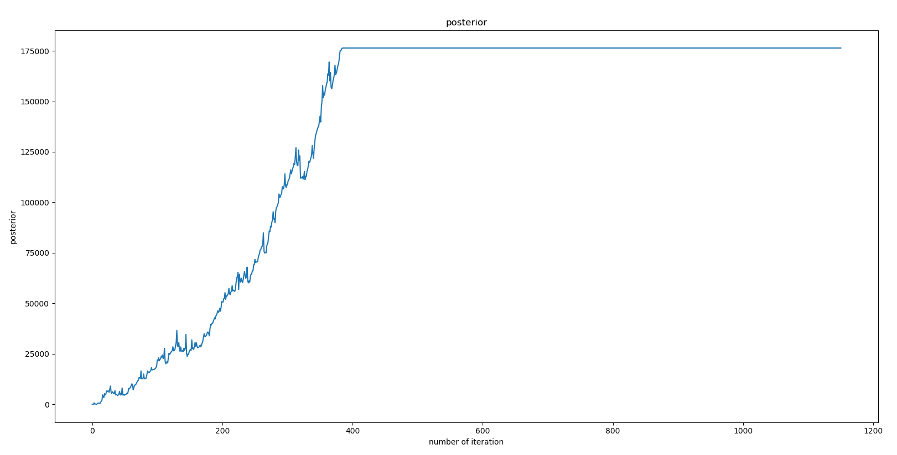

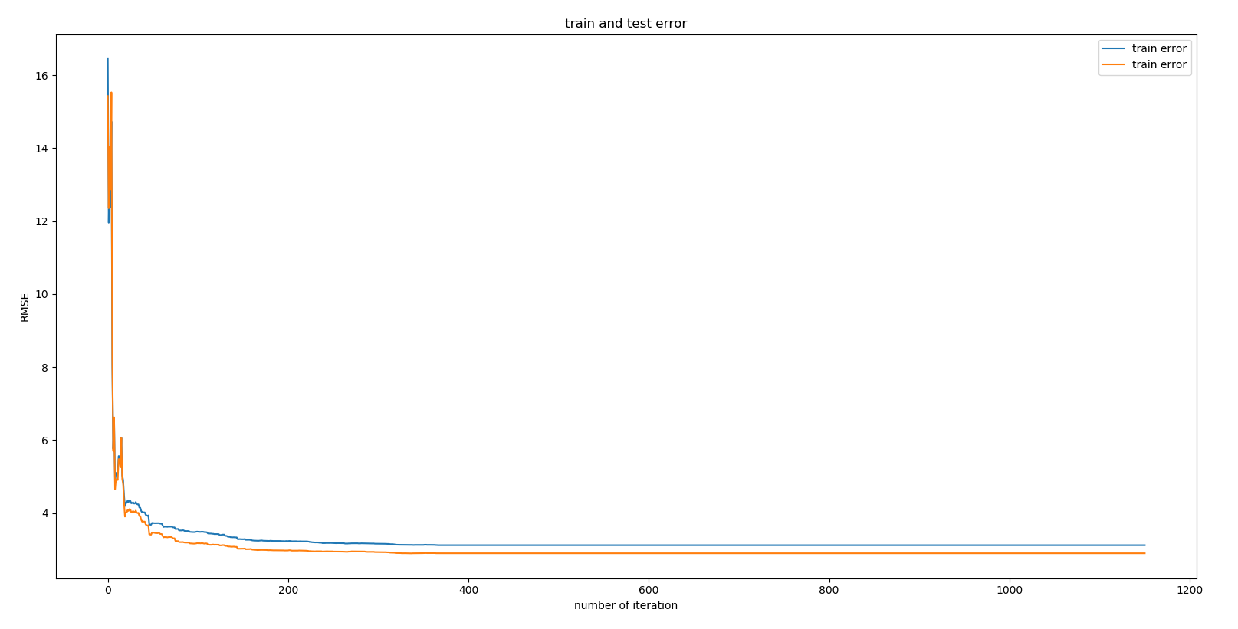

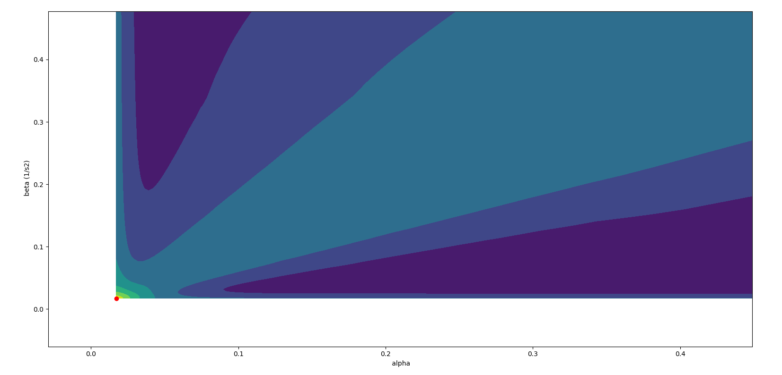

**Task 3**

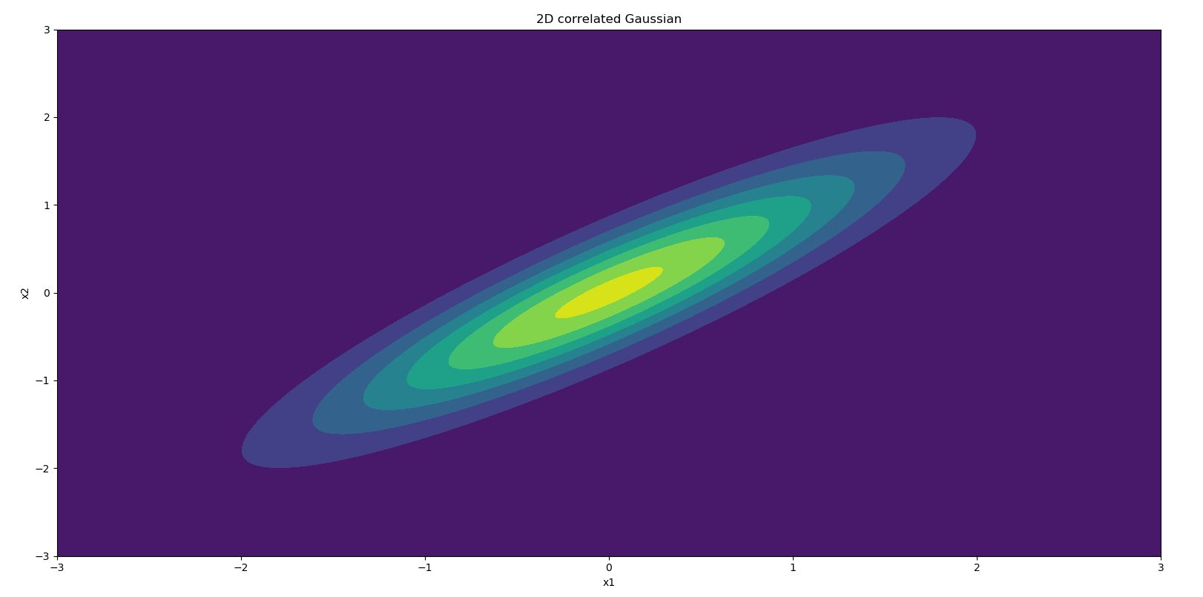

**Design of toy problem**

Mean and variance of both variables are 0 and 1

Correlation is 0.9

**Find suitable epsilon**

choose epsilon=0.487 because it is the value after this make accuracy below 0.8 for the first time

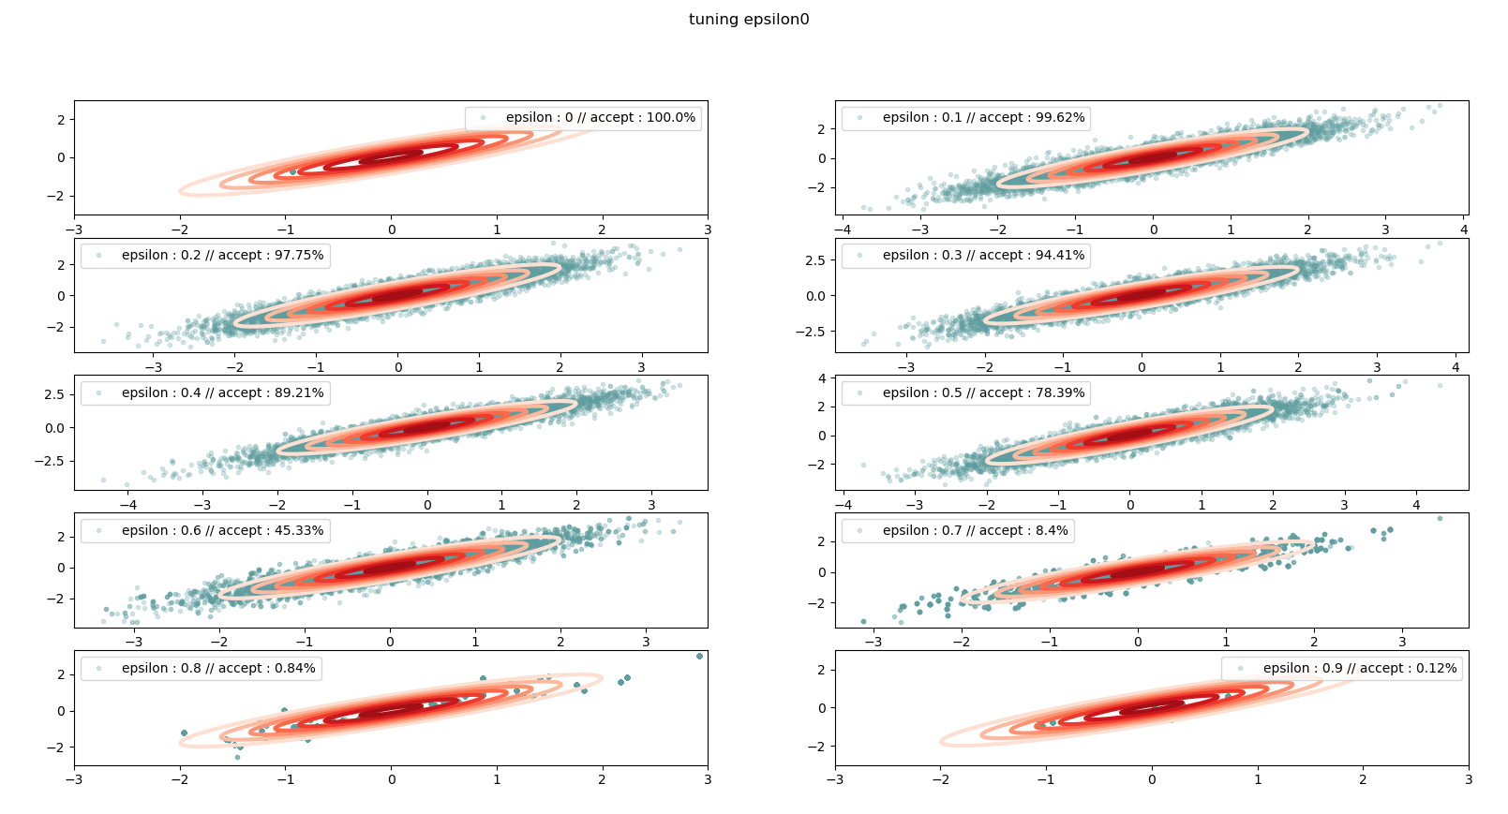

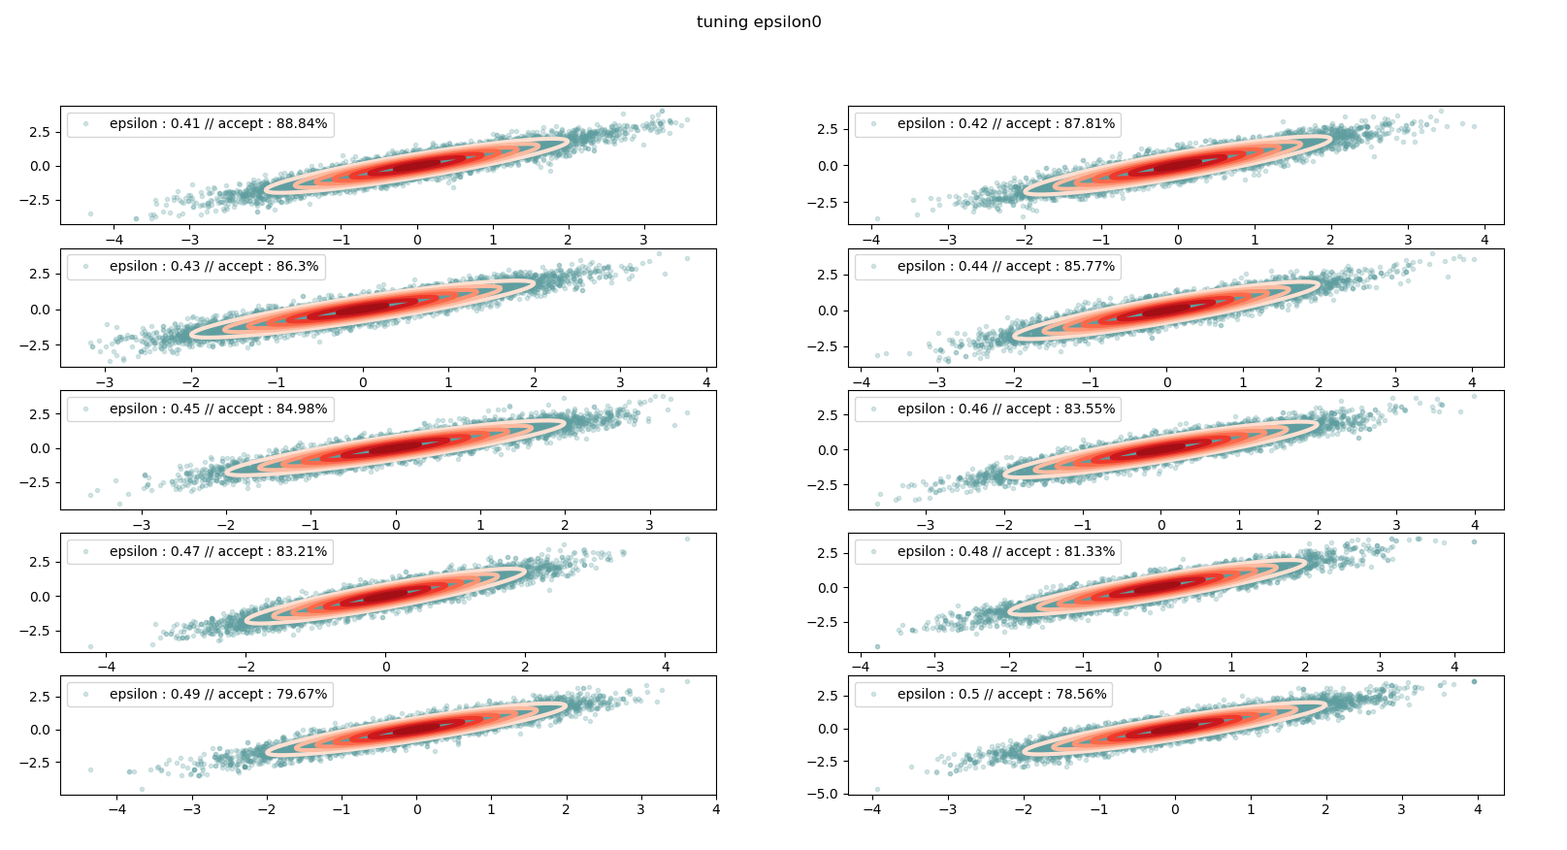

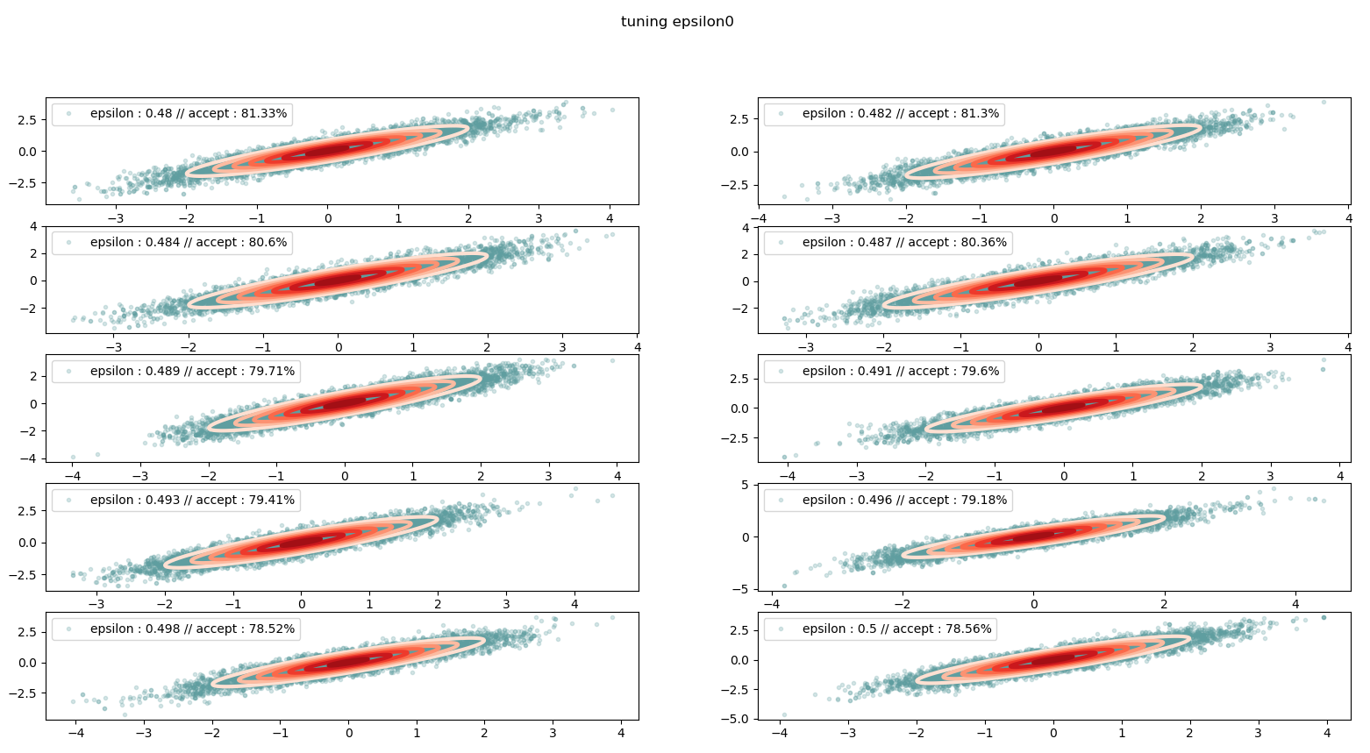

**report the values of R, L and epsilon0**

R :10000

L : 25

Epsilon0 : 0.487

**verify and demonstrate (with appropriate ﬁgures or numerical tables) that your HMC works as expected**

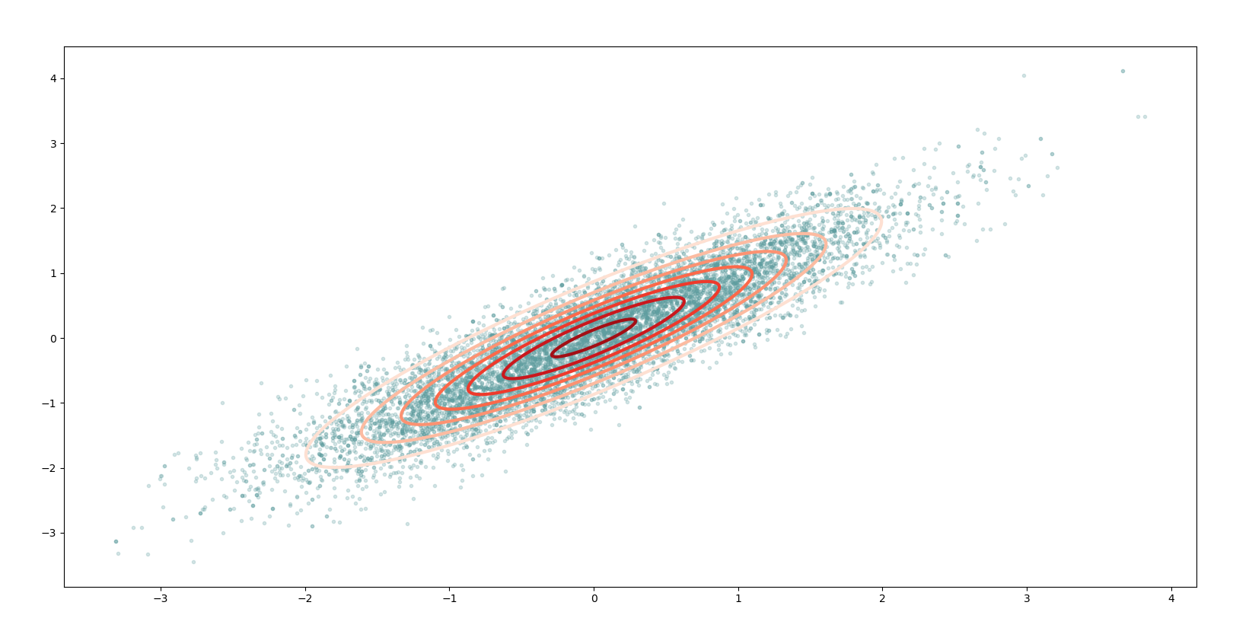

**report your designed functions energy_func and energy_grad** 