**Live Video Streaming (Android)**

**Under the guidance of**

**Shrinivas Dudhani.**

**Index**

# Table of Contents

1. Problem definition 3

2. Project Scope 3

3. Architecture 4

4. Coding standards 5

5. Software Development Life Cycle (SDLC) 6

6. Waterfall Model 6

7. Feasibility Study 7-9

* 1. Technical Feasibility 7
  2. Economical Feasibility 8

7.3 Operational Feasibility 9

8. Data Flow Diagram 10-12

8.1 Level 0 10

8.2 Level 1.1 10

8.3 Level 1.2 11

8.4 Level 1.3 11

8.5 Level 1.4 12

8.6 Level 2.1 12

8.7 Level 2.2 12

9. Quality Assurance 13

10. Software and Hardware Requirements 13

11. Team Members 13

**Live Video Streaming**

**(Android)**

Stream live video using a mobile camera to a distant /remote computer and view the same on the web browser.

**Problem Definition:**

Current solutions, first streams the video to the server and save the same. It is then broadcasted to the client’s browser. This type of streaming is not live (i.e. stored and then broadcasted).

**Project Scope:**

This project allows a real-time video streaming service from an Android mobile device’s camera to a server. The real-time video can then be viewed from a web browser on the client’s computer. The project builds on open source code and open protocols to implement a set of software components that successfully stream live video using RTSP protocol (Real Time Streaming Protocol).

Users will have the ability to broadcast news and events live, using only an Android based mobile devices and an internet connection via the cellular network or Wi-Fi.

All these phases are cascaded to each other so that the next phase is started as and when a defined set of goals are achieved for first phase and it is signed off. Hence the peculiar name. All the methods and processes undertaken in the model are more visible.

**Architecture**

The following figure presents architecture overview of the project. When the camera is switched on, on the Android phone the transmission starts. The video is sent as RTP packets to the RTSP server. Users communicate with this server to view video. When RTSP server receives request from the client, it will begin forwarding the RTP packets to the user’s browser. The video is then buffered and played on the browser.

**Web**

**Browser**

**Android Mobile Camera**

**RTSP Server**

**RTP Packet**

**Figure 1: Architecture Diagram**

**Android Mobile Device:**

Android is a recently developed operating system designed for mobile devices. It was developed by Google and uses a Linux based kernel, Java compatible libraries along with the just-in-time compiler for development in the Java programming language. It supports many hardware components. Common hardware consists of cameras, a Wi-Fi communications chip, Bluetooth sender and receiver and a color touch screen. The Android Application Program Interface (API) contains many functions and classes to control the cellular devices. This functionality is all available in a single device with at least a day worth battery life.

In our project we use platform Android 2.2.

**Real –Time Streaming Protocol:**

The main protocol that is used in Streaming is RTSP i.e. Real Time Streaming Protocol. RTSP is an application level protocol that aims to provide a robust protocol for streaming multimedia over many applications and to support interoperability between clients and servers from different vendors. RTSP is considered more of a framework than a protocol. RTSP is designed to work on top of RTP to both control and deliver real-time content.

**How does RTSP Work?**

RTSP takes advantage of streaming which breaks data into packets sized according to the bandwidth available between client and server. When the client has received enough packets, the user's software could be playing one packet, decompressing another while downloading the third. This enables the user to listen or view the real time file almost immediately, and without downloading the entire media file. This applies to live data feeds as well as stored clips.

**Functions of RTSP:**

* Provides for on demand access of multimedia items such as stored real time audio/video files, live real time feeds or stored non-real time items.
* Allows interoperability between client server multimedia products from multiple vendors.
* Provides for control and delivery of real time media and associated events between a media server and large numbers of media clients.

**Differences from HTTP:**

* RTSP server needs to maintain state by default in almost all case.
* RTSP server and client can issue requests.
* The Request URI always contains the absolute URI.

**Real-Time Transfer Protocol Server:**

The RTP server receives the RTP packets from the Android device. When a viewer connects to the RTSP server and requests to play a stream, the RTP server sends the RTP packets and forwards them to the viewing users.

**Coding Standards:**

General coding standards pertain to how the developer writes code.

General Software Coding Standards and Guidelines:

1. Inline Comments

Inline comments are used to explain the functioning of the task.

1. Naming Convention

a. Classes

Names of classes must start with Capital Letter. They should follow Upper Camel Case.

b. Methods

Methods should be in Lower Camel Case; that is, with the first letter lowercase and the first letters of subsequent words in uppercase.

c. Variables

Variable names should be short yet meaningful. They should follow Lower Camel Case.

d. Constants

Names should be in uppercase.

**Software Development Life Cycle:**

A software development process, also known as a software development life cycle (SDLC), is a structure imposed on the [development of a software product](http://en.wikipedia.org/wiki/Software_development). There are several [models](http://en.wikipedia.org/wiki/Software_development_process#Software_development_models) for such structures, each describing approaches to a variety of [tasks or activities](http://en.wikipedia.org/wiki/Phases_of_the_software_development_cycle) that take place during the development process.

**Waterfall Model:**

This project follows 'The Waterfall Model' for the SDLC. In this approach, the whole process of software development is divided into separate phases. These phases are:

1. Requirement specifications phase
2. Software design
3. Implementation
4. Testing and maintenance

All these phases are cascaded to each other so that the next phase is started as and when a defined set of goals are achieved for first phase and it is signed off. Hence the peculiar name. All the methods and processes undertaken in the model are more visible.

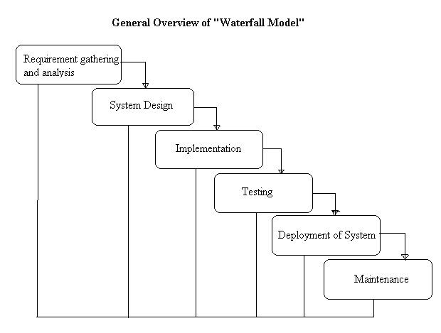

**Fig-1-Waterfall model**

**Reasons to follow this Approach:**

The project requirements are very well known, clear and are fixed. There are no ambiguous requirements. Similarly, the technology is going to be used is also known. As every phase is fixed, there is no need of revisiting.

**Feasibility Study:**

The final step of initial investigation of system is the feasibility study. It is carried out to

check the workability of the candidate system. It’s impact on the organizational ability to

meet user needs and effective use of the system. Feasibility is the testing of the proposed

system according to its workability.

A feasibility study is carried out to select the best system that meets all performance

requirements. The result of feasibility study is a formal proposal. This is simply a report-

a formal document detailing the nature and scope of the proposed solution. The proposal

summarizes what is known and what is going to be done.

There are three key consideration involved in the feasibility analysis:

• Technical Feasibility.

• Economical Feasibility.

• Operational Feasibility.

**Technical Feasibility:**

The technical feasibility study compares the level of technology available in the  software development firm and the level of technology required for the development of   the product. Here the level of technology consists of the programming   language, the hardware resources, software recourses.

**Our technical feasibility parameters involves:**

* Do we have the right technical inputs / clarity of this project?
* Do we have the right technical skills to take up this project?
* Do we have the right tools to take up this project?
* Is there any training required / technical mentoring?
* Do we have the right understanding of the concept and deliverable that the

customer desires to have?

* Did we analyze the right way to do this project?

An Androidmobile device combined with its camera and internet capabilities is used to stream real-time video to a web page. It accomplishes the streaming using various open source projects and open protocols. Using standardized and open protocols increases compatibility among clients and results in far more support than less popular or closed protocols.

The open source protocols used in this project is **Real Time Streaming Protocol (RTSP).** The RTSP is a network control [protocol](http://en.wikipedia.org/wiki/Communications_protocol) designed for use in entertainment and communications systems to control [streaming media](http://en.wikipedia.org/wiki/Streaming_media) [servers](http://en.wikipedia.org/wiki/Web_server). This protocol is used for establishing and controlling media sessions between end points. RTSP defines control sequences useful in controlling multimedia playback.

**Web Browser** embedded with **Flash player** plug-in is required to view videos on client’s browser.

**Android Development Tools (ADT)** :It is a plug-in for the Eclipse IDE that is designed to give you a powerful, integrated environment to build Android applications. Developing in Eclipse with ADT is required and is the better way to get started. ADT extends the capabilities of Eclipse viz: to let you quickly set up new Android projects, create an application UI.

**Eclipse (Helios):** Its free a software tool, **open implementation.** It’s release also features new [Linux tools](http://www.eclipse.org/linuxtools/) and JavaScript tools.

**Economical Feasibility:**

Economic analysis is the most frequently used method for evaluating the effectiveness of a new system or project benefit of the proposed system. More commonly known as [cost/benefit analysis](http://en.wikipedia.org/wiki/Cost-benefit_analysis), the procedure is to determine the benefits and savings that are expected from a candidate system and compare them with costs.

Return on investment is also important. [Analysis](http://www.businessdictionary.com/definition/analysis.html) of a [project's](http://www.businessdictionary.com/definition/project.html) [costs](http://www.businessdictionary.com/definition/costs.html) and [revenues](http://www.businessdictionary.com/definition/revenue.html) in an effort to determine whether or not it is logical and possible to complete. The objective of the economic feasibility is to develop a financial model of the business venture. The product of this step is a complete integration of the technical product information and the market study into one or more break-even financial models.

The estimated cost usually considers the whole cost of ownership which includes:

1. Ongoing support

2. Maintenance cost

3. Acquisition cost

In this project, financial requirements are very low, required things are:

1. Eclipse **(**Helios): It is a free software tool.

2.Android Development Tools (ADT): It helps us to develop mobile applications on the Android platform. It is a plug-in for the Eclipse IDE that is designed to give you a powerful, integrated environment to build android applications. It is also a free tool.

3. Android based mobile device with a built in camera.

4. RTSP Server to transfer the Real-time Transfer Protocol.

**Operational Feasibility:**

Operational feasibility is a measure of how well a proposed system solves the problems, takes advantage of the opportunities identified during scope definition and how it satisfies the requirements identified in the requirements analysis phase of system development.

The willingness and ability of management, employees, customers and suppliers to operate and support a proposed system. Operational feasibility depends on several vital issues. For example, consider the following questions:  
  
1. Does management support the project?

2. Do customers support the project?

3. Do users see the need for change?

Operational feasibility is mainly concerned with issues like whether the system will be used if it is developed and implemented. A system that has operational feasibility is the one that will be used effectively after it has been developed. The proposed system works effectively on different Android mobile devices. Analyzes the inside operations on how a deemed process will work, be implemented, and dealing with change resistance and acceptance.

**Data Flow Diagrams(D.F.D.):**

**Level 0:**

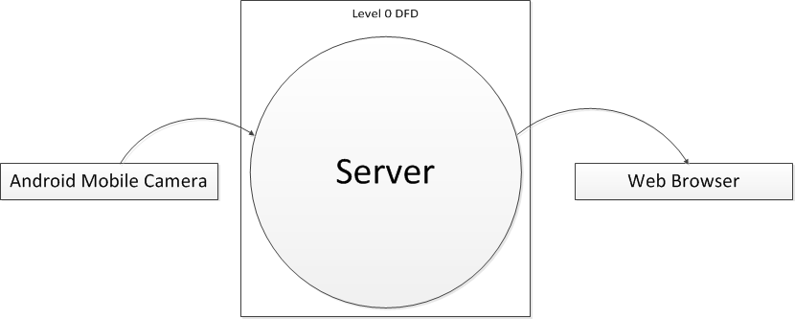

**Level 1.1:**

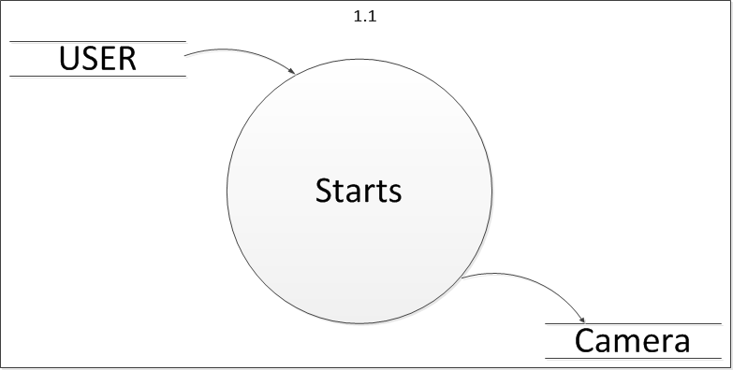

**Level 1.2:**

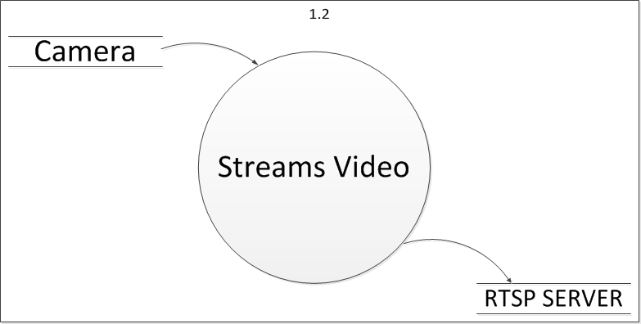

**Level 1.3:**

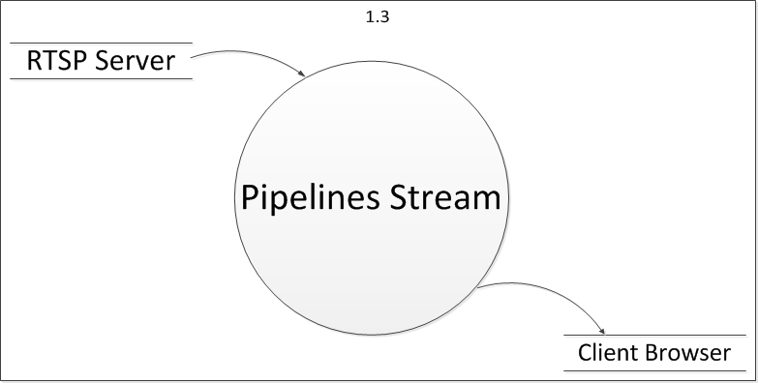

**Level 1.4:**

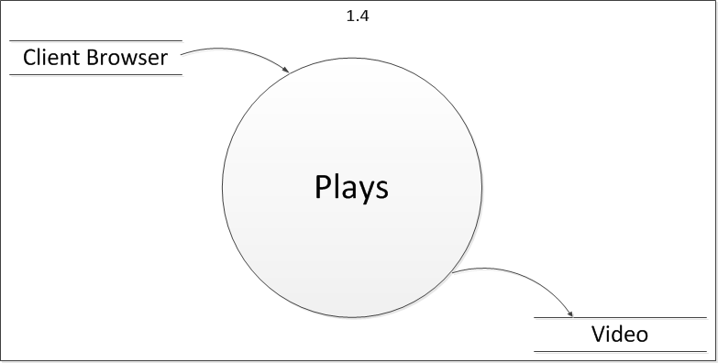

**Level 2.1:**

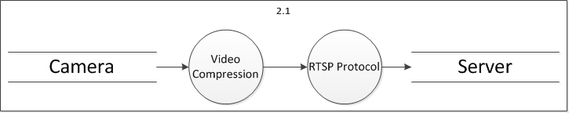

**Level 2.2:**

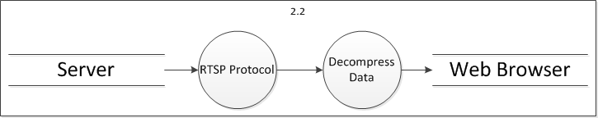

# Use of Quality Assurance Practices:

Quality Assurance is a broad practice used for assuring the quality of products or services. Quality Assurance makes sure the project will be completed based on the specifications, standards and functionality requirement without defects and possible problems.

It monitors and tries to improve the development process from the beginning of the project.

Quality assurance function of an organization uses a number of tools for enhancing the quality practices. These tools vary from simple techniques to sophisticated software systems. To achieve better quality we are using BugZilla tool.

**Software and Hardware Requirements:**

**Software:**

* Eclipse (Helios)
* ADT plug-in(Android Development Tools)
* Android SDK
* Web Browser

**Hardware**:

* Android based mobile with embedded camera.
* An implementation of the Real-time Streaming Protocol (RTSP) server in order to transfer the video to viewing clients.

**Team Members:**

* 1. Akshay Velhal.
  2. Yashwant Patel.
  3. Chetan Paunikar.
  4. Pritesh Jadhav.
  5. Vivek Saxsena.
  6. Prashant Varpe.
  7. Pranali Deshpande.
  8. Sonali Dhome.
  9. Gauri Tembare.
  10. Pradnya Bagave