ECA56 – ADVANCED WIRELESS COMMUNICATION SYSTEMS
EXPERIMENT 2
Modeling of Hexagonal Cellular Coverage, Cell Splitting and Handoff
Prepared by: G. Chennakesavareddy
AIM
To model a central hexagonal cell with six adjacent cells, illustrate cell splitting and user capacity, and demonstrate a mobile handoff between two cells.
APPARATUS / SOFTWARE REQUIRED
Computer with MATLAB Online/Desktop. No physical hardware is required; this is a software simulation.
MATLAB / ARDUINO CODE
clc;
clear;
close all;
% EXPERIMENT 2: Hexagonal cellular coverage and handoff
cellRadiusKm = 0.5;
axial = [0 0; 1 0; 1 -1; 0 -1; -1 0; -1 1; 0 1];
xCenter = sqrt(3)*cellRadiusKm*(axial(:,1)+axial(:,2)/2);
yCenter = 1.5*cellRadiusKm*axial(:,2);
figure;
hold on;
theta = (0:6)*pi/3 + pi/6;
for k = 1:7
x = xCenter(k) + cellRadiusKm*cos(theta);
y = yCenter(k) + cellRadiusKm*sin(theta);
plot(x,y,'k-','LineWidth',1.5);
text(xCenter(k),yCenter(k),sprintf('Cell %d',k), ...
'HorizontalAlignment','center');
end
axis equal; grid on;
xlabel('Horizontal Distance (km)');
ylabel('Vertical Distance (km)');
title('Hexagonal Cellular Coverage');
% Cell splitting: simple capacity illustration
radius = [0.5 1.0];
capacity = [240 60];
figure;
bar(radius,capacity);
grid on;
xlabel('Cell Radius (km)');
ylabel('Estimated User Capacity');
title('Cell Splitting and User Capacity');
% Mobile handoff between cell 1 and cell 2
mobilePosition = -1:0.01:1;
servingCell = ones(size(mobilePosition));
servingCell(mobilePosition >= 0) = 2;
figure;
stairs(mobilePosition,servingCell,'b','LineWidth',2);
grid on;
xlabel('Mobile Position (km)');
ylabel('Serving Cell');
title('Mobile Handoff Between Two Cells');
ylim([0.5 2.5]);
OUTPUT SCREENSHOTS
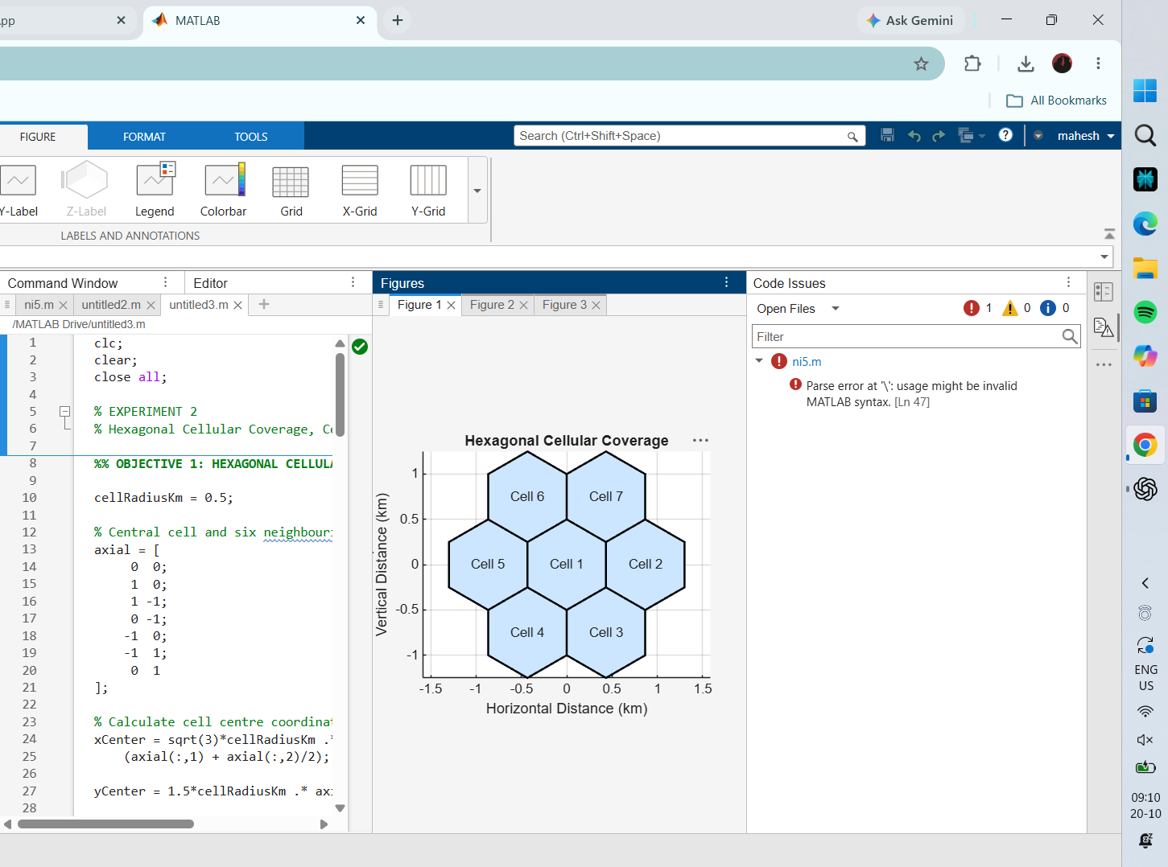
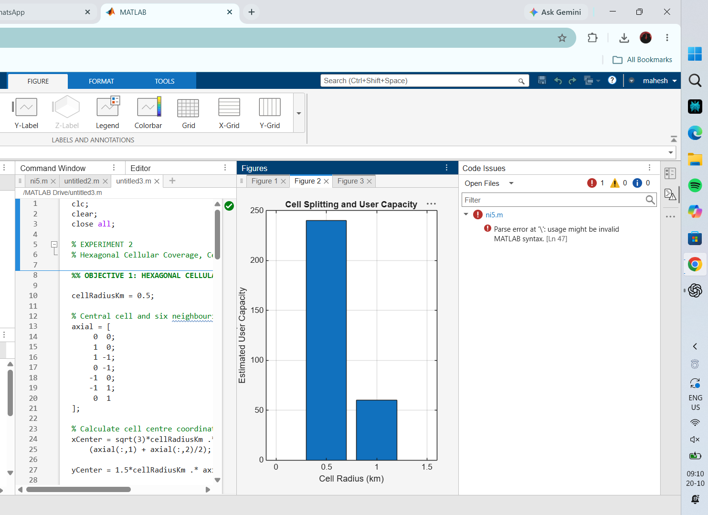
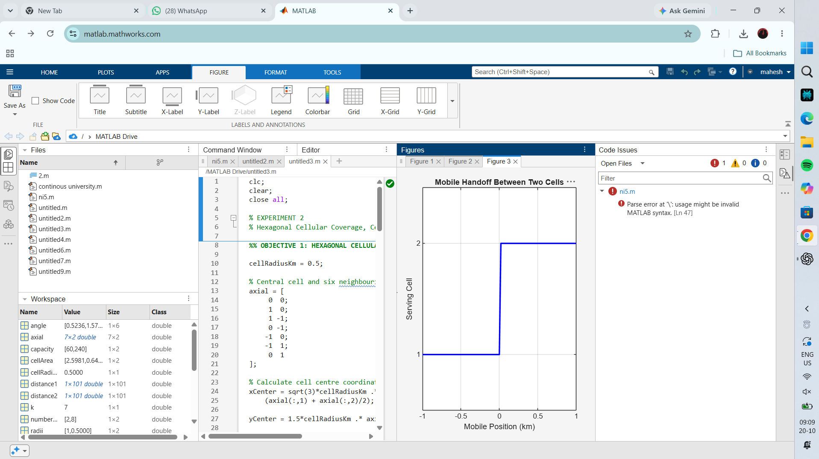
RESULT
The plots show a seven-cell hexagonal layout, an illustrative cell-radius/capacity comparison, and a serving-cell change as the mobile moves across the handoff boundary.

