**Aguado, Ricky M.**

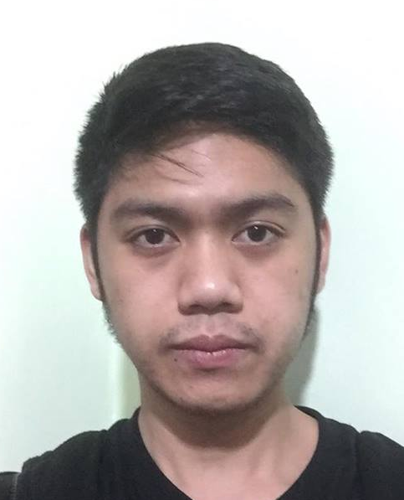

# Portfolio

|  |
| --- |
|  |

**Welcome to my ePortfolio**

Hello. My name is Reeve Michael Angelo Callejo and I’d like to welcome you to my ePortfolio. I am a student at University of Baguio, Information Technology Student; I’m currently enrolled in the Probability and Statistics and this ePortfolio is being created as one of the projects I am completing for the computer course that I am taking as part of my four-year Diploma.

In addition to this computer course, I am also taking courses on Network Administration, Communications, basic programming and various law-related areas such as ITLAWS. My goal is to complete this Subject (ENGMAT9) and to graduate, so I can work as a IT in ISP’s or government office.

In addition to this Welcome page, my ePortfolio includes a Curriculum vitae. On my CV page you will find some description and information about me and my skills I’ve learned throughout my pass courses. My Work page contains a sample of several different projects I’ve completed for this ENGMAT9 class.

My Contact Me page holds information about how you can contact me for an interview or if you require any other information about me.

I hope you enjoy reading over the information in my ePortfolio as much as I enjoyed creating it for you!

**My Work Page**  
  
I have completed several different projects/experiments/topics in a lecture covering various aspects of the legal profession in this course.  On this page, I have attached examples of these projects/experiment narratives/narrative report on what I’ve learned in each topic lecture:

**FIRST GRADING:**

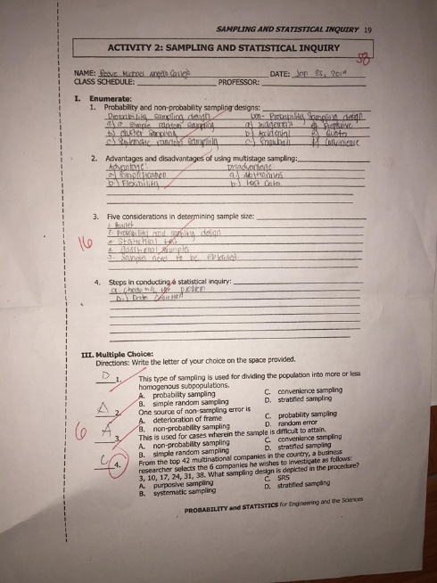

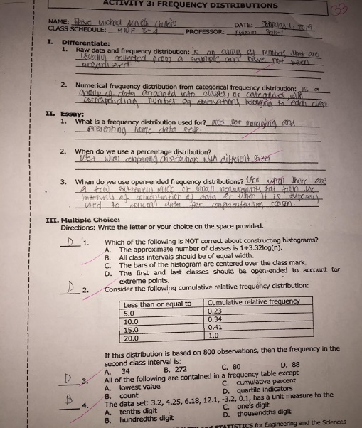

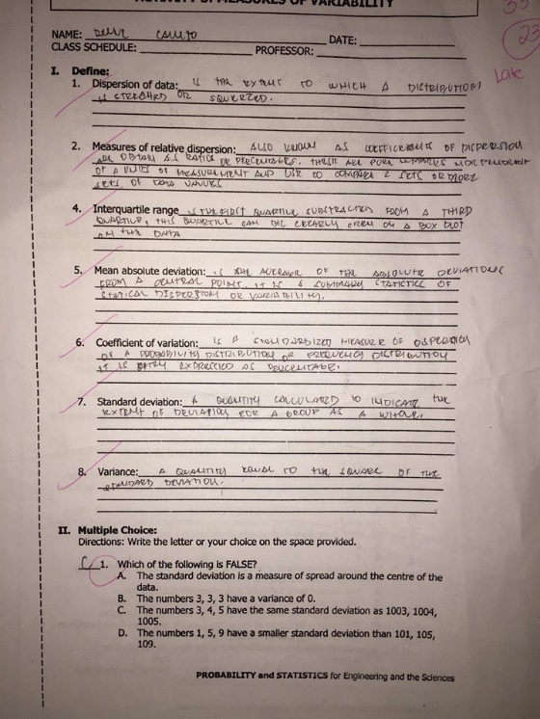

**NARRATIVE REPORT:** It is the introduction of what is Probability and Statistics, basically we’ve discuss all the basic information we need to know about this subject it is the foundation for further lessons. Some examples are Areas of statistics and general use, types of data, variables and measurements, methods of collecting data etc...

**MIDTERMS:**

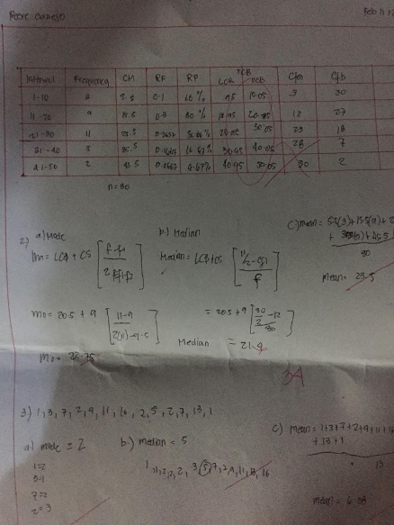

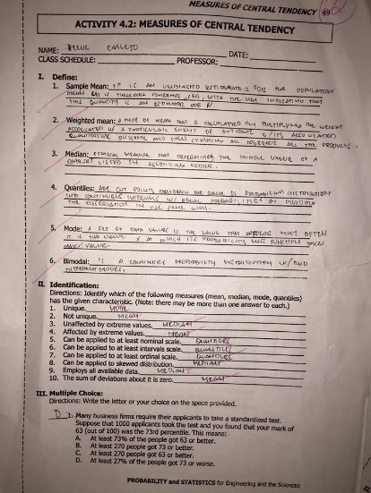

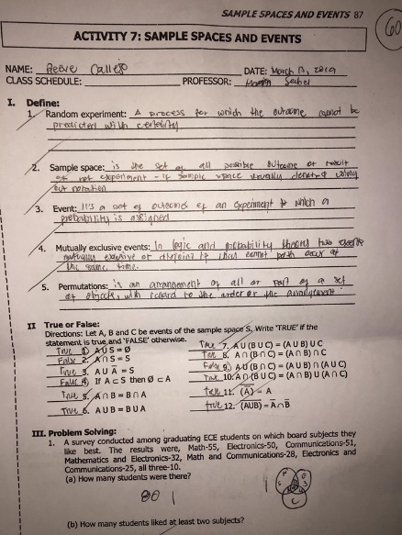

**NARRATIVE REPORT:** During midterms we discuss how to determine the mean,median and mode. And with the use of this we can fill the frequency distibution table. We also learn how to construct different type of presenting a data through Histograms, pictograms and skewness.

**FINALS:**

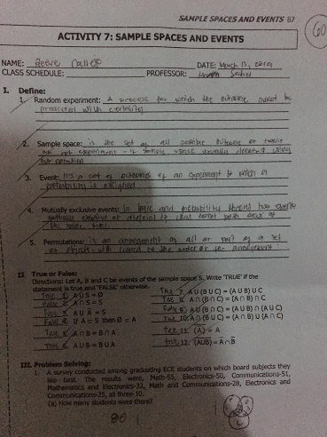

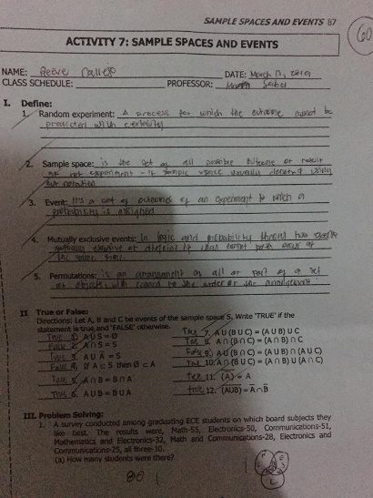

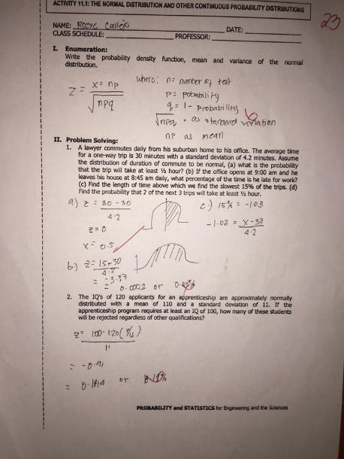

**NARRATIVE REPORT:** It is the difficult part of me because all of the pass lessons are implemented during finals, finding the probability is the hardest part, and also the estimating and hypothesis testing.

**I hope you enjoy reviewing them. And I really hope we pass.**

**RESUME PAGE**

|  |  |
| --- | --- |
| Reeve  **Callejo** | Address: Pinget, Baguio City  Phone: 09159048734  Email: reevechels@gmail.com  LinkedIn Profile:  Twitter/Blog/Portfolio: |

|  |  |
| --- | --- |
|  | Objective |

To replace this text with you own, just click it and start typing. Briefly state your career objective, or summarize what makes you stand out. Use language from the job description as keywords.

|  |  |
| --- | --- |
|  | **Education** |

**Tertiary Level | University of Baguio**

**Secondary Level | Saint Albert The Great School 2012**

**Elementary Level | Josefa Cariño Elementary School**

|  |  |
| --- | --- |
|  | **Skills** |

|  |  |
| --- | --- |
| Hardware troubleshooting  Network troubleshooting  Programming(Java,C#,Visual Basic,HTML)  Microsoft Office(MS  Word,Excel,Powerpoint,Internet,etc)  Adobe Creative Suite(Photoshop,Premiere Pro) | Highly organized and effient.  Ability to work independently or as part  of the team.  Basic Knowledge on Project Management |

**CONTACT ME**

If you have any questions, or would like me to come in for an interview, you may contact me by phone

at: 09159048734

You may contact me by email at:reevechels@gmail.com

I look forward to hearing from you.