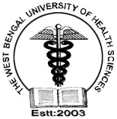

JOINT ACADEMIC PROGRAMME ON

“BIOMEDICAL INSTRUMENTATION” (BMI)

University of Calcutta and The West Bengal University of Health Sciences

Website(s): www.japbmi.in, www.caluniv.ac.in, www.wbuhs.ac.in, www.wbhealth.gov.in

Contact No.:-9830925208 (02:00Pm -04:00Pm (Except Sundays)), E-mail: admin@japbmi.in

Academic programme on Biomedical Instrumentation (BMI) introduced jointly by University of Calcutta (CU) and The West Bengal University of Health Sciences (WBUHS) from 2014-15. Considering the ever increasing demand of specialized manpower in this interdisciplinary field of studies and the success in last several years in terms of placement of the pass out students in reputed bio-medical industries, hospital/ health-care units as well as in academia, the joint programme between CU and WBUHS is formalized to include all academic & research activities in the area of Biomedical Science and Instrumentation Technology. The Programme covers a broad range of techniques for developing fundamental skills for medical applications of Applied Electronics and instrumentation. Further, it will provide students with a thorough understanding of the field, specifically with practical knowledge and expertise sufficient to evaluate, design and build medical instrument systems using a wide range of tools and techniques.

The 2 years master of science (M.Sc.) degree course in “Biomedical Instrumentation”

(BMI) under this Joint Academic Programme between CU and WBUHS shall enable honors graduate students in Science discipline to focus themselves towards a career in Biomedical Instrumentation Science and Engineering.

APPLICATIONS ARE INVITED for admission to the academic year 20167–20178 from

highly motivated Honours Graduates in Science discipline (Physics, Electronics Science, Chemistry, Computer Science or its equivalent) with good academic records. Twentylve (20)(12) students will be admitted on the basis of their throughout academic records and interview performance.

At the end of each academic year, an Internship Programme of three (3) months duration, for the certificate holders under this Joint Academic Programme, will be pursued at different Hospitals, Bio-Medical Sectors and Health-Care Units. Degree will be awarded jointly by both the University of Calcutta (CU) and The West Bengal University of Health Science (WBUHS).

RESERVATION OF SEATS:

Reservation of seats for candidates belonging to SC/ST and OBC shall be in accordance with the reservation policy of the Government of West Bengal.
JOINT ACADEMIC PROGRAMME ON

“BIOMEDICAL INSTRUMENTATION” (BMI)

University of Calcutta and The West Bengal University of Health Sciences

Website(s): www.japbmi.in, www.caluniv.ac.in, www.wbuhs.ac.in, www.wbhealth.gov.in

Contact No.:-9830925208 (02:00Pm -04:00Pm (Except Sundays)), E-mail: admin@japbmi.in

INSTRUCTION TO CANDIDATES

- The application fees of Rs. 100/-, admission fees of Rs. 500/-, course fees of Rs. 18000/- per semester, examination fees as per decision of the Universities have to be deposited by the candidates, as and when asked for.

- A candidate who has discontinued the academic programme during any semester with permission from Board of Studies (BOS) will be permitted by the Vice-Chancellor (s) to take re-admission to the new academic year at the beginning of the semester concerned, in a subsequent year, not however beyond a gap of two years. Fees shall not be refunded or adjusted during subsequent admission.

- Candidates should send the hard copy of the duly filled application form along with attested copies of all certificates, two copies of recent colour passport size photograph and the counterpart/ photocopy of the challan (application fees) to the JAP-BMI Information Centre (contact address given in the website: www.japbmi.in). Candidates should also provide the same through mail to the given email id. (japbmi@hotmail.com).

- Names of short-listed candidates will be posted on the website (s) only. No individual letter will be sent.

- Before applying, the applicants should ensure that they fulfill the essential qualifications and other conditions stipulated in the advertisement. If a candidate is found not eligible, his/ her candidature will be cancelled at any stage of the admission.

- The prescribed essential qualifications are the minimum and more possession of the same does not entitle a candidate to be called for interview. If the number of application becomes large, the Universities may resort to short listing criteria to restrict the number of candidatures to be called for the interview to a reasonable limit.

- The interested and eligible candidatures may keep a watch at these sites for any amendment.

- No interim queries will be entertained except technical queries regarding application.

NOTES:

- The right to change/ modify any or all condition (s) prescribed in this prospectus is/ are at the sole discretion of the University of Calcutta (CU) and The West Bengal University of Health Science (WBUHS).

- Any dispute with regard to the selection process will be subject to Courts/ Tribunals having jurisdiction at Calcutta High Court, West Bengal.

IMPORTANT DATES:

Forms available till: 28.09.2018, 16:00 hrs. IST

Date for Receipt of filled-in Application Forms: Will be announced

Announcement of the list of candidates qualified for the Interview: Will be announced
Interview Date: Will be announced

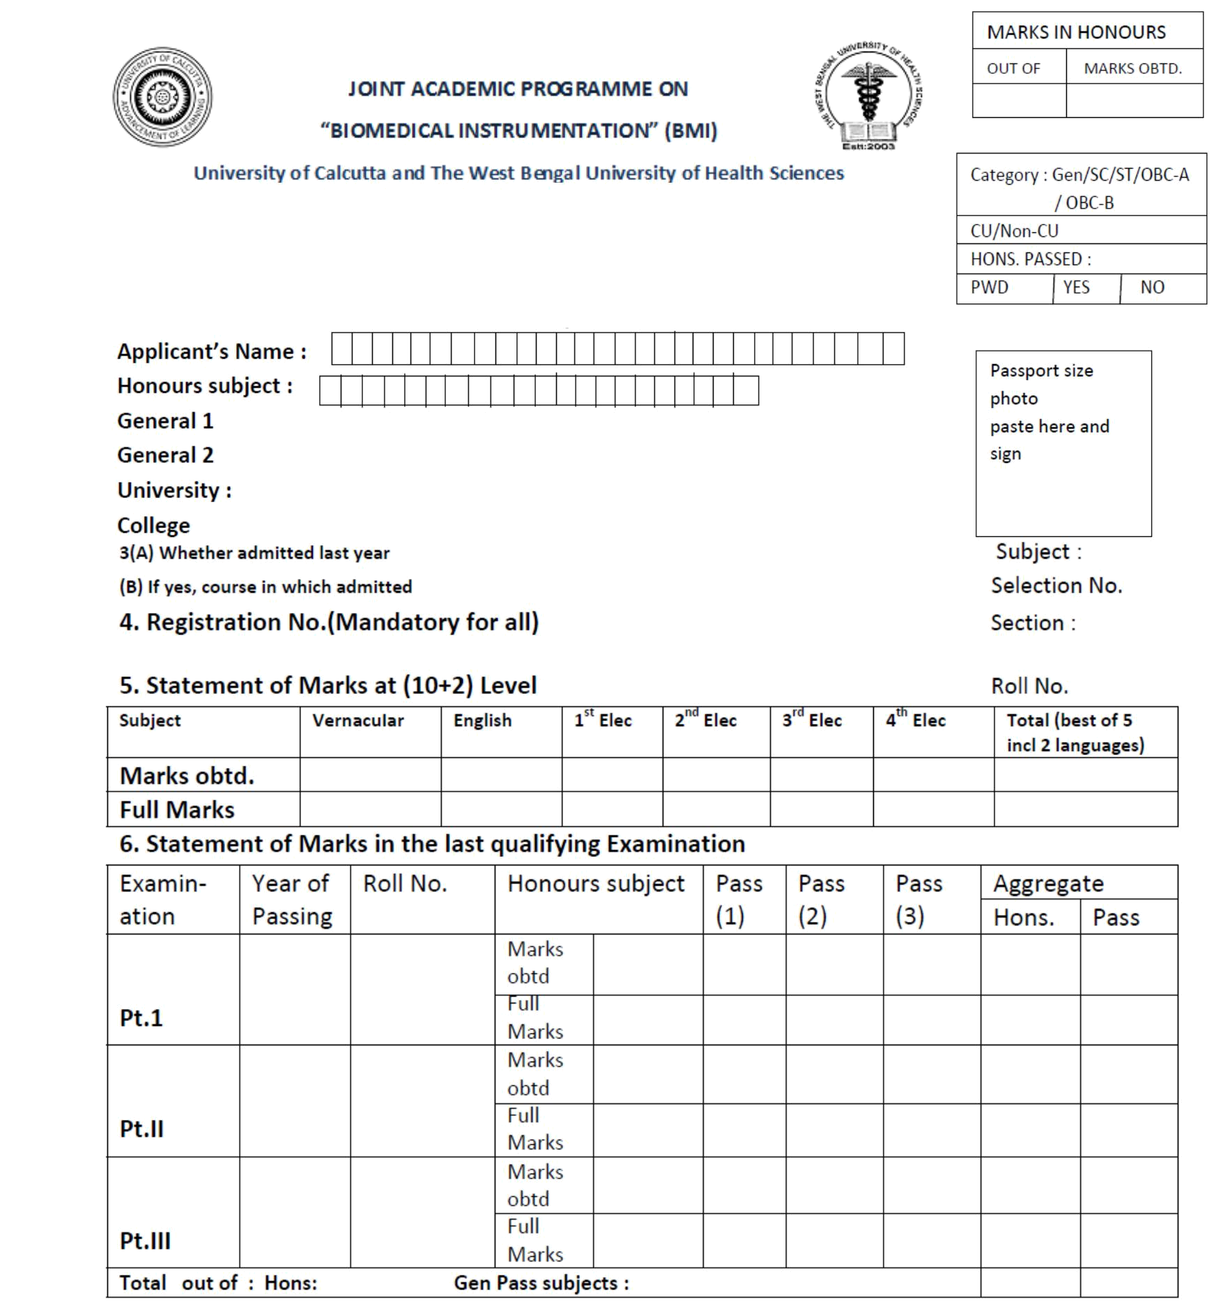
Form No.

Application Form for Admission to Two Years M.Sc. Degree in Biomedical Instrumentation (BMI) : 2018-19

B.Sc.

I

B.Sc.

B.Sc.

N.B.: Application Fee Rs.100/‐ (Rs.50/‐ for SC/ST/PWD) (Deposit to Bank of Boroda, Ext. Counter, Surya Sen Street, inside Rajabazar Sc. College Campus, CU Br. SB A/c No. 98210100001618 under the “JAP-BMI P.G. offline application” . Please attach Counter part of
Cash Deposition receipt and write on the reverse Name, Course applied for and Mobile No. of the candidate.

 |  | Signature of the Applicant
 | An application form for M.Sc. in BIOMEDICAL INSTRUMENTATION with the Honours marks of
Receipt
Receipt | …………………… in | ………….………………….from …………………………… (Name of student) has been accepted by the

office for the session ……………………

Signature/ Official Stamp (Received by)
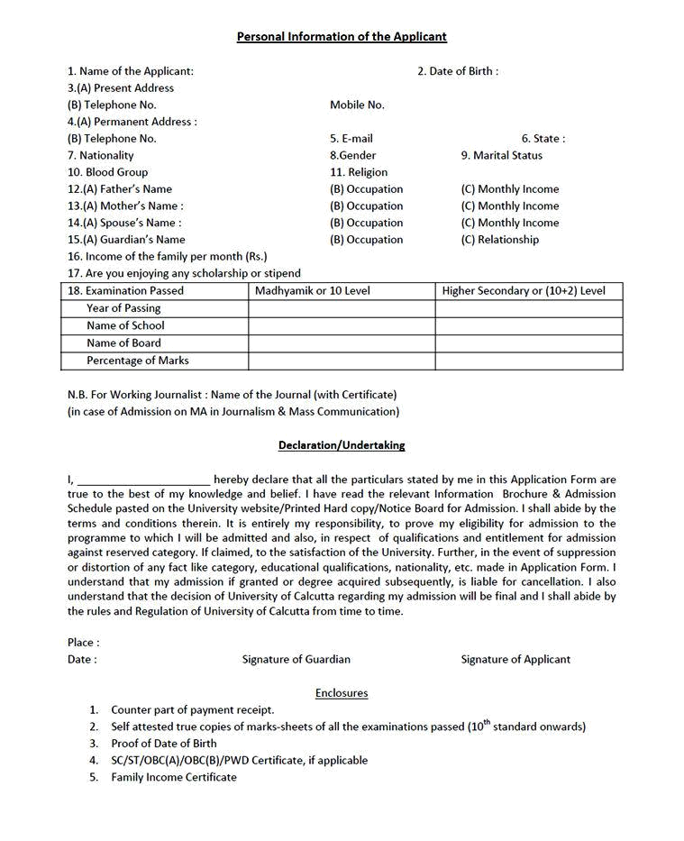

web: www.japbmi.in

